-First of all we use STAX parser:

STAX vs SAX vs DOM

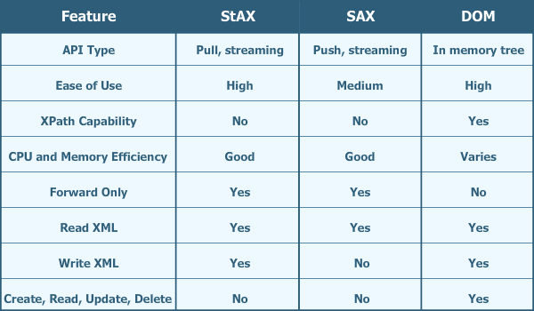

->From the previous table and as the STAX( writes and read) we choose it but the DOM is overhead on the memory but you can append row in your table and SAX only (reads) .. it can't write in the file.

-There is a database of students that contains there information like there name, surname, age and city.

-we have DBMS class that contains the operations of the file, it contains some functions:

Create Table: it creates a new xml file and take the name and the type of each column in the table of this file.

Drop Table: it deletes the file that includes the table we want to delete.

Insert into Table: it inserts the data we want in each column chosen in the tables of the database.

Delete from Table: it deletes some data from a table we choose depending on a condition which the user asks for.

Select from Table: it selects some columns which have a condition depends on the user's decision.

- we have the side of REGEX that validates the input from user and chooses the function we want to use either create table, drop table, delete from table, insert to the table or select column from table.

-the XSD that validates the table in the database and contains the data types of our columns.

-we implemented the interface that contains the three methods that the user will use to control the database.

The UML Diagram:

