Course Title: Advanced Programming Laboratory

Course Code: 0714 02 CSE 2100

# Field of application: Club Management

**Implementation of SRP (Single Responsibility Principle):**

All classes are kept seperate so that they bear only one responsibility. Which means, Each class can provide only one type of service.

**Implementation of (Open/Closed Principle):**

According to OCP principle, classes should be open for extenson, but closed for modification.

For Social Engagement, interface Post holds only ‘post()’ method. ‘Social Platform’ class implements this interface and defines ‘post()’ method. ‘SocialMediaPost’ class extends ‘Social Platform’ class.

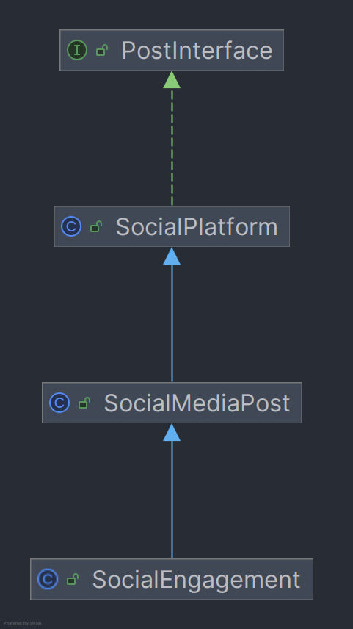

**Implementation of LSP (Liskov Substitution Principle):**

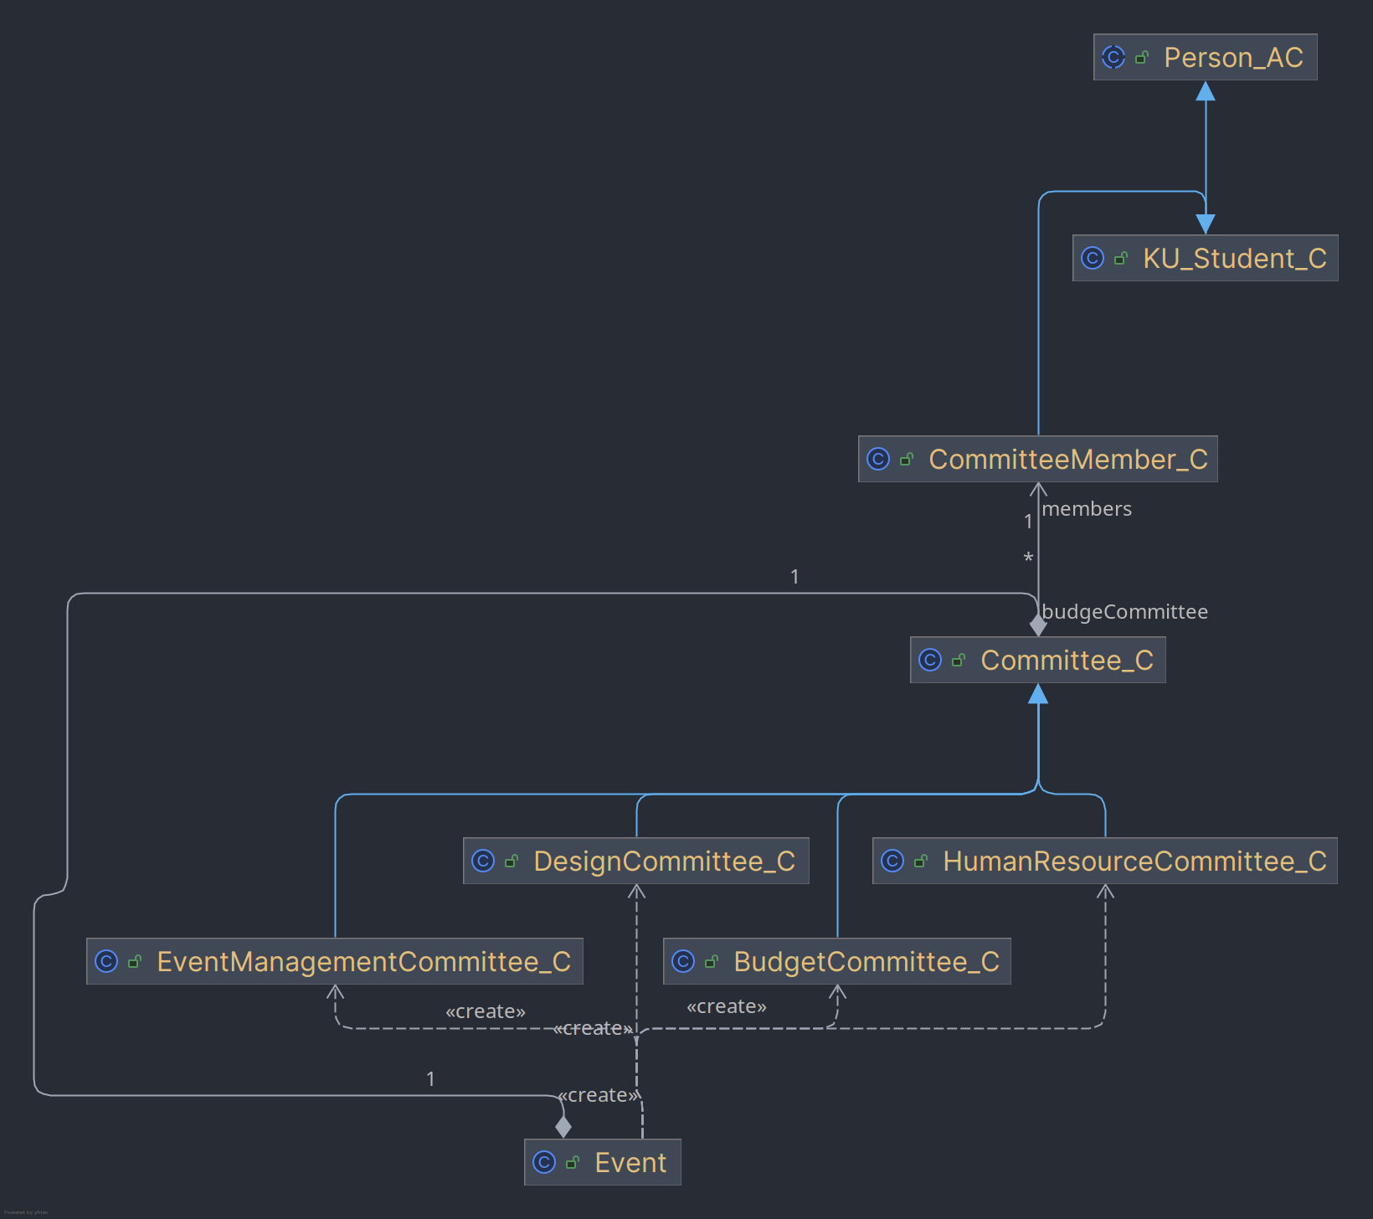

Implementation of