Course Title: Advanced Programming Laboratory

Course Code: 0714 02 CSE 2100

# Field of application: Club Management

**Implementation of SRP (Single Responsibility Principle):**

All classes are kept seperate so that they bear only one responsibility. Which means, Each class can provide only one type of service.

**Implementation of OCP (Open/Closed Principle):**

According to OCP principle, classes should be open for extenson, but closed for modification.

For Social Engagement, interface Post holds only ‘post()’ method. ‘Social Platform’ class implements this interface and defines ‘post()’ method. ‘SocialMediaPost’ class extends ‘Social Platform’ class.

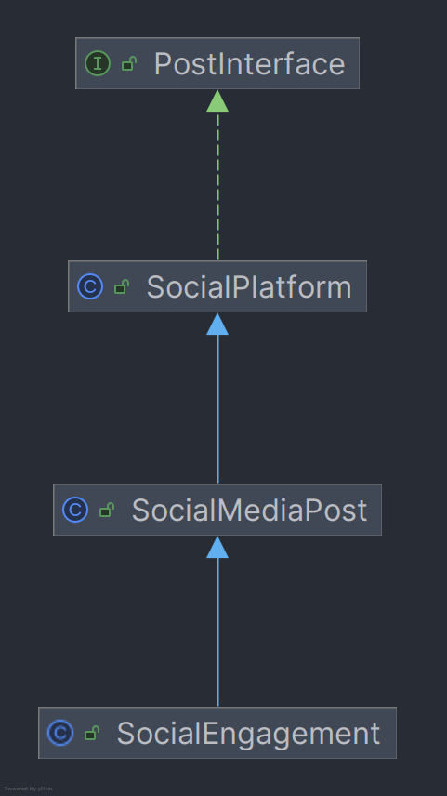

**Implementation of LSP (Liskov Substitution Principle):**

According to LSP, subclass should remain compatible with the behavior of the superclass. Here, ‘Committee_C’ is superclass and ‘EventManagementCommittee_C’ class, ‘DesignCommittee_C class’, ‘BudgetCommittee_C’ class, ‘HumanResourcesCommittee_C’ class are subclasses of ‘Committee_C’ class.

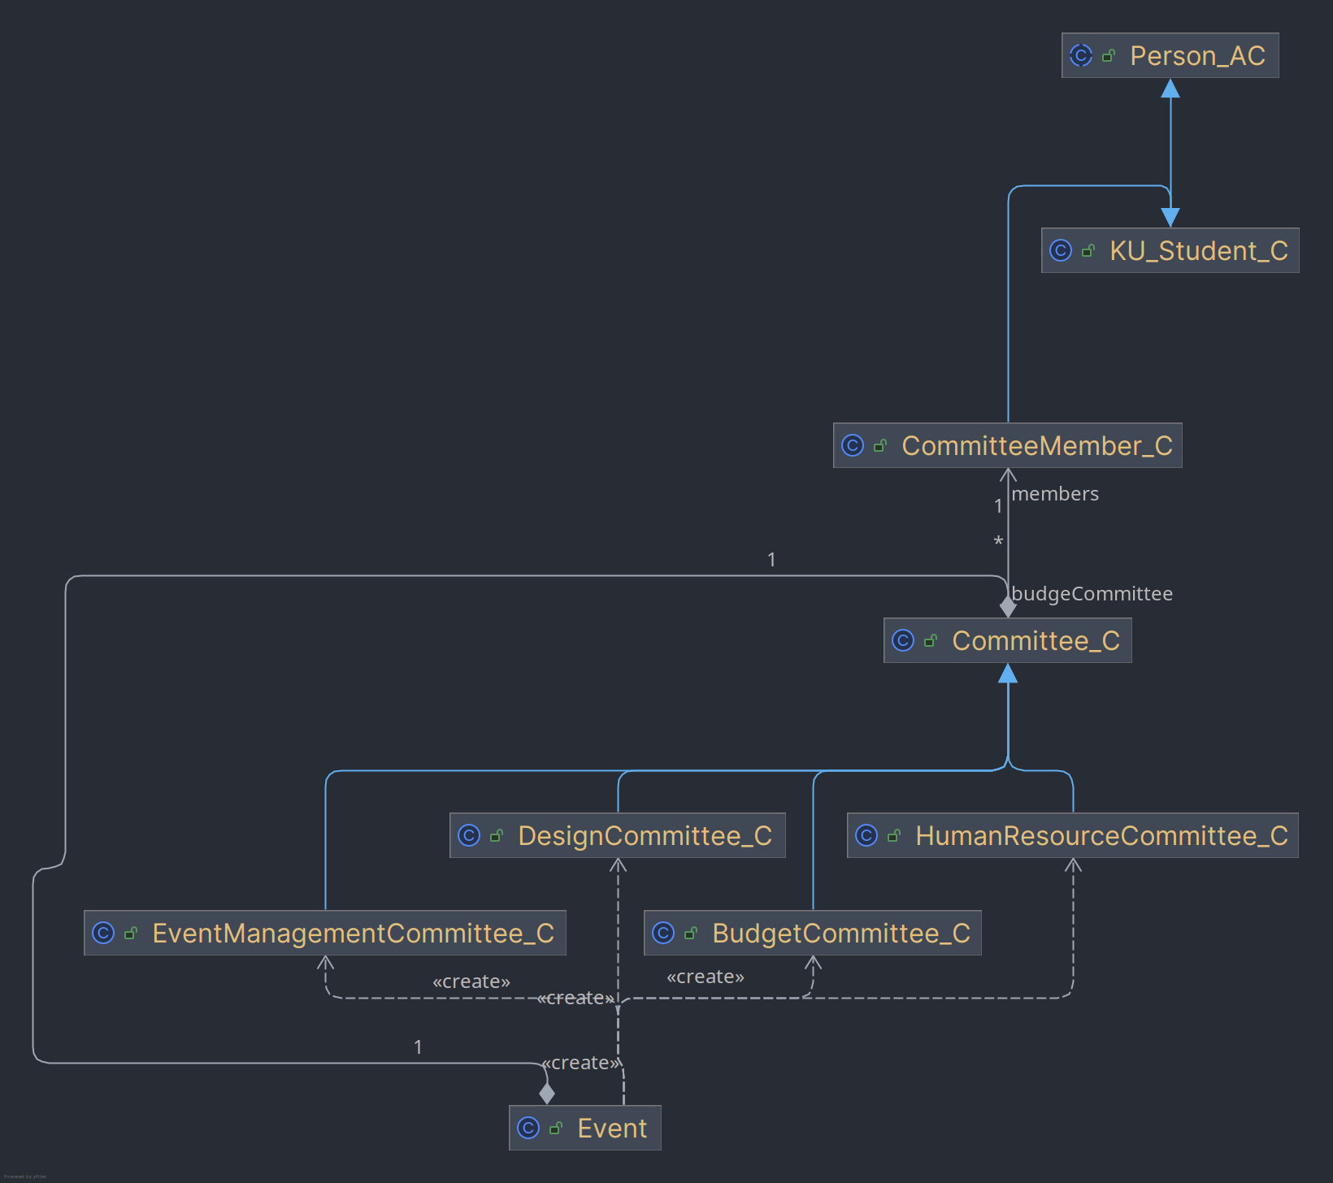

**Implementation of ISP (Interface Segregation Principle):**

ISP states that Clients shouldn’t be forced to depend on methods they do not use. To achieve this goal, different interfaces can be created that holds not more than one method signature. Since multiple interface implementation is supported, our classes can extend only necessary interfaces and override necessary methods.

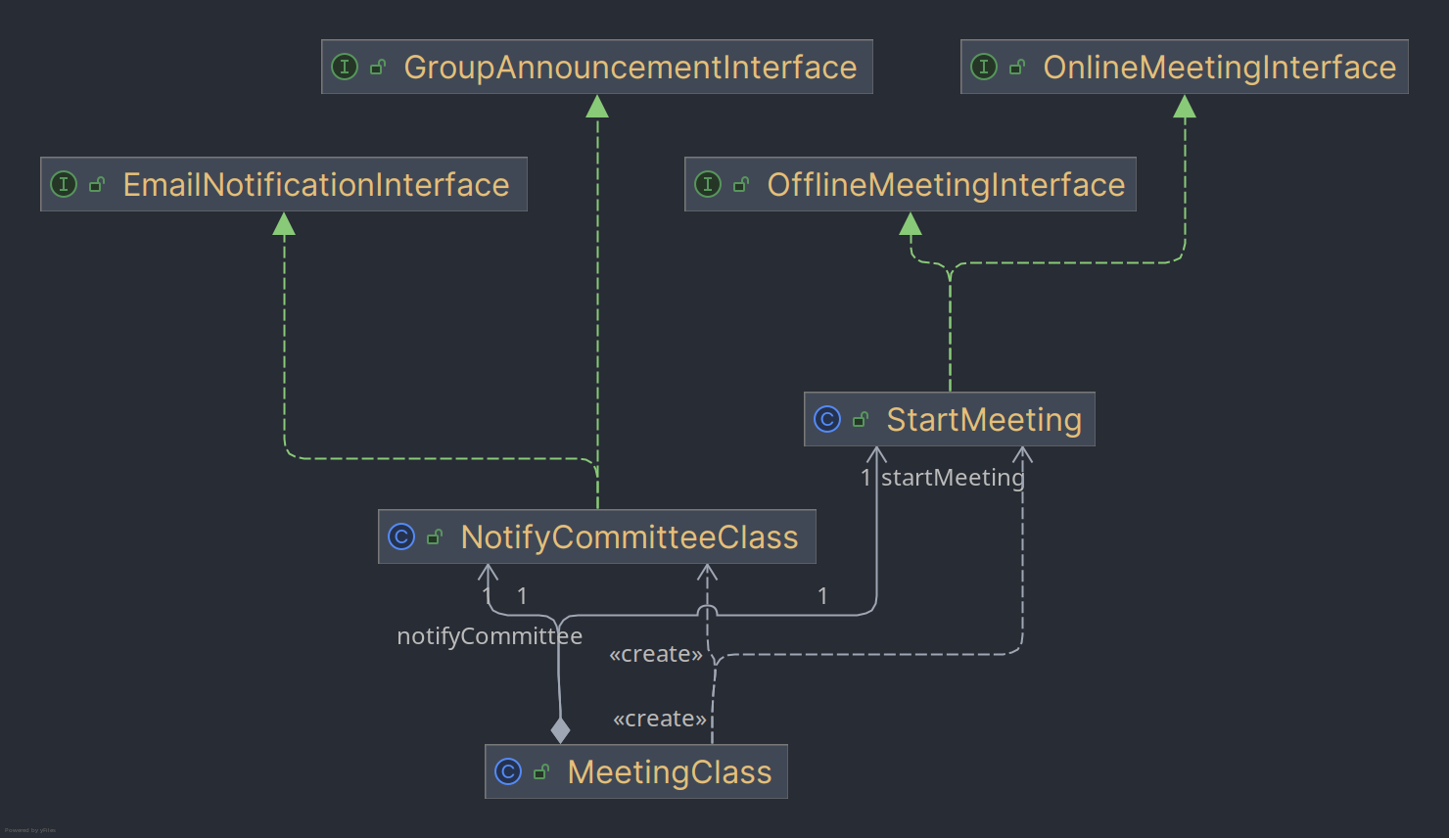

**Implementation of DIP (Dependency Inversion Principle):**

According to High-level classes shouldn’t depend on low-level classes. Both should depend on abstractions. In this implementation, ResultClass, DecisionMakerClass, JudgeClass, SubmissionClass, PrizeClass, AnnouncementClass do not depent on low level classes, rather depends on interfaces respectively ResultInterface, DecisionMakerInterface, JudgeInterface, SubmissionInterface, PrizeInterface, AnnouncementInterface.

