**SMART HAND SANITIZER**

**Shreya Ghosal, Shanya, Afaq Ahmad and Hriday Banerjee**

**Abstract -**

*Coronavirus disease is an infectious disease which can be spread from an infected person through their mouth or nose. Most people who fall sick with COVID-19 will experience reasonable symptoms and can be recovered without treatment. Unlike, some infected people become seriously ill and need medical assistance. It can be prevented by washing your hands or sanitizing them frequently and getting vaccinated. Though sanitization will not permanently kill the germs but it decreases in numbers. As schools and colleges are reopened, teachers must ensure that each student follow personal hygiene by maintaining record of all students*. *In this research, we designed an IOT based smart camera hand sanitizer, as in this pandemic period we need the pre-emptive action to reduce the spread of disease as recommended by WHO (World Health Organization), which includes hygiene of hands. Hygiene is the habit of keeping up good health and obviating the spread of disease. Hand sanitizer is fluid or foam used to minimize germs on the* *hand*. *This research work aims to design and implement a* *hand sanitizer with Arduino UNO, ultrasonic sensor, relay and ESP32 CAM. In this smart hand sanitizer, the ultrasonic sensor is used to detect the presence of the hand, and when it detects the hand, it turns on the relay that turns on the pump, and then the liquid (sanitizer) is poured into the hand. And then the person has to get in front of the camera to store her information.*

**Keywords**- Internet of things (IOT), Arduino UNO,

• Afaq Ahmad • Hriday Banerjee • Dept. of Computer Science, University of Engineering & Management, Jaipur, India • afaq.ahmed@uem.edu.in • hriday.banerjee@uem.edu.in

**I. Introduction-**

Coronavirus can affect respiratory tract and gastrointestinal by many ways. These viruses can be found in various varieties and mainly come from wild birds and hence to human.

The coronavirus has changed our world so much. Before this pandemic, we were in middle school shaking hands, talking and moving freely. And currently we can't think of going out without a mask and sanitizer or soap. And we have to sanitize our hands from time to time and also maintain social distancing. The outbreak of the COVID-19 (Coronavirus Disease-2019) pandemic has become a significant global concern for people's wellbeing and has led to a tremendous use of hand sanitizers given its transmittable environment. As of May 7, 2020, a total of 3.8 billion incident cases affecting more than 200 countries worldwide have been reported. [[1](https://www.ncbi.nlm.nih.gov/pmc/articles/PMC7246736/#B1-ijerph-17-03326)].

Hand sanitizer can generally be categorized into two parts: alcohol-based or alcohol-free. It may contain one or more types of alcohol, with or without other excipients and substances, to be applied to the hands to kill germs and momentarily suppress their growth [2]. Mandatory direction is provided by the authority for places that will need immediate and direct contact with people.

The importance of hand hygiene in preventing the transference of microorganisms and reducing the spread of infections following the global pandemic virus (COVID-19) was emphasized. If a person is infected, there is a chance that the virus will spread through contact. So in order to overcome this, we have designed a smart sanitizer in which an ultrasonic sensor detects the presence of the hand and does not require contact with the hand sanitizer dispenser.

One of the recommendations is to provide hand sanitizers next to the entrance to an on-site apartment. Accordingly, it is obligatory for the owner of the premises to acquire and provide the disinfectant for the general public. Normally, the hand sanitizer dispenser is prepared in a manual dispenser. Therefore, there will be direct contact between the distributor and the end user, and the distributor will be degraded. Therefore, the goal of this research is to implement a smart hand sanitizer that dispenses an adequate amount of sanitizer based on palm visualization with enhanced IoT functionalities.[3]

Combined documentary research from the sites concerned. The participant was instructed by a professional contamination authority regarding the hand hygiene process suggested by the WHO. The scientist put forward four parts to hit the target. The first part begins with the drying period of the rubbing hands with different capacities of foam, 65% ethanol and 10% n-propanol alcohol in gel, fluid and foam. The second part is access at your fingertips for ABHRs of different capacity.

**II. Literature Review-**

[1] The objective is to manage the record of all students and faculties for sanitization at least once in a contact way due to COVID-19. Here , An ultrasonic sensor determines the presence of the hands. When it senses the hand below 10cm, the relay will turn on and turn on the pump, to pour the sanitizer on the hand. The delay is given four seconds. Once the disinfectant has spilled, this person must come in front of the camera to capture their image.

[2] In the model proposed with hand detection, camera is also added. We use microcontroller which is Arduino UNO in this system to control all connected devices, namely: ultrasonic sensor, DC motor, relay, esp32 cam. The power supply provides the voltage and current necessary for the proper operation of the system.

[3] Connected objects and esp32 cam are used sanitize without coming in contact with machine and also to store the information for those who have sanitized once via IOT technology.

[4] The proposed model is to reduce the cost by connecting Arduino UNO which is a microcontroller board that connects ultrasonic sensor, power supply, relay. An ultrasonic sensor detects the hand and turns on the relay, which turns the pump on and then pumps a sanitizer on the hand. Arduino-connected ESP32 Cam captures the image of the person in front of the camera.

[5] The model help in executing hand hygiene and is much safer and suggested because of its touchless property and also is low cost user friendly that any one can use.

[6] The author has proposed a model to keep hand sanitized whenever someone needs to do it, without coming in contact with the dispenser. It is designed to take the preventive measure which should be taken due to COVID- 19.

[7] Arduino UNO, Ultrasonic sensor, Relay, ESP32 Cam in a proposed model. This article provides the literature review as well as support the conversation and provides the future scope for the proposed model.

[8] Designed a model with Esp32 Cam which captures the image of person who sanitize their hand and comes infront of the camera. The result of the proposed model shows the accuracy and efficiency of the model.

[9] The main focus of this paper is to design and execute a cost friendly and touchless smart hand sanitizer with camera that include features which are ESP32 cam, relay, DC Motor, based on Microcontroller.

[10] It has a small container which dispenses minute amount of liquid and identifies the amount of liquid in the container.

**III. Objective-**

The main objective of this project is to keep record of all students and faculties for sanitization at least once in a contact way due to COVID-19. As along with social distancing, sanitizing time to time is also an important aspect. Keeping all this in mind, we came across to an IOT based project smart hand sanitizer which will ensure that there’s no direct contact with machine and will store the information for those who have sanitized once.

**IV. Proposed Model-**

An ultrasonic sensor determines the presence of the hands. When it senses the hand below 10cm, the relay will turn on and turn on the pump, to pour the sanitizer on the hand. The delay is given four seconds. Once the disinfectant has spilled, this person must come in front of the camera to capture their image. We use microcontroller in this system to control all connected devices, namely: ultrasonic sensor, DC motor, relay, esp32 cam. The power supply provides the voltage and current necessary for the proper operation of the system.

This system consists of two parts, Hardware and Software.

**4.1 Hardware includes:**

* Ultrasonic sensor
* ESP-32 cam
* Pump
* Connecting wires
* Arduino UNO
* Relay
* Adapter
* Container
* Pipe

**4.2 Software includes:**

* Arduino IDE

**V. Working:**

**Arduino UNO:**

The Arduino Uno is a microcontroller board. There are fourteen digital input/output pins (six of which can be used as pulse width modulation outputs), six analog inputs, 16 mega-hertz quartz crystals, USB connection, power jack, an ICSP header and a reset switch. The Arduino UNO is a type of Arduino product that is mainly used by beginners in electronic projects and circuit design.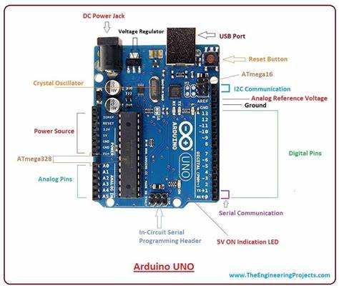

**Fig.1 [4]**

**Ultrasonic sensor:**

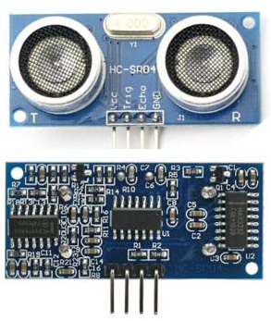

**Fig.2[5]**

An ultrasonic sensor is used to measure the distance to an object and to provide more accurate and reliable data using sound waves. The ultrasonic sensor determines the distance to reach the target by measuring the time interval between the transmitter and receiver of the ultrasonic pulses.

**Relay:**



**Fig.3[6]**

A relay is an automatic switch that is generally used in an automatic control circuit and to control high current using a low-current signal. The input voltage of the relay signal scale is from 0 to 5V. It is one type of electromechanical component that acts as a switch. The relay loop is energized by DC so that contact switches can be opened or closed. The relay module decides whether or not to allow the current to flow through.

**ESP32 CAM:**

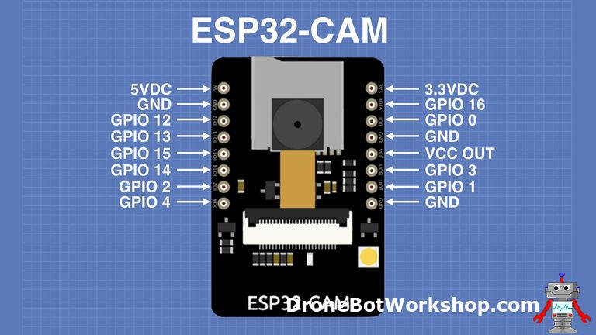

**Fig.4[7]**

This module is a complete microcontroller with integrated video camera and microSD card socket as well. It's cheap and easy to use, and consumes less power. It is suitable for various IoT applications such as wireless monitoring, smart home devices etc. ESP32 CAM has components on both sides of the printed circuit board. On the top of the board it has the connector for the camera module, as well as the microSD card socket.

**5.1 Flow chart:**

From the below flow chart, we can say that :

Step 1: When an object is detected at a distance less than equal to 10 cm.

Step 2: Then it will automatically turn the relay on.

Step3: Simultaneously the pump will pour the sanitizer on your palm.

Step 4: After poring the liquid, the ESP-32 CAM module attached to the model will detect the face of the person

Step 5: If the face is detected successfully then it will capture the image and store it in Arduino UNO.

Step 6: If the face to detected is failed then it will simply end.

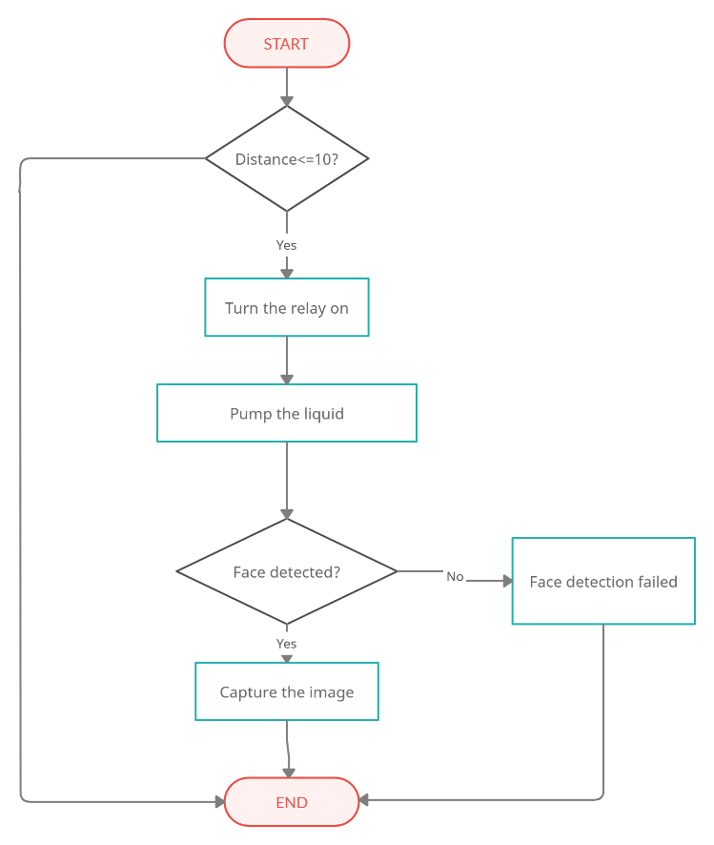

**Fig 5: The flow chart of the system.**

**5.2 Block diagram:**

Arduino UNO is a microcontroller board that connects ultrasonic sensor, power supply, relay. An ultrasonic sensor detects the hand and turns on the relay, which turns the pump on and then pumps a sanitizer on the hand. The block diagram below shows the full system connection. Arduino-connected ESP32 Cam captures the image of the person in front of the camera.

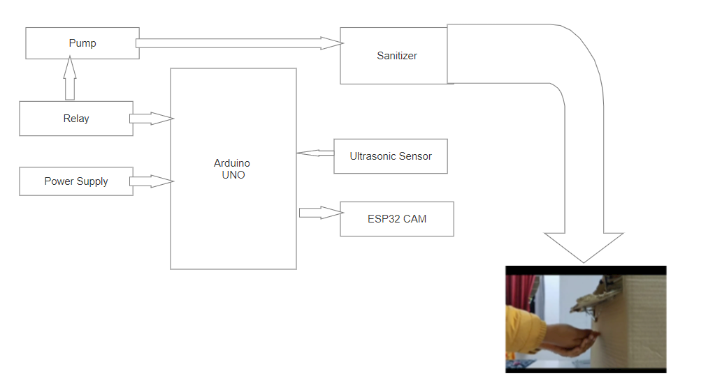 **Fig 2: The Block Diagram of the system.**

**5.3 Circuit Diagram:**

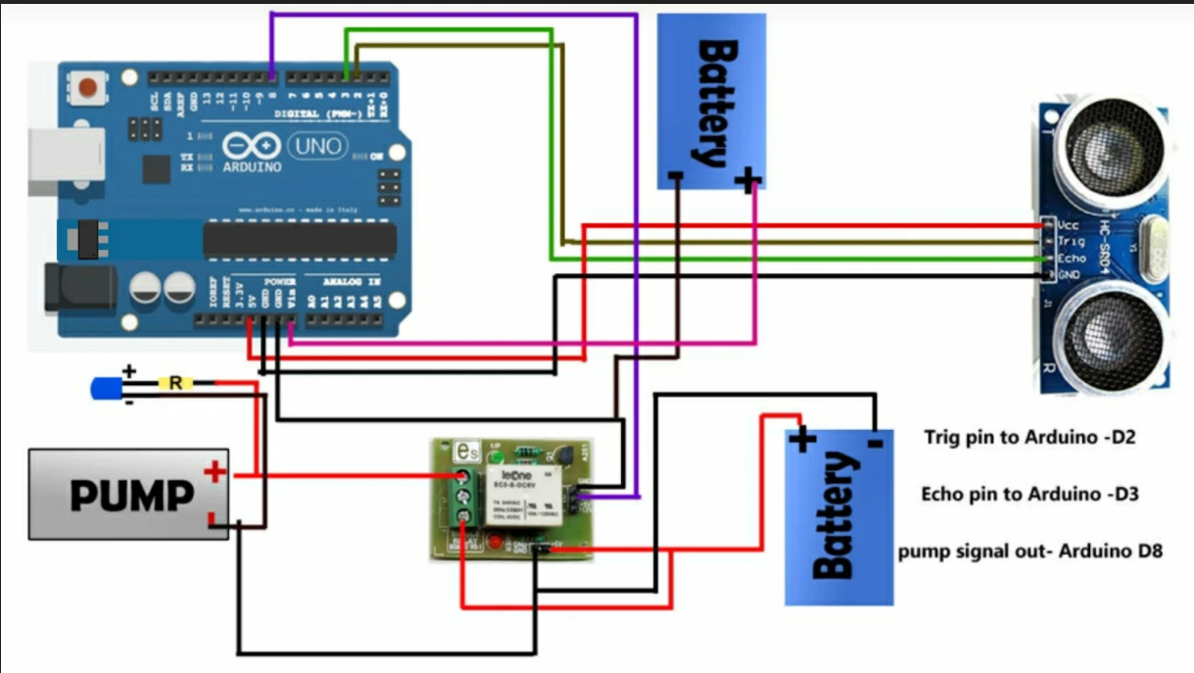**Fig 3: The Circuit Diagram of the system.**

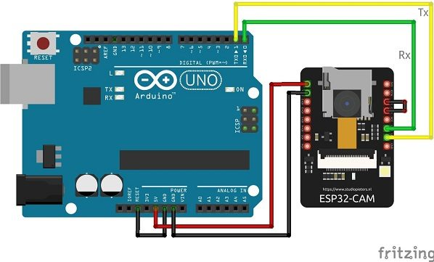**Fig 4: The Circuit Diagram of the ESP32 CAM.**

**VI. Result:**

The following are the result obtained from our work:

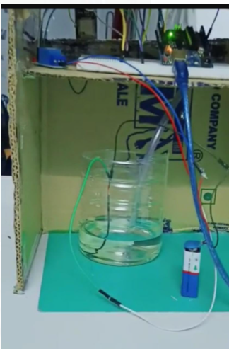 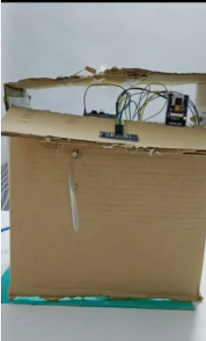

Fig-5 Fig-6

 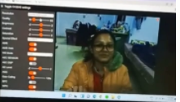

Fig-7 Fig-8

The Ultrasonic Sensor will sense the presence of the hand within the given distance. After sensing the presence of the hand relay will be turned on which will turn on the pump, which will pour liquid(sanitizer) on the hand. And then the person has to come in front of camera to store their image.

**Conclusion and Future Scope:**

From the above discussion, we can assure that in colleges or schools, registered students and faculties have disinfected once. The system will certainly help in the implementation of hand hygiene without any complaints as it will be necessary to disinfect if a person has access to an entry point. It is much more intact and sanctioned due to its non-contact property which reduces the chance of cross contamination. We can add an LCD screen, PIR sensor and buzzer so that if a person approaches the dispenser and leaves without sanitizing, the buzzer will go off and display on the LCD screen "NOT SANITIZED".

**References:**

[1] Baloch, S., Baloch, M.A., Zheng, T. and Pei, X., 2020. The coronavirus disease 2019 (COVID-19) pandemic. *The Tohoku journal of experimental medicine*, *250*(4), pp.271-278.

[2]. McKee RS, Schnadower D, Tarr PI, Xie J, Finkelstein Y, Desai N, Lane RD, Bergmann KR, Kaplan RL, Hariharan S, Cruz AT. Predicting hemolytic uremic syndrome and renal replacement therapy in Shiga Toxin–producing Escherichia coli–infected children. Clinical Infectious Diseases. 2020 Apr 10;70(8):1643-51.

[3] Zainudin ZI, San LY, Abdulla R. Smart hand sanitizer dispenser. Journal of Applied Technology and Innovation (e-ISSN: 2600-7304). 2022;6(1):10

[4] Aung WP, Zaw KK, Win HK. Labview Interfacing Arduino for Servo Motor Control in Mini Vending Machine.

[5] Andria G, Attivissimo F, Giaquinto N. Digital signal processing techniques for accurate ultrasonic sensor measurement. Measurement. 2001 Sep 1;30(2):105-14.

[6] Tjandi Y, Kasim S. Electric Control Equipment Based on Arduino Relay. In Journal of Physics: Conference Series 2019 Jun 1 (Vol. 1244, No. 1, p. 012028). IOP Publishing.

[7] Kumar S, Sharma K, Raj G, Datta D, Ghosh A. Arduino and ESP32-CAM-Based Automatic Touchless Attendance System. In Proceedings of the 3rd International Conference on Communication, Devices and Computing 2022 (pp. 135-144). Springer, Singapore.