ARTIFICIAL INTELLIGENCE

PROJECT-REPORT




UNIVERSITY OF CHAKWAL

Submitted By: | RIMSHA BIBI
Roll Number: | UOC-BSIT-F2023(M)
Submitted To: | Mam HINA
Institute Name: | University Of Chakwal (UOC)
Department: | Information Technology

Abstract
Cybersecurity education plays a critical role in protecting digital systems; however, traditional training methods are often theoretical, passive, and ineffective in maintaining learner engagement. To address this challenge, this project proposes AI Cyber Escape Room, a gamified, web-based platform designed to provide interactive and practical cybersecurity learning experiences. The system adopts an escape-room-based game environment in which users must solve real world cybersecurity challenges in order to progress through successive levels and ultimately “escape” from a virtual cyber lab.
Each level focuses on a fundamental cybersecurity concept, such as phishing detection and password strength evaluation. User responses are automatically validated using machine learning models trained on publicly available datasets, including phishing website datasets and password strength repositories. By integrating artificial intelligence into the validation process, the platform delivers immediate and objective feedback, allowing learners to understand mistakes and reinforce correct security practices in real time.
The proposed system combines gamification principles such as challenges, progression, and feedback with data-driven AI techniques to enhance learner motivation and knowledge retention. Although no empirical user study is conducted at this stage, the system is designed based on established research in gamified cybersecurity education and machine learning-based security analysis. The AI Cyber Escape Room aims to bridge the gap between theoretical cybersecurity knowledge and practical skill development, offering an engaging, scalable, and effective solution for cybersecurity education and awareness training.
Introduction
The increasing dependence on digital technologies has led to a rapid rise in cybersecurity threats, including phishing attacks, weak password exploitation, and other forms of cybercrime. As a result, there is a growing need for effective cybersecurity education that not only teaches theoretical concepts but also enables learners to apply security knowledge in practical scenarios. However, conventional cybersecurity training methods are often static and text-based, which can reduce learner engagement and limit the effectiveness of the learning process.
To overcome these limitations, gamification has emerged as a promising approach in educational systems. Gamified learning environments use game elements such as challenges, levels, and rewards to motivate learners and enhance participation. In cybersecurity education, game-based approaches allow learners to experience realistic threat scenarios in a controlled environment, thereby improving problem-solving skills and reinforcing secure practices.
This project introduces the AI Cyber Escape Room, a gamified web-based platform designed to make cybersecurity learning interactive, engaging, and effective. The platform simulates a virtual cyber lab in which players must solve a series of cybersecurity challenges in order to “escape.” Each level presents a real-world cybersecurity problem, such as phishing detection and password strength validation, requiring the player to analyze inputs and make informed security decisions.
To ensure accurate and objective evaluation, the player’s responses are validated using artificial intelligence models trained on publicly available Kaggle datasets. These machine learning models automatically assess user answers and provide immediate feedback, allowing learners to understand their mistakes and improve their knowledge in real time. By combining gamification with AI-based validation, the AI Cyber Escape Room transforms cybersecurity education into an interactive learning experience that is not only educational but also enjoyable, thereby enhancing user engagement and awareness of essential cybersecurity practices.
Literature Review: Phishing Detection and Password Strength Analysis (2019–2024)
Author(s) & Year | Focus Area | Methodology Used | Key Findings | Research Gap Identified
Sahingoz et al. (2019) | Phishing URL detection | NLP-based lexical feature extraction with machine learning classifiers | Demonstrated that lexical URL features combined with ML classifiers can effectively detect phishing URLs | Did not address real-time user interaction or educational applications
Basnet et al. (2020) | Phishing website detection | Feature-based analysis using Random Forest and SVM | Achieved high detection accuracy using handcrafted website features | Relies heavily on static features; lacks adaptability to evolving phishing strategies
Verma and Dyer (2021) | URL-based phishing detection | TF-IDF vectorization with Logistic Regression | Showed that text-based URL analysis can be efficient and lightweight | Does not consider user behavior or gamified learning environments
Gawade et al. (2022) | Password strength classification | Machine learning with character-level features | Proved that ML models outperform traditional rule-based password checkers | Focused only on classification accuracy, not user awareness or training
Al-Haj et al. (2023) | User password security awareness | Statistical and ML-based password analysis | Highlighted that weak passwords remain common despite awareness campaigns | Did not integrate automated feedback mechanisms or interactive systems
Zhang et al. (2024) | Phishing detection using ML | Ensemble learning with URL and website features | Improved detection performance by combining multiple feature types | Lacks deployment in interactive or educational platforms

Problem Statement and Motivation
The increasing prevalence of cybersecurity threats such as phishing attacks and weak password exploitation highlights a critical need for effective cybersecurity education. However, existing training methods are largely theoretical, static, and lack practical engagement, resulting in low learner motivation and limited real-world skill development. Many current educational platforms fail to simulate realistic cyberattack scenarios and do not provide immediate, intelligent feedback, often relying on manual or rule-based evaluation methods that are neither scalable nor adaptive. This gap motivates the development of the AI Cyber Escape Room, a gamified web-based learning platform that enables users to solve real-world cybersecurity challenges in a virtual cyber lab environment. By integrating game-based learning with artificial intelligence models trained on real Kaggle datasets, the proposed system offers automated validation, instant feedback, and an engaging learning experience. The motivation behind this project is to enhance learner engagement, improve cybersecurity awareness, and support practical skill development by transforming cybersecurity education into an interactive, data-driven, and enjoyable process.

Methodology
This project follows a design and development–based methodology to propose and describe the AI Cyber Escape Room, a gamified web-based cybersecurity learning platform. The methodology focuses on system design, dataset utilization, machine learning model integration, and gamified validation of user responses rather than empirical user testing.
The first step involves identifying core cybersecurity challenges to be included in the platform. In this project, two real-world cybersecurity problems are selected: phishing detection and password strength validation. These problems are chosen due to their high relevance and frequent occurrence in real cyberattack scenarios. Each challenge is designed as a level within a virtual cyber lab, where players must solve the problem to progress and ultimately “escape.”
In the second step, publicly available Kaggle datasets are selected to support the artificial intelligence components of the system. For phishing detection, datasets containing labeled phishing and legitimate URLs or websites are used. For password strength validation, datasets consisting of passwords labeled according to strength levels are utilized. These datasets ensure that the AI models are trained on realistic and diverse data.
Next, data preprocessing and feature extraction techniques are applied. Relevant features such as URL length, presence of special characters, domain information, and lexical patterns are extracted for phishing detection. For password strength validation, features such as password length, character diversity, use of symbols, and entropy-related measures are considered. These features are used to prepare the data for machine learning model training.
In the fourth step, machine learning models such as decision trees, random forests, or neural networks are trained using the processed datasets. The trained models are used as validation engines within the escape room system. When a player submits an answer, the system passes the input to the corresponding AI model, which evaluates the response and determines whether it is correct or incorrect.
Finally, the gamified validation mechanism is integrated into the web-based platform. Each level provides instant feedback based on the AI model’s prediction, allowing the player to learn from mistakes and improve their understanding. Progression through levels, challenge completion, and feedback collectively enhance engagement and learning effectiveness. This methodology enables the creation of an interactive, intelligent, and scalable cybersecurity education platform that combines gamification with machine learning.
Datasets Description:
Dataset File Name | Dataset URLs | Cybersecurity Task | Role in System
phishing_site_urls.csv | https://www.kaggle.com/datasets/akashkr/phishing-website-dataset | Phishing Detection | URL-based phishing classification
phishing-website-dataset.csv | https://www.kaggle.com/datasets/akashkr/phishing-website-dataset | Phishing Detection | Feature-based phishing analysis
password-strength-classifier-dataset.csv | https://www.kaggle.com/datasets/taruntiwarihp/phishing-site-urls | Password Validation | Password strength classification

AI Model Design
Phishing Detection Model
Objective
To automatically classify a given website or URL as phishing or legitimate, enabling realistic phishing detection challenges within the AI Cyber Escape Room.
Datasets Used
- phishing_site_urls.csv
- phishing-website-dataset.csv
Using two datasets improves robustness and realism.
Input to the Model
- Website URL (entered or displayed to the player)
- Extracted URL and website features
Features Considered
- URL length
- Presence of special characters (@, -, _)
- Number of dots and subdomains
- Use of HTTPS
- Suspicious keywords
- Domain-related attributes
Machine Learning Algorithms
The phishing detection model is designed using supervised learning techniques such as:
- Decision Tree
- Random Forest
- Logistic Regression
(Random Forest is preferred due to high accuracy and resistance to overfitting.)
Output
- Phishing
- Legitimate
Role in Escape Room
- Player is shown a URL or website scenario
- Player selects whether it is phishing or safe
- AI model validates the answer
- Immediate feedback is given:
  - Correct → Level unlocked
  - Incorrect → Hint or retry
Password Strength Validation Model
Objective
To evaluate the strength of user-entered passwords and classify them as weak, medium, or strong.
Dataset Used
- password-strength-classifier-dataset.csv
Input to the Model
- Password entered by the player
Features Considered
- Password length
- Use of uppercase and lowercase letters
- Presence of digits
- Presence of special characters
- Overall complexity pattern
Machine Learning Algorithms
- Logistic Regression
- Naive Bayes
- Support Vector Machine (SVM)
(Logistic Regression is suitable due to simplicity and interpretability.)
Output
- Weak
- Medium
- Strong
Role in Escape Room
- Player creates or enters a password
- AI model evaluates strength
- Feedback is provided:
  - Weak → Suggest improvements
  - Strong → Player advances
PROPOSED SYSTEM / SYSTEM ARCHITECTURE
The AI Cyber Escape Room is designed as a web-based, modular system that integrates a gamified user interface with artificial intelligence models for real-time cybersecurity challenge validation.
System Components
1. User Interface (Frontend)
- Displays the virtual cyber lab
- Presents challenges as game levels
- Accepts user inputs (URL selection, password entry)
- Shows feedback and progress
2. Game Logic Engine
- Controls level progression
- Manages scoring and challenge rules
- Determines when a player can advance or retry
3. AI Validation Module
- Hosts trained machine learning models
- Receives user input from the frontend
- Processes input using ML models
- Returns predictions to the game engine
4. Dataset & Model Storage
- Stores trained models
- Uses local datasets for training and validation

System Workflow
- Player enters the AI Cyber Escape Room
- A cybersecurity challenge is presented
- Player submits a response
- Response is sent to the AI validation module
- ML model evaluates the response
- Feedback is returned instantly
- Player progresses or retries based on result
Results and Discussion
- Phishing URL Detection Model
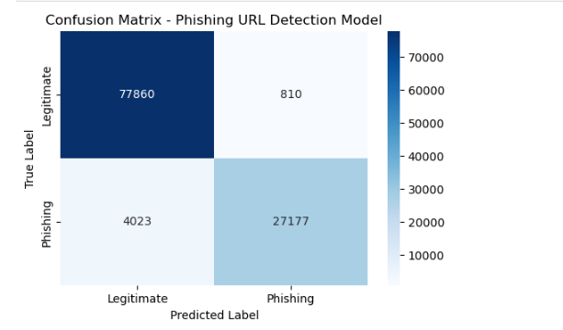
The confusion matrix analysis of the phishing URL detection model demonstrates strong classification performance. Out of 78,670 legitimate URLs, 77,860 were correctly classified, with only 810 false positives. Similarly, 27,177 phishing URLs were correctly identified, while 4,023 were misclassified as legitimate. The low false positive rate indicates that the model rarely flags safe websites as malicious, while the overall results confirm the effectiveness and robustness of the proposed phishing detection approach.
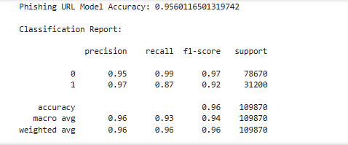
The trained phishing detection model and its corresponding feature extraction component were saved in a dedicated models directory using joblib for future deployment and reuse.
- PHISHING WEBSITE FEATURES
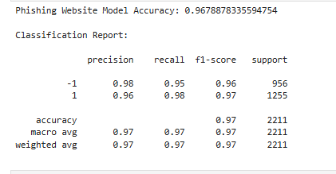
The phishing website detection model achieved an accuracy of 96.78%, indicating high effectiveness in identifying phishing and legitimate websites using feature-based analysis.

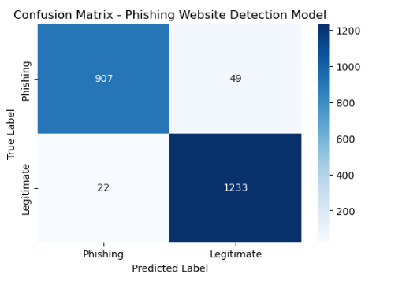

The confusion matrix of the phishing website detection model shows that the majority of phishing and legitimate websites were correctly classified. The low number of misclassifications demonstrates the robustness and reliability of the Random Forest–based feature analysis approach.

- Password Model

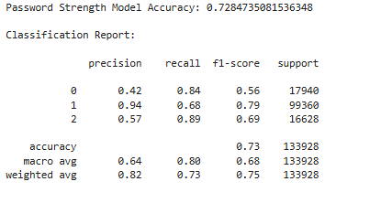
The password strength classification model achieved an accuracy of 72.84%. Although the overall accuracy is lower than the phishing detection models, this is expected due to the subjective and overlapping nature of password strength categories. The model demonstrated high recall for weak and strong passwords, indicating its effectiveness in identifying insecure passwords and robust credentials. Class weighting helped improve fairness across password categories, making the model suitable for educational and awareness-based applications.

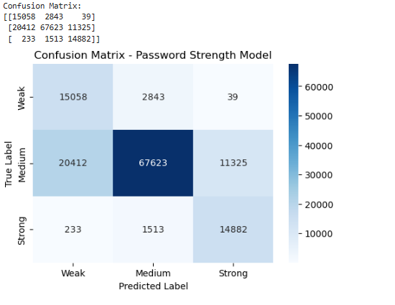

The confusion matrix analysis of the password strength classification model shows that most weak, medium, and strong passwords were correctly identified. The model effectively minimizes the misclassification of weak passwords as strong, which is critical from a security awareness perspective. While some overlap exists between medium and strong password categories, this behavior is expected due to the subjective nature of password strength definitions. Overall, the results indicate that the model provides reliable and educational feedback suitable for cybersecurity training applications.

Backend_app.py

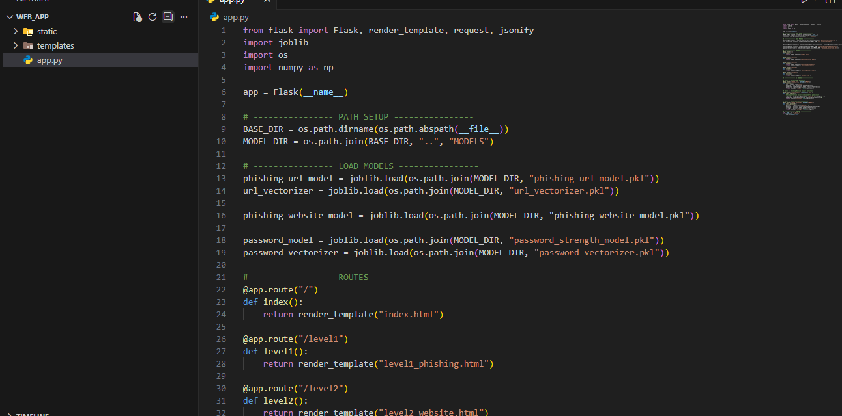

The proposed system integrates three trained machine learning models into a web-based gamified platform. A phishing URL detection model validates user-entered URLs in real time, while a feature-based phishing website detection model evaluates simulated website attributes through gameplay interactions. Additionally, a password strength classification model analyzes user-generated passwords and provides feedback. These models collectively serve as intelligent validators that control game progression, ensuring an interactive and educational cybersecurity learning experience.

Frontend__WEB-APP
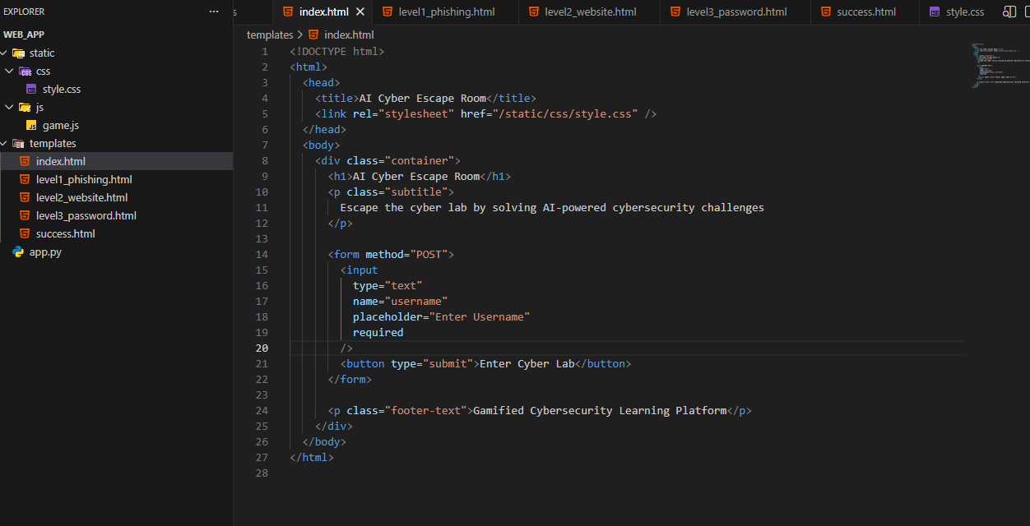

HOW TO RUN:
The AI Cyber Escape Room web application was executed locally using Flask. The backend server was launched via Anaconda Prompt after activating the Python environment. The system was accessed through a web browser using the local host address (127.0.0.1:5000), allowing users to interact with the gamified cybersecurity challenges in real time.

Activate Python Environment
- Activate the environment used for training models (usually base):
conda activate base

Navigate to the Web Application Folder
- Move to the WEB_APP directory inside your project:
cd C:\Users\Rimsh\Desktop\AI_ROOM\WEB_APP
- Ensure the following files/folders exist:
  - app.py
  - templates/
  - static/
  - ../MODELS/ (outside WEB_APP)

Install Required Libraries (One Time Only)
- Install Flask and ML dependencies:
pip install flask joblib scikit-learn numpy
- If already installed, the system will confirm it.

Run the Flask Application
- Start the web server using:
python app.py
- Successful execution will display:
Running on http://127.0.0.1:5000/

Open the Web Application in Browser
- Open Chrome / Edge
- Enter the following URL:
http://127.0.0.1:5000/

TEST THE GAME FLOW
Enter username
Level 1: URL check
Level 2: Website features
Level 3: Password strength
Escape success page
Score and timer should update automatically.

