**CC-213L**

**Data Structures and Algorithms**

**Laboratory 01**

**Algorithms Performance Analysis and Measurement**

**Pre_Lab_01**

**BIT-F22**

**BITF22M029**

**Rimsha Majeed**

**Practice Question**

**A**ttempt to formulate the time equation for this algorithm

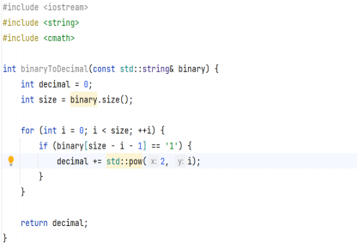

***Complexity Equation:*  1 + 1 + n + n + n + 1 = 3 + 3n**

***Big O:* O(3n) = O(n)**

|  |  |
| --- | --- |
| **Step Count Complexity Equation:** | **Big O** |
| **4n^2 + 2n + 5** | **n^2** |
| **(n^2 + 3) * log (n)** | **n^2** |
| **(n + 1) * log (n^2 + 1** | **Nlog(n)** |
| **2^n + n ^ 10 + log (n)** | **2^n** |
| **𝑙𝑜𝑔2(𝑛) + 10** | **Log(n)** |
| **2^n + n! + 9** | **N!** |

**Task 01: Step Count and construction of a Time Equation**

**Time Equation:**

**Code 1:**

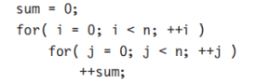

***Complexity Equation =*** *n + n2*

***Big O= O(n2)***

**Code 2:**

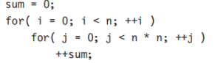

***Complexity Equation =*** *n + n( n2) = n + n3*

***Big O = O(n3)***

**Code 3:**

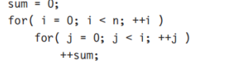

***Complexity Equation*** *=* n +  *+ (n2)*

***Big O= O(n2)***

**Code 4:**

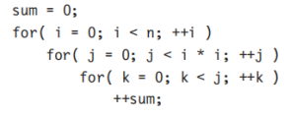

***Complexity Equation:*** n + n(n2 ) + n(n2(n2)) = n + n3 + n5

***Big O: O(n5)***

**Part 2**

**Code 1**

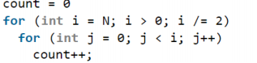

***Complexity Equation:*** 2n

***Big O:*** O(2n) = ***O(n)***

**Task 02: Space Complexity Analysis**

Find the space equation as well as its big-O notation for the following snippets:

**Code 01:**

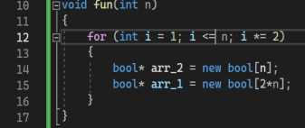

Complexity Equation : 2 +n + 2n = 2 + 3n

Big O: O(3n) =  **O(n)**

**Code 2:**

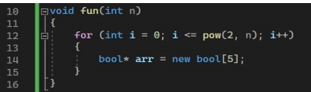

Complaxity Equation: 2 + 5 = 7

Big O: O(f(n)) = **O(1)**

**Code 3:**

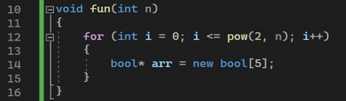

**Complexity Equation: 2 + 5 = 7**

**Big O:** O(7) = **O(1)**

**Code 4:**

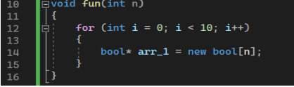

**Complexity Equation:**  2 + 10n

**Big O:** O(10n) **= O(n)**

**Code 5:**

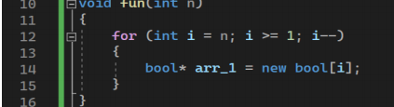

**Complexity Equation:** 2 + n

**Big O: O(n)**

## In-Lab

**Task 1**

**Part 4**

**void fnSelectionSort (int Array [],unsigned int Size, int SortKey);**

Precondition: None

Post condition: Array should be ordered according to sort key, in ascending order if SortKey=0 and in descending order otherwise

|  |  |  |  |
| --- | --- | --- | --- |
| **Exp no** | **Input Size** | **Input Range** | **Instruction Executed** |
| 1 | 5 = { 4 , 6,2,10} | 2 - 10 | 52 |
| 2 | 3 = {30,50,10} | 10-50 | 34 |
| 3 | 5 = {1,7,9,5,3} | 1 - 9 | 74 |

**Task 02: Calculate the running time complexity for the following.**

|  |  |  |  |  |
| --- | --- | --- | --- | --- |
| **Function** | **Input size** | **Range** | **Search/Sort Key** | **Execution Time** |
| fnLinearSearch | 5 = {2, 4,,6,8,10 | 1. 10 | 10 | 923 msec |
| fnBinarySearch | 5 = {2, 4,,6,8,10} | 2 - 10 | 8 | 500 |
| fnBubbleSort | 5 = {1 , 4, 5, 2,3} | 1 - 5 | 3 | 1833 |
| fnSelectionSort | 5 = {1 , 4, 5, 2,3} | 1. 5 | 3 | 3642 |