**CC-213L**

**Data Structures and Algorithms**

**Laboratory 04**

**Stack ADT**

**Version: 1.0.1**

**Release Date: 09-10-2024**

**Department of Information Technology**

**University of the Punjab**

**Lahore, Pakistan**

**Contents:**

* Learning Objectives
* Required Resources
* General Instructions
* Background and Overview
  + Pointers and Dynamic memory allocation
  + Data Structures
  + Types of Data Structures
  + Stack ADT
  + Types of Stack ADT
* Activities
  + Pre-Lab Activity
    - Task 01: Stack ADT I
    - Task 02: Stack ADT II
    - Task 03: Balanced Parenthesis
  + In-Lab Activity
    - Application Of Stack ADT for different Problems
    - Task 01: String palindrome
    - Task 02: Reverse word of String
    - Task 03: Text Editor
    - Task 04: Hero Survival Game
  + Post-Lab Activity
    - Infix Expression
    - Prefix Expression
    - Post Expression
    - Pseudo code to convert infix to prefix
    - Pseudo code to convert infix to postfix
    - Task 01: Program to convert Infix to Prefix
    - Task 02: Program to convert Infix to Postfix
    - Task 03: C to assembly converter
* Submissions
* References and Additional Material
* Lab Time and Activity Simulation Log

**Learning Objectives:**

* Pointers and Dynamic memory allocation
* Stack Data Structure
* Using the concepts of Dynamic Memory Allocation
* Standard Operations on the Stack Data Structure
* Use of Stack ADT in Different Applications

**Resources Required:**

* Desktop Computer or Laptop
* Microsoft ® Visual Studio 2022

**General Instructions:**

* In this Lab, you are **NOT** allowed to discuss your solution with your colleagues, even not allowed to ask how s/he is doing, this may result in negative marking. You can **ONLY** discuss with your Teaching Assistants (TAs) or Lab Instructor.
* Your TAs will be available in the Lab for your help. Alternatively, you can send your queries via email to one of the followings.

|  |  |  |
| --- | --- | --- |
| **Teachers:** | | |
| Course / Lab Instructor | Prof. Dr. Syed Waqar ul Qounain | [swjaffry@pucit.edu.pk](mailto:swjaffry@pucit.edu.pk) |
| Teacher Assistant | Muhammad Tahir Mustafvi | bcsf20m018@pucit.edu.pk |
|  | Maryam Rasool | bcsf21m055@pucit.edu.pk |

**Background and Overview:**

**Pointers and Dynamic memory allocation**

In C++, pointers and dynamic memory allocation are fundamental concepts for managing memory and creating more flexible data structures. Here's an overview of pointers and dynamic memory allocation in C++:

**Pointers:**

Pointer Basics: A pointer is a variable that stores the memory address of another variable. It "points" to the location in memory where the data is stored. In C++, you declare a pointer using an asterisk (*) before the variable name.

**Dynamic Memory Allocation:**

C++ provides the new operator for allocating memory dynamically on the heap and the delete operator for freeing that memory when it's no longer needed.

**Example:**

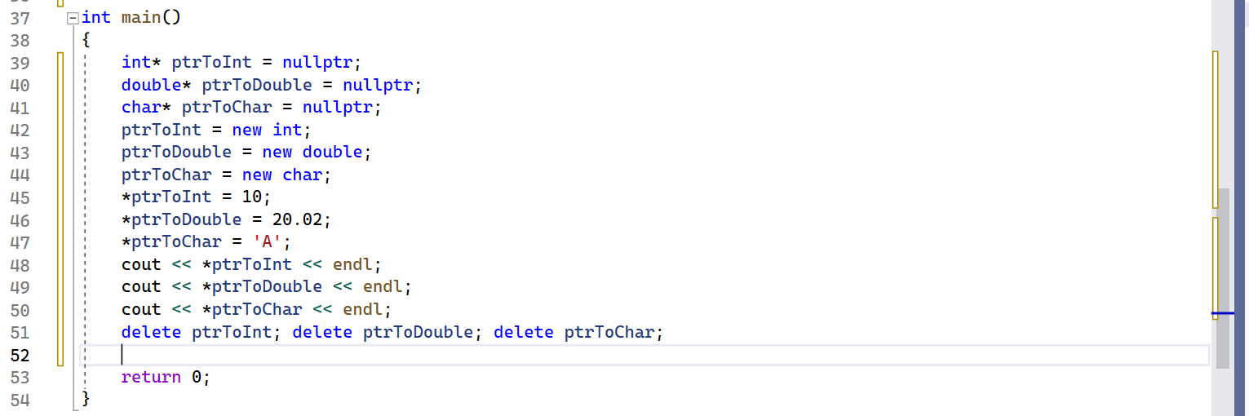

Figure 1 (pointer and dynamic memory)

**Explanation:**

This C++ program demonstrates the allocation of memory for an integer, a double, and a character. In line 39, we declare a pointer to an integer, and in lines 40 and 41, we declare pointers to a double and a character, respectively. Starting from line 42 and extending to line 44, we utilize the `new` operator to reserve memory for these variables dynamically. Subsequently, in lines 45 to 47, we initialize these memory locations with specific values. After displaying the values, we proceed to deallocate all of these memory allocations. The `delete` operator is employed for this purpose, ensuring that the allocated memory is released properly.

**Output:**

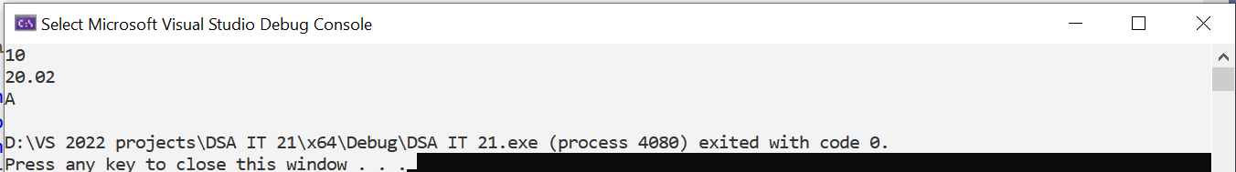

Figure 2 (Pointers and dynamic memory allocation)

**Memory Management Best Practices:**

* Always free dynamically allocated memory using delete or delete[] to avoid memory leaks.
* Be cautious when using raw pointers, as they can lead to bugs like null pointer dereferences and memory leaks. Consider using smart pointers when possible.
* Avoid allocating excessive memory on the heap, as it can lead to fragmentation and reduced program performance.
* Practice good memory management by deallocating memory as soon as it's no longer needed.

**Data Structure:**

Data structure refers to the way data is organized, stored, and accessed in a computer system. It provides a systematic way of managing and manipulating data efficiently. Data structures are designed to optimize operations such as insertion, deletion, searching, and sorting of data.

**Types of Data Structure:**

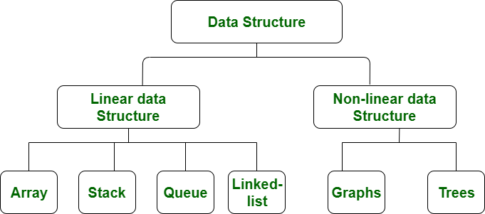

Figure 3 (Types of Data structures)

**Linear Data Structures:**

Linear data structures store data elements sequentially, one after another, in a linear fashion. They follow a specific order or sequence. Examples include arrays, linked lists, stacks, and queues.

**Non-linear Data Structures:**

Non-linear data structures do not store elements in a sequential manner. They allow elements to be connected in multiple ways, forming a hierarchical or interconnected relationship. Examples include trees and graphs.

**Stack ADT:**

A stack is a linear data structure that follows the **Last-In-First-Out** (LIFO) principle. It can be visualized as a stack of plates, where the last plate placed on top is the first one to be removed. The two main operations on a stack are **push** (to add an element to the top) and **pop** (to remove the top element). The element below the top is inaccessible until the top element is removed. A basic example of a stack is the call stack in programming, which keeps track of function calls and their local variables. Another example is the Undo feature in text editors, where the most recently performed action can be undone by popping it from the stack.

**Types of Stacks:**

**Fixed Size Stack:**

As the name suggests, a fixed size stack has a fixed size and cannot grow or shrink dynamically. If the stack is full and an attempt is made to add an element to it, an overflow error occurs. If the stack is empty and an attempt is made to remove an element from it, an underflow error occurs.

**Demonstration:**

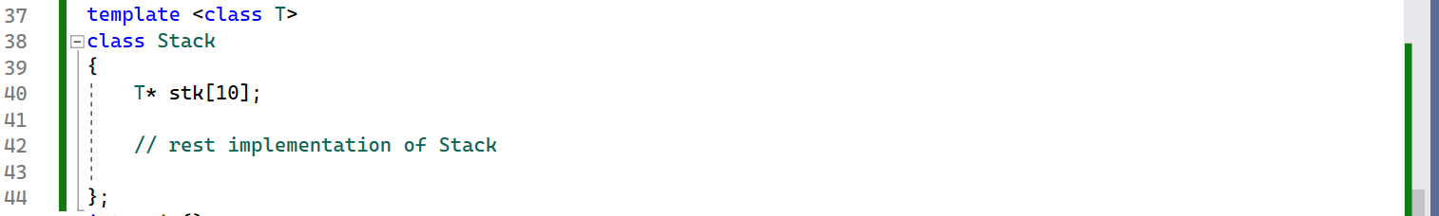

Figure 4 (Fixed sized Stack)

**Explanation:**

Line 40 statically allocates a fixed-size stack using an array of 10 elements. Each time an object of the "Stack" class is created, it will have a pre-allocated array of 10 elements in memory, and this size remains constant.

**Dynamic Size Stack:**

A dynamic size stack can grow or shrink dynamically. When the stack is full, it automatically increases its size to accommodate the new element, and when the stack is empty, it decreases its size. This type of stack is implemented using a linked list, or dynamically allocated Array as it allows for easy resizing of the stack.

**Demonstration:**

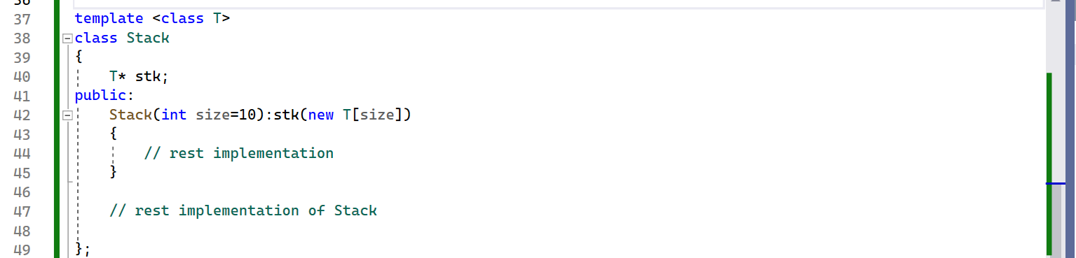

Figure 5 (Dynamic Stack)

**Explanation:**

In line number 40 there is pointer to generic type. In constructor we have allocated memory of 10 size array. Stack of any size can be allocated at run time by passing any size of array to the constructor of Stack. In below figure in line 66 Stack of size 10 is allocated which was the default size. In line 20 Stack of 20 size is allocate and at line number 68 Stack of size 100 is allocated.



Figure 6 (Stacks of Different sizes)

**Activities**

**Pre –Lab activities:**

**Task 01: Stack ADT I**

**Problem Statement:**

In this task, you are required to implement an Abstract Data Type (ADT) for a **fixed-sized stack** using an array. The array should be statically allocated in the stack memory, meaning its size is fixed at compile-time, and it does not grow dynamically. You will need to implement standard stack operations like push (), pop (), top (), and isEmpty () while handling edge cases such as overflow and underflow.

**Requirements:**

* **Fixed Size**: Define a constant size for the stack array.
* **Static Allocation**: The array must be statically allocated, i.e., its memory should not be allocated dynamically (no new or heap memory).
* **Operations**:
  + push(x): Adds an element x to the top of the stack.
  + pop (): Removes the top element from the stack.
  + Top (): Returns the top element without removing it.
  + isEmpty (): Returns true if the stack is empty, false otherwise.
  + isFull (): Returns true if the stack is full, false otherwise.
  + getCapacity (): returns the total capacity of the Stack.
  + getNumOfElems (): return the number of elements currently in stack.
  + Overloaded Assignment Operator and copy constructor
* **Error Handling**: Handle stack overflow and underflow conditions appropriately.

**Example:**

**Test Case: Basic Push and Pop Operations**

**Task 02: Stack ADT II**

Now modify your above program in such a way that should take size of Stack at run time and allocate memory at heap. For this purpose, Implement dynamic sized stack ADT.

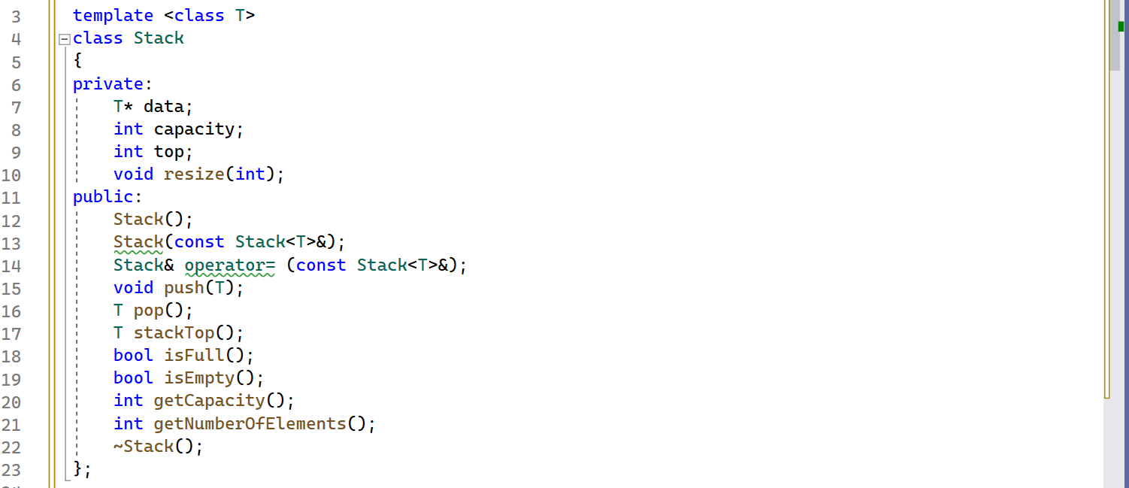

Figure 7 (Dynamic Stack)

**Explanation:**

At line number 4, a class called "Stack" is defined. In line 6, this class encapsulates private data representing the essential components of a Stack Abstract Data Type (ADT). In line 8, a member variable is introduced, which is a pointer capable of referencing objects of any generic type. Within the public section of the class, various operations associated with the Stack ADT are defined. These member functions are specialized methods tailored to the behaviors expected from a stack ADT

**Example Run:**

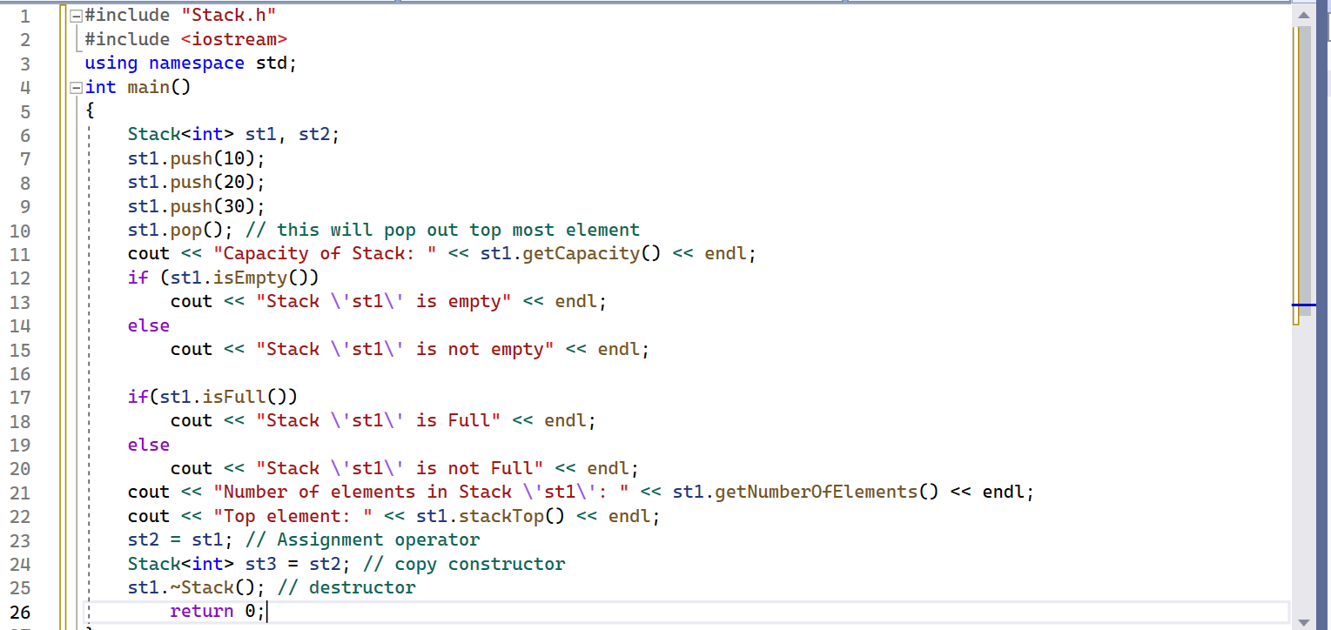

Figure 8 (Example run of Stack)

**Explanation:**

On line 6, we've declared two instances of the Stack class. Between lines 7 and 9, we've pushed three elements onto the stack named st1. On line 10, we've removed the top element from st1 using a pop operation. Subsequently, we've tested the **isFull()** and **isEmpty()** member functions in the following lines. On line 23, the assignment operator is invoked, and on line 22, we've displayed the top element. On line 24, the copy constructor is utilized. Finally, on line 25, the destructor for the st1 instance of the Stack class is called, freeing up the allocated memory.

**Output:**

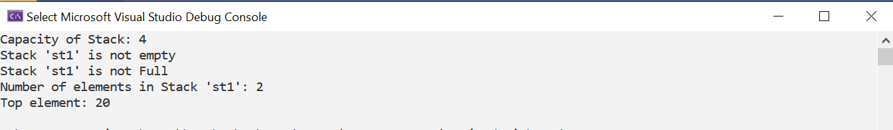

Figure 9 (Output)

**Task 03: Balanced Parenthesis**

Your task is to implement a function that receives a string and returns true if the parentheses in the expression are balanced otherwise returns false.

You should only consider round brackets “()” as parentheses. Parentheses are considered balanced if each opening parenthesis has its corresponding closing parenthesis and they are properly nested.

**For example**:

“(a + b) * (c - d)” 🡪 balanced

“(((a + b) * (c - d)))” 🡪 balanced

“((a + b) * (c - d)” 🡪 not balanced (missing closing parenthesis)

“(a + b) * (c - d))” 🡪 not balanced (extra closing parenthesis)

**bool isBalanced(const string& str);**

Think for a while: Does this task really need to be done with stack?

**In–Lab Activities:**

Utilize the implemented Stack Abstract Data Type (ADT) to tackle various programming challenges and solve problems. Apply problem-solving skills by harnessing the power of the stack data structure to address a wide range of programming challenges effectively.

**Task 01: String Palindrome**

A string is called palindrome if it remains the same even if it is reversed. For example, the string “racecar” is a palindrome because its reversed string is also “racecar”. Your task is to implement a function that receives a string and tells whether it is palindrome or not using stack.

**bool isPalindrome(const string& str);**

**Example Runs**

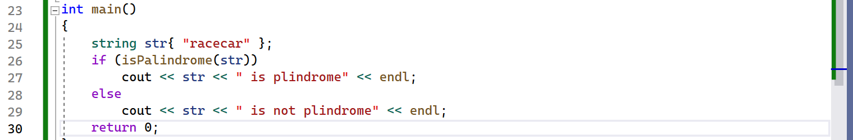

Figure 10 (string Palindrome)

**Explanation:**

In line 25 a string named str is initialized with a string that is already a palindrome. If statement header calls isPalindrome function by passing str to it. As string is palindrome so true will be returned and “racecar is palindrome” will be displayed.

**Output:**



Figure 11 (Output)

**Second Example:**

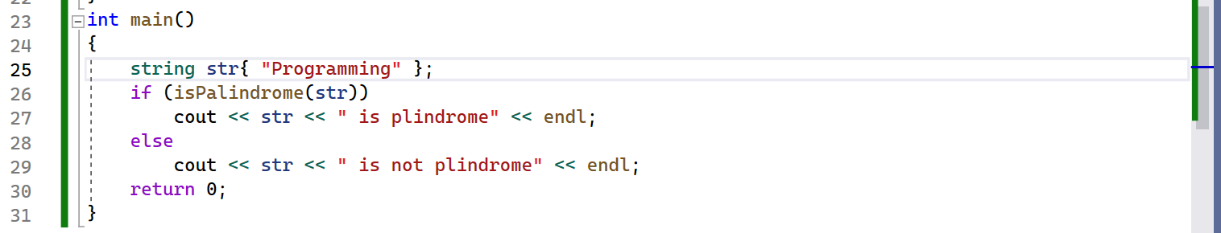

Figure 12 (Palindrome)

**Output:**



Figure 13 (Output)

**Task 02: String words Reverse**

Your task is to implement a function that receives a string and reverses each word in it using stack. You can assume that the string only consists of alphabets and spaces. The order of the words should remain the same but characters within each word should get reversed.

**For example:**

String: “Welcome to DSA”

Modified string: “emocleW ot ASD”

**void reverseWords(string& str);**

**Bonus:** Solve this problem in place.

**Task 03: Text Editor Undo/Redo with Stacks**

**Description:**You are tasked with designing a system that simulates a text editor's undo and redo functionality using two stacks. The editor keeps track of a sequence of actions (such as typing characters) and allows the user to undo and redo these actions efficiently.

**Instructions:**

1. Implement a function performAction to perform a new action and store it in the "undo" stack.
2. Implement a function undoAction that undoes the most recent action by popping it from the "undo" stack and pushing it onto the "redo" stack.
3. Implement a function redoAction that redoes the most recently undone action by popping it from the "redo" stack and pushing it back onto the "undo" stack.

**Constraints:**

* Use two stacks: undoStack and redoStack.
* Assume that an action can be represented as a string (e.g., typing a single character).
* Perform each operation (perform, undo, redo) in constant time, i.e., O(1).

**Task 04: Hero Survival Game**

You are given a series of heroes with different power levels represented as integers in an array. The index “i” of the array represents the ith hero. The game works as follows:

* As a new hero arrives (i.e., the next number in the array is encountered), the earlier heroes either survive or die.
* A previous hero survives only if their power is greater than or equal to the current hero. Otherwise, the current hero kills all heroes that have **lower power** than themselves.

**Objective:**

Determine the final list of heroes that survive the game in the correct order.

**Example:**

If the input is [3, 7, 2, 5, 8], the game would proceed like this:

* Hero 3 enters the first
* Hero 7 enters and kills 3
* Hero 2 enters but is weaker than 7, so it stays
* Hero 5 enters, kills 2 → Surviving Heroes are [7, 5]
* Hero 8 enters, kills both 7 and 5
* The surviving heroes are [8].

Your Function may look like: **Void KillWeaker(int* arr, int n)**

* The Function will input all heroes and after going through array it will print winner/s.

**Post-Lab Activities**

**Infix Expression:**

An infix expression is a mathematical expression in which operators are placed between operands. In other words, in an infix expression, you write the operator between the two operands. This is the common way mathematical expressions are typically written in human-readable form. For example:

* + - * + 3 + 5
        + a * (b + c)
        + (2 * x) / (y - 1)

In infix expressions, the precedence of operators determines the order of operations, and parentheses are often used to clarify or change the order of evaluation when needed.

While infix expressions are easy for humans to read and write, they can be more challenging to evaluate programmatically. In contrast, programming languages and computer systems often use postfix (also known as Reverse Polish Notation or RPN) or prefix (also known as Polish Notation) expressions, which are more straightforward to evaluate using a stack-based approach.

To perform calculations with infix expressions in computer programs, they are typically converted to postfix or prefix notation first, and then a stack-based algorithm can be used to evaluate the expression efficiently.

**Prefix Expression:**

A prefix expression, also known as Polish notation, is a mathematical expression in which the operator precedes its operands. In other words, in a prefix expression, you write the operator before the operands. This notation eliminates the need for parentheses to indicate the order of operations, as it enforces a strict order of evaluation.

For example, the infix expression "3 + 5" in prefix notation would be "+ 3 5." Similarly, the infix expression "(2 * x) / (y - 1)" in prefix notation would be "/ * 2 x - y 1."

To evaluate a prefix expression, you typically use a stack-based algorithm that reads the expression from left to right, pushes operands onto the stack, and when an operator is encountered, it pops the required number of operands from the stack, performs the operation, and pushes the result back onto the stack.

Prefix notation is commonly used in computer science and programming, particularly in languages like Lisp and Forth. It has the advantage of being unambiguous and not requiring parentheses to specify the order of operations.

**Postfix Expression:**

A postfix expression, also known as Reverse Polish Notation (RPN), is a mathematical expression in which the operator follows its operands. In a postfix expression, you write the operator after the operands. This notation also eliminates the need for parentheses to specify the order of operations because the order of evaluation is determined by the position of the operators.

For example, the infix expression "3 + 5" in postfix notation would be "3 5 +." Similarly, the infix expression "(2 * x) / (y - 1)" in postfix notation would be "2 x * y 1 - /."

To evaluate a postfix expression, you typically use a stack-based algorithm. You read the expression from left to right, pushing operands onto the stack, and when an operator is encountered, you pop the required number of operands from the stack, perform the operation, and push the result back onto the stack.

Postfix notation is commonly used in computer science and programming, particularly in calculators, some programming languages (e.g., Forth), and certain computer architecture instruction sets. It has the advantage of being unambiguous and not requiring parentheses to specify the order of operations.

**Pseudo code to convert infix to prefix**

1. Reverse infix expression & swap ‘(‘to”)’ & ‘)’ to” (‘
2. Scan Expression from Left to Right
3. Print Operands as the arrive
4. If OPERATOR arrives & Stack is empty, PUSH to stack
5. IF incoming OPERATOR has HIGHER precedence than the TOP of the Stack, PUSH it on stack
6. IF incoming OPERATOR has EQUAL precedence with TOP of Stack && incoming OPERATOR is ‘^’, POP & PRINT TOP of Stack. Then test the incoming OPERATOR against the NEW TOP of stack.
7. IF incoming OPERATOR has EQUAL precedence with TOP of Stack, PUSH it on Stack.
8. IF incoming OPERATOR has LOWER precedence than the TOP of the Stack, then POP and PRINT the TOP. Then test the incoming OPERATOR against the NEW TOP of stack.
9. At the end of Expression, POP & PRINT all OPERATORS from the stack
10. IF incoming SYMBOL is ‘(‘PUSH it onto Stack.
11. IF incoming SYMBOL is ‘)’ POP the stack & PRINT Operators till ‘(‘is found or Stack Empty.  POP out that ‘(‘from stack
12. IF TOP of stack is ‘(‘PUSH OPERATOR on Stack
13. At the end Reverse output string again.

**Pseudo code to convert infix to postfix**

1. Scan Expression from Left to Right
2. Print Operands as the arrive
3. If OPERATOR arrives & Stack is empty, push this operator onto the stack
4. IF incoming OPERATOR has HIGHER precedence than the TOP of the Stack, push it on stack
5. IF incoming OPERATOR has LOWER precedence than the TOP of the Stack, then POP and print the TOP. Then test the incoming operator against the NEW TOP of stack.
6. IF incoming OPERATOR has EQUAL precedence with TOP of Stack, use ASSOCIATIVITY Rules.
7. For ASSOCIATIVITY of LEFT to RIGHT –
   1. POP and print the TOP of stack, then push the incoming OPERATOR
8. For ASSOCIATIVITY of RIGHT to LEFT –
   1. PUSH incoming OPERATOR on stack.
9. At the end of Expression, POP & print all OPERATORS from the stack
10. IF incoming SYMBOL is ‘(‘PUSH it onto Stack.
11. IF incoming SYMBOL is ‘)’ POP the stack and print Operators till ‘(‘is found. POP that ‘(‘
12. IF TOP of stack is ‘(‘PUSH OPERATOR on Stack

**Task 01: Program to Convert Infix to Prefix Expression**

Implement a C++ program that should take an infix expression and convert to Prefix Expression. Finally display the infix expression as well as Prefix Expression.

**Example Run:**

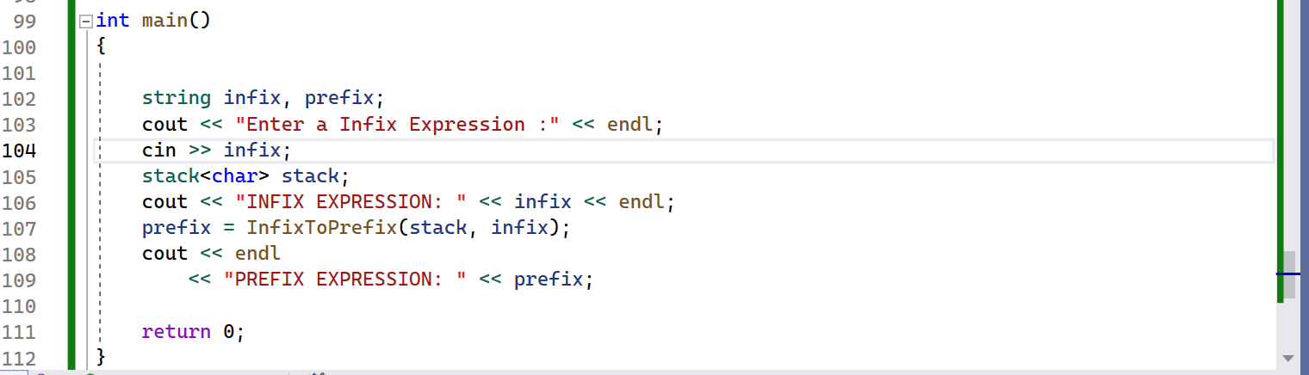

Figure 15 (Infix to Prefix)

**Output:**

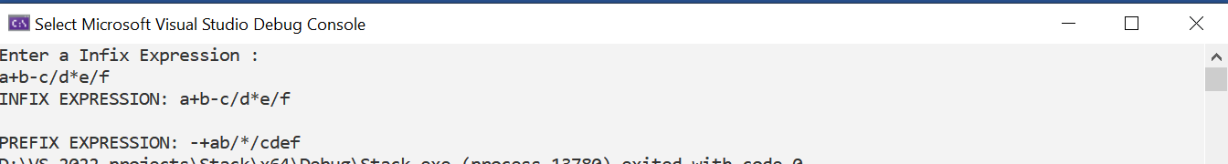

Figure 16 (Output)

**Task 02: Program to Convert Infix to Postfix Expression**

Implement a C++ program that should take an infix expression and convert it to Postfix Expression. Finally display the infix expression as well as Postfix Expression.

**Example Run:**

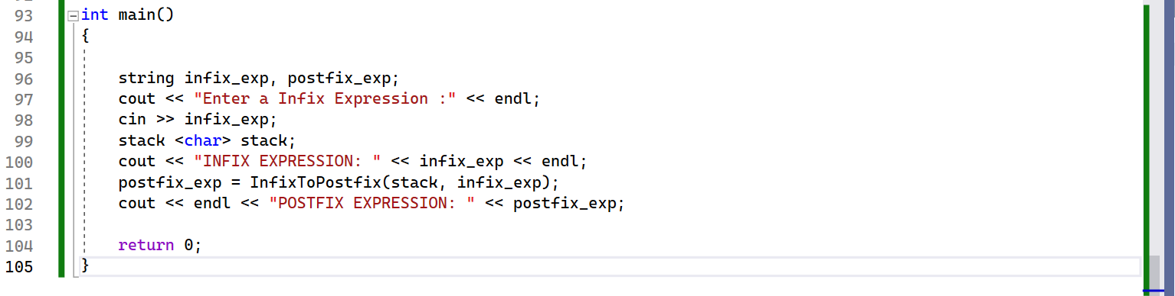

Figure 17 (Infix to Postfix)

**Output:**

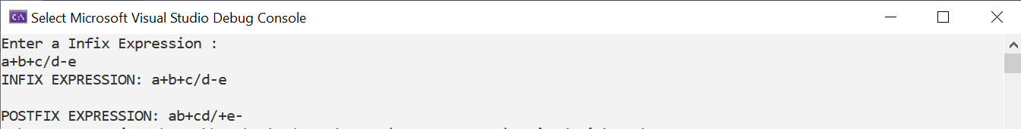

Figure 18 (Output)

**Task 03: Program to Convert Infix to Prefix Expression**

Assume that a machine has a single register AX, and an instruction set consisting of only six commands described below:

|  |  |  |
| --- | --- | --- |
| **Command** | **Operands** | **Description** |
| LD | AX, A | Loads the value of variable A into the register AX |
| ST | AX, A | Stores the value of the register AX into variable A |
| ADD | AX, A | Adds the contents of the variable A in the contents of register AX and leaves the result in register AX |
| SUB | AX, A | Subtracts the contents of variable of A from the contents of register AX and leaves the result in register |
| MUL | AX, A | AX Multiplies the contents of variable A and the contents of register AX and leaves the result in the register AX |
| DIV | AX, A | Divides the contents of register AX by the contents of variable A and leave the result in register AX |

Write a program in C++, which will accept an expression in IN-FIX form and convert this expression into the POST-FIX form and then generate its Assembly code using the above-mentioned instruction set. The program will also simulate all these steps, i.e. program will show the steps while evaluating the expression, and a pointer IP will show what line of the code is executing.

**Example:**

**Input String in IN-FIX Form**: A + B + B * (D + E)

**POST-FIX Expression:** ABC++DE+*

**Assembly Code :**

LD AX, A

ADD AX, B

ADD AX, C

ST AX, TEMP

LD AX, D

ADD AX, E

MUL AX, TEMP

**Submissions:**

* For In-Lab Activity:
* Save the files on your PC.
* TA’s will evaluate the tasks offline.
* For Pre-Lab & Post-Lab Activity:
* Submit the .cpp file on Google Classroom and name it to your roll no.

**Evaluation Metric:**

* All the lab tasks will be evaluated offline by TA’s
* **Division of Pre-Lab marks: [30 marks]**
* Task 01: Fixed sized stack [10 marks]
* Task 02: Dynamic Sized stack [10 marks]
* Task 03: Balanced Parenthesis [10 marks]
* **Division of In-Lab marks: [35 marks]**
* Task 01: String palindrome [05 marks]
* Task 02: String words reverse [05 marks]
  + In Place Reversal [05 marks]
* Task 03: Min Stack [10 marks]
* Task 04: Kill the weaker [10 marks]
* **Division of Post-Lab marks: [60 marks]**
* Task 01: Infix to Prefix Conversion [20 marks]
* Task 02: Infix to Postfix Conversion [20 marks]
* Task 03: C to Assembly converter [20 marks]

**References and Additional Material:**

Stack Data Structure

<https://www.geeksforgeeks.org/stack-data-structure/>

Infix to prefix conversion

<https://simplesnippets.tech/infix-to-prefix-conversion-using-stack-data-structure-with-c-program-code/>

Infix to Postfix conversion

<https://simplesnippets.tech/infix-to-postfix-conversion-using-stack-data-structure-with-c-program-code/>

**Lab Time Activity Simulation Log:**

* Slot – 01 – 02:15 – 02:30: Class Settlement
* Slot – 02 – 02:30 – 03:00: In-Lab Task 01
* Slot – 03 – 03:00 – 03:30: In-Lab Task 02
* Slot – 04 – 03:30 – 04:15: In-Lab Task 03
* Slot – 05 – 04:15 – 05:00: In-Lab Task 04
* Slot – 06 – 05:00 – 05:15: Discussion on Post-Lab Task
* Slot – 07 – 05:15 – 05:45: Evaluation