Create two Ec2 instance with HTTP traffic allow and in user data install and configure or print hello in it

**User data**

#!/bin/bash

# Install Apache HTTP Server

yum update -y

yum install httpd -y

# Start Apache and configure it to start on boot

systemctl start httpd

systemctl enable httpd

# Create a simple HTML file to be served

echo "<html><body><h1>Hello</h1></body></html>" > /var/www/html/index.html

# Print a message to the console

echo "HTTP server configured. Visit this instance's public IP to see 'Hello'."



Both of them work check it . Both print hello ..

Now next step is to create load balancer (ALG) and then take these steps

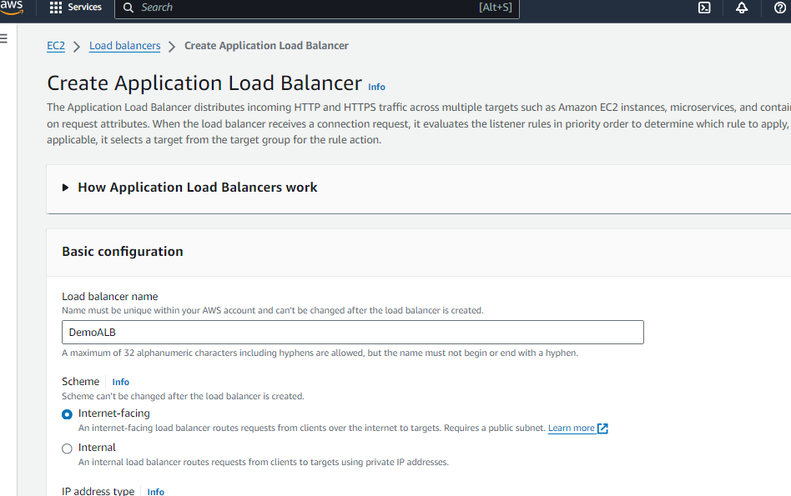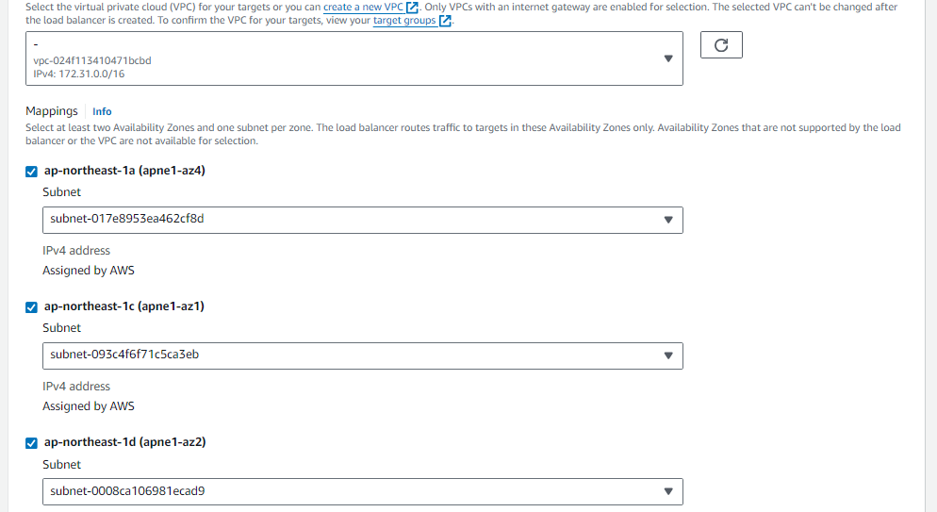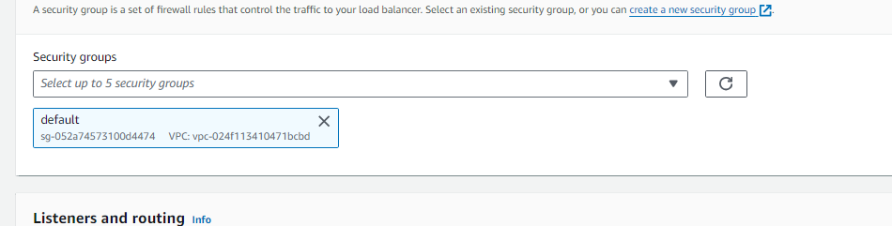In this you need to create the new security group with only HTTP

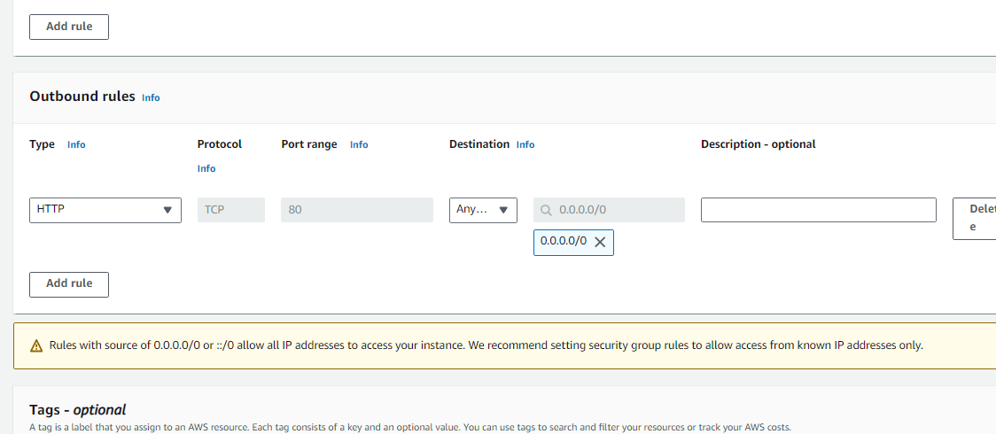

After that create the target group with these step and add the target group by selecting your instances.

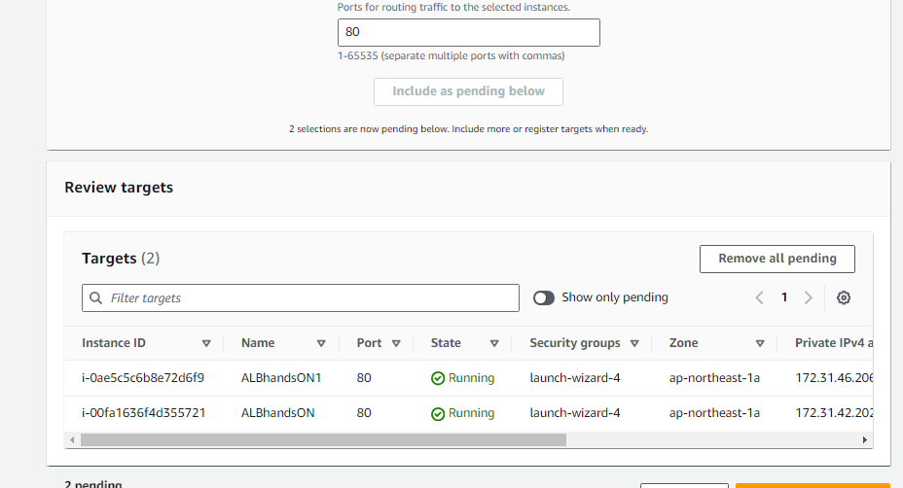

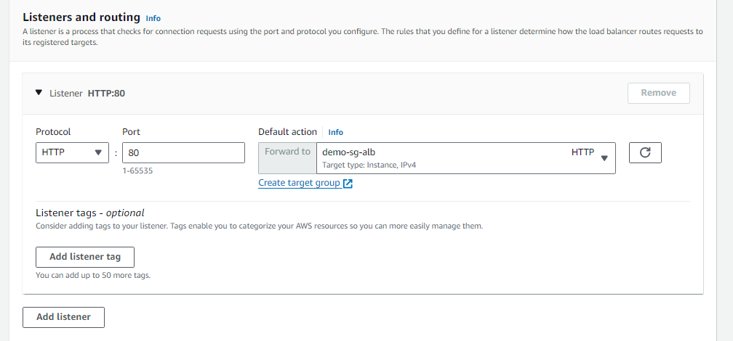

After that select you create target group

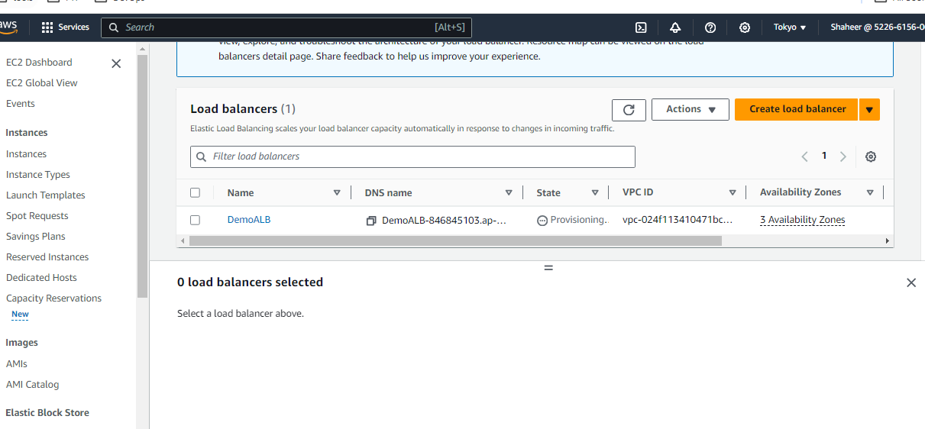

After the ALB active you can copy DNS name and paste and load it again again and you can see its switching between the instances

And if you stop one instance it make it unused and doesn't go to that instance balance the thing out.

That for this But yeah you can also add rule ad condition in like change the setting of security groups and also

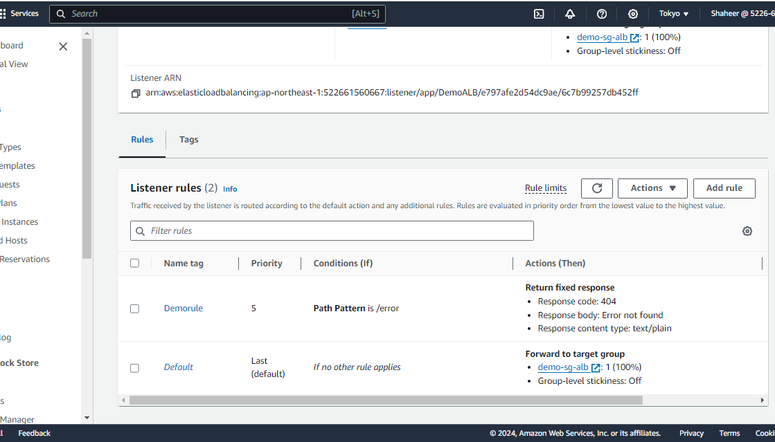change the listeners rule and print the thing out

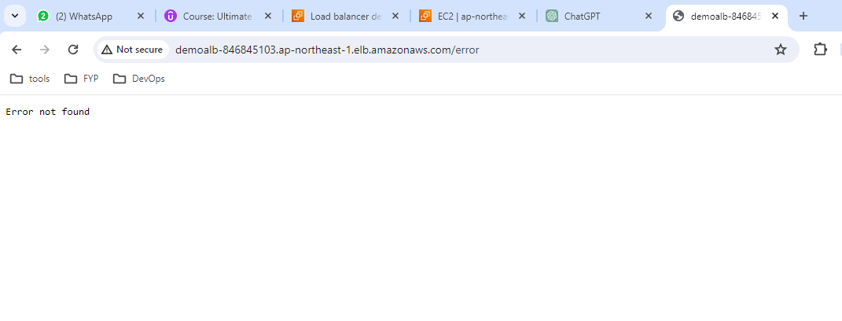while creating this I add the /error request response and then error not found in it so by using this I can see the results.