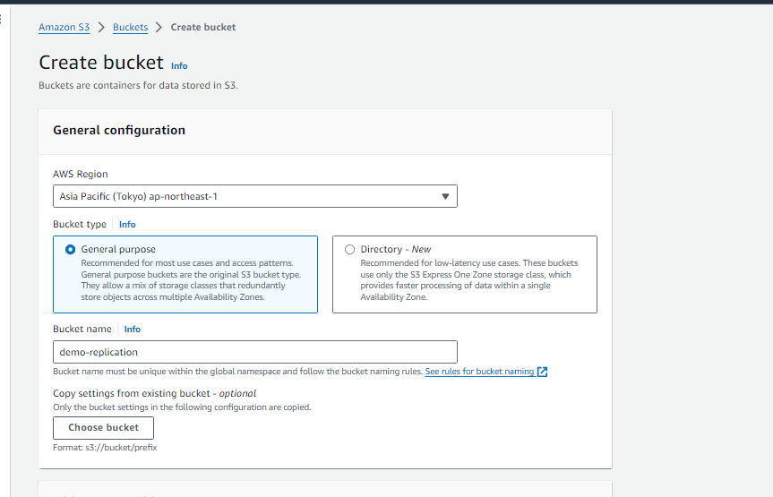

Must enable the versioning.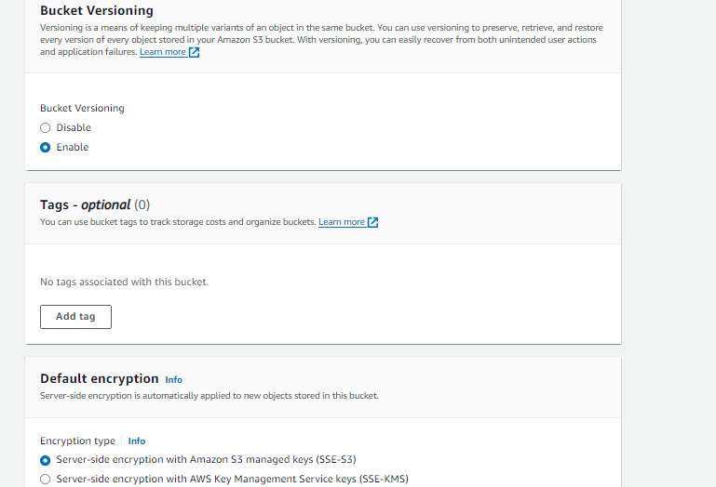

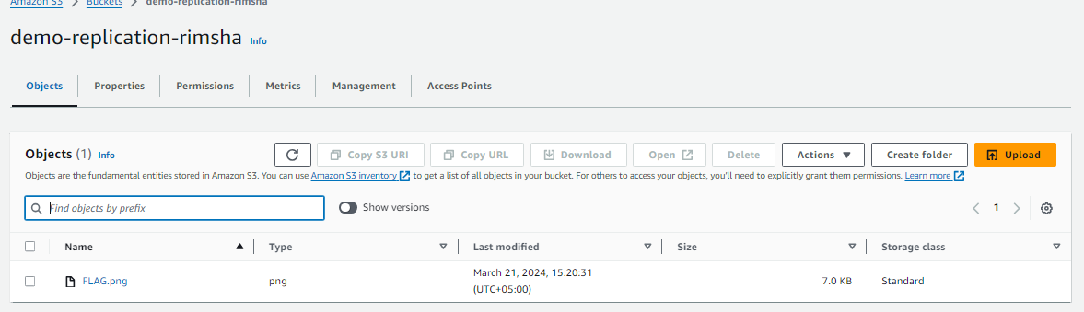

Now make another S3 in different region if you want CRR(cross region replication) replication if you want SRR then you make in same region I do in cross region so make in other region

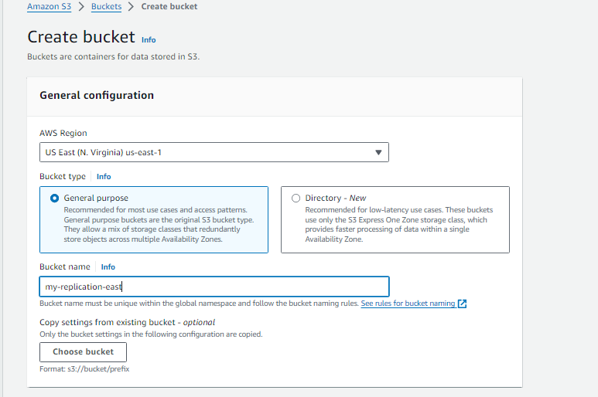

Make sure to enable the version of this also.

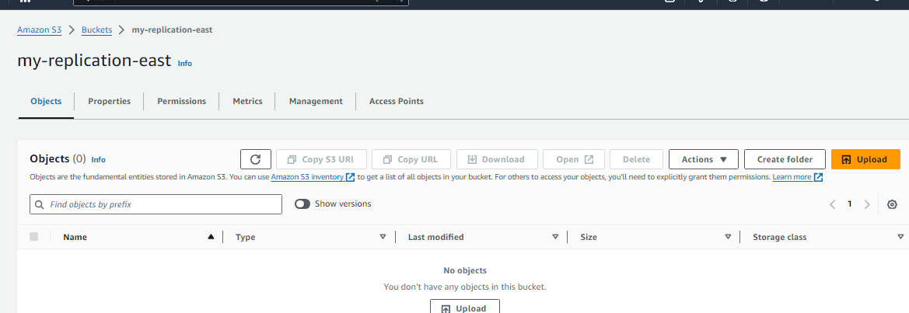

You can see that nothing in second bucket . In my first bucket I go to management and create replication

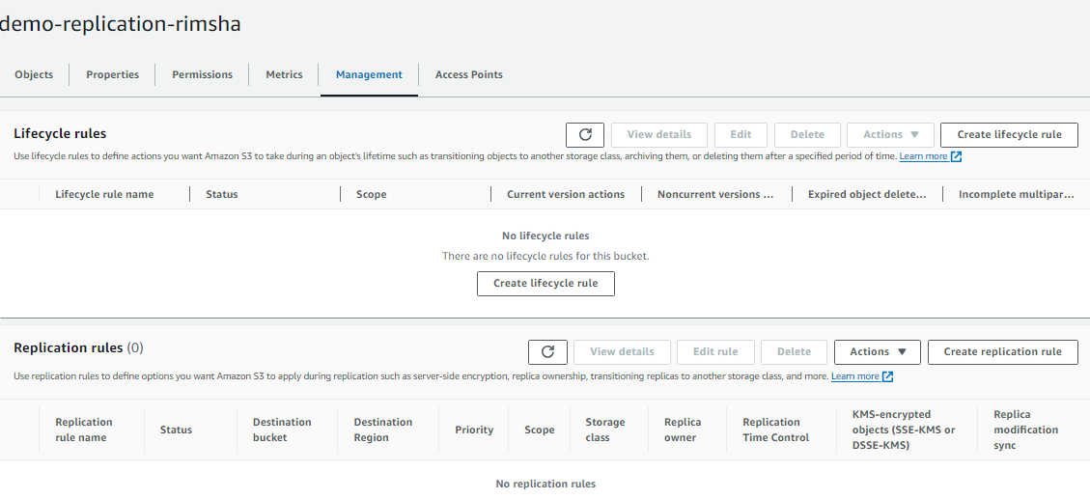

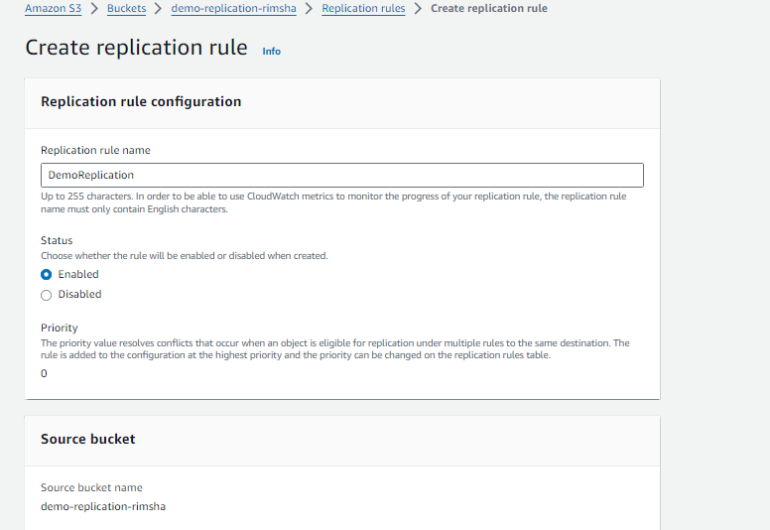

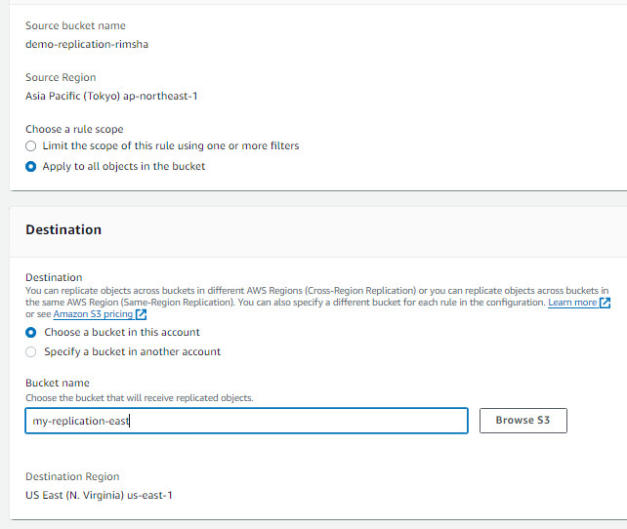

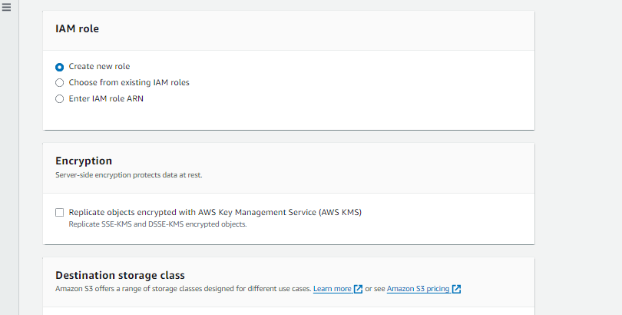

I don't to copy existing second bucket remain same and then upload new entry in S3 1 bucket and see it replicate to second or not

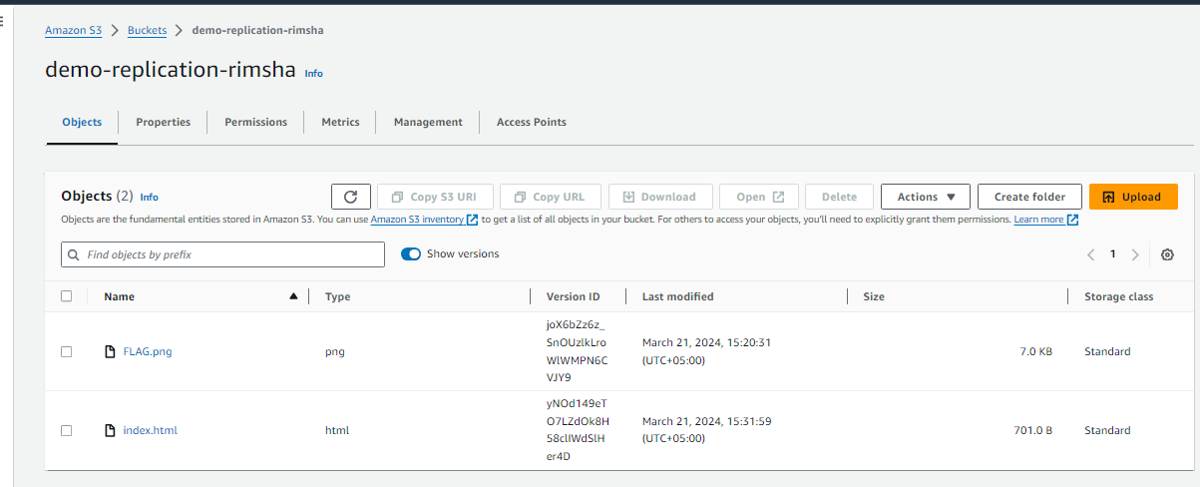

See I uploaded in first bucket so let see our second bucket

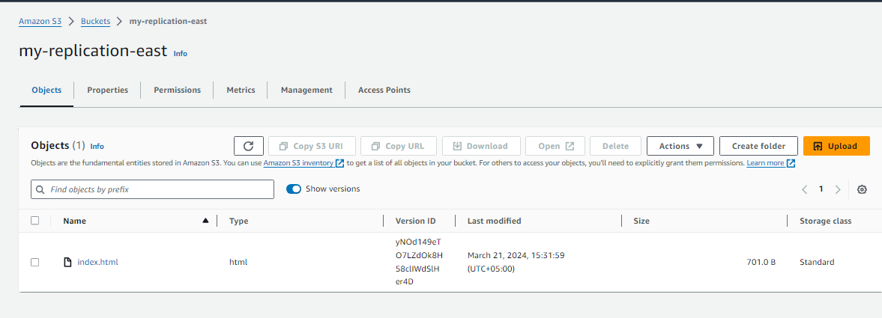

See its uploaded it copy with same version ID . If delete in second its doesn't the S3 our first bucket I deleted the item from my second bucket and upload new in first bucket you can see the object remain same in first one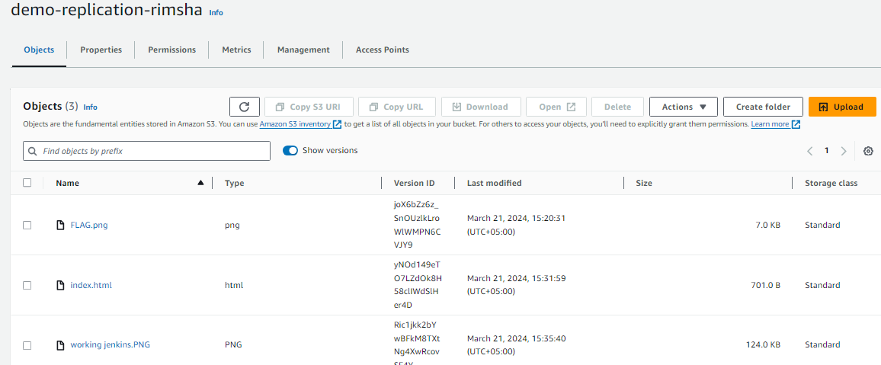

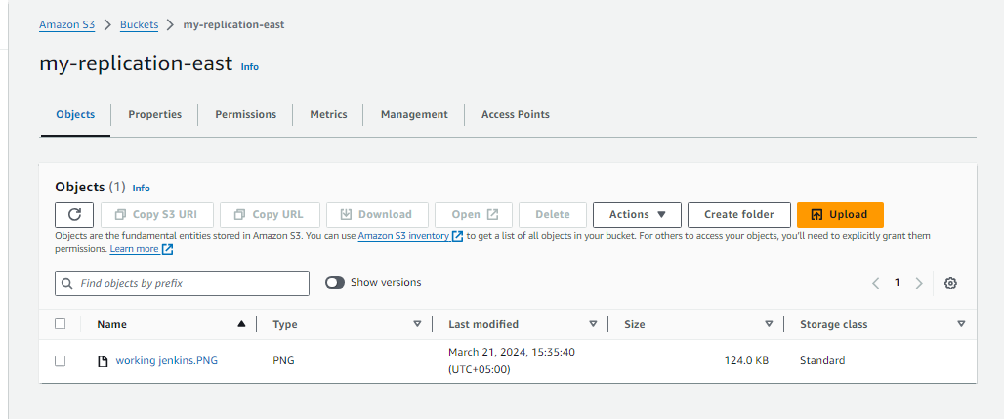You can see I delete the object from the bucket 1 and its doesn't effect the second and also update the older object and this make change in our second bucket and appear their.

