Create the two buckets and enable their sever Logging in properties bucket must be in same region

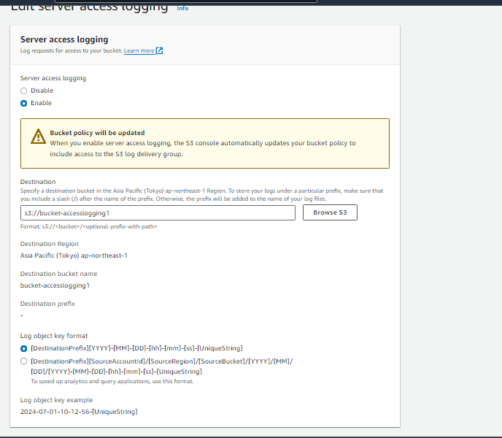

We can see the policy permission is changed automatically for second bucket its allow the logging. If you upload something or delete it appear . But its take time for this.

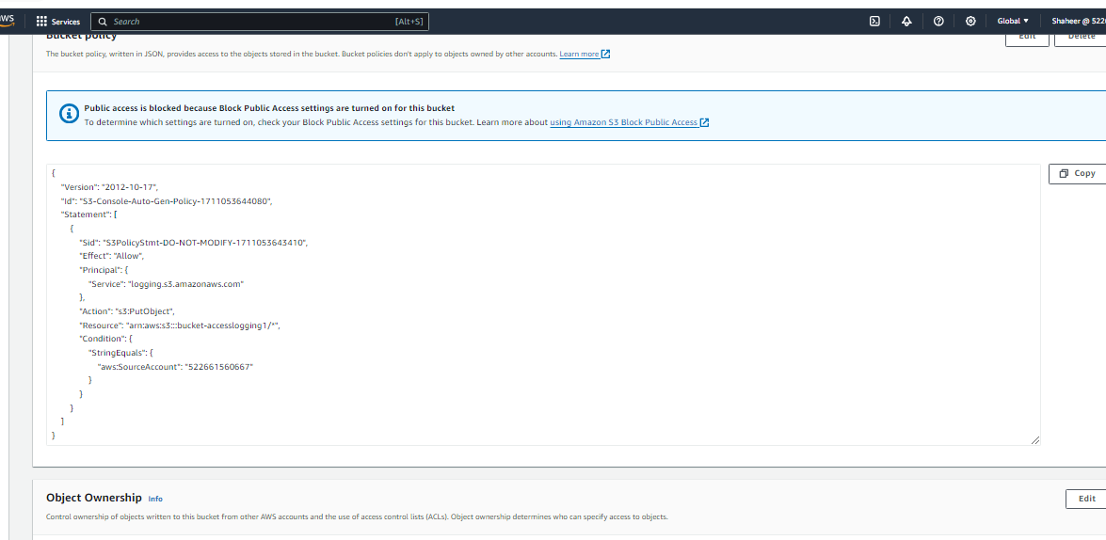

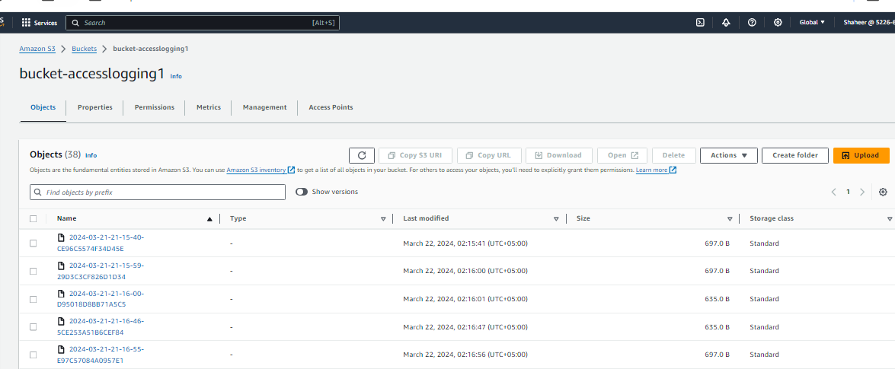

AND Now have hand-ON on Presigned URL this is done basically to give access of some specific file publically to someone for specific time . So yeah just go to object and click on object actions

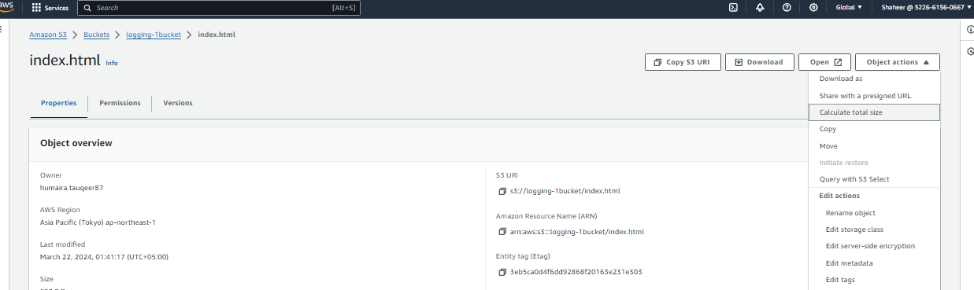

Go to share presignedURL and Set it

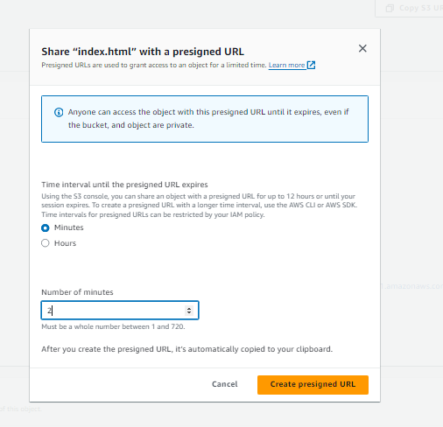

And now its just copy it and give to other.

