Here we use S3-CORS for cross region access the object like if in my bucket I have HTML file in this file the other edge which use in HTML have in other bucket and do website deployment .

So first we need to create the two S3 bucket in different region and having public IP address on and with static website enable. And in each bucket add policy of GET object .

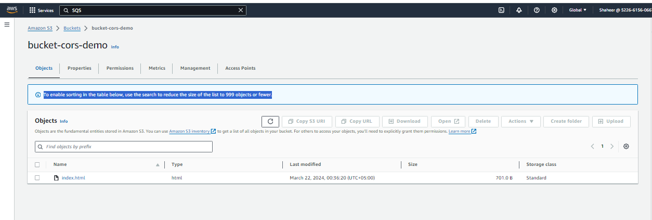

In my first bucket I upload the index.html and in which I want to print my S3 bucket also which I will place in second bucket in other S3 bucket.

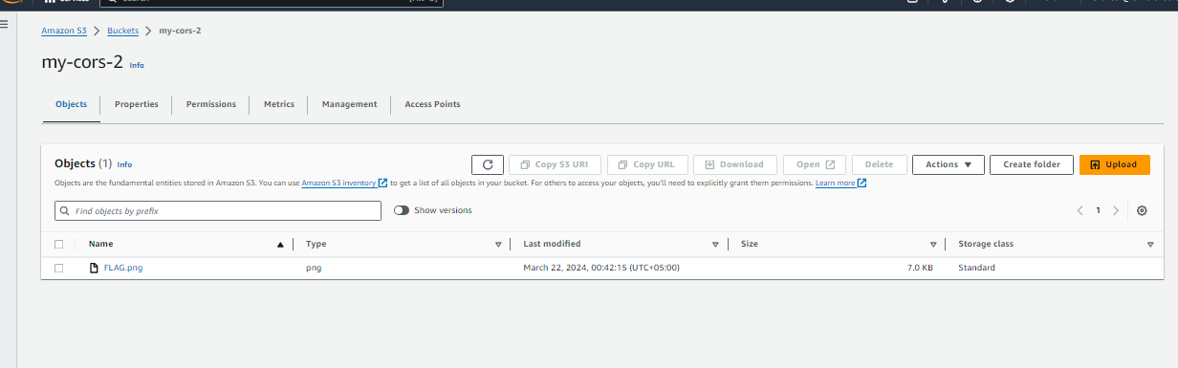

Lets see what happened

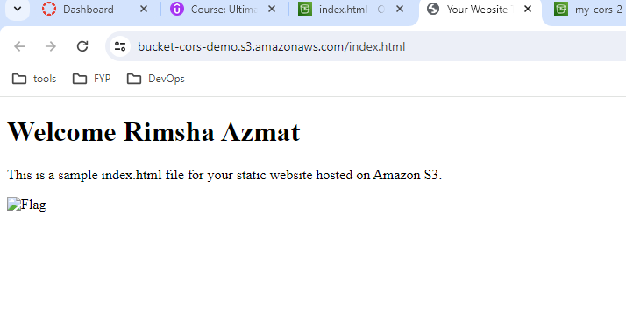

Its doesn't show our image because its in other region now lets do CORS use. Go to permission of your bucket (second bucket) and edit the CORS settings and add this script change the URL with first bucket access

[

{

"AllowedHeaders": ["\*"],

"AllowedMethods": ["GET", "POST", "PUT", "DELETE", "HEAD"],

"AllowedOrigins": ["https://bucket-cors-demo.s3.amazonaws.com/index.html"],

"ExposeHeaders": ["ETag"],

"MaxAgeSeconds": 3000

}

]

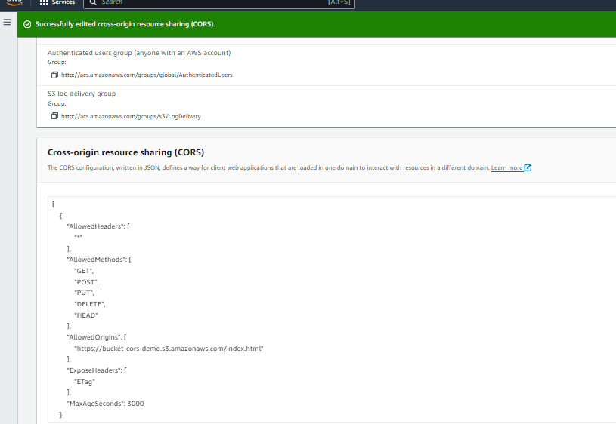

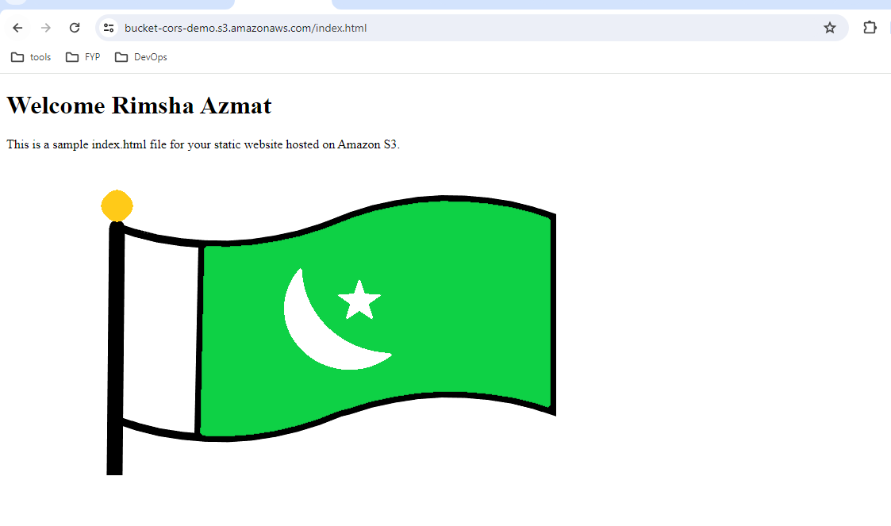

My index.html

<!DOCTYPE html>

<html lang="en">

<head>

<meta charset="UTF-8">

<meta name="viewport" content="width=device-width, initial-scale=1.0">

<title>Your Website Title</title>

<!-- Add any additional styles or meta tags here -->

</head>

<body>

<h1>Welcome Rimsha Azmat</h1>

<p>This is a sample index.html file for your static website hosted on Amazon S3.</p>

<!-- Add your content here -->

<div>

<img src="https://my-cors-2.s3.ca-central-1.amazonaws.com/FLAG.png" alt="Flag">

</div>

<!-- Example of linking to a CSS file (replace with your actual CSS file) -->

<!-- <link rel="stylesheet" href="styles.css"> -->

</body>

</html>