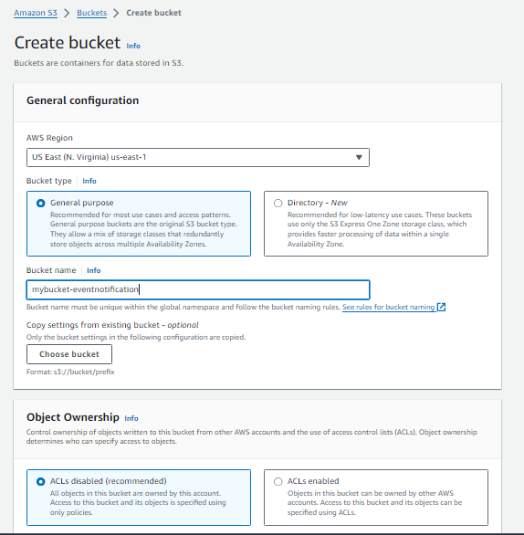

Go to the properties enable event bridge and move to event notification and create it

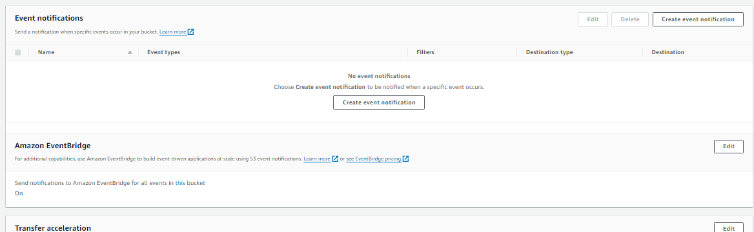

Before creating the event notification you have to create in which want the notification like SQS , Lambda and SNS . In this we are work with SQS

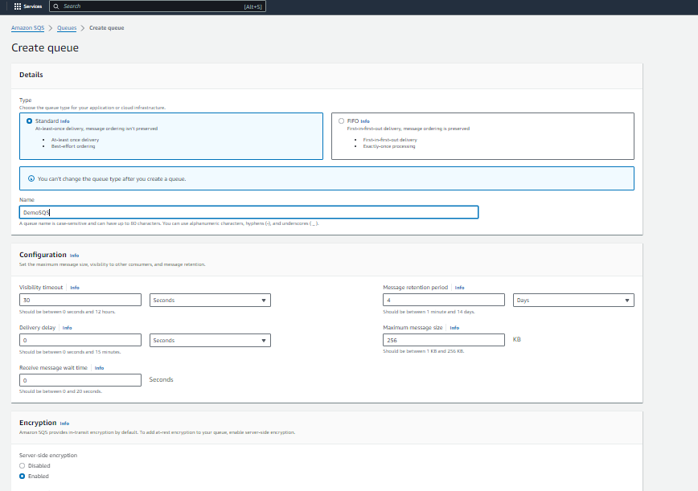

Once you create the SQS you need to update its policy to send message let do that

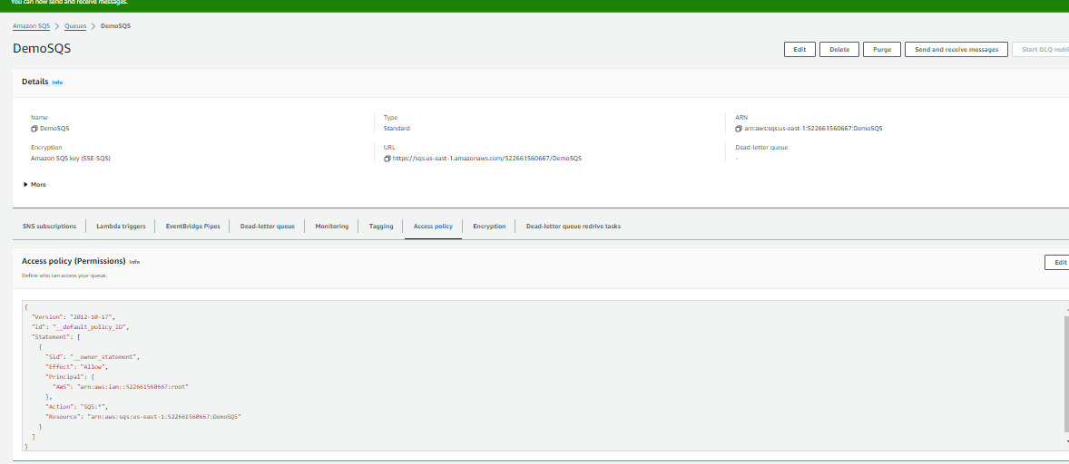

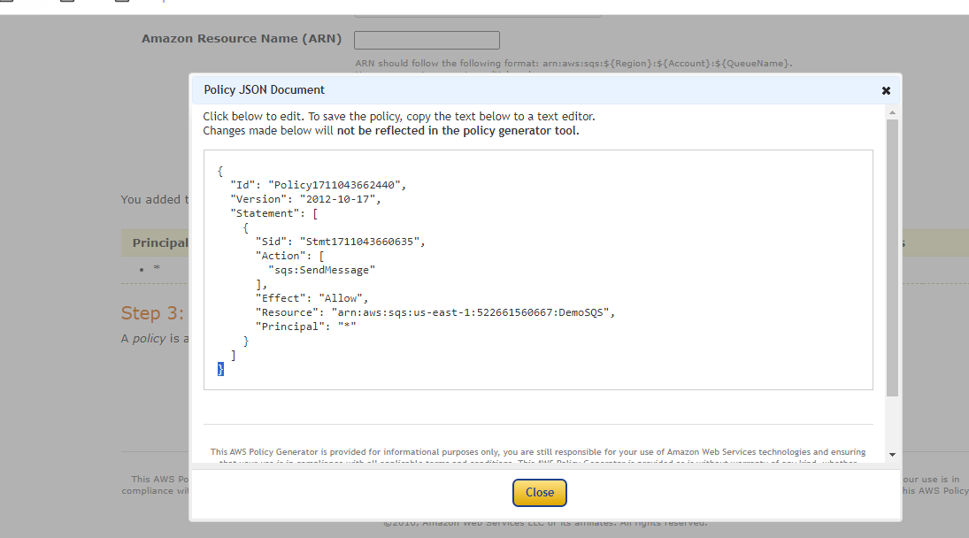

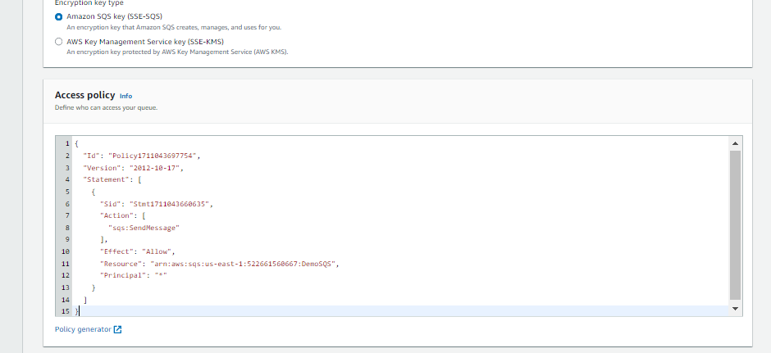

Now move to create the Event

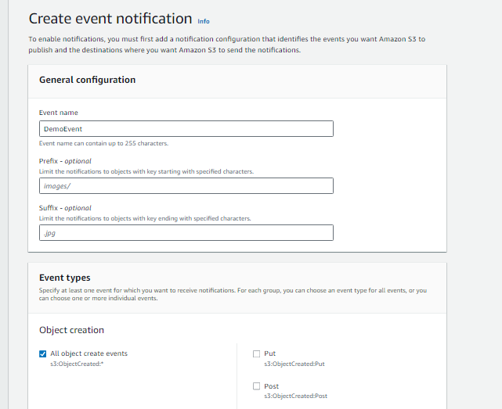

Select event types according to your need we keep it simple and lets move next

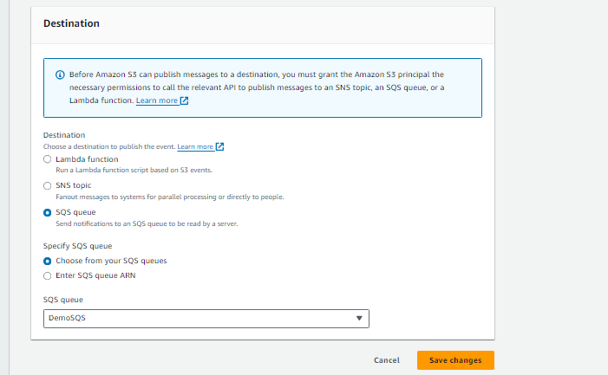

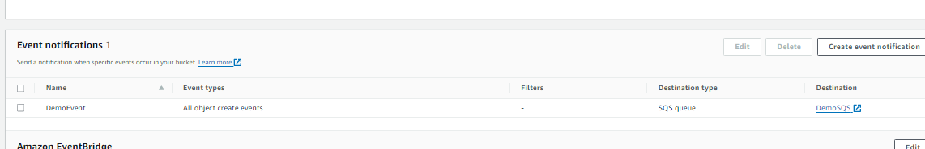

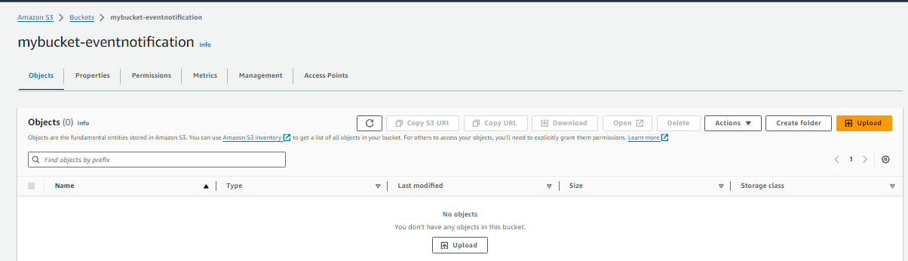

The bucket is empty lets upload something and see the effect

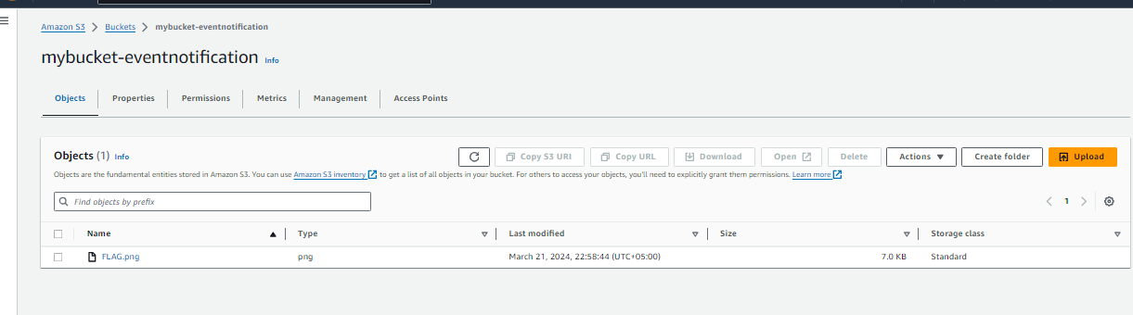

Now go to SQS and click on send and receive message and move to the receive and poll the message and then you can see two message one for event test and other is in bucket the object is inserted .

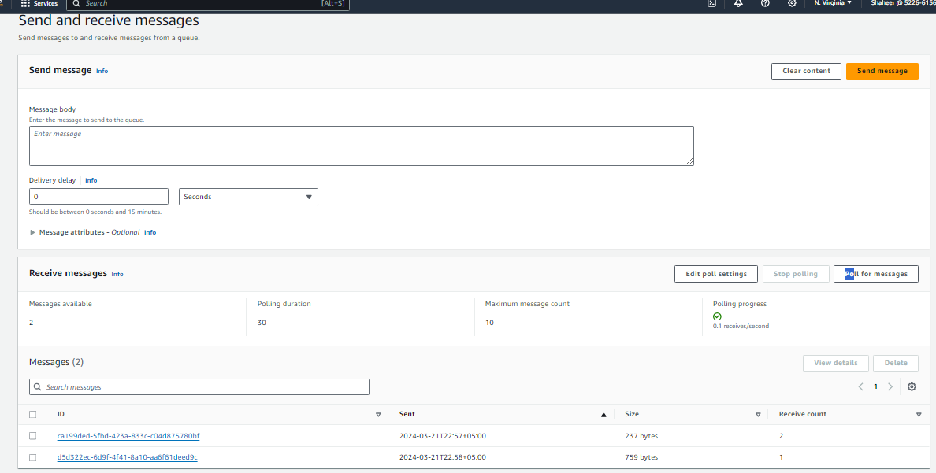

Lets see what's in these messages

