Create the S3 bucket upload a file in it and good to properties and you can change the storage classes of the bucket according to your need

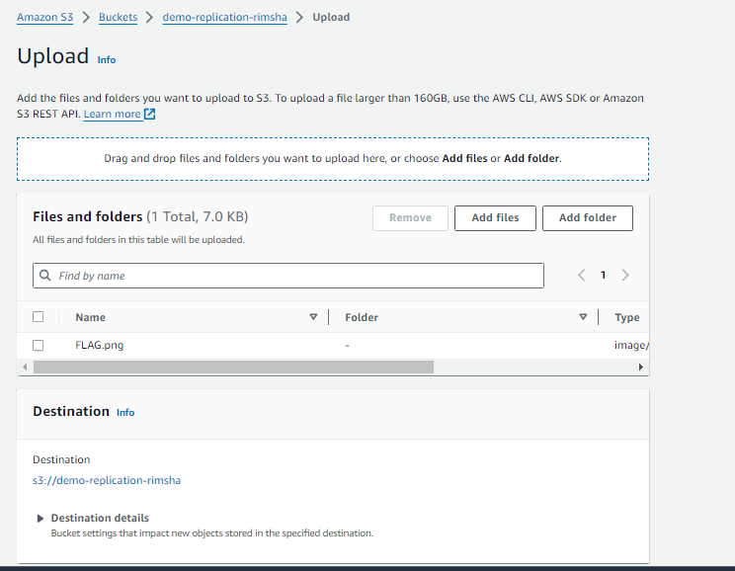

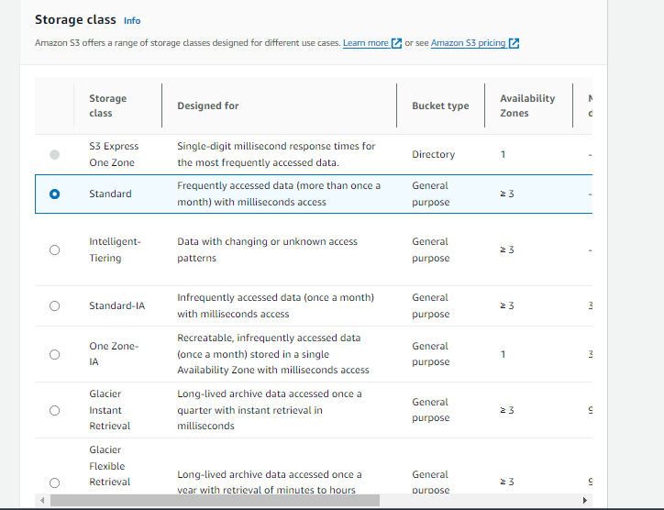

You can choose according to need and you can also change any time And in management you can also create lifecycle of your need

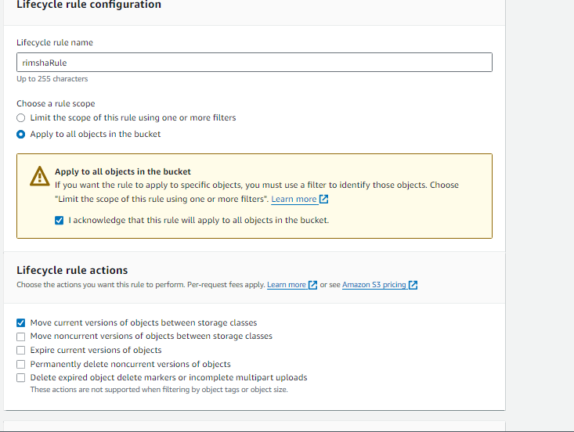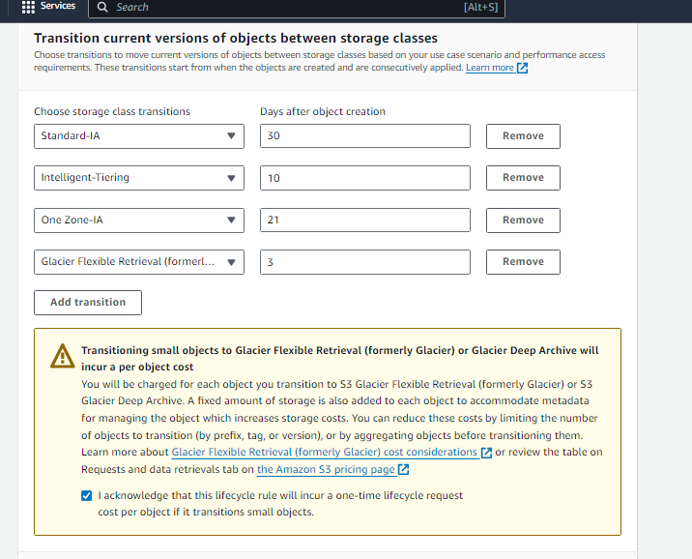

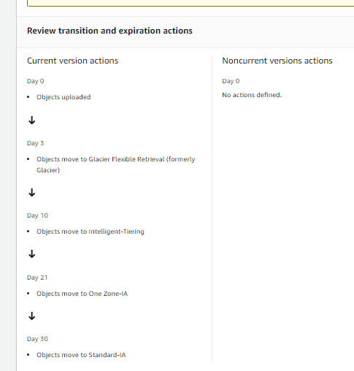  
As you can See I create lifecycle rule of my bucket objects. 