Create the S3 bucket

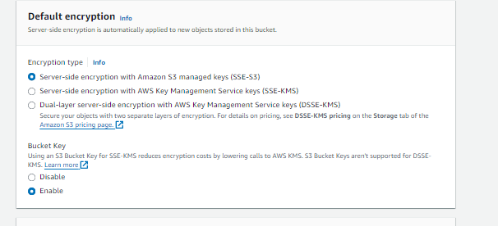

With this setting you can change first we try this and then update or edit this. And also enable the versioning.

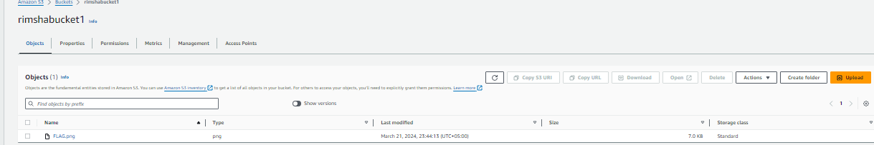

Open the object and in properties you can change the server-side-encryption

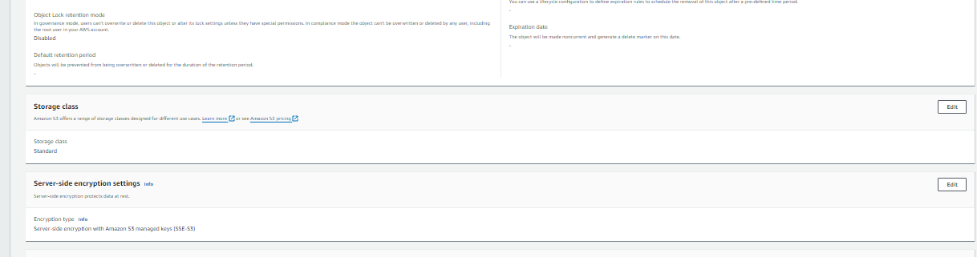

If create KMS key it will cost so you can choose it in your account.

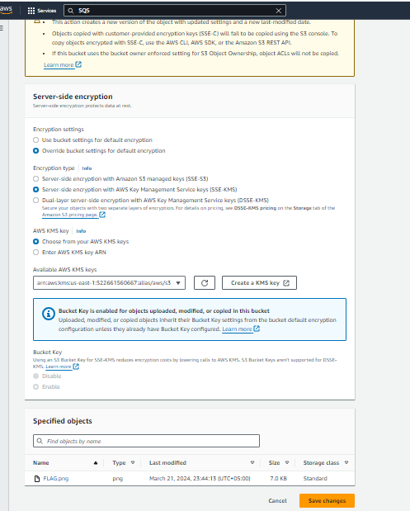

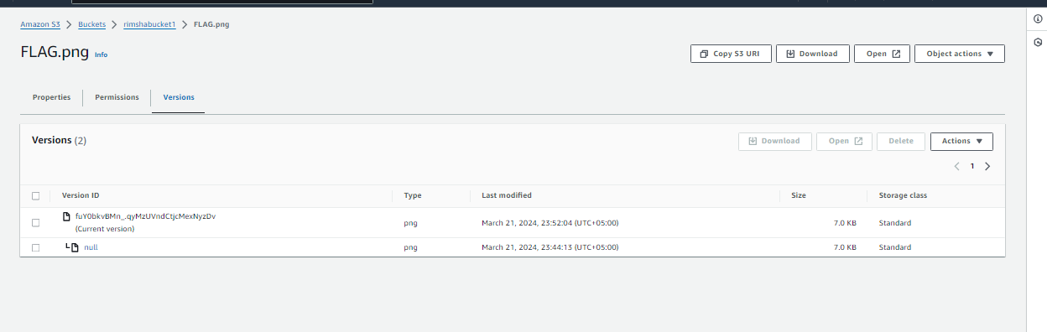

You can see its change now.

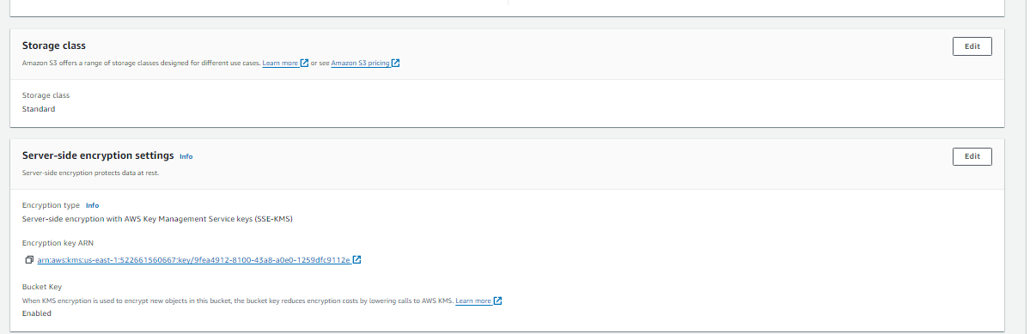

You can change it while uploading the file or folder let's do that in that way

