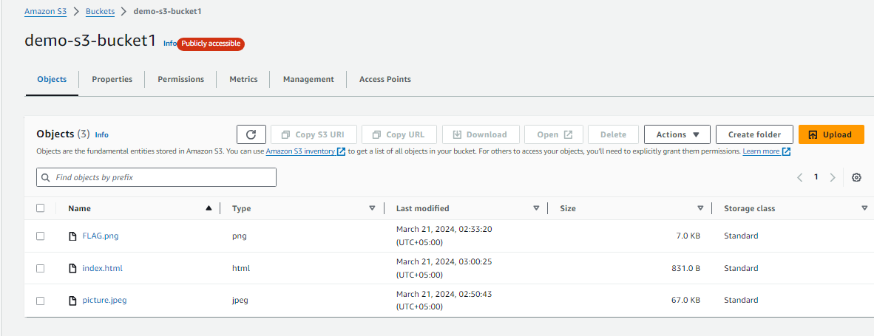

First we create the S3 bucket add file then in properties we enable static website feature which is at last.

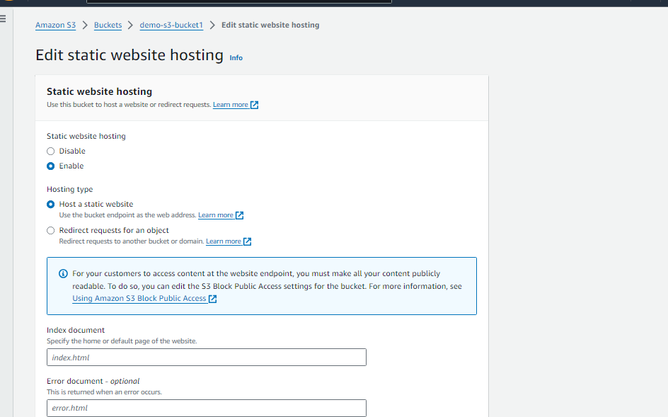

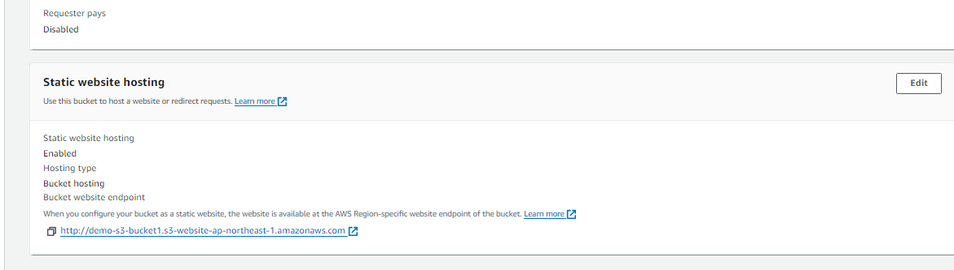

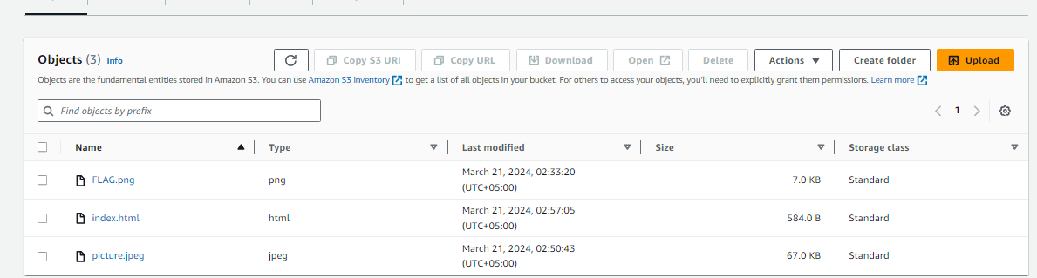

<!DOCTYPE html>

<html lang="en">

<head>

<meta charset="UTF-8">

<meta name="viewport" content="width=device-width, initial-scale=1.0">

<title>Your Website Title</title>

<!-- Add any additional styles or meta tags here -->

</head>

<body>

<h1>Welcome to Your Website</h1>

<p>This is a sample index.html file for your static website hosted on Amazon S3.</p>

<!-- Add your content here -->

<!-- Example of linking to a CSS file (replace with your actual CSS file) -->

<!-- <link rel="stylesheet" href="styles.css"> -->

</body>

</html>

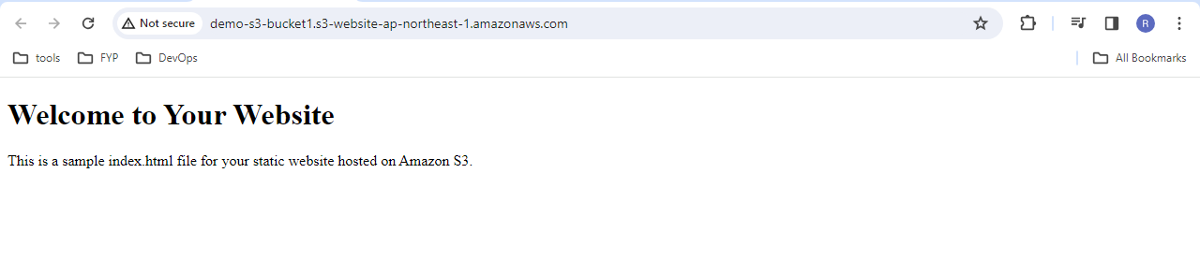

<!DOCTYPE html>

<html lang="en">

<head>

<meta charset="UTF-8">

<meta name="viewport" content="width=device-width, initial-scale=1.0">

<title>Your Website Title</title>

<!-- Add any additional styles or meta tags here -->

</head>

<body>

<h1>Welcome to Your Website</h1>

<p>This is a sample index.html file for your static website hosted on Amazon S3.</p>

<!-- Add your content here -->

<div>

<img src="https://demo-s3-bucket1.s3.ap-northeast-1.amazonaws.com/picture.jpeg" alt="Picture">

</div>

<div>

<img src="https://demo-s3-bucket1.s3.ap-northeast-1.amazonaws.com/FLAG.png" alt="Flag">

</div>

<!-- Example of linking to a CSS file (replace with your actual CSS file) -->

<!-- <link rel="stylesheet" href="styles.css"> -->

</body>

</html>

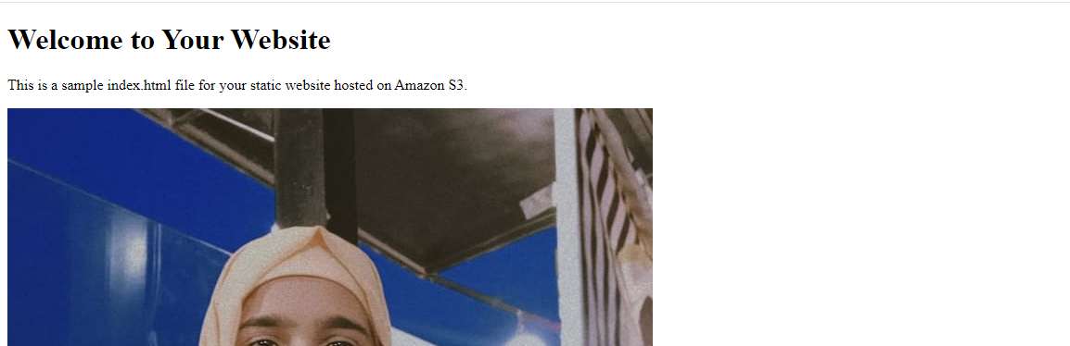

So yeah we can also S# bucket publically access in this ad access them through browser.