**Name Rimsha Azmat**

**Course DevOps**

**Submitted to Sir Sajjad**

**Assignment**

**Clone & Fork a Repo**

* Clone the remote repo

<https://github.com/aqeelanwar/Tic-Tac-Toe>

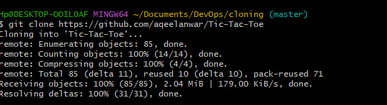

* This may be setup with the master branch instead of the main
* Check the branches in git to verify
* Update the last two commands with the appropriate branch name

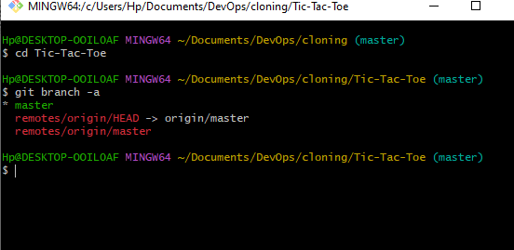

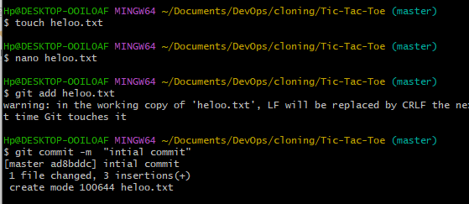

* Create a private repo on your GitHub account called Tic-Tac-Toe
* Set the remote origin with your new repo clone URL
  + git remote set-url origin https://github.com/XXXXX-USERID-XXXXX/Tic-Tac-Toe.git

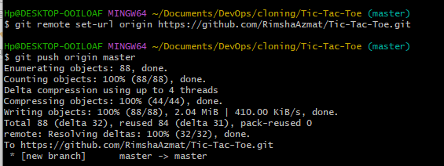

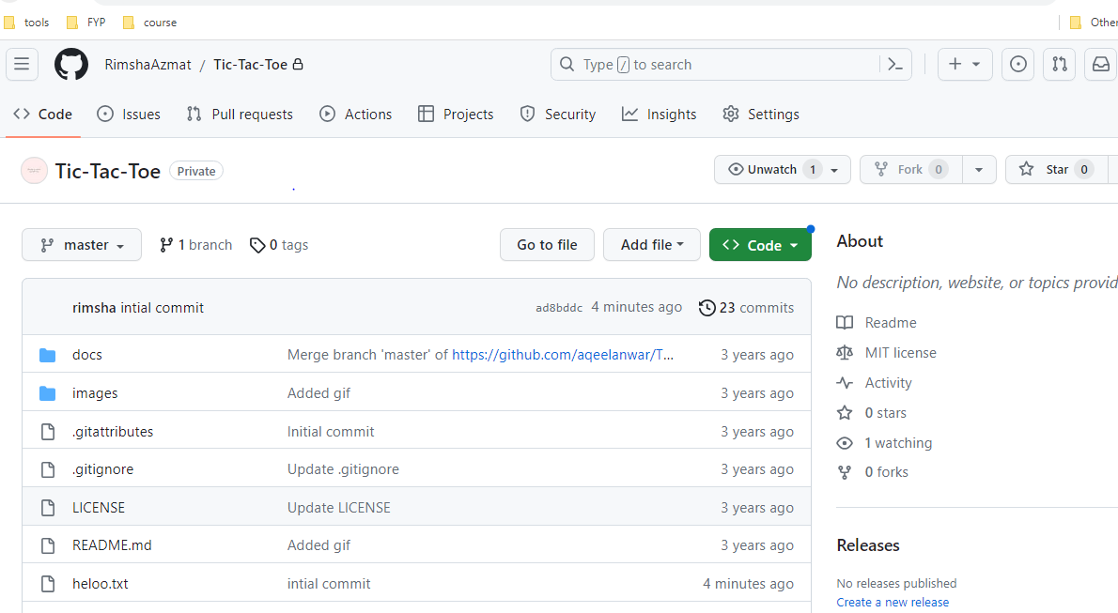

* Run the following commands to push your local repo to GitHub
  + git branch -M main
  + git push -u origin main

