**Name Rimsha Amzat**

**Course DevOps**

**Submitted to Sir Sajjad**

Assignment

# Bash Script: Counts the Number of Files and Subdirectories in that Directory

This script takes a directory path as an argument, counts the number of files and subdirectories in that directory, and lists the largest files in descending order.

Save the below code in a file with a .sh extension, such as complex_script.sh. Make the file executable by running the command chmod +x complex_script.sh in the terminal. Then you can execute the script by providing a directory path as an argument, like this: ./complex_script.sh /path/to/directory.

The script first checks if a directory path was provided as an argument and if the directory exists. Then it counts the number of files and subdirectories in that directory. Finally, it lists the largest files in the directory, showing the top 5 files based on their sizes.

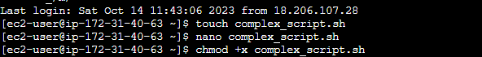

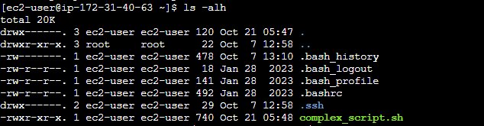

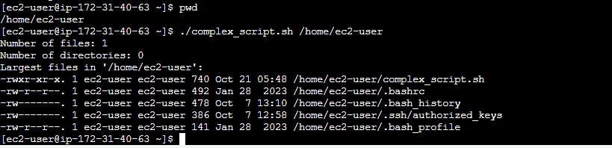

You can modify and expand this script further based on your requirements by adding more functionality or implementing additional tasks.

Change I made is given below

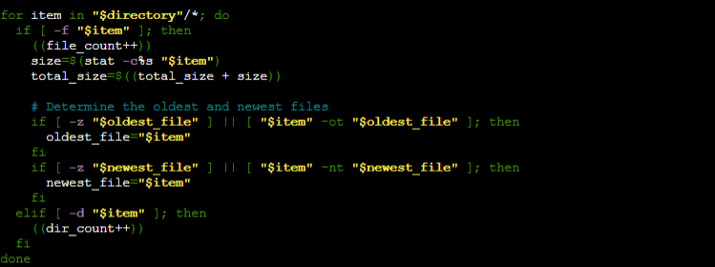

The **-z** flag is used to check if a variable is empty or unset. In this context, it is used to determine if the variables **oldest_file** and **newest_file** have been initialized.

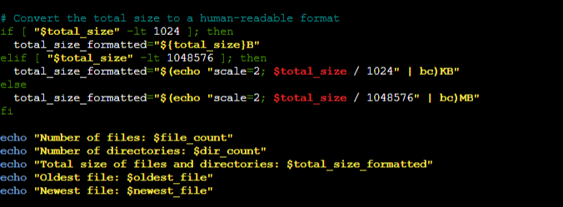

This code is used to convert the total size of files and directories, represented by the **total_size** variable, into a human-readable format.

**Output**

