**Name Rimsha Amzat**

**Course DevOps**

**Submitted to Sir Sajjad**

Assignment

Linux: Create a User, Dir, File, and Permissions

1. Switch to root (admin) user by this command  sudo su –



1. Create a new user called "exerciseuser" with a home directory and a login shell. Hint: Use the useradd command.
   1. Verify the home directory
2. Set a password for the "exerciseuser" account. Hint: Use the passwd command. 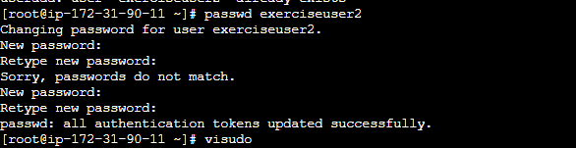
3. Grant "exerciseuser" sudo privileges. Hint: Use the visudo command to edit the sudoers file (/etc/sudoers) and add the appropriate entry. 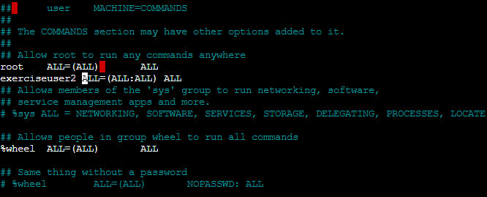
   1. [https://heshandharmasena.medium.com/explain-sudoers-file-configuration-in-linux-1fe00f4d6159Links to an external site.](https://heshandharmasena.medium.com/explain-sudoers-file-configuration-in-linux-1fe00f4d6159)
4. Switch to the "exerciseuser" account. Hint: Use the su command or log out and log in as the "exerciseuser".
5. Create a new directory called "exercise" in the "exerciseuser" home directory. Hint: Use the mkdir command. 
6. Create an empty file called "data.txt" in the "exercise" directory. Hint: Use the touch command. 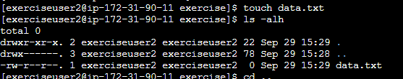
7. Change the ownership of the "exercise" directory and its contents to the "exerciseuser" user. Hint: Use the chown command. 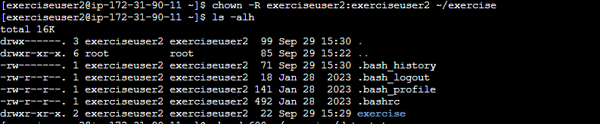
8. Restrict the permissions of the "data.txt" file so that only the owner can read and write to it. Hint: Use the chmod command.

