**Name Rimsha Azmat**

**Course DevOps**

**Assignment**

Bash Script: Retrieve Weather Information for a Given Location using the OpenWeatherMap API

**Solution**

Before any change to code the output

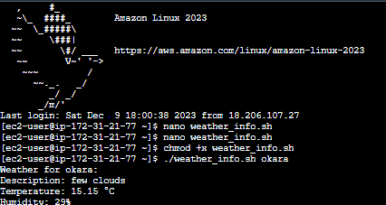

After that I made some change the code so the code given

**Code**

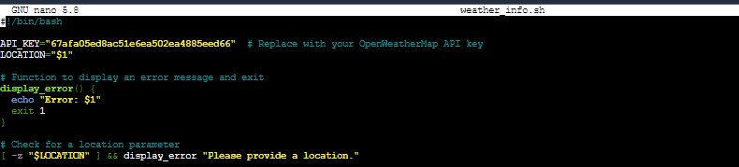

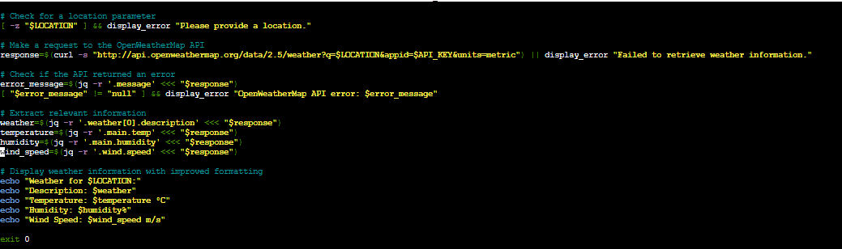

**Output**

