**Name Rimsha Azmat**

**Course DevOps**

**Submitted to Sir Sajjad**

**Assignment**

Linux: System Administration and Automation - Add Logs with Timestamps & Change the Stdout & Stderr to a log file

See there is no file with name file.log or file.err but file with name file.sh I already create this and add the bash script in this

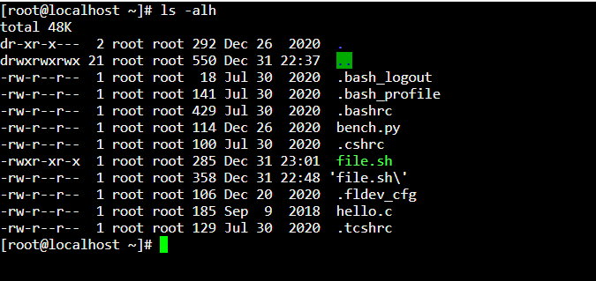

File I just add the add timestamp in this script . I have another to add the this by simply making log function call this . It looks like that

#!/bin/bash

# Function to log messages with timestamps

log() {

echo "$(date '+%Y-%m-%d %H:%M:%S') - $1"

}

log "Hi, welcome to DevOps!"

log "Rimsha is working on DevOps tasks."

log "Rimsha working hard to do this tasks."

echo best of luck"

But I work with simple script and at the end I add the error in this bash script .

The script in this file is given below

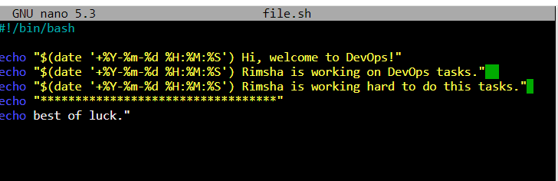

Then I execute the the script the output given with error

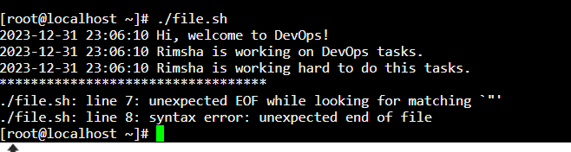

Here I execute the file as well I want to print the stdout to the file.log so I redirect this here I use single> which make the file as well print my output on that file and it replace whatever in that file if file already exist…..

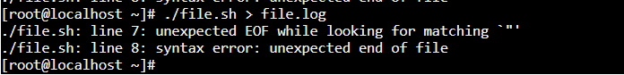

Same step I do for file.err than I use cat to show that files. As you can that the console output redirect towards the log or error file but still error is displaying in the console.

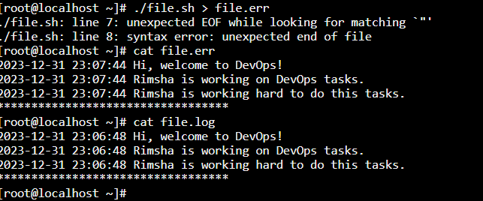

After that I use double > sign and append new output in the file.log

In very next command I use 2 to redirect the error in the file.err and you can see output is still showing in console and error redirect towards the file.err after that you can see the both file data .

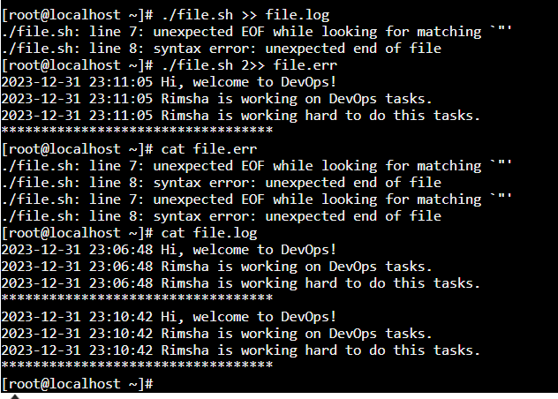

Next command in file log the output is redirect to that and use 2>> to redirect the error in the file.err .

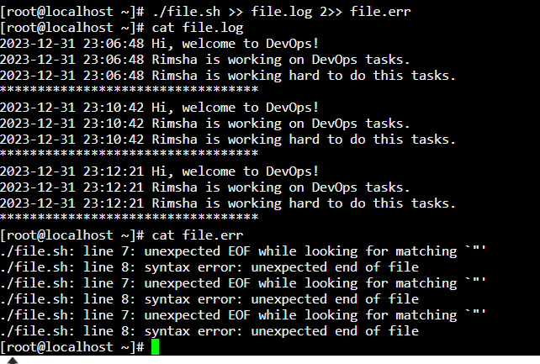

In this step I redirect the both error and output in the same file which is file.log and we can the output

