**Name Rimsha Azmat**

**Course DevOps**

**Submitted to Sir Sajjad**

**Assignment**

**Linux Processes System Monitoring**

Provide the output of 11 commands from the below list.

1. List all running processes on your Linux machine. Hint: Use the ps command or its variants (ps aux, ps -ef, etc.).

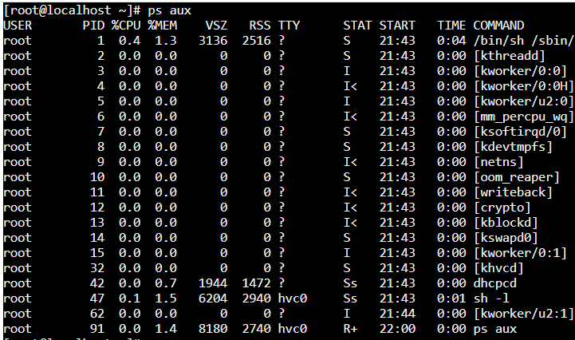

1. Identify the process ID (PID) of a specific process (e.g., bash, nginx). Hint: Use the ps command with filters or the pgrep command.

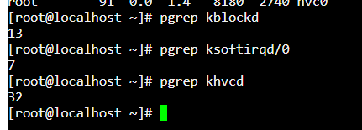

1. Display detailed information about a specific process using its PID. Hint: Use the ps command with the -p option followed by the PID, or use the top or htop command.

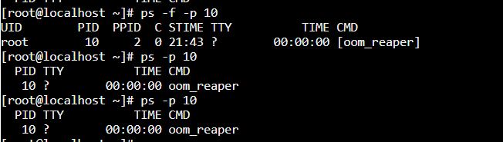

1. Terminate a running process gracefully using its PID. Hint: Use the kill command with the PID.

I use -9 here to confirm that it is necessary to kill that process don't ignore this. That’s why its easily killed.

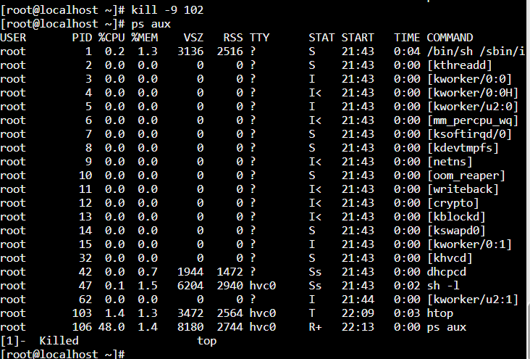

1. Monitor system resource usage (CPU, memory, disk, etc.) in real-time. Hint: Use the top or htop command

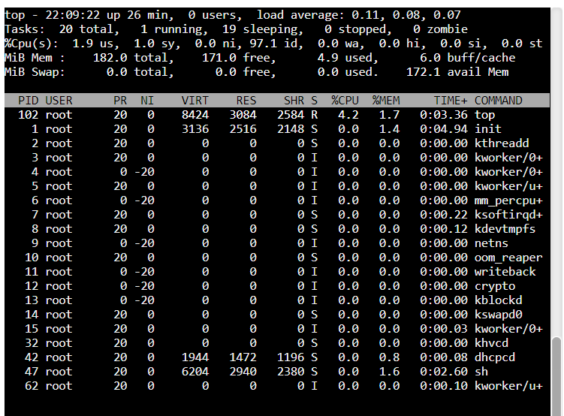

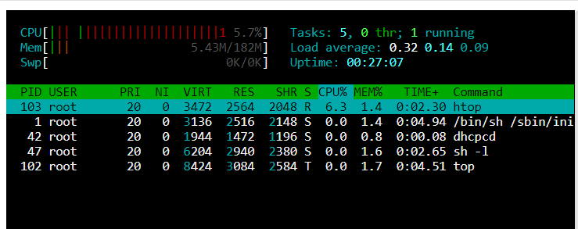

1. Monitor disk usage for a specific directory. Hint: Use the df command or the du command with appropriate options.

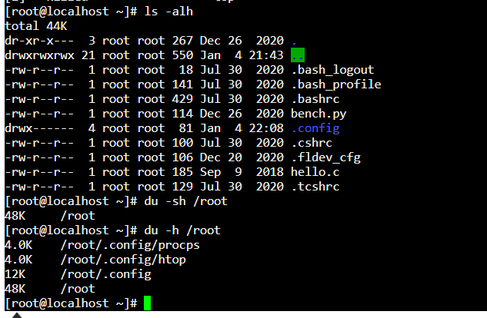

1. Monitor network activity and connections on your Linux machine. Hint: Use the netstat command or the ss command.

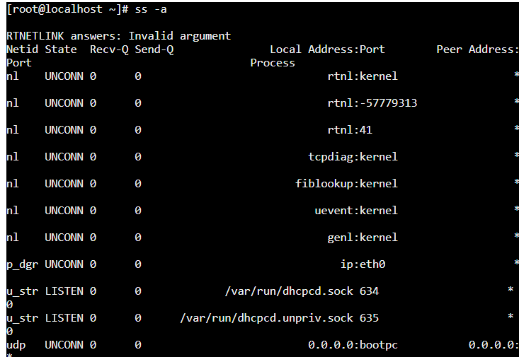

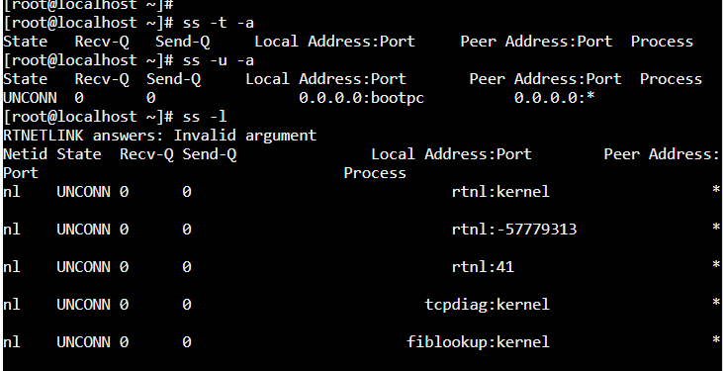

1. Monitor system log files (e.g., /var/log/messages, /var/log/syslog) for any recent entries. Hint: Use the tail command with appropriate options to display the last few lines of the log files.

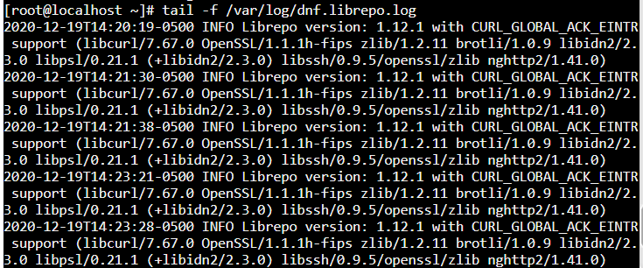

1. Monitor CPU usage by individual processes. Hint: Use the top or htop command and sort the processes by CPU usage.

Using **htop**: Run **htop**, and if it's not already sorted by CPU, you can press **F6** and select **CPU%** to sort by CPU usage.

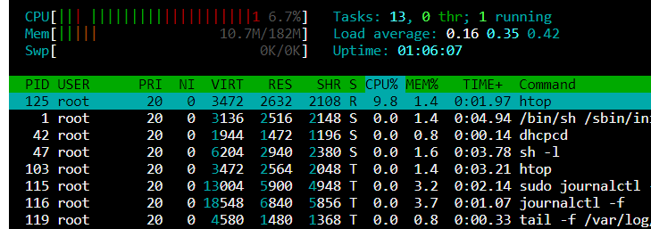

1. Monitor memory usage by individual processes. Hint: Use the top or htop command and sort the processes by memory usage.

Using **top**: Run **top**, then press **Shift** + **M** to sort by memory usage.

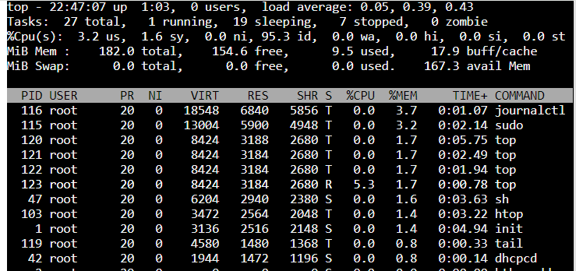

1. Monitor system load average. Hint: Use the uptime command or the top command.



1. Monitor active network connections and associated programs. Hint: Use the lsof command with appropriate options.

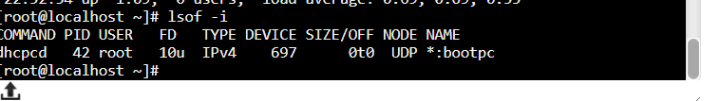

1. Monitor system temperature and fan speeds (if available). Hint: Use the sensors command or the lm_sensors package.
2. Monitor real-time file system activity. Hint: Use the inotifywait command or the dnotify command.