**Name Rimsha Azmat**

**Course DevOps**

**Assignment**

Read Password without Echoing Back

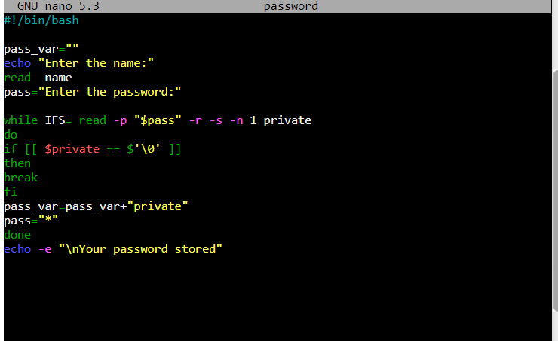

Output

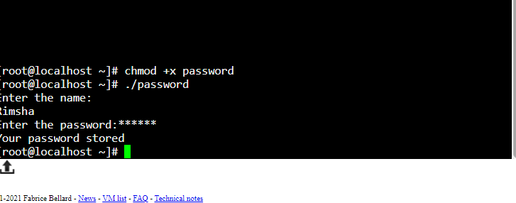

Explanation

-s is used for silent input

-n 1 represent that the script should only read one input/character at a time.

In if statement \0 indicate the input of user is done now its end of input.

-r is use to consider / spaces as a input and also consider as input from user.