Frist we need to create two instances and run these to check its server works or not or make sure to add HTTP port in security group

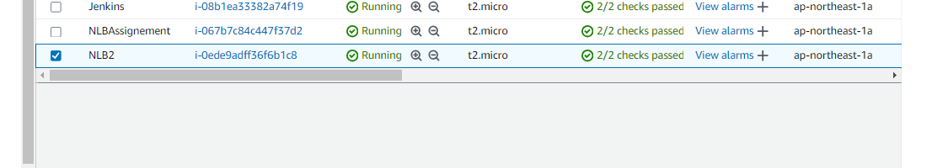

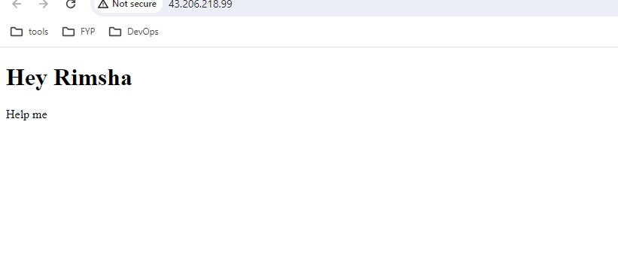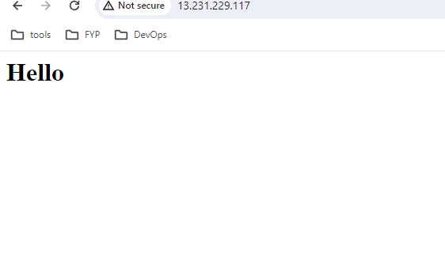

After that we need to go to the load balancer and choose network load balancer.

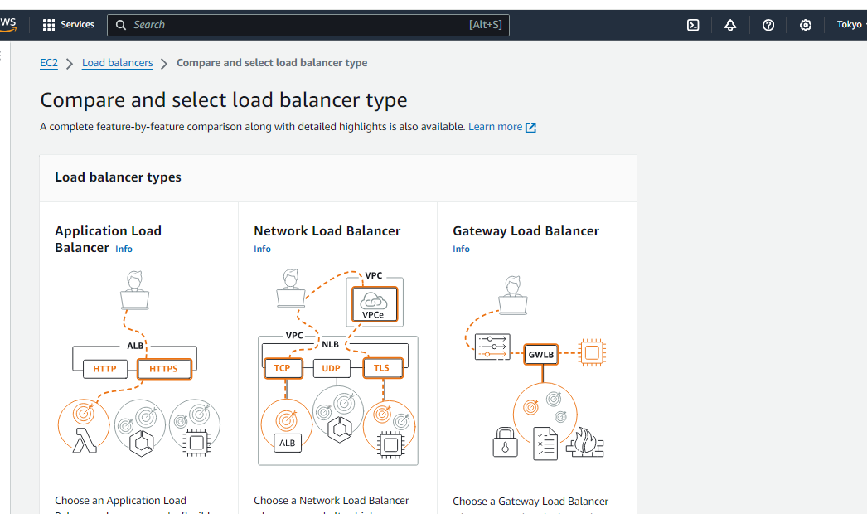

While making configuration we need to create the target group with HTTP and add this.

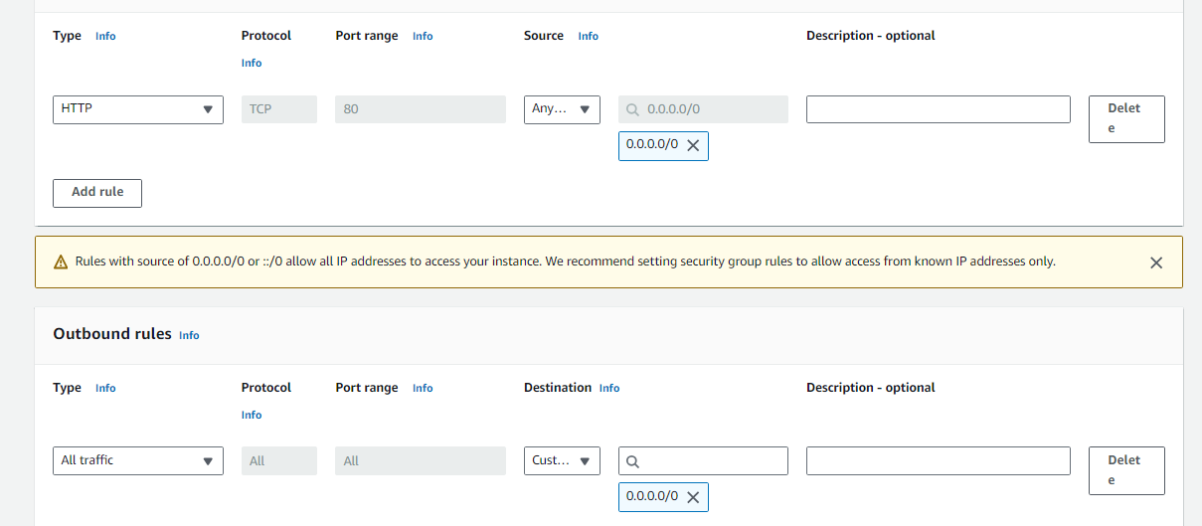

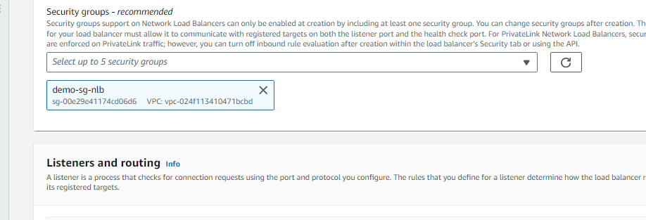

Target group creation and select Ec2 you create to balance.

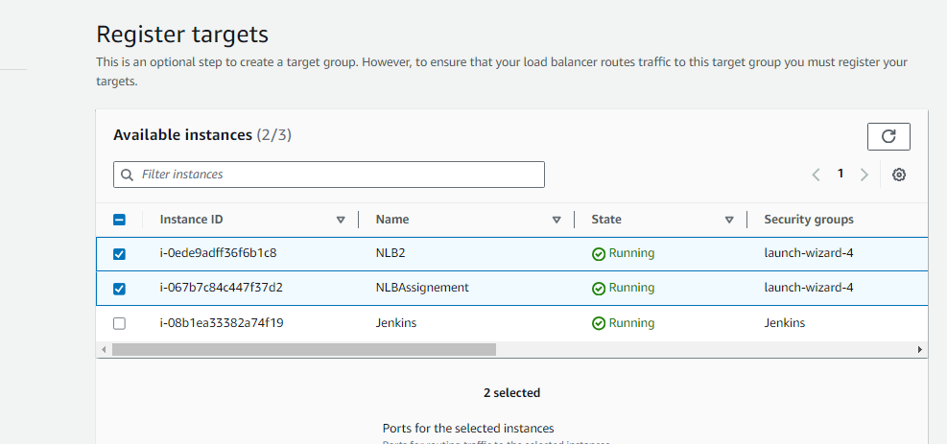

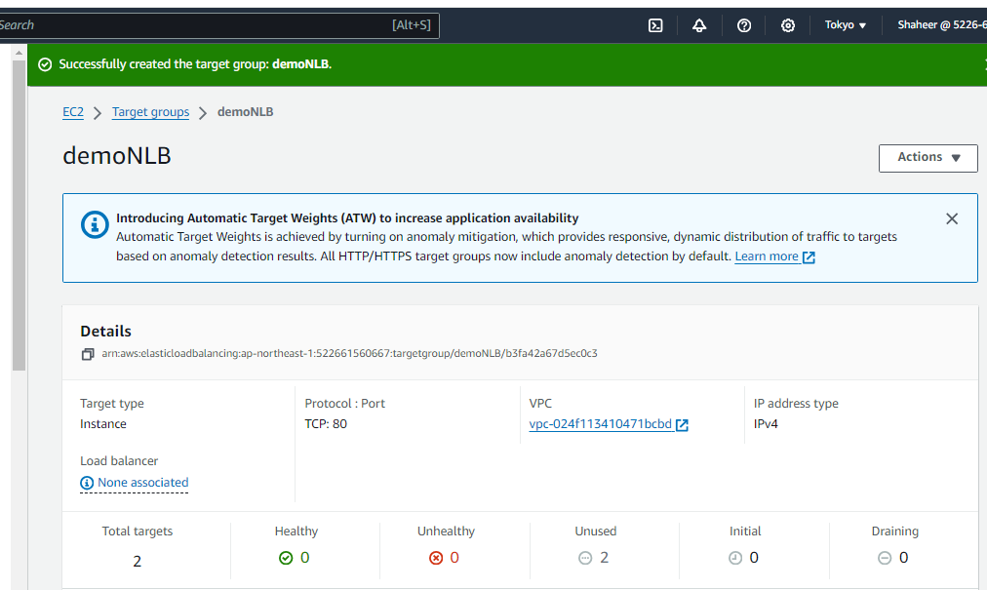

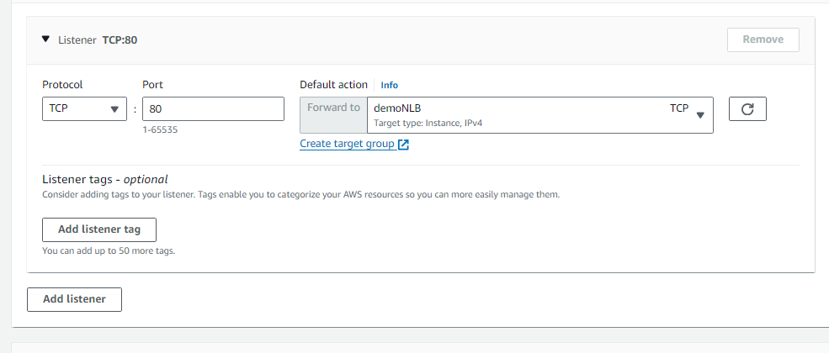Here the creation of Load Balancer done and after that just copy the DNS name and paste it in browser and see its running both EC2 in each refresh . If you terminate any instance the load Balancer run the running instance and skip the unhealthy instance .  
