Name Rimsha Azmat

Course DevOps

Submitted to Sir Sajjad

**Assignment**

**Install WordPress on an Amazon EC2 instance**

LAMP Installation

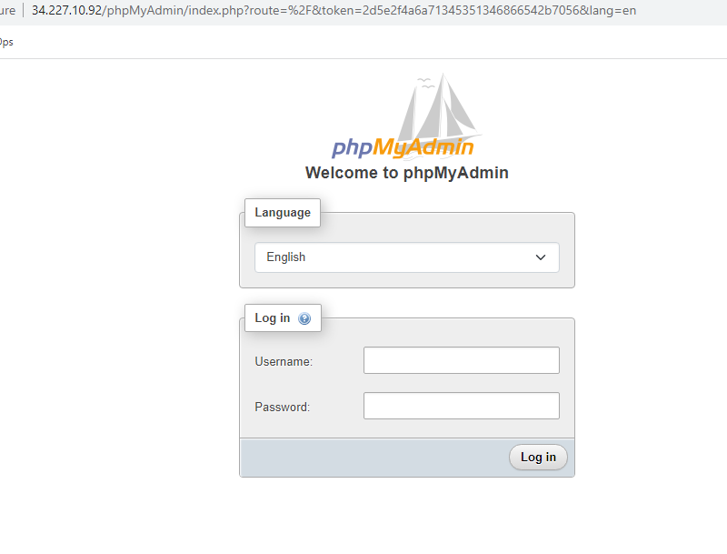

1. Install and configure WordPress: Download the latest WordPress release using the following command:

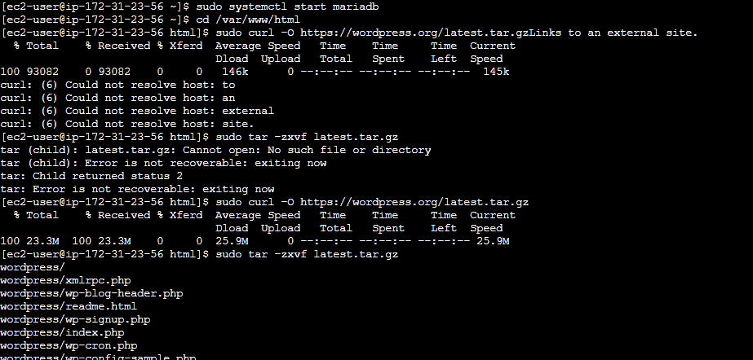

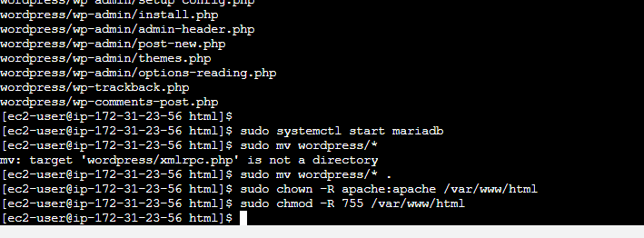

1. Configure the WordPress database: Create a new MySQL database and user for WordPress. Access the MySQL shell with the following command:

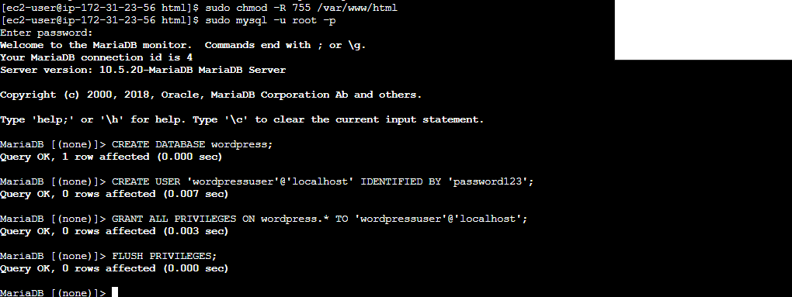

1. Configure WordPress: Open a web browser and access your EC2 instance's public IP address or DNS name. You will see the WordPress installation wizard. Select the language and provide the required information, including the database details you configured in the previous step.

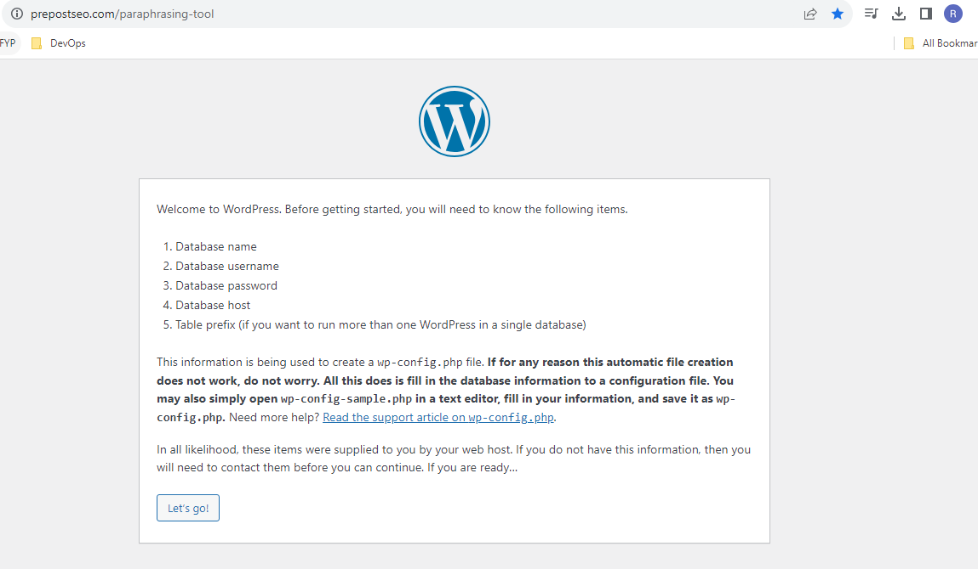

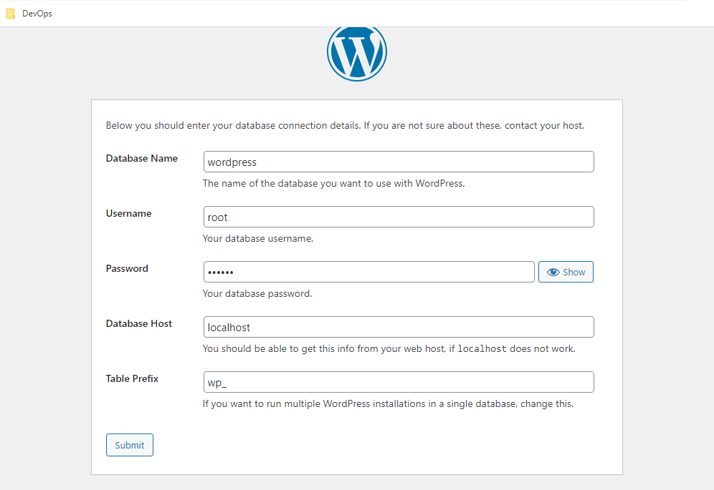

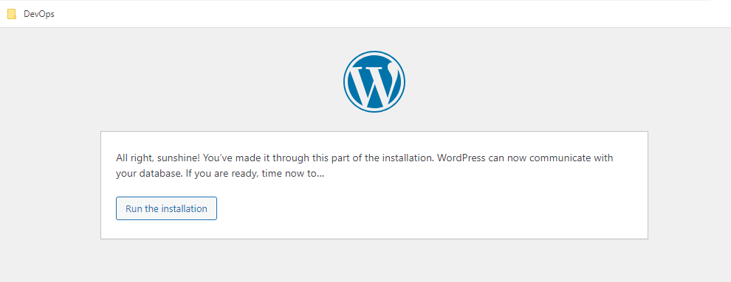

1. Complete the installation: After providing the necessary details, click "Run the Installation." Once the installation is complete, you can log in to your WordPress admin dashboard and start using WordPress.

