**Installation and Environment setup in windows 10**

https://reactnative.dev/docs/environment-setup

1. Install Node JS software
2. Install Chocolatey

<https://chocolatey.org/install>

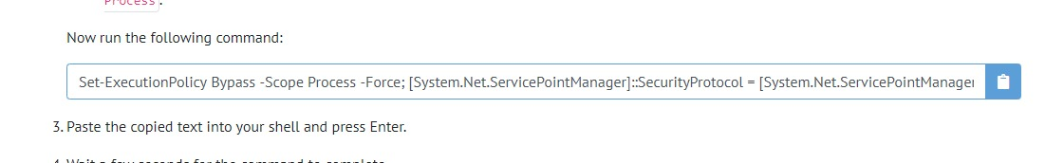

Run in Powershell(as administration)

Now run command:

**choco install -y nodejs.install python2 openjdk8**

1. **Install Java SE Development Kit (JDK)**
2. **Install Android Studio**
3. **Set Environment variables:**

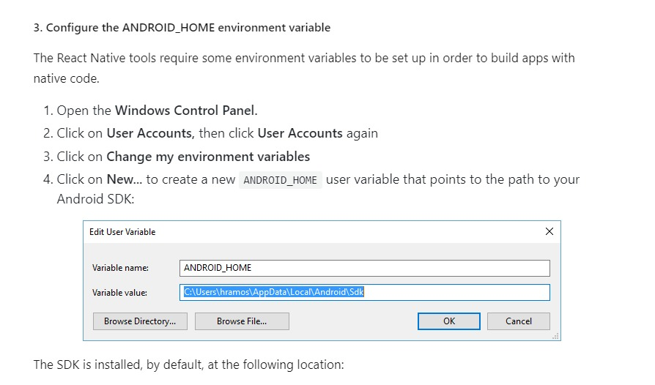

In **User variable for dell** section make new variable

Variable Name: ANDROID_HOME

Value: C:\User\dell\Appdata\Local\Android\SDK

**Note:**search for Appdata in **hidden variables**

**Now:**

In Path variable,double click it and add new path:

C:\Users\osaid\AppData\Local\Android\Sdk\platform-tools

1. If you have any Emulator in Android AVD, **Delete it.**
2. Make folder for all projects,open CMD in it(Write CMD in link it will open)
3. Nevigate to exact flder using **cd command.**
4. **Create new project:**

npx react-native init demo

1. After creation of project ,navigate to project folder:



1. To open VSCode



1. To run on Mobile:Do all mobile steps to set on Dev mode,then connect via wire mobile to laptop and write this command:

npx react-native run-android