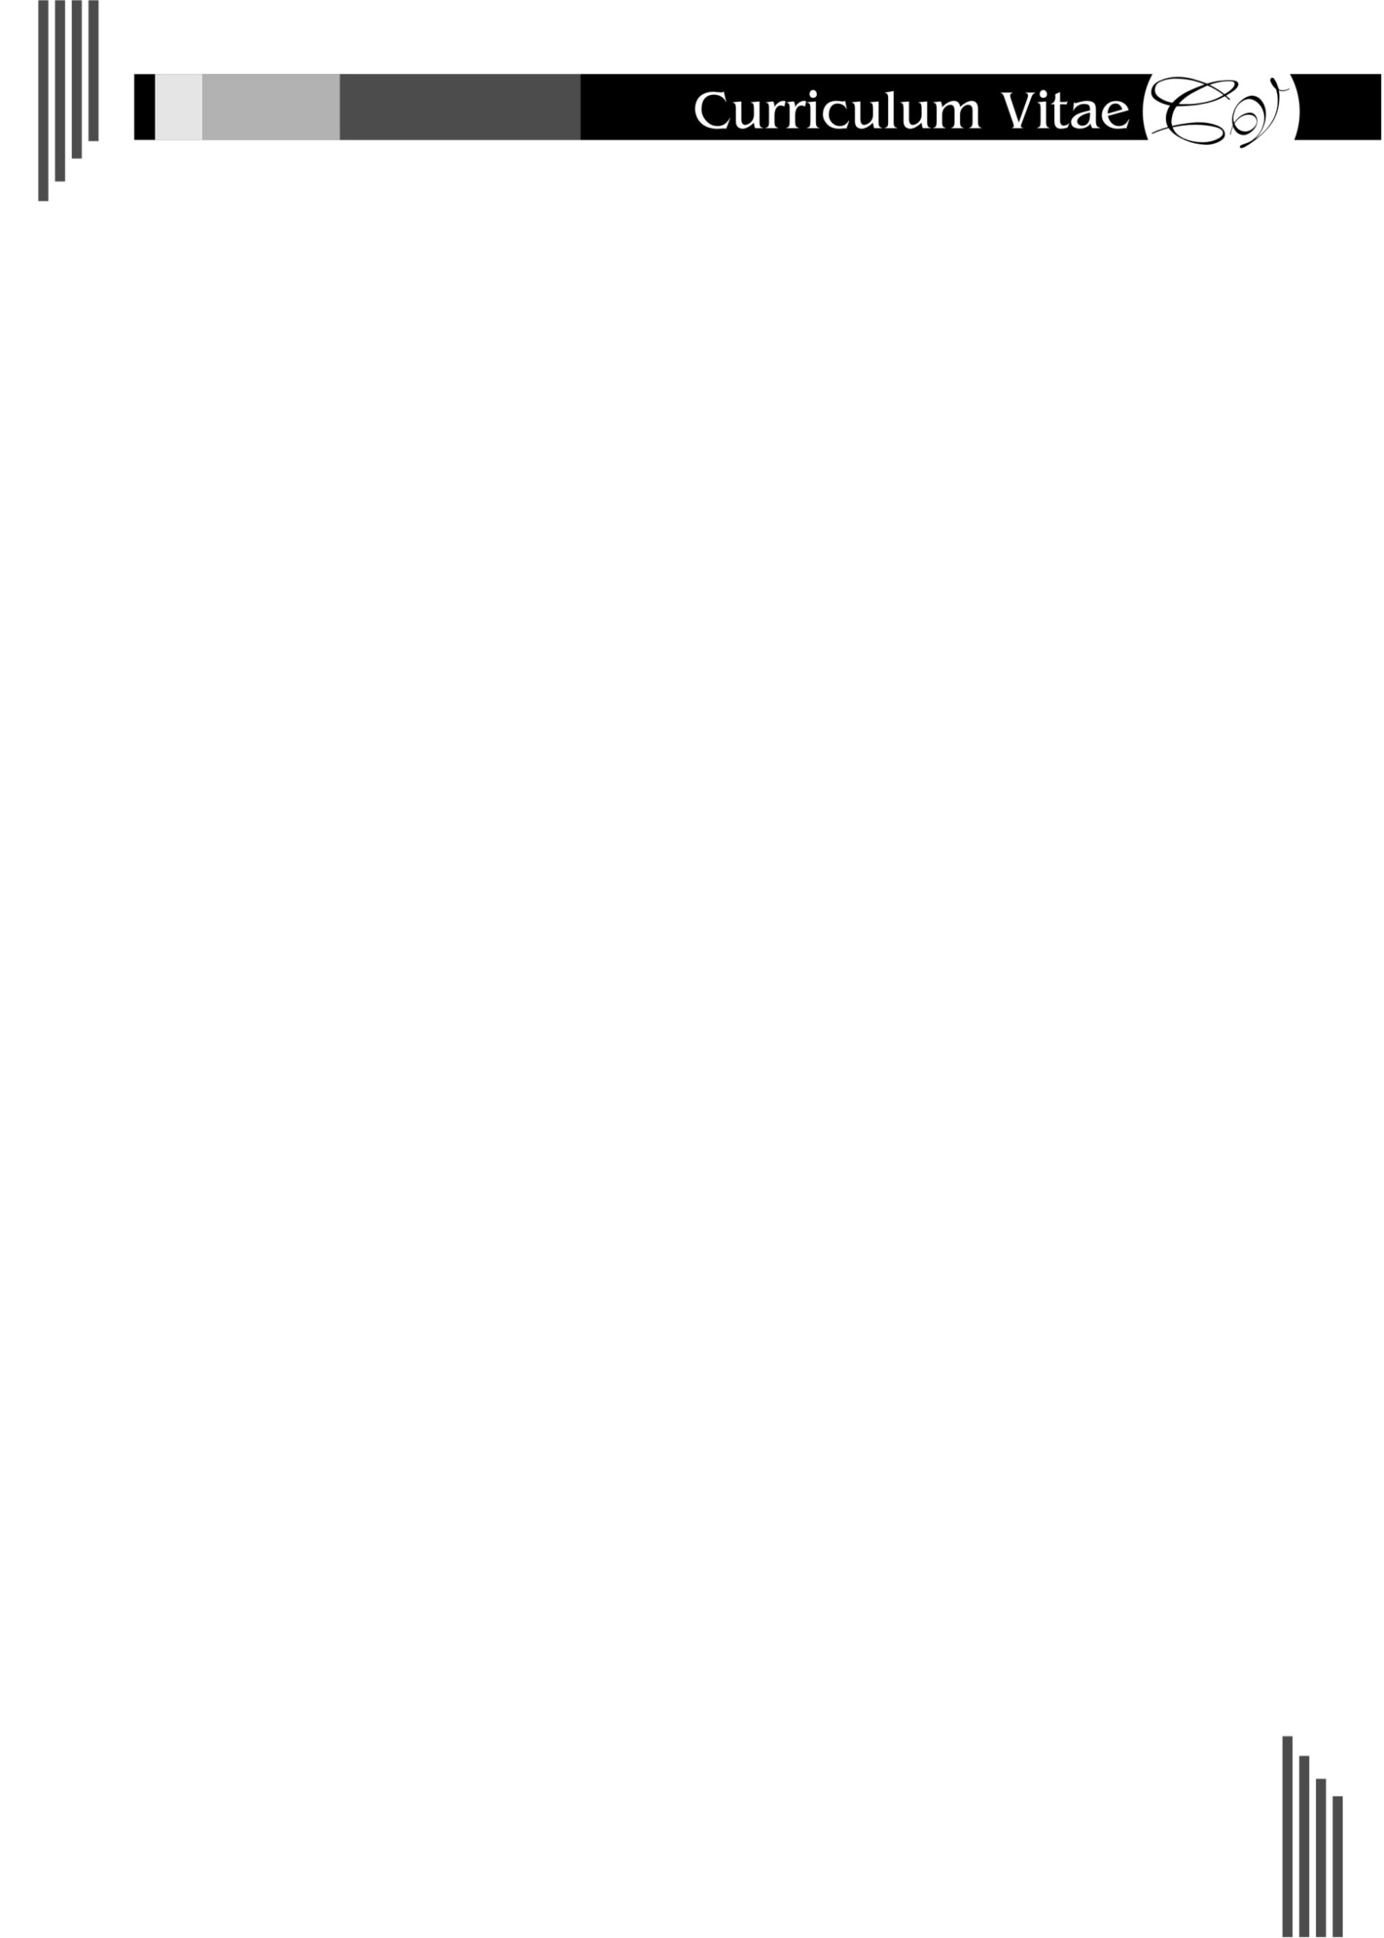RIMSHA MANZOOR ABBASI

Email: r.abasi20980@gmail.com

|  |
| --- |
| ***Profile*** |

*I’m a passionate web developer with experience as a project manager and frontend developer primarily focusing on frontend development. I also possess a strong understanding of backend technologies, making me a full-stack developer.*

|  |
| --- |
| ***Education*** |

* *Full Stack development Course from Aptech learning. 2024*
* *Bachelor in Education (B.Ed) from Hamdard University. 2023*
* *Bachelor in Commerce (Pvt.) from the University of Karachi.2019*
* *Intermediate in Commerce from Khatoon-e-Pakistan College.2016*
* *Matriculation in Science from Govt. Girls secondary school Lines area. 2013*

|  |
| --- |
| ***Professional Development Courses*** |

* *English for Career Development*
* *Integrating Critical Thinking into EFL Classroom*
* *Be Aware of Learning Disability*
* *Teaching through Activities*
* *Effective Art of Questioning*
* *English Calligraphy Skills*

|  |
| --- |
| ***Experience*** |

* *Project & QA Manager Jan 2022-present*
* *Front-end developer Intern Jan 2022- May 2023*
* *05 years of working experience as a Teacher in Green Flag Schools and College System*
* *03 years of working experience as a Teacher in The Educators*
* *03 years of working experience as a Teacher in Baithak School Network (SEW)*

|  |
| --- |
| ***Personal Information*** |

* *Father Name : Manzoor Hussain Abbasi*
* *Date of Birth : 20-08-1998.*
* *Marital Status : single*
* *Nationality : Pakistani.*
* *Religion : Islam.*
* *NIC No. : 42201-1657958-4*
* *Language : English & Urdu*

|  |
| --- |
| ***Reference*** |

* *Available on request*