

***ASSIGNMENT NO#01***

***Name***

***Rimsha Afzaal***

***Roll No***

***17581556-105***

***Course***

***SI&A***

***Submitted to***

***Sir Noman Mazhet***



**Data Visualization using python on jupyter Notebook**

**QS:Write a program in python using matplotlib that make a plot of given csv format dataset.**

First of all,you must have two softwares named python and jupyter installed in your system.

Download a dataset from kaggle website(www.kaggle.com) in csv format(must be in csv format).

Then make a workplace.

* Import some libraries of python to make a plot of given csv format dataset:
* **Import pandas as pd**
* **Import seaborn as sns**
* Then we set a color code to make dataset attractive**.**
* **Weather = pd.read_csv(‘Book1.csv’)**
* **read** is a function of pandas that access the dataset fila nemed **Book1**.
* **Weather.head()** is used to sow dataset with headings.

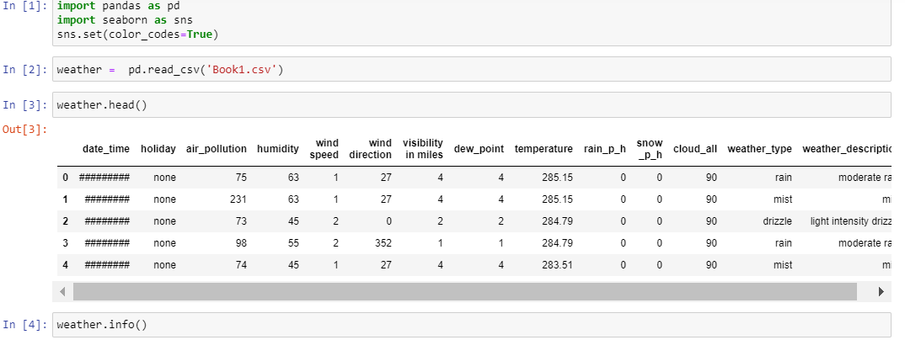

* **Weather.info()** is used to check data/column values and data/column types.

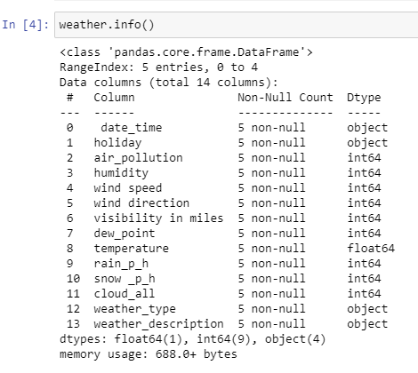

After checking of all info about dataset. we make plot of dataset in csv format.

* **In seaborn, we have a different function:**
* First is univaried function is **barplot/histogram.**So according to our dataset:
* ***sns.barplot(weather['humidity'],weather['temperature'])***

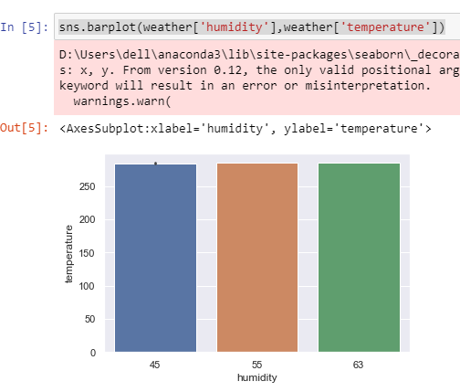

* Then is **displot function** which is used to show a single column detail.
* ***sns.displot(weather['humidity'])***

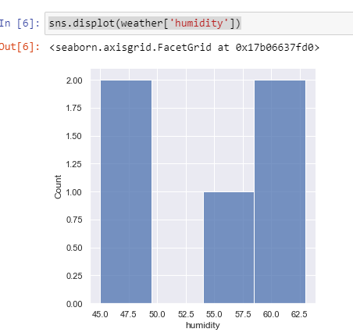

* **Jointplot function**
* ***sns.jointplot(weather['humidity'],weather['temperature'])***
* 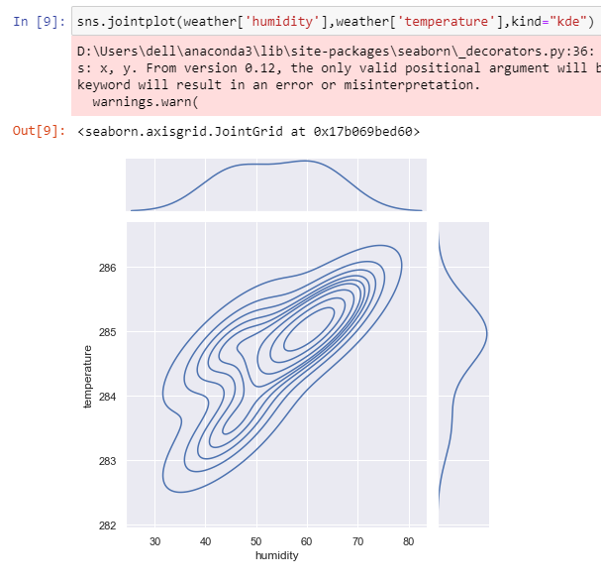
* **Pairplot function**
* ***sns.pairplot(weather[['humidity','temperature','air_pollution' ]])***

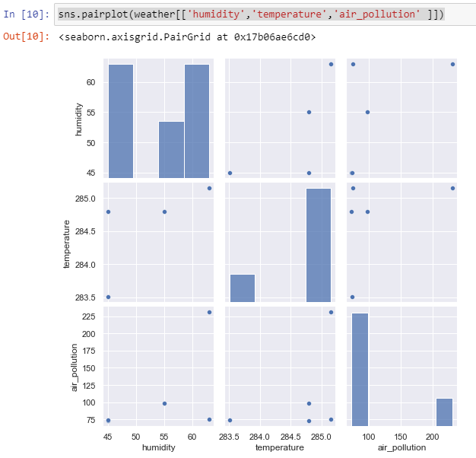

* **Stripplot function**
* ***sns.stripplot(weather['weather_type'],weather['temperature'])***

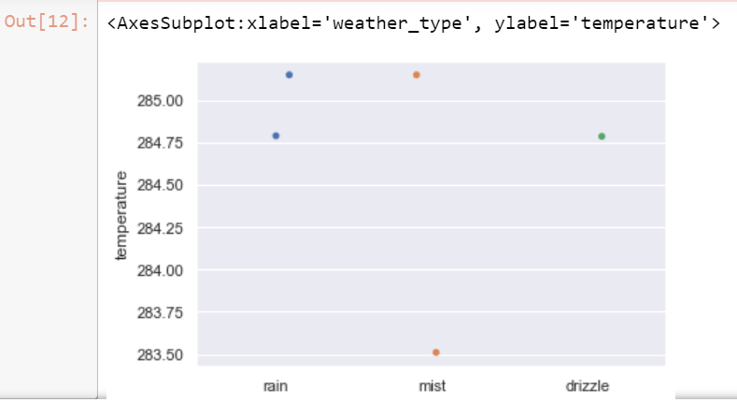

* **Boxplot**(hue is used which show a weather_type that will visualise a dataset).
* ***sns.boxplot(weather['humidity'],weather['temperature'],hue-weather['weather_type'])***

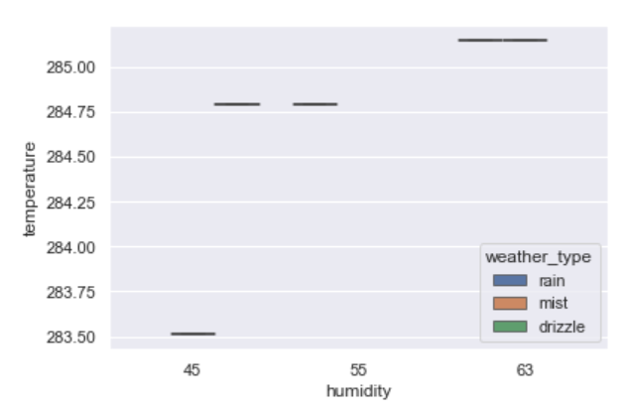

* **Countplot** is used to show a type of weather.
* ***sns.countplot(weather['weather_type'])***

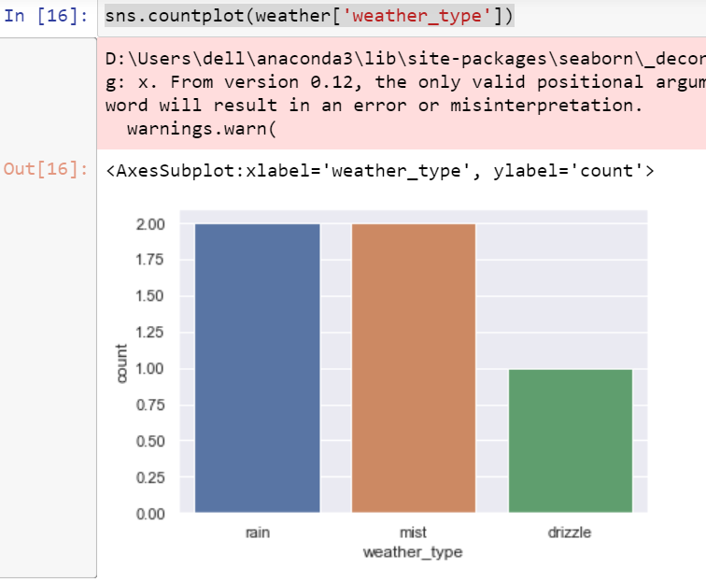

* **Implot** is used to show a linear equation.it is a widely used function to quickly plot a linear relationship between two variables.
* ***sns.lmplot(x="humidity",y="temperature", data=weather)***

