Executive Summary
Growth Potential Modeling for SkyCity Auckland Restaurants & Bars

Why this matters
Expansion funding is more effective when it targets branches that are structurally ready to grow. We assessed 1,696 branches on demand, cost, channel mix and delivery reach and assigned each a Growth Potential Score (0-100), an archetype and a recommended action.

Key findings
- 24% of branches are loss-making overall. They are almost all full-service restaurants, whose cost base (about 87% of revenue) is structurally too high.
- Third-party platforms are nearly margin-free: Uber Eats and DoorDash return about 0.8% net margin versus 27% in store and 23% on self-delivery. About 32% of branches lose money on each platform.
- Only 560 branches (33%) are ready for investment now (Optimize); 508 need channel rebalancing and 628 should hold and stabilise.
- The Auckland CBD is the only subregion with a contracting growth factor (0.99); the other subregions grow 3-5% per month in the data.

Six branch archetypes
Archetype | Restaurants | GPI | Net margin | Policy stance
Scalable Self-Delivery Leaders | 215 | 71.0 | 20.8% | Invest and scale
Stable Local Performers | 250 | 65.8 | 17.5% | Invest selectively
Aggregator-Dependent Low Margin | 368 | 46.2 | 15.1% | Rebalance channels
Operationally Strong, Under-Scaled | 405 | 45.1 | 14.6% | Rebalance, then scale
High-Growth / High-Risk | 199 | 37.1 | -5.1% | Fix costs first
Overextended, Low Return | 259 | 34.7 | -6.2% | Stabilise or restructure

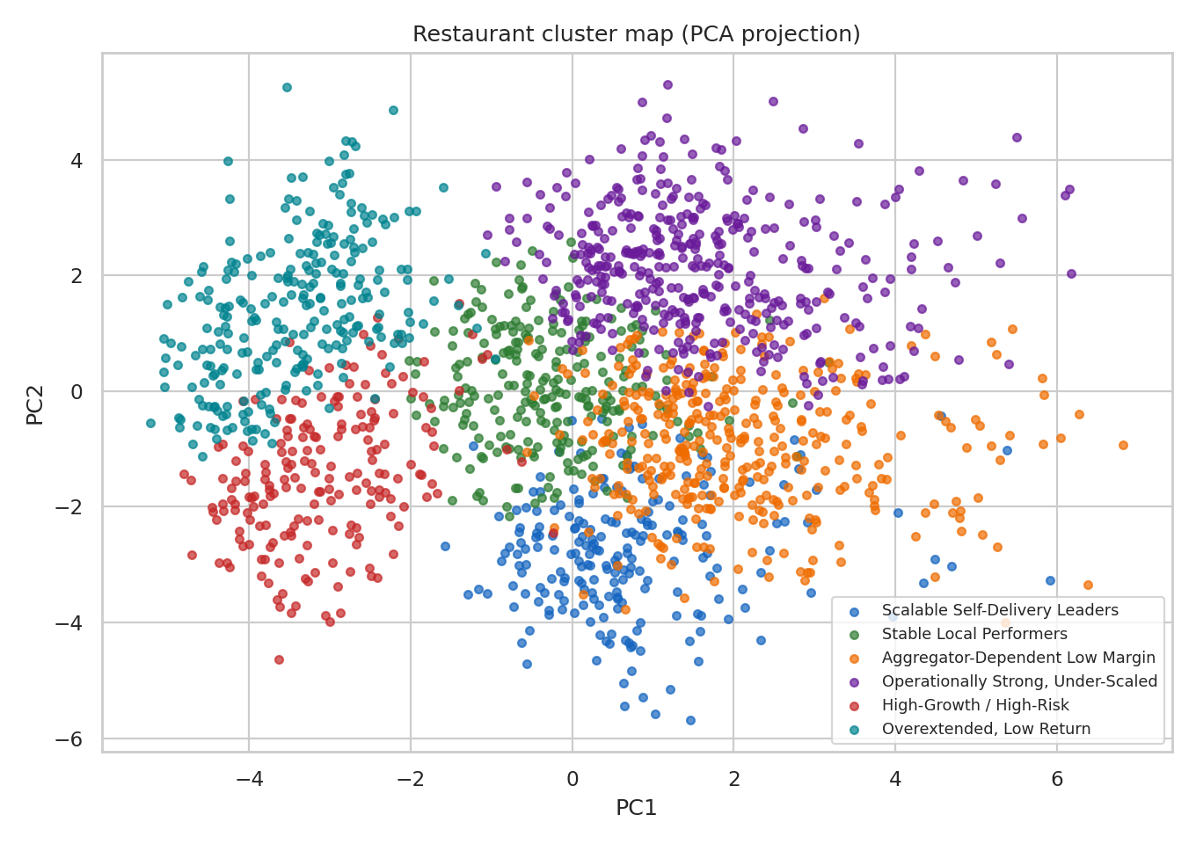
Branches projected into two dimensions and coloured by archetype.

Recommendations for stakeholders
- Direct growth capital to branches flagged Optimize, led by the Scalable Self-Delivery Leaders and Stable Local Performers.
- Support channel rebalancing: encourage direct and self-delivery ordering and commission renegotiation for aggregator-heavy branches.
- Pause expansion support for loss-making full-service branches until cost ratios are corrected.
- Use defensive rather than expansion measures in the CBD.
- Refresh the scoring monthly using time-series data to measure growth momentum and cost stability directly.

Caveat
Results come from a single monthly snapshot and expert-set scoring weights. Archetypes overlap, so the continuous score should guide ranking and the archetype should guide the type of action.

