Restaurant Growth Potential Modeling & Strategic Classification System
SkyCity Auckland Restaurants & Bars | Unified Mentor Internship Program | Research Paper
Author: Rimsha Naaz

Abstract
Expansion decisions across 1,696 SkyCity Auckland restaurant branches are usually uniform and intuition-based. This study builds a growth-readiness lens from 19 engineered features covering demand, channel mix, cost structure and logistics. After skew correction and scaling, PCA compressed the data to 6 components (90.5% of variance). K-Means with k = 6 produced six interpretable archetypes, validated against hierarchical clustering (ARI 0.62). A transparent Growth Potential Index (GPI, 0-100) scores every branch, and a rule layer assigns one of three actions: Optimize, Rebalance channels, or Hold / Stabilize. The strongest archetype is Scalable Self-Delivery Leaders (mean GPI 71.0); two archetypes, both dominated by full-service restaurants, lose money on average.

1. Introduction and problem statement
Not every restaurant should follow the same growth path. Some are aggregator-ready but margin fragile, some operationally strong but under-scaled, and some overextended. Conventional analytics describe what happened or what is optimal now. This project asks which restaurants are structurally positioned for sustainable growth, how they should be classified, and which levers matter most.

2. Data
The dataset has 1,696 branches and 30 fields: identity (cuisine, segment, subregion), demand (orders, AOV, growth factor), channel orders, revenues and net profits for in-store, Uber Eats, DoorDash and self-delivery, cost rates, commission, and delivery logistics.
Data quality checks performed:
- No missing values and no duplicate branches; RestaurantID is unique.
- Channel order counts sum exactly to MonthlyOrders for every row.
- Channel net profits reproduce Revenue x (1 - COGS - OPEX [- Commission]) and self-delivery cost equals orders x cost per order, within rounding.
- The supplied InStoreShare column deviates from InStoreOrders / MonthlyOrders by up to 0.20 (correlation 0.995), so shares were recomputed from order counts. The supplied UE, DD and SD shares match delivery-order shares.
- Column names in the file differ slightly from the brief (for example InStoreOrders instead of InStoreOrdersCount, DeliveryCostPerOrder instead of DeliveryCostOrder).
- GrowthFactor takes only four values and is fully determined by subregion (see Section 4). It carries location information rather than branch-level momentum.

3. Methodology

3.1 Feature engineering and KPIs
KPI / feature | Definition used
Scale | MonthlyOrders x GrowthFactor
Cost Discipline | 1 - (COGSRate + OPEXRate); cross-sectional, so level stands in for stability
Aggregator Dependence | (UberEats + DoorDash orders) / MonthlyOrders
Expansion Headroom | DeliveryRadiusKM per 100 delivery orders
Revenue Quality | AOV x NetMargin x margin consistency, where consistency = 1 / (1 + std of the four channel margins)
Channel Balance | Normalized Shannon entropy of the four channel order shares
Net Margin | Total net profit / total revenue across channels

3.2 Preprocessing
- Log transform on heavily skewed variables (scale, revenue, headroom, revenue quality, delivery cost ratio), then Yeo-Johnson power transform and standardization to remove multi-scale dominance.
- One-hot encoding of segment, cuisine and subregion, down-weighted to 0.35 so that categories inform but do not dominate the geometry.

3.3 Dimensionality reduction and clustering
PCA retained the components needed for 90% of variance (6 components). K-Means (20-30 restarts, fixed seed), Ward hierarchical clustering and DBSCAN (eps from the 90th percentile of k-distance) were run on the PCA scores. Archetype names were assigned by matching each cluster centroid to a signed feature profile for each archetype using optimal one-to-one assignment, so labels are reproducible rather than hand-picked.

3.4 Growth Potential Index
Component | Inputs (percentile-ranked)
Growth signal (30%) | Scale, GrowthFactor, AOV
Cost resilience (30%) | Net margin, 1 - cost burden, 1 - commission drag, revenue quality
Channel balance (20%) | Channel entropy, 1 - aggregator dependence, aggregator margin
Logistics scalability (20%) | Self-delivery margin, expansion headroom, 1 - delivery cost ratio, radius

The weighted sum is min-max scaled to 0-100. Weights are configurable in src/config.py.

3.5 Recommendation rules
- Optimize: GPI in the top third.
- Rebalance channels: GPI below the top third and either aggregator dependence in the top third or channel balance as the weakest GPI component.
- Hold / Stabilize: everything else.

4. Exploratory data analysis
Channel economics are the starkest pattern. In-store net margin is 26.8% and self-delivery 22.9%, while Uber Eats (0.8%) and DoorDash (0.9%) earn almost nothing after a roughly 30% commission. 32% of branches lose money on Uber Eats and 32% on DoorDash, versus 5% on self-delivery and none in store.
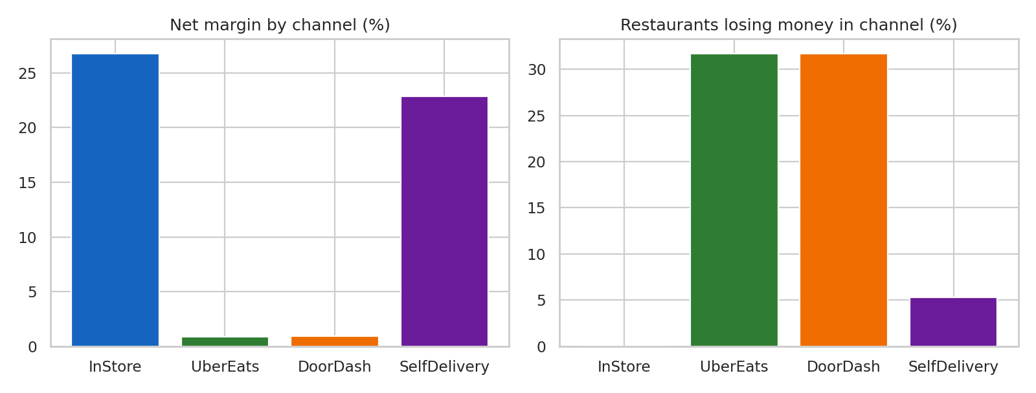
Figure 1. Channel margin and share of branches with a negative channel profit.
Cost structure is determined by segment. Full-service branches carry a mean COGS + OPEX rate of 87.5% and a mean net margin of -5.9%, whereas ghost kitchens run at 54.7% with a 22.0% margin.
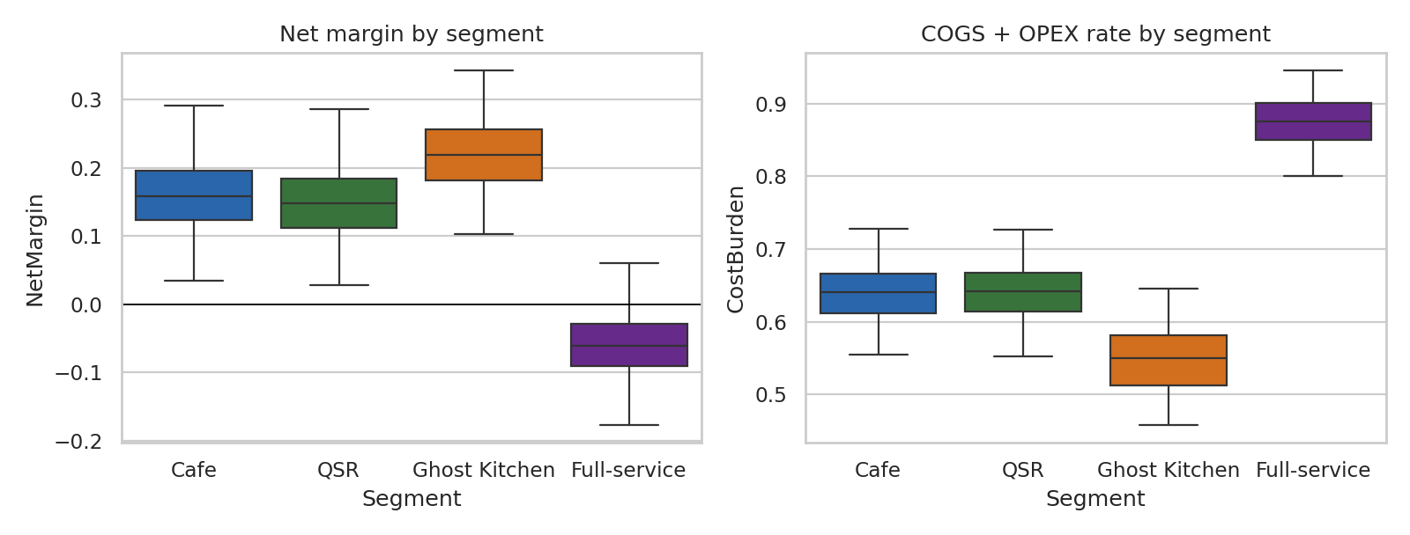
Figure 2. Net margin and cost burden by segment.
GrowthFactor equals 0.99 in the CBD, 1.03 on the North Shore, 1.04 in West Auckland and 1.05 in South Auckland for every branch, so the CBD is the only contracting area.
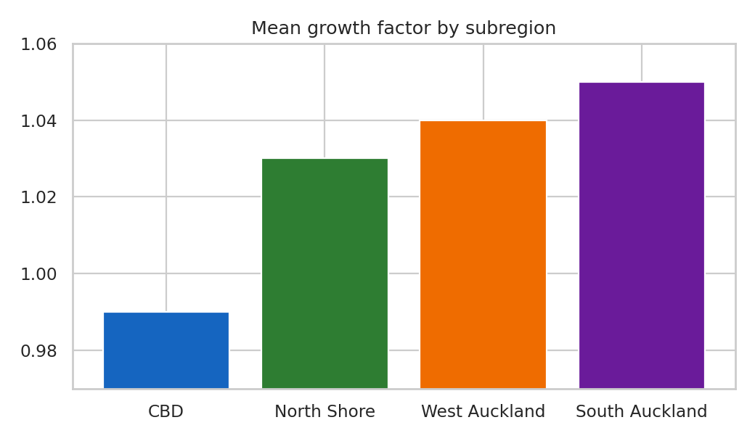
Figure 3. Growth factor is constant within each subregion.

5. Results

5.1 Latent structure (PCA)
The first three components explain 68.6% of variance. PC1 (30.6%) is a cost pressure / profitability axis (cost burden against self-delivery margin, aggregator margin, net margin). PC2 is a logistics reach axis (delivery radius, headroom, delivery cost). PC3 is a channel leverage axis (self-delivery share against aggregator dependence and commission drag). Growth momentum is weak in the latent space because growth is constant within a subregion.
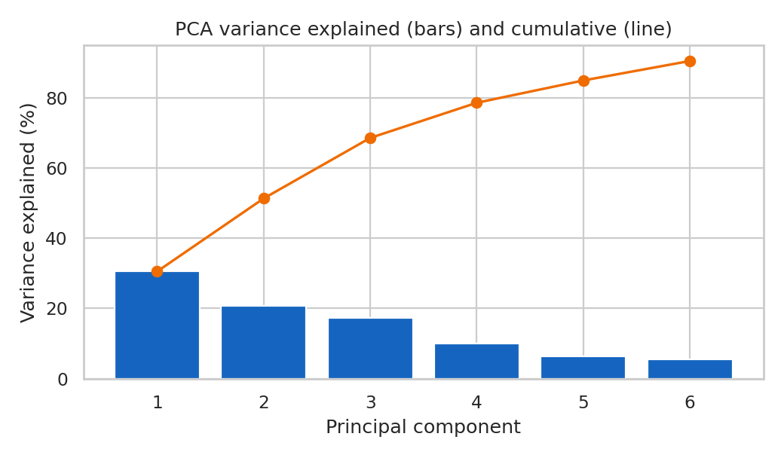
Figure 4. PCA variance explained.
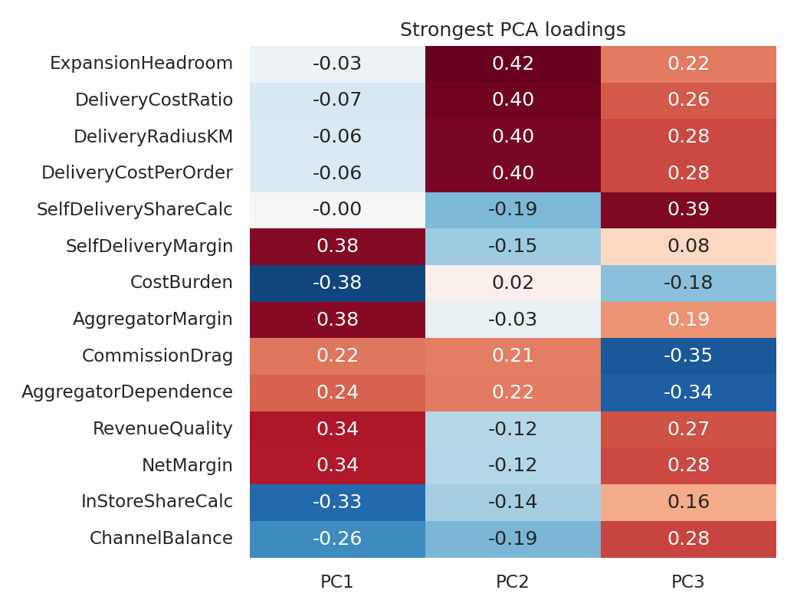
Figure 5. Strongest loadings on PC1-PC3.

5.2 Clustering and validation
Silhouette is highest at k = 3 (0.230) and declines slowly to 0.195 at k = 6. k = 6 was chosen because it is the smallest solution in which the brief's strategic archetypes are all separable (cost level x delivery radius x channel mix), at a modest silhouette cost. K-Means and Ward clustering agree with ARI 0.62. DBSCAN found 1 dense region with 1.0% noise, indicating a continuous cloud rather than isolated islands; the archetypes should therefore be read as strategic segments, not natural species. A random forest recovers the cluster from the features with 96.0% held-out accuracy.
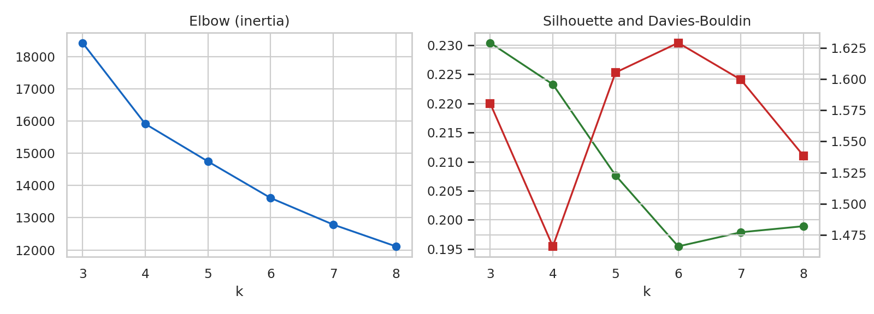
Figure 6. Model selection for k.
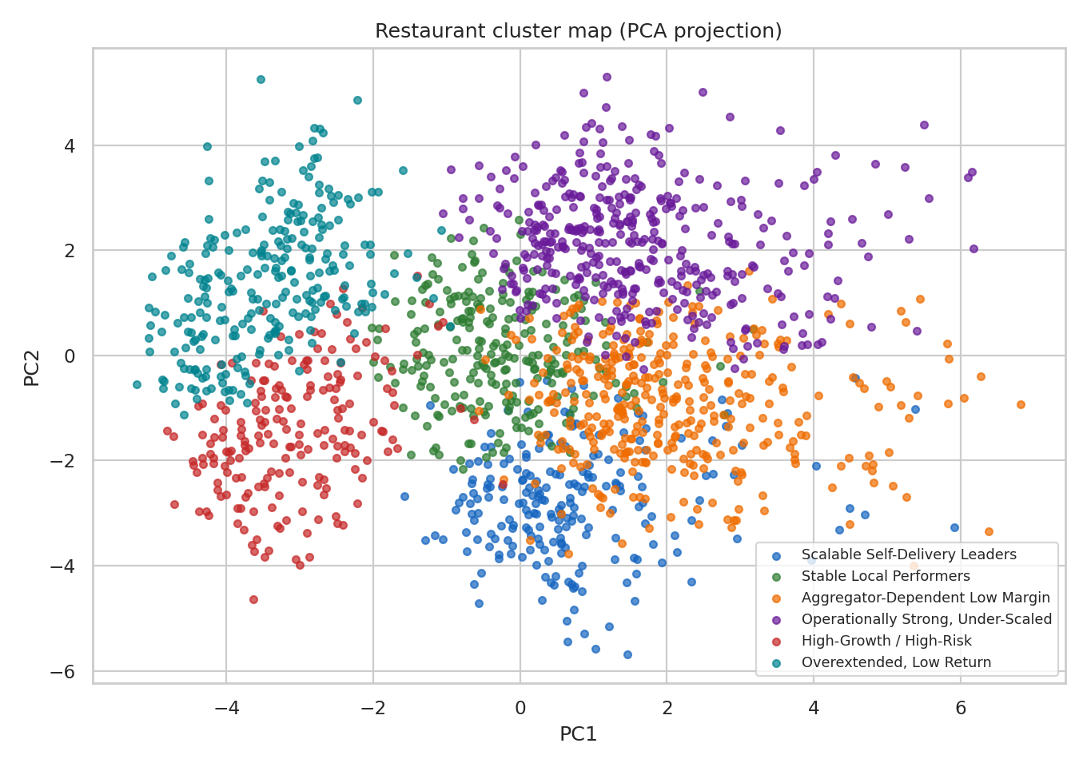
Figure 7. Cluster map in PCA space.

5.3 Archetypes
Archetype | Restaurants | GPI | NetMargin | COGS+OPEX | Aggregator dep. | Radius km
Scalable Self-Delivery Leaders | 215 | 71.0 | 20.8% | 62% | 52% | 6.4
Stable Local Performers | 250 | 65.8 | 17.5% | 64% | 53% | 14.0
Aggregator-Dependent Low Margin | 368 | 46.2 | 15.1% | 62% | 72% | 6.4
Operationally Strong, Under-Scaled | 405 | 45.1 | 14.6% | 62% | 72% | 14.4
High-Growth / High-Risk | 199 | 37.1 | -5.1% | 88% | 56% | 6.5
Overextended, Low Return | 259 | 34.7 | -6.2% | 87% | 57% | 13.9

Loss-making archetypes: High-Growth / High-Risk and Overextended, Low Return together contain 458 branches, almost all full-service, with combined monthly net profit of -1.27M. They differ in reach: the High-Growth / High-Risk group has the highest order scale but a short radius, while the Overextended group pairs a long radius with the same cost burden.
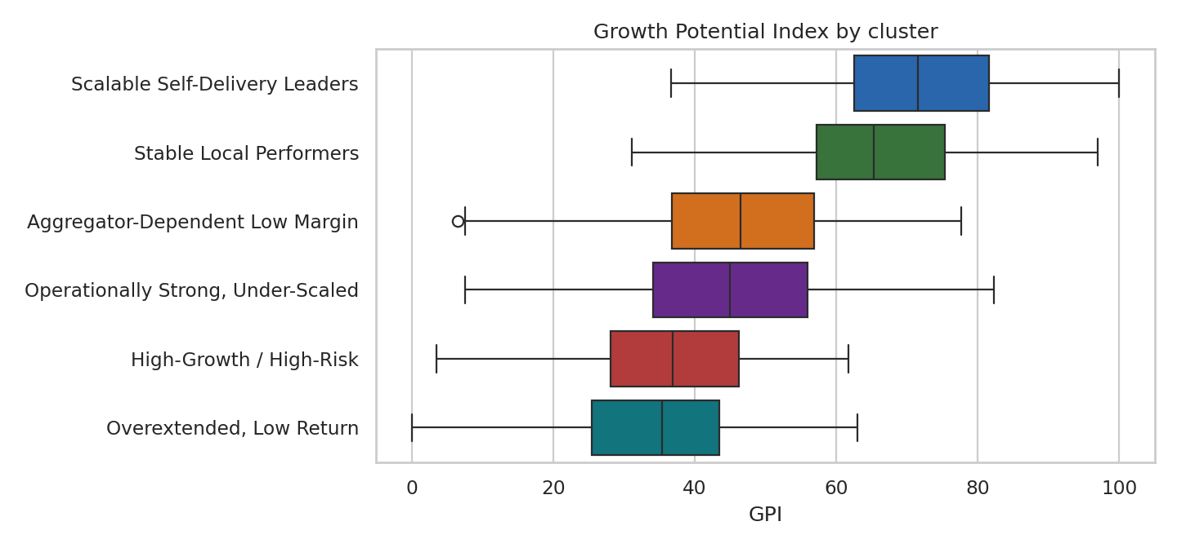
Figure 8. GPI distribution by archetype.
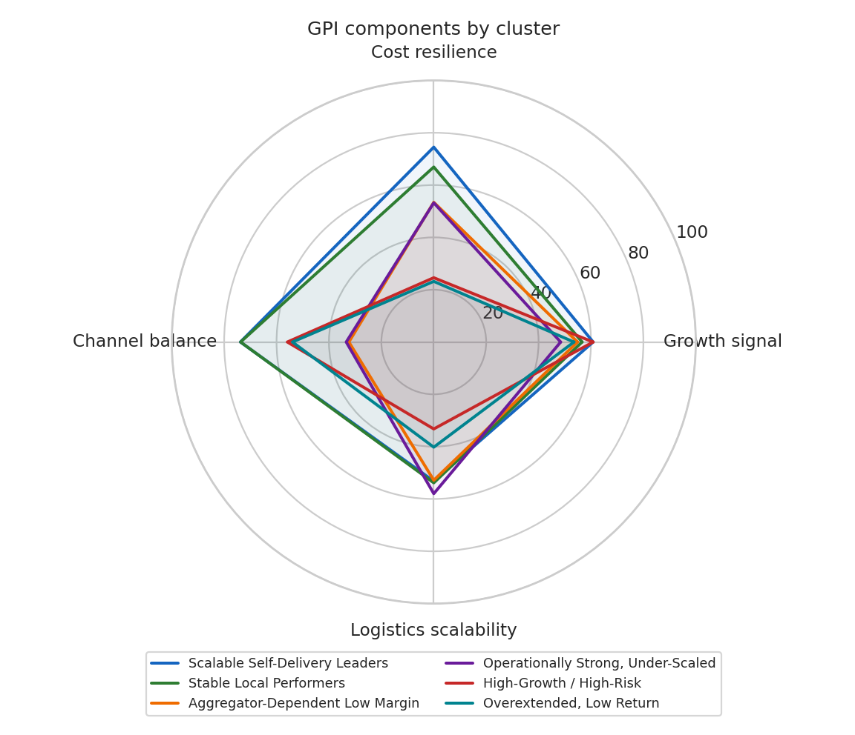
Figure 9. GPI component radar by archetype.

5.4 Strategic classification
Optimize: 560 branches; Rebalance channels: 508; Hold / Stabilize: 628. Optimize branches average a GPI of 70.3 and a net margin of 19.9%.
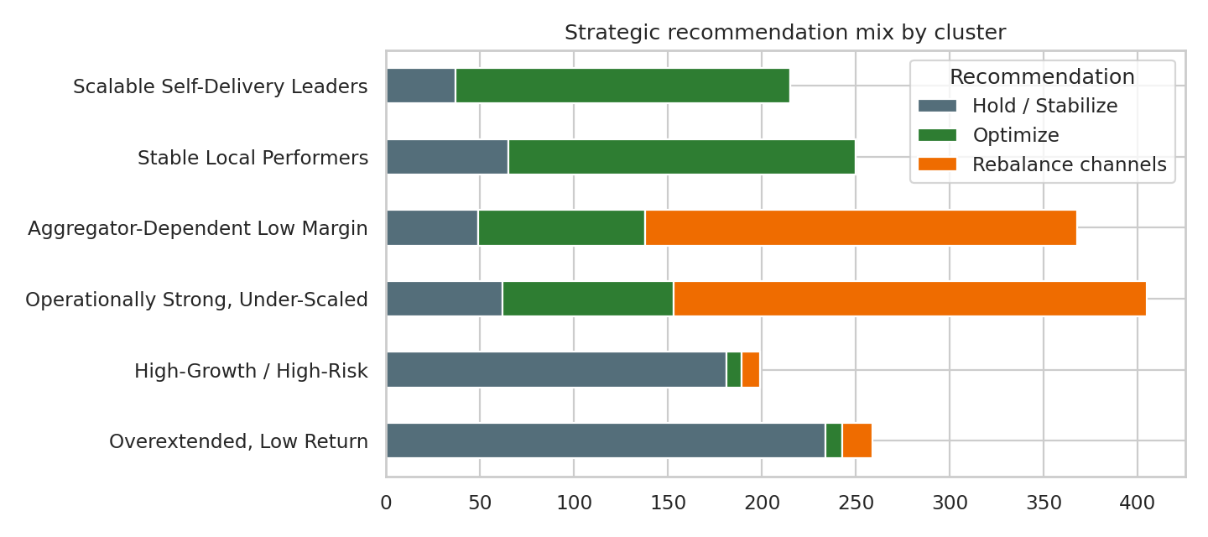
Figure 10. Recommendation mix by archetype.

5.5 Which levers matter most
Ranked by the share of variance that separates the archetypes (eta squared), the strongest levers are SelfDeliveryMargin (0.77), RevenueQuality (0.76), NetMargin (0.73), CostBurden (0.73), AggregatorMargin (0.72). Margin and cost levers dominate because full-service economics split the network in two; channel mix and delivery radius then separate the profitable groups.
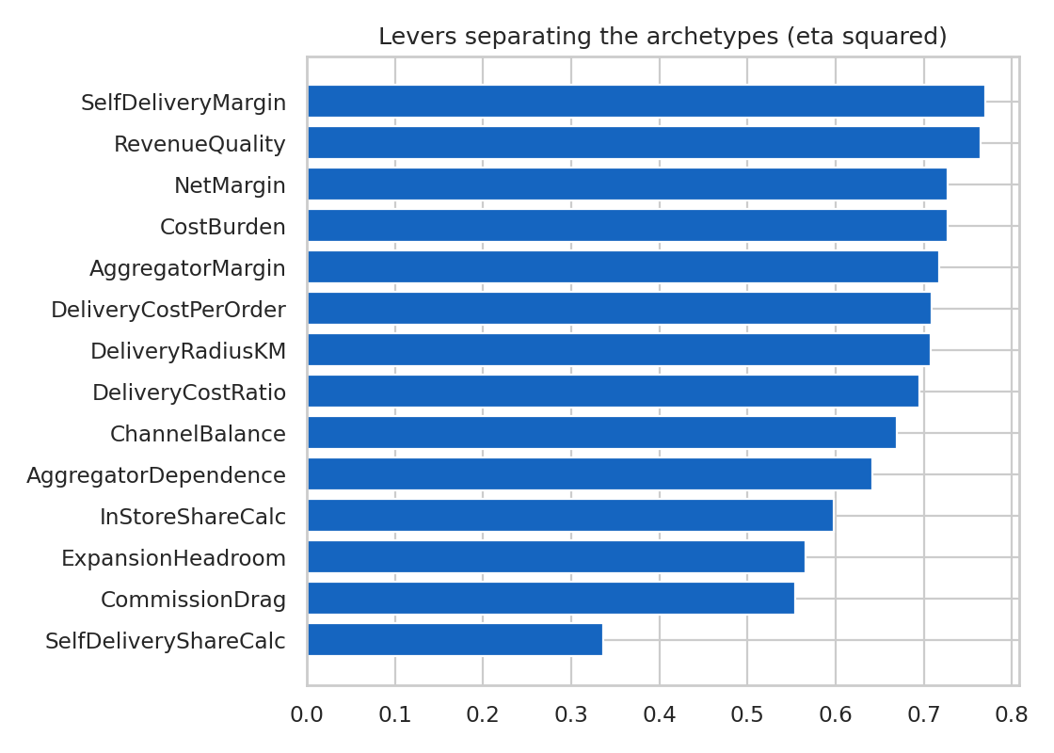
Figure 11. Lever importance.

6. Strategic recommendations
- Scalable Self-Delivery Leaders and Stable Local Performers: prioritise for capital; widen delivery radius selectively and protect margin.
- Aggregator-Dependent Low Margin and Operationally Strong, Under-Scaled: rebalance toward in-store and self-delivery, renegotiate commission, and use marketplaces for acquisition rather than as the primary channel.
- High-Growth / High-Risk and Overextended, Low Return: hold expansion; fix COGS and OPEX before adding volume, because growth multiplies a negative margin.
- CBD: contraction (growth factor 0.99) suggests defensive, not expansion, investment.

7. Limitations
- Single monthly snapshot: cost 'stability' and growth momentum cannot be measured over time; GrowthFactor is constant within subregion.
- Silhouette scores near 0.2 mean clusters overlap; treat labels as segments and use the continuous GPI for ranking.
- GPI weights are expert-set, not estimated against a realised outcome. Sensitivity of rankings to the weights should be tested before capital allocation.
- Aggregator commission is applied uniformly in the source data, so channel economics reflect those assumptions.

8. Conclusion
Growth readiness at SkyCity is driven less by demand than by structure: segment-level cost burden, reliance on low-margin aggregators, and delivery economics. The GPI and archetype framework turns those structural differences into branch-level actions and is delivered as a live Streamlit dashboard.

