RESULTS:

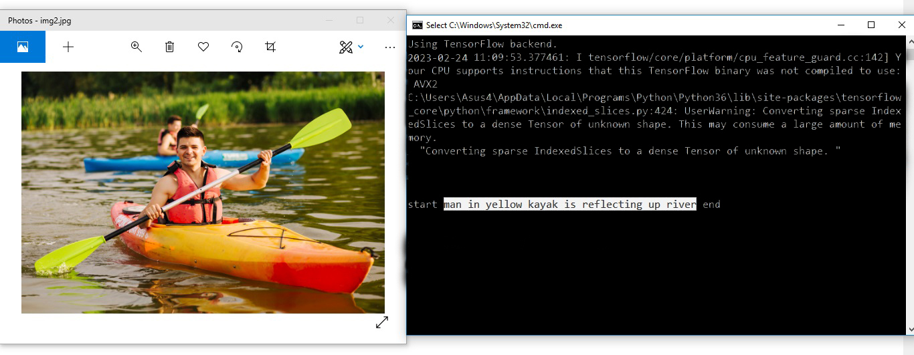

Student No.: 13397087

Student No.: 13397087

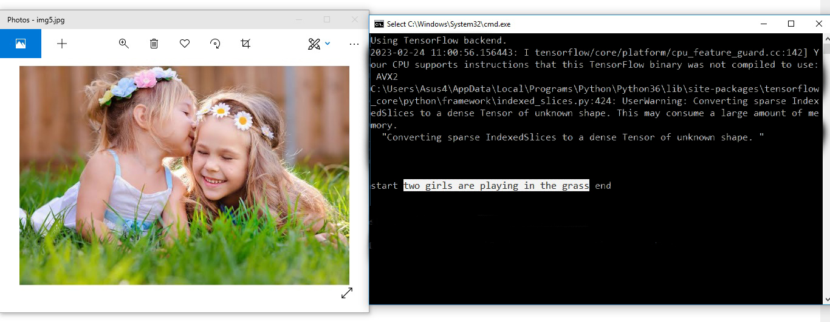

Student No.: 13397087

Student No.: 13397087

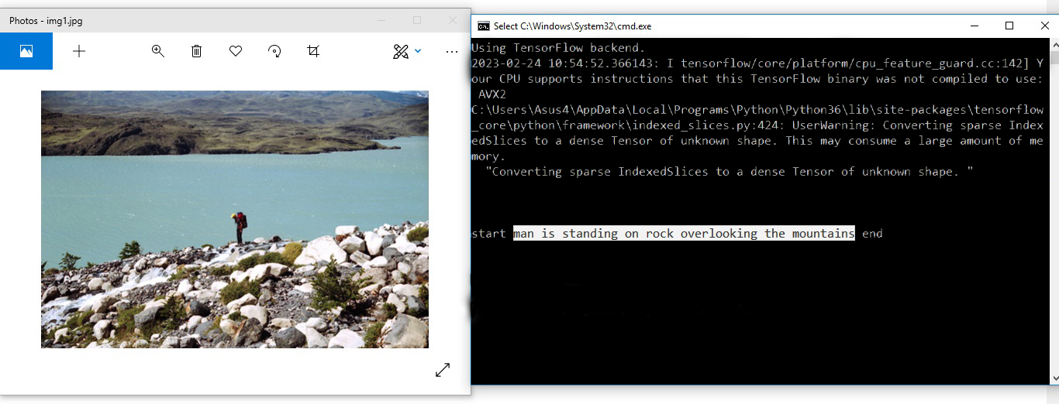

Student No.: 13397087

Student No.: 13397087

Also, on running it for more images we came across some good (original caption matches predicted caption) and bad (original caption does not matches predicted caption) captions as well. For example:

* **Bad captions:**

Student No.: 13397087

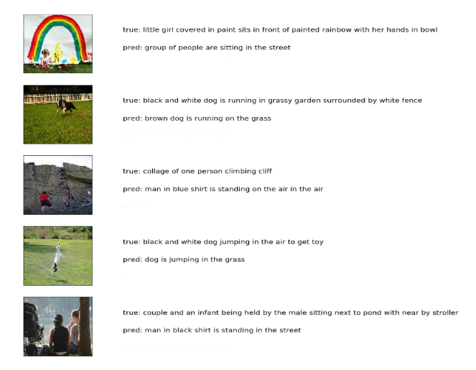

* **Good captions:**

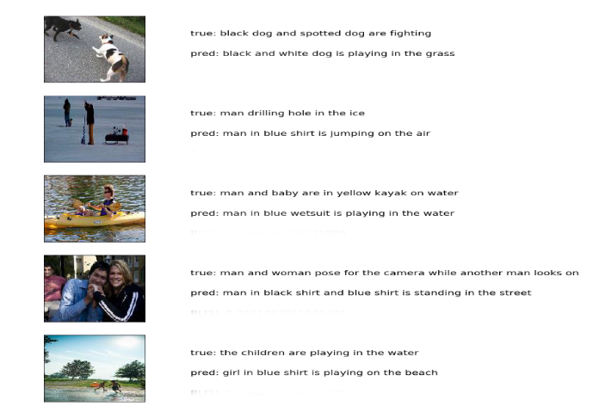

Student No.: 13397087