ANTONINE UNIVERSITY
Faculty of Engineering
Department of Technology in Computer Science
Envision
Student(s) Nataly Fakih, 202311766
Rim Tarhini, 202311535
Major CS
Campus BA
Supervisor(s) Dr. Joseph Costantin
Spring 2025

ACKNOWLEDGMENT
We would like to express our deepest gratitude to all those who have contributed to the successful completion of this Final Year Project.
We extend our sincerest thanks to Dr. Roger Al Achkar, Dean of the Faculty of Engineering, for his leadership and for fostering an academic environment that encourages innovation and excellence.
Our heartfelt appreciation goes to Dr. Charbel Geyamel, Head of Department, for his guidance, support, and the direction he provided throughout our academic journey.
We are especially grateful to our supervisor, Dr. Joseph Constantin, whose invaluable expertise, continuous encouragement, and dedicated mentorship were instrumental in shaping this project from its earliest stages to its final form. His insightful feedback and constructive guidance greatly contributed to the quality of this work.
We also wish to thank all the professors, instructors, and staff of the Faculty of Engineering for their teaching, advice, and support over the course of our studies. Their knowledge and dedication have profoundly influenced our academic and professional development.
Finally, we extend our warmest thanks to our families and friends for their unwavering support, patience, and encouragement throughout this journey. Their belief in us has been a constant source of motivation.

ABSTRACT
Visual impairment is a global public health challenge of significant scale. According to the World Health Organization (WHO), 2.2 billion people worldwide live with some form of vision impairment, among whom 43 million are blind and 295 million suffer from moderate-to-severe impairment [1]. For a large portion of this population, navigating unfamiliar environments independently remains a daily challenge, driving the urgent need for accessible, affordable assistive technology.
Existing assistive tools either rely on expensive dedicated hardware, require constant internet connectivity, or fail to provide real-time, contextually meaningful feedback suited for dynamic navigation scenarios. Most smartphone-based solutions lack sufficient accuracy and responsiveness to be reliably trusted during pedestrian navigation [2] [3].
Envision is a Flutter-based mobile application designed for blind and visually impaired users, leveraging an on-device YOLOv8n (You Only Look Once, version 8 nano) TFLite (TensorFlow Lite) model for real-time object detection combined with a comprehensive voice feedback system and hands-free voice command interaction. The application processes live camera frames entirely on-device, estimates object proximity through bounding box heuristics, and delivers prioritized audio announcements to guide users through their surroundings without requiring an internet connection.
The system was tested across varied real-world environments and lighting conditions, evaluating detection accuracy, latency, and the relevance of voice feedback. A key debugging phase addressed a YUV420-to-RGB (Red, Green, Blue) color space conversion error in the camera pipeline, and confidence thresholds were calibrated to balance sensitivity and false positive suppression.
Following the color space fix, object detection confidence reached 56–64% for common classes such as persons, with the voice service successfully delivering proximity-aware, deduplicated announcements in real time, demonstrating the feasibility of a fully offline, low-latency assistive navigation tool on a standard smartphone.

TABLE OF CONTENTS
Contents
1. Problem Identification (Context and General Problem) 5
2. Problem Statement / Formulation 5
3. Solution Approach / Methodology 6
3.1 Identifying the Opportunity 6
3.2 Developing Requirements 6
3.3 Performing Analysis and Synthesis 7
3.3.1 Model Selection 7
3.3.2 Inference Pipeline Design 7
3.3.3 Image Pre-processing and Data Processing 7
3.3.4 Output Parsing and Non-Maximum Suppression 8
3.3.5 Distance Estimation 8
3.3.6 Voice Feedback Design 8
3.4 Generating Multiple Solutions 8
3.5 Risk Assessment 9
3.6 Trade-off Analysis 9
4. Report Outline 9
1. Introduction 11
2. Project Planning 11
2.1 Team Management 11
2.2 Time Management 11
2.3 Budget 12
3. Project Functional Requirements 12
4. Project Constraints 13
4.1 Technical Constraints 13
4.2 Non-Technical Constraints 13
Accessibility 13
Safety 13
Usability and Cognitive Load 14
Ethical Obligations 14
4.3 Standards, Codes, and Regulations 14
5. Conclusion 14
1. Introduction 16
2. Context and Domain of Application 16
3. Existing Solutions and Methods 16
3.1 Hardware-Based Solutions 16
3.1.1 Smart Canes and Wearable Sensors 16
3.1.2 OrCam MyEye 17
3.2 Smartphone-Based Applications 17
3.2.1 Microsoft Seeing AI 17
3.2.2 Google Lookout 17
3.2.3 Be My Eyes 17
3.2.4 TapTapSee 17
3.3 Related Academic Work 17
3.3.1 Object Recognition App for Visually Impaired (IEEE PuneCon, 2019) 17
3.3.2 Tool for Blind Users with AI Object Detection and Haptic Feedback (MDPI) 18
3.3.3 Development and Evaluation of a Tool for Blind Users with AI Object Detection (2025) 18
3.3.4 Comprehensive Deep Learning Framework for Real-Time Emotion Detection (2025) 18
4. Comparative Study 18
5. Project Objectives 19
6. Conclusion 20
1. Introduction 21
2. Design of the Proposed Solution 21
2.1 Solution Architecture (Project Architecture) 21
2.2 Refined Solution Architecture (System Architecture) 22
3. Design Blocks Description 22
3.1 Camera Input Block 22
3.2 Background Isolate and Concurrency Block 23
3.3 Image Pre-processing and Data Processing Block 23
3.4 Inference Block 24
3.5 Post-Processing Block 24
3.6 Distance Estimation Block 25
3.7 Voice Feedback Block (VoiceService) 25
3.8 Voice Command Block (STT) 26
4. Conclusion 26
1. Introduction 28
2. Hardware Development and Implementation 28
2.1 Input Block 28
2.2 Processing Block 28
2.3 Communication Block 28
3. Software Development and Implementation 28
3.1 Database Structure 28
3.2 Software Functionalities 28
4. Conclusion 29
1. Introduction 30
2. Prototype / Application 30
3. System Tests / Simulations / Experiments 30
3.1 Test 1: Object Detection Accuracy 30
3.1.1 Test Description 30
3.1.2 Test Scenario 30
3.1.3 Test Result 30
3.1.4 Test Interpretation 30
3.1.5 Discussion 30
3.2 Test 2: Inference Latency 30
3.2.1 Test Description 30
3.2.2 Test Scenario 31
3.2.3 Test Result 31
3.2.4 Test Interpretation 31
3.2.5 Discussion 31
3.3 Test 3: Distance Estimation Accuracy 31
3.3.1 Test Description 31
3.3.2 Test Scenario 31
3.3.3 Test Result 31
3.3.4 Test Interpretation 31
3.3.5 Discussion 31
3.4 Test 4: Voice Feedback Quality and Cooldown Behavior 31
3.4.1 Test Description 31
3.4.2 Test Scenario 31
3.4.3 Test Result 31
3.4.4 Test Interpretation 31
3.4.5 Discussion 32
4. Impact of the Proposed Solution 32
5. Conclusion 32
1. Report Summary 33
2. Future Work and Perspectives 33

CHAPTER I: GENERAL INTRODUCTION
This chapter introduces the Envision project by establishing its context, identifying the problem it addresses, describing the proposed solution approach, and outlining the structure of this report. By the end of this chapter, the reader will have a clear understanding of the motivation behind the project, the specific engineering challenges it tackles, and the methodology followed to develop, implement, and validate the solution.

1. Problem Identification (Context and General Problem)
Vision impairment represents one of the most pervasive and underaddressed disability challenges of our time. According to the World Health Organization (WHO), 2.2 billion people worldwide live with some form of vision impairment, among whom 43 million are completely blind and 295 million suffer from moderate-to-severe impairment [1]. Despite these staggering numbers, the assistive technology landscape has remained largely inaccessible — dominated by expensive dedicated hardware or cloud-dependent solutions that exclude the very population they aim to serve.
The application domain of this project sits at the intersection of mobile computing, computer vision, and human-computer interaction (HCI), with a specific focus on accessibility engineering. As smartphones have become powerful enough to run machine learning (ML) models locally, a genuine opportunity has emerged to deliver real-time assistive intelligence to visually impaired users at near-zero hardware cost [4].
Envision addresses this opportunity by developing a Flutter-based mobile application that processes live camera input on-device to assist blind users in understanding their surroundings. The problem, however, is far from trivial. It spans multiple interconnected technical sub-problems: efficient real-time object detection under mobile hardware constraints, accurate color space conversion from camera-native YUV420 format to RGB for model inference, low-latency voice feedback that is meaningful without being overwhelming, and hands-free voice command interaction for on-demand queries — all functioning simultaneously without internet connectivity.
Each of these components introduces competing technical demands. Increasing detection accuracy tends to increase latency; improving frame resolution strains memory and processing budgets; voice announcements must be frequent enough to be useful yet sparse enough to avoid cognitive overload. These trade-offs, combined with the safety-critical nature of navigation assistance and the diversity of the target user base, make Envision a genuinely complex engineering problem that demands careful design, rigorous testing, and disciplined iteration across software, machine learning, and user experience dimensions [2] [3].

2. Problem Statement / Formulation
Visually impaired and blind individuals face significant barriers in independently navigating unfamiliar environments, identifying surrounding objects, and receiving timely audio-based feedback about their immediate surroundings — challenges that directly impact their autonomy, safety, and quality of life. While assistive technologies exist, they are largely unaffordable, cloud-dependent, or limited in scope, leaving the majority of the 2.2 billion people affected by vision impairment [1] without a practical, real-time solution.
The primary objective of this project is to develop Envision, a fully offline mobile application that provides blind and visually impaired users with real-time audio-based awareness of their surroundings through on-device object detection combined with distance estimation and hands-free voice interaction — all processed on-device without any internet dependency.
This project is directly relevant to blind and visually impaired individuals as its primary beneficiaries, as well as their caregivers, families, and accessibility-focused organizations who support independent living. It applies in everyday use cases including pedestrian navigation, indoor orientation, and object identification, and aligns with the broader goals of assistive technology developers, healthcare institutions, and NGOs working toward disability inclusion. The solution is deployable on any Android or iOS smartphone through Flutter's cross-platform framework [15], making it accessible to a wide range of users across both developed and developing regions where specialized hardware is not a viable option.

3. Solution Approach / Methodology
The development of Envision followed a structured engineering design process, progressing from opportunity identification through requirement definition, analysis, solution generation, risk assessment, and deliberate trade-off resolution.

3.1 Identifying the Opportunity
The project addresses a critical accessibility gap faced by visually impaired individuals, who currently lack affordable, real-time, and hands-free tools to navigate their surroundings safely. Through stakeholder analysis, it was established that conventional screen readers do not interpret the physical environment, and dedicated hardware alternatives such as sensor-equipped smart canes remain costly and non-portable [8] [9]. This identified the core opportunity: a smartphone-based assistive application capable of continuously perceiving and communicating the surrounding environment to the user through voice, running entirely on-device with no internet dependency.

3.2 Developing Requirements
From the identified opportunity, the following functional and non-functional requirements were derived:
- Real-time detection: The system must process live camera frames at sufficient speed to support navigation, targeting near real-time performance with minimal perceptible lag.
- Audio feedback: Detected objects must be announced verbally with distance context, without overwhelming the user with excessive speech.
- Voice interaction: The user must be able to query the system entirely hands-free using natural language commands such as “What’s in front of me?” or “How many chairs are there?”
- On-device operation: The solution must function without internet connectivity, on a standard Android or iOS smartphone, within acceptable battery and memory consumption limits.

3.3 Performing Analysis and Synthesis

3.3.1 Model Selection
A key design decision involved the choice of object detection model. Three candidate architectures were evaluated against the criteria of accuracy, inference speed, and on-device feasibility, as summarized in Table 1.

Model | Accuracy | Speed | On-device Feasibility
SSD MobileNet | Low–Medium | Fast | Yes
YOLOv5 | Medium | Medium | Partial
YOLOv8n (TFLite) | High | Medium–Fast | Yes
Table 1 Comparison of candidate object detection models
YOLOv8n was selected for its favorable accuracy-speed trade-off and its native exportability to TensorFlow Lite format, enabling fully on-device inference [7]. The model accepts 640×640 pixel inputs and produces 8,400 candidate bounding boxes across 80 COCO (Common Objects in Context) object classes per frame.

3.3.2 Inference Pipeline Design
To preserve UI (User Interface) responsiveness during inference, the detection pipeline is offloaded to a dedicated background Dart isolate implemented in detector.dart. Raw camera frames are passed from the main UI thread via SendPort/ReceivePort message channels, and structured detection results are returned asynchronously. This concurrency model ensures that heavy computation does not cause frame drops or UI freezes.

3.3.3 Image Pre-processing and Data Processing
Raw camera frames, captured in YUV420 (Luminance-Chrominance) format on Android and BGRA (Blue, Green, Red, Alpha) on iOS, undergo a multi-stage pre-processing pipeline before being fed to the model. Frames are first converted to RGB, then rotated according to the device sensor orientation. A letterbox resize algorithm scales the frame to 640×640 while preserving the original aspect ratio through black-pixel padding, preventing geometric distortion of detected objects. Pixel values are normalized to the [0.0, 1.0] range by multiplying by (1/255), and a pre-allocated Float32List buffer is reused across frames to eliminate per-frame memory allocation overhead. A critical color space conversion bug in the base repository [14] was identified and corrected at this stage (detailed in Chapter IV, Section 3.3).

3.3.4 Output Parsing and Non-Maximum Suppression
The model outputs a [84 × 8400] tensor per frame, containing four bounding box coordinates and 80 class confidence scores per candidate detection. Post-processing proceeds in four numbered steps:
- Confidence thresholding: A threshold of 0.35 filters low-quality detections.
- Sigmoid activation (conditional): Applied only when class scores are detected to be raw logits, with result cached after the first frame.
- Bounding box remapping: Coordinates are remapped from letterbox space back to original image space using stored padding offsets.
- NMS (Non-Maximum Suppression): An IoU (Intersection over Union) threshold of 0.45 suppresses duplicate detections by retaining the highest-confidence box and discarding all overlapping candidates.

3.3.5 Distance Estimation
Object distance is estimated using the pinhole camera model [17], applying the relationship: distance = (HᴿᵉᵃᲬ × f) / Hₚᵢᵮᵉᵌ, where HᴿᵉᵃᲬ is the known real-world height of the object class, f is the focal length in pixels (approximated at 500 px), and Hₚᵢᵮᵉᵌ is the bounding box height in pixels. Estimated distances are then categorized into four human-readable ranges: very close (< 1 m), close (< 2.5 m), ahead (< 5 m), and far ahead (≥ 5 m).

3.3.6 Voice Feedback Design
A cooldown mechanism suppresses re-announcement of the same object-distance pair within a 3-second window to prevent audio overload. A single-pending-message queue discards stale announcements when the TTS (Text-to-Speech) engine is busy, ensuring only the most recent detection is communicated. Speech-to-text (STT) input is paused during TTS output to eliminate microphone feedback loops.

3.4 Generating Multiple Solutions
Three interaction modes were considered and evaluated, as described in Table 2.

Mode | Description | Trade-off
Live camera + continuous TTS | Real-time frame-by-frame announcements | High utility, risk of audio overload
Photo analysis | User captures or selects a photo for static analysis | Lower cognitive load, not real-time
Voice command only | User manually triggers queries | Non-intrusive but purely reactive
Table 2 Comparison of candidate interaction modes
The final design integrates all three modes. The live camera mode provides proactive continuous announcements, voice commands allow on-demand queries, and photo analysis serves as a fallback for low-confidence or low-resource scenarios.

3.5 Risk Assessment
The principal risks identified during the design phase and their corresponding mitigations are presented in Table 3.

Table 3: Risk assessment and mitigation strategies
Risk | Mitigation
Inference latency causing UI freeze | Background isolate decouples inference from the UI thread
False detections misleading the user | Confidence threshold (0.35) and NMS filter unreliable results
Audio overload from repeated announcements | Per-label cooldown (3 s) and single-pending-message queue
Distance estimation inaccuracy | Categorical output abstracts over metric imprecision
STT capturing TTS output | TTS is halted before STT begins; queue is cleared during listening
App crash on camera permission denial | Graceful fallback with permanent-denial detection
Table 3 Risk assessment and mitigation strategies

3.6 Trade-off Analysis
Several competing engineering concerns required deliberate resolution:
- Accuracy vs. speed: YOLOv8n at 640×640 was preferred over lighter architectures such as SSD MobileNet to maximize detection quality. Hardware acceleration delegates — specifically XNNPack on Android and GPU on iOS — offset the additional inference cost.
- Proactive vs. reactive feedback: Continuous announcements improve navigational safety but risk cognitive overload. The cooldown mechanism and message queue represent the engineering balance between these two competing needs.
- Distance precision vs. usability: A continuous metric output (e.g., "2.3 metres") was evaluated and rejected in favour of categorical labels, as precise numerical distances add cognitive load without improving practical navigational utility for the target user
- On-device vs. cloud inference: Cloud-based inference was rejected despite its potential accuracy gains, as it introduces latency, requires connectivity, and raises user privacy concerns. On-device processing was retained as a hard requirement throughout the design.

4. Report Outline
The remainder of this report is organized as follows. Chapter II defines the functional requirements and constraints of the project, covering team management, project planning, technical and non-technical constraints, and applicable standards. Chapter III surveys the existing solutions and related works in the domain of assistive technology and mobile computer vision, leading to a comparative study that motivates the design choices made in this project. Chapter IV presents the proposed solution architecture and the design of its constituent components. Chapter V details the development and implementation of both the software pipeline and the machine learning inference engine. Chapter VI presents the experimental results, including detection accuracy, latency measurements, and voice feedback evaluation. Finally, Chapter VII concludes the report with a summary of contributions and a discussion of future work and perspectives.

CHAPTER II: PROJECT REQUIREMENTS AND CONSTRAINTS

1. Introduction
This chapter outlines the planning, requirements, and constraints that governed the development of the Envision project. It begins with a description of the project planning process, covering team organization, timeline management, and budget considerations. It then defines the functional requirements that the system must fulfill to be considered successful, followed by an analysis of the technical and non-technical constraints that shaped design decisions. Finally, the applicable standards, regulations, and ethical guidelines relevant to the project are identified and discussed. Together, these elements establish the engineering boundaries within which the Envision system was designed, implemented, and evaluated.

2. Project Planning

2.1 Team Management
The Envision project was carried out by a two-member team: Nataly Fakih and Rim Tarhini, both students in the Computer Science program at the Faculty of Engineering, Antonine University. The team adopted a fully collaborative approach in which both members contributed actively and equally to all aspects of the project, including the machine learning pipeline, Flutter application development, voice feedback system, and system testing. This approach ensured that both members maintained a comprehensive understanding of the system at every stage and enabled continuous peer review throughout the development cycle.
Regular coordination meetings were held to synchronize progress, resolve technical blockers, and align on design decisions. Version control was managed through a shared GitHub repository, enabling parallel contributions and full traceability of changes across the development lifecycle.

2.2 Time Management
The project was conducted entirely during the Spring 2025 semester. The timeline was structured into seven sequential phases, each targeting a specific set of deliverables, as described below and illustrated in the Gantt chart provided in Figure 1.
- Phase 1: Research and Analysis (Weeks 1–2): Review of existing assistive technologies, study of object detection architectures, and definition of functional requirements.
- Phase 2 — System Design (Weeks 3–4): Design of the overall application architecture, selection of the YOLOv8n TFLite model, and planning of the inference and voice feedback pipelines.
- Phase 3 — Initial Prototyping (Weeks 5–6): Development of the core Flutter application structure, integration of the TFLite model, and implementation of basic live object detection with bounding box rendering.
- Phase 4 — Feature Development (Weeks 7–10): Implementation of the voice feedback service, speech-to-text interaction, and static photo analysis mode.
- Phase 5 — Debugging and Optimization (Weeks 11–12): Resolution of the YUV420-to-RGB color space conversion bug, inference pipeline optimization, confidence threshold calibration, and performance tuning.
- Phase 6 — Testing and Evaluation (Weeks 13–14): Systematic testing across varied environments and lighting conditions, evaluation of detection accuracy, latency, and voice feedback quality.
- Phase 7 — Documentation and Finalization (Weeks 15–16): Report writing, results analysis, and final project submission.

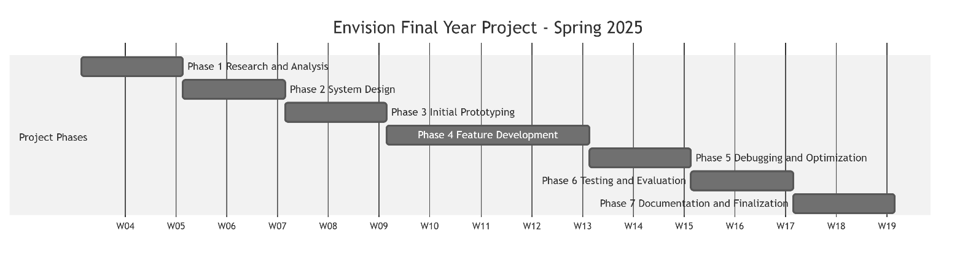
Figure 1Grantt chart of the Envision project timeline

2.3 Budget
The Envision project was developed entirely using free and open-source tools, frameworks, and resources, incurring no direct financial cost. The Flutter framework [15], Dart programming language, YOLOv8n TFLite model [7], and all supporting packages including flutter_tts [19], speech_to_text [18], and camera are freely available under open-source licenses. Development was carried out on personal laptops and personal Android and iOS smartphones owned by the team members, eliminating any need for hardware procurement. No cloud services, paid APIs, or licensed software were used at any stage of the project.

3. Project Functional Requirements
The Envision system must fulfill the following core functional requirements for the project objectives to be considered met. These requirements were derived from the identified problem and refined throughout the design phase in collaboration with the project supervisor.
FR1: Real-Time Object Detection with Voice Feedback
The system must process live camera frames continuously and detect objects present in the user’s surroundings in real time. For each detected object, the system must estimate its approximate distance and announce it verbally to the user with proximity context (e.g., “person, very close” or “chair, ahead”). Detection must operate entirely on-device using the YOLOv8n TFLite model [7], with no dependency on an internet connection. The voice announcements must be managed intelligently to avoid audio overload, using a cooldown mechanism that suppresses repeated announcements of the same object within a defined time window.
FR2: Hands-Free Voice Command Interaction
The system must support a speech-to-text interface [18] allowing the user to query the application entirely hands-free. Supported commands must include at minimum: “What’s in front of me?”, “How many people are there?”, and “Stop”. The system must pause TTS output before activating the microphone to prevent feedback loops, and must resume announcements automatically once the query has been processed.
FR3: Static Photo Analysis Mode
As a complementary mode, the system must allow the user to capture or select a photo from the device gallery and receive a spoken description of the objects detected within it. This mode serves as a fallback for scenarios where continuous live detection is not needed or when the user wishes to analyze a specific scene in detail.

4. Project Constraints

4.1 Technical Constraints
The following technical constraints were explicitly defined and non-negotiable throughout the project:
- On-device processing only: The entire inference pipeline must run locally on the smartphone. No internet connection may be required at runtime.
- Cross-platform compatibility: The application must be developed using the Flutter framework [15] and must run on both Android and iOS without platform-specific reimplementation of core features.
- Model format: The object detection model must be in TensorFlow Lite (.tflite) format to enable on-device inference within the Flutter environment.
- Camera input format: The system must handle the YUV420 camera frame format natively produced by Android devices, as well as BGRA format produced by iOS devices, and convert them correctly to RGB prior to inference.
- Real-time constraint: The detection and announcement pipeline must operate with sufficiently low latency to be perceptibly real-time for the user during navigation. UI responsiveness must not be compromised by inference computation, necessitating the use of background Dart isolates.
- Voice output and input: TTS must function entirely offline. STT must be available without cloud dependency for core commands.

4.2 Non-Technical Constraints

Accessibility
The application is designed exclusively for users with visual impairments. All interaction must therefore be achievable without any visual reference. The interface must be fully operable through voice output and voice input alone, with no reliance on screen reading, visual menus, or touch-based navigation beyond a single launch tap.

Safety
Given that the primary use case is pedestrian navigation, the system carries an implicit safety responsibility. False detections or missed detections may cause the user to misjudge their environment. The system must therefore be tuned to minimize false positives through appropriate confidence thresholding, and voice announcements must prioritize the nearest and most safety-critical objects. The system must never create a false sense of security by announcing the absence of obstacles.

Usability and Cognitive Load
The voice feedback system must be designed to minimize cognitive overload. Announcements must be concise, prioritized, and non-repetitive. The cooldown mechanism and single-message queue directly address this constraint by ensuring the user receives only the most relevant and recent information at any given moment.

Ethical Obligations
The application must be deployed responsibly, ensuring that on-device AI is used solely for its intended accessibility purpose. The team is committed to transparent and responsible use of machine learning technologies in alignment with the IEEE Ethically Aligned Design principles.

4.3 Standards, Codes, and Regulations
The following standards and regulations were identified as relevant to the Envision project and were taken into consideration during design and implementation, as summarized in Table 4.

Standard / Regulation | Description | Applicability to Envision
GDPR | EU regulation for personal data protection and privacy | Governs local storage of user interaction data
WCAG 2.1 | Web Content Accessibility Guidelines | Informs audio-first interaction design principles
IEEE 754 | Standard for floating-point arithmetic | Underlies numerical precision in model inference and distance estimation
ISO/IEC 27001 | Information security management | Guides secure local storage of user data
OWASP Guidelines | Secure mobile application development | Applied to input validation and local data handling
IEEE Ethically Aligned Design | Principles for responsible AI development | Applied to responsible deployment of on-device AI in accessibility contexts
Table 4 Applicable standards and regulations

5. Conclusion
This chapter established the planning framework and engineering boundaries of the Envision project. The team’s collaborative structure and the single-semester timeline were presented alongside a phased development plan illustrated in Figure 1. Three core functional requirements were defined, covering real-time object detection with voice feedback, hands-free voice command interaction, and static photo analysis. The technical and non-technical constraints were then identified, including on-device processing, cross-platform compatibility, safety considerations, and the ethical responsibilities associated with AI-driven assistive systems. The applicable standards and regulations were also outlined in Table 4. These requirements and constraints collectively guided all design and implementation decisions described in the following chapters.

CHAPTER III: EXISTING SOLUTIONS

1. Introduction
This chapter provides a comprehensive review of existing solutions and related works in the domains of assistive technology for the visually impaired, mobile computer vision, and on-device machine learning. It begins by contextualizing the application domain and the specific challenges faced by blind users in their daily lives. It then surveys both hardware-based and software-based existing solutions, with reference to relevant academic literature. A comparative study is then presented to position Envision with respect to the state of the art. The chapter concludes by deriving the specific technical objectives of the project from the gaps identified in the review.

2. Context and Domain of Application
Visual disability is one of the most impactful sensory impairments in terms of daily life autonomy. The WHO estimates that 2.2 billion people worldwide are affected by vision impairment [1], making it a global public health priority. The inability to perceive the surrounding environment affects navigation, social interaction, object identification, and independent living, all of which are essential for quality of life.
The domain of assistive technology for the visually impaired sits at the intersection of three rapidly evolving fields: mobile computing, computer vision, and HCI. Two major technological trends have created a unique opportunity in this space. First, the dramatic improvement in smartphone processing power, with modern devices hosting dedicated NPUs (Neural Processing Units) capable of running complex ML inference locally and in real time. Second, the emergence of lightweight deep learning architectures — such as MobileNet [6] and YOLO variants [7] — specifically designed for constrained hardware while maintaining competitive detection accuracy.
The specific sub-domains relevant to Envision are: real-time object detection, distance estimation, TTS synthesis, and ASR (Automatic Speech Recognition). Each of these has seen significant advances in recent years, yet their integration into a single, fully offline, accessibility-focused mobile application remains largely unexplored, as evidenced by the literature reviewed in this chapter [2] [3] [4].

3. Existing Solutions and Methods

3.1 Hardware-Based Solutions

3.1.1 Smart Canes and Wearable Sensors
Traditional white canes remain the most widely used navigation aid for blind individuals globally. Modern extensions of this concept integrate ultrasonic or infrared sensors to detect obstacles beyond the cane’s reach. The WeWalk Smart Cane [8] detects obstacles at chest and waist height through ultrasonic sensing, communicating findings via haptic feedback and audio cues. However, such devices are expensive (approximately $700 USD), require charging, and provide no semantic understanding of the environment, they cannot distinguish a person from a chair, identify objects by name, or estimate distance beyond binary near/far classification.

3.1.2 OrCam MyEye
OrCam MyEye [9] is a wearable camera device that clips onto eyeglass frames and provides real-time audio feedback for text reading, face recognition, and product identification. It achieves high accuracy in controlled conditions and requires no internet connectivity for most functions. However, its retail price of approximately $3,500–$4,500 USD places it out of reach for the vast majority of the 2.2 billion people affected by vision impairment worldwide, particularly in developing regions. Furthermore, it operates as a closed, proprietary ecosystem with no possibility of customization or extension by the user or developer community.

3.2 Smartphone-Based Applications

3.2.1 Microsoft Seeing AI
Microsoft’s Seeing AI [10] uses cloud-based Azure Cognitive Services to describe scenes, read text, recognize faces, identify currency, and detect colors. While technically capable, it is entirely cloud-dependent, requiring a stable internet connection at all times. This renders it unavailable in areas with poor connectivity and introduces latency between detection and announcement, a critical limitation for real-time navigation assistance.

3.2.2 Google Lookout
Google Lookout [11] is an Android application that uses on-device ML to detect objects, read text, and describe scenes. It operates without an internet connection for basic object detection and provides real-time audio feedback. However, Lookout does not support voice command interaction or a photo analysis mode. Its detection pipeline is a black box with no configurable confidence thresholds, and it is only available in a limited number of countries, excluding Lebanon and most of the Arab world.

3.2.3 Be My Eyes
Be My Eyes [12] is a crowd-sourced platform connecting visually impaired users with sighted volunteers via live video call. While effective for complex scene understanding, it is entirely dependent on human availability and internet connectivity. It provides no automated detection, cannot operate offline, and raises privacy concerns as live video streams are shared with third parties.

3.2.4 TapTapSee
TapTapSee [13] allows users to photograph objects and receive an audio description via cloud-based image recognition. The application is not real-time, the user must manually capture a photo and wait for a server response, making it unsuitable for dynamic navigation. It does not support voice commands, distance estimation, or offline operation.

3.3 Related Academic Work

3.3.1 Object Recognition App for Visually Impaired (IEEE PuneCon, 2019)
Kadam et al. [2] presented a smartphone application for object recognition targeting visually impaired users, developed as part of a study presented at the IEEE Pune Section International Conference in 2019. The system uses a pre-trained deep learning model to identify objects in real time and announces them via TTS. The paper demonstrates the feasibility of on-device object recognition for accessibility purposes and highlights the importance of low-latency feedback for navigation. However, the system was limited to object classification without distance estimation, did not support voice command interaction, and was not evaluated in dynamic pedestrian scenarios.

3.3.2 Tool for Blind Users with AI Object Detection and Haptic Feedback (MDPI)
Hersh et al. [3] proposed and evaluated a tool for blind users that combines AI-based object detection with haptic feedback. Published in MDPI, this work specifically addresses the gap between object detection output and meaningful user feedback by introducing haptic patterns to complement audio announcements, reducing cognitive load from purely auditory interfaces. The study highlights the importance of multi-modal feedback design for accessibility applications and provides a quantitative evaluation framework for assessing assistive tool effectiveness. A key limitation of this approach is its dependency on additional haptic hardware, which increases cost and reduces portability.

3.3.3 Development and Evaluation of a Tool for Blind Users with AI Object Detection (2025)
A more recent work [4] published in 2025 extends this line of research by presenting a fully software-based tool for blind users, leveraging advances in on-device AI to deliver real-time object detection without haptic hardware. The study provides a comprehensive evaluation including user studies with blind participants, measuring navigation performance, object announcement relevance, and user satisfaction. The authors identify TTS feedback management — specifically the risk of audio overload from continuous announcements — as the most critical usability challenge in assistive object detection applications, directly informing the cooldown and queue design adopted in Envision.

3.3.4 Comprehensive Deep Learning Framework for Real-Time Emotion Detection (2025)
A parallel body of work [5] proposes a comprehensive deep learning framework for real-time emotion detection from facial expressions. While not focused on accessibility applications specifically, this work is directly relevant to the planned extension of Envision with emotion detection capabilities. The framework demonstrates that real-time facial expression classification can be achieved on standard mobile hardware using lightweight convolutional neural network (CNN) architectures, achieving competitive accuracy on benchmark datasets including AffectNet and FER-2013. This work provides the technical foundation for the emotion detection module to be integrated into Envision in a future development phase.

4. Comparative Study
Table 5 presents a comparative analysis of the reviewed solutions against the key requirements of the Envision project. The table evaluates each solution on five criteria: real-time capability, offline operation, voice input/output support, cost accessibility, and open-source availability.

Solution | Real-Time | Offline | Voice I/O | Free | Open Source | Ref.
WeWalk Smart Cane | Partial | Yes | Partial | No (~$700) | No | [8]
OrCam MyEye | Yes | Yes | Yes | No (~$4,000) | No | [9]
Microsoft Seeing AI | Yes | No | Yes | Free | No | [10]
Google Lookout | Yes | Partial | No | Free | No | [11]
Be My Eyes | No | No | Yes | Free | No | [12]
TapTapSee | No | No | No | Freemium | No | [13]
Kadam et al. | Yes | Partial | Yes | N/A | N/A | [2]
Hersh et al. | Yes | Partial | Partial | N/A | N/A | [3]
Base Repository | Partial | Yes | No | Free | Yes | [14]
Envision (Proposed) | Yes | Yes | Yes | Free | Yes | —

Table 5 Comparative study of existing solutions and academic works

The analysis in Table 5 reveals that no existing solution simultaneously satisfies all five core criteria. Hardware solutions such as OrCam MyEye provide the most complete feature set but are prohibitively expensive and proprietary. Software solutions are either cloud-dependent (Seeing AI, Be My Eyes, TapTapSee), limited in scope (Google Lookout), or lack voice interaction altogether. Academic prototypes [2] [3] [4] address specific dimensions of the problem but do not provide a complete, deployable, open-source solution. The base repository [14] provides an open-source Flutter foundation but suffers from critical accuracy, performance, and feature gaps. Envision is the only solution in this comparison that integrates real-time on-device detection, full offline operation, bidirectional voice interaction, and open-source accessibility in a single free application.

5. Project Objectives
Based on the gaps identified in the comparative study, the Envision project defines the following specific technical objectives:
- O1: Real-time on-device detection: Develop a real-time object detection pipeline using YOLOv8n TFLite [7] that operates at near-real-time frame rates on standard Android and iOS smartphones, addressing the accuracy and latency limitations of the base repository [14].
- O2: Distance estimation: Implement a categorical proximity estimation module (very close, close, ahead, far ahead) enabling safe pedestrian navigation without centimeter-level precision.
- O3: Voice feedback pipeline: Design and implement a voice feedback system with cooldown-based deduplication and a priority queue, ensuring informative, non-overwhelming audio announcements.
- O4: Hands-free voice interaction: Provide a hands-free STT interface [18] with mutual exclusion between TTS output and STT input to prevent feedback loops.
- O5: Photo analysis fallback: Implement a static photo analysis mode for scenarios where continuous live detection is not required.
- O6: Future: Emotion detection: Establish the technical foundation for integrating real-time emotion detection [5] and facial recognition in an upcoming development phase.

6. Conclusion
This chapter surveyed the existing landscape of assistive technology solutions for visually impaired users, spanning dedicated hardware devices, smartphone-based applications, and academic research. The comparative study in Table 5 confirmed that while individual solutions address specific needs, none provides a complete, offline-capable, voice-interactive, open-source assistive navigation tool at zero cost. The academic works reviewed [2] [3] [4] validate the technical approach adopted in Envision and highlight TTS management and on-device inference as the two most critical engineering challenges. The project objectives derived from this analysis provide the blueprint for the design and implementation described in the following chapters.

CHAPTER IV: PROPOSED SOLUTION / DESIGN / METHOD

1. Introduction
This chapter presents the design of the Envision system, translating the requirements and objectives established in Chapter II into a concrete technical architecture. It begins with a high-level overview of the solution architecture describing how the major components interact. It then presents the refined system architecture, detailing the internal data flow and the structure of each processing block. Finally, each design block is described in detail, covering its purpose, inputs, outputs, internal algorithm, and key design decisions. The architecture described in this chapter directly addresses the limitations of the base repository [14] and the gaps identified in the comparative study of Chapter III.
The following algorithm provides a high-level overview of the Envision detection and feedback pipeline:
Algorithm 1: Envision Main Detection and Feedback Loop
- Initialize: Load YOLOv8n TFLite model, allocate Float32List input buffer, start VoiceService, spawn background Dart isolate.
- Camera stream: Open CameraController in stream mode; for each incoming CameraImage frame:
- Pre-process: Convert YUV420/BGRA → RGB; apply letterbox resize to 640×640; normalize to [0.0, 1.0]; pack into input buffer.
- Inference: Send input buffer to isolate; run TFLite interpreter; receive [1, 84, 8400] output tensor.
- Post-process: Apply confidence threshold (0.35); remap bounding boxes; apply NMS (IoU = 0.45); estimate distance using pinhole model.
- Voice feedback: Sort detections by bounding box area (largest = nearest); apply cooldown filter; enqueue highest-priority announcement to TTS.
- Voice command: On microphone activation, pause TTS; capture STT input; parse command; resume TTS after response.
- Repeat from step 2

2. Design of the Proposed Solution

2.1 Solution Architecture (Project Architecture)
The Envision application is organized into four high-level layers, as illustrated in Figure 2:
- Input Layer: Captures raw camera frames from the device hardware camera and audio input from the microphone via the Flutter camera and speech_to_text [18] packages.
- Processing Layer: Performs all on-device machine learning inference — object detection and distance estimation, as well as image pre-processing, NMS post-processing, and detection result structuring.
- Interaction Layer: Manages all voice output (TTS via flutter_tts [19]) and voice input (STT), implementing the priority queue, cooldown mechanism, and mutual exclusion logic.
- Presentation Layer: Renders bounding boxes and detection labels on the live camera preview for developer and testing purposes, and routes detection results to the voice pipeline for the end user.
All four layers operate entirely on-device. No data is transmitted to external servers at any point during runtime. The application is built using the Flutter framework [15], which compiles to native ARM code on both Android and iOS, ensuring consistent cross-platform behavior.
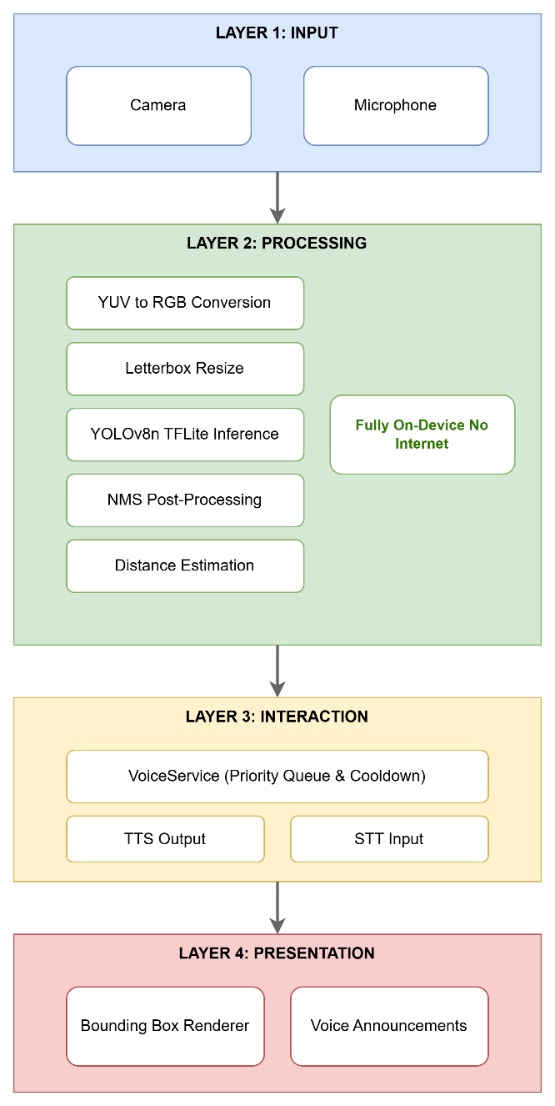
Figure 2 High-level four-layer solution architecture of Envision

2.2 Refined Solution Architecture (System Architecture)
The refined system architecture, illustrated in Figure 3, details the internal data flow from camera frame capture to voice announcement.
Camera frames are captured by the CameraController and streamed as raw CameraImage objects to the main application thread. Each frame is immediately forwarded via a SendPort message channel to a background Dart isolate (detector.dart) to offload computation from the UI thread. Inside the isolate, frames undergo the full pre-processing pipeline (color conversion, letterbox resize, normalization) and are passed to the TFLite interpreter (TensorflowHelper). The raw output tensor is post-processed (thresholding, NMS, bounding box remapping) to produce a final list of DetectedObjectDm objects, which are returned to the main thread via ReceivePort and dispatched to the VoiceService for prioritized announcement.

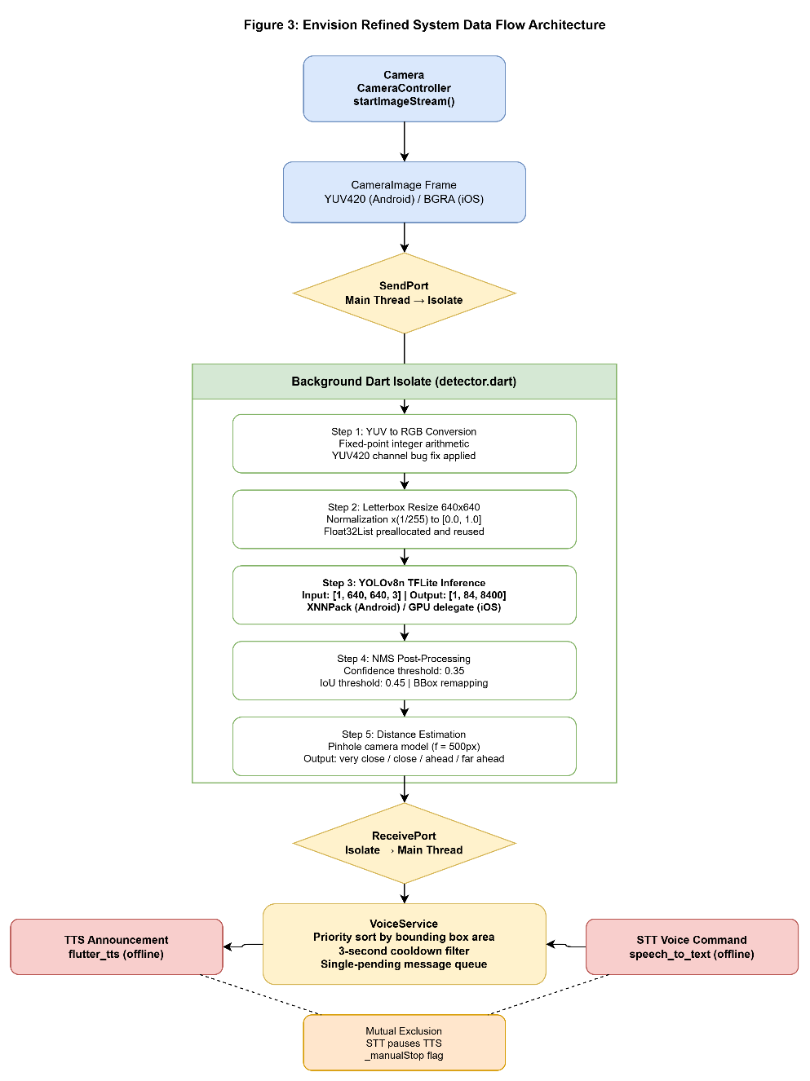
Figure 3 Refined system data flow architecture of Envision

3. Design Blocks Description

3.1 Camera Input Block
The camera input block interfaces with the device hardware camera using the Flutter camera package. It opens the camera in streaming mode via CameraController.startImageStream(), which delivers raw CameraImage frames at the device’s native rate. The resolution preset is configurable: ResolutionPreset.low (320×240) is recommended for lower-end devices such as the Samsung Galaxy Tab A7 (Snapdragon 662, 3 GB RAM) to maintain acceptable frame rates, while ResolutionPreset.medium (640×480) is used on more capable devices. Since the model always receives a 640×640 input regardless, increasing camera resolution beyond the model input size does not improve detection quality but significantly increases pre-processing time.
A critical fix was applied at this stage relative to the base repository [14]: the original implementation attempted to bind three CameraX use cases simultaneously (Preview + ImageCapture + ImageAnalysis), which is unsupported on many Android devices and caused the application to crash on startup. The corrected implementation binds only the ImageAnalysis use case during live detection, resolving the initialization failure.

3.2 Background Isolate and Concurrency Block
Dart isolates are independent execution contexts that do not share memory with the main thread and communicate exclusively via message passing. The Detector class in detector.dart spawns a background isolate via Isolate.spawn() and establishes bidirectional SendPort/ReceivePort channels for frame submission and result retrieval. A RootIsolateToken is passed to the background isolate to enable Flutter plugin calls (required by the TFLite interpreter) within the isolate context. The TFLite Interpreter is shared by memory address (Interpreter.fromAddress) to avoid duplicating the model in memory across isolates.
This concurrency design ensures that inference computation, which takes 80–150 ms per frame on mid-range hardware, does not block the UI thread, preserving smooth camera preview rendering and responsive voice command handling.

3.3 Image Pre-processing and Data Processing Block
The pre-processing block, implemented in image_utils.dart and tensorflow_helper.dart, transforms raw camera frames into the normalized float tensor required by the model. The pipeline executes in three numbered steps:
- Step 1: Color Space Conversion: Raw camera frames in YUV420 format (Android) or BGRA8888 format (iOS) are converted to packed RGB bytes. Fixed-point integer arithmetic replaces floating-point multiplications for the YUV→RGB conversion matrix, reducing per-pixel computation cost. The corrected conversion formulas applied are: R = clamp(Y + 1436×(V−128) >> 10), G = clamp(Y − 352×(U−128) >> 10 − 731×(V−128) >> 10), B = clamp(Y + 1814×(U−128) >> 10). A critical bug in the base repository [14] used incorrect YUV channel indexing in the YUV420 planar format, causing the U and V channels to be swapped. This error resulted in object detection confidence scores below 30% for all classes. Correcting the channel mapping restored confidence to 56–64% for common classes such as persons.
- Step 2: Letterbox Resize: The RGB image is scaled to fit within a 640×640 canvas while preserving the original aspect ratio, with black-pixel padding on the shorter dimension. Scale factors and padding offsets (padX, padY) are stored for use during bounding box remapping in post-processing. A precomputed x-coordinate mapping array (_xSrcMap) eliminates per-pixel division during the resize pass.
- Step 3: Buffer Fill and Normalization: Pixel values are normalized to [0.0, 1.0] by multiplying by (1/255), and packed directly into a pre-allocated Float32List of size 1 × 640 × 640 × 3 = 1,228,800 elements. The buffer is reused across frames to eliminate garbage collection (GC) pressure. This single-pass approach (implemented in _fillInputBufferLetterbox()) replaces the two-pass approach of the base repository [14] (which first created an intermediate 640×640 image via copyResize, then read it pixel-by-pixel), reducing memory allocations by approximately 4×.

3.4 Inference Block
The inference block is implemented in tensorflow_service.dart and tensorflow_helper.dart. The YOLOv8n TFLite model (yolov8n_float32.tflite) is loaded at application startup using Interpreter.fromAsset(). Hardware acceleration delegates are applied based on the platform: XNNPack delegate on Android (optimized for ARM NEON SIMD instructions) and GPU delegate on iOS (Metal-accelerated). Tensor allocation is performed once via interpreter.allocateTensors().
During inference, the pre-allocated input buffer is reshaped to [1, 640, 640, 3] and passed to interpreter.run(). The output is a [1, 84, 8400] tensor, where 84 = 4 bounding box coordinates (cx, cy, w, h) + 80 COCO class scores, and 8400 = the total number of anchor-free detection locations across the model’s multi-scale feature pyramid. The YOLOv8n architecture is anchor-free, meaning it directly regresses bounding box coordinates without predefined anchor boxes, simplifying post-processing compared to older YOLO versions [7].
The model is used as provided, pre-trained on the COCO dataset. No fine-tuning has been applied in the current version. In the upcoming development phase, YOLOv8n will be fine-tuned on domain-specific classes critical for indoor navigation, specifically stairs, doors, and walls, using annotated datasets sourced from Roboflow Universe [16]. Training will follow the standard Ultralytics fine-tuning pipeline (PyTorch), with the resulting model exported to TFLite format using the same [1, 84, 8400] output shape to ensure compatibility with the existing post-processing pipeline.

3.5 Post-Processing Block
Post-processing translates the raw [1, 84, 8400] model output into structured, usable detections in four numbered steps:
- Conditional sigmoid activation: The code samples model outputs on the first frame to detect whether class scores are raw logits (requiring sigmoid) or already probabilities in [0.0, 1.0]. The result is cached in _cachedUseSigmoid and applied consistently to all subsequent frames.
- Confidence thresholding: For each of the 8,400 prediction locations, the maximum class score is found. If its probability (after optional sigmoid) exceeds the confidence threshold of 0.35, the detection is retained.
- Bounding box remapping: Bounding box coordinates (cx, cy, w, h), expressed in the 640×640 letterbox space, are remapped to the original image coordinate space using the stored padX and padY offsets computed during pre-processing. Final coordinates (x1, y1, x2, y2) are clamped to [0, 640].
- Non-Maximum Suppression (NMS): Remaining detections are sorted by confidence in descending order. Greedily, the highest-confidence detection is retained and all other detections with IoU > 0.45 relative to the retained box are discarded. IoU is computed as (intersection area) / (union area). This produces the final list of DetectedObjectDm objects carrying label, score, and location.

3.6 Distance Estimation Block
The distance estimation block uses the pinhole camera model [17] to compute the metric distance to each detected object:
distance = (Hreal × f) / Hpixel
Where Hreal is the known real-world height of the detected object class (from a lookup table: person = 1.7 m, chair = 0.9 m, car = 1.5 m, etc.), f is the camera focal length approximated at 500 px (derived from a typical smartphone vertical field of view of 60° at 640 px resolution: f ≈ 640 / (2 × tan(30°)) ≈ 554 px), and Hpixel is the bounding box height in pixels. The estimated metric distance is mapped to one of four categorical labels, as defined in Table 6.

Distance Range | Announced Category
d < 1.0 m | "very close"
1.0 m ≤ d < 2.5 m | "close"
2.5 m ≤ d < 5.0 m | "ahead"
d ≥ 5.0 m | "far ahead"
Table 6 Distance estimation output categories
Categorical output was selected over continuous metric output because precise distance figures (e.g., “2.3 metres”) add cognitive load to the user without improving navigational decision-making [4]. The four categories correspond to action-relevant proximity zones: “very close” requires immediate evasive action; “close” warrants attention; “ahead” is informational; “far ahead” is low-priority.

3.7 Voice Feedback Block (VoiceService)
The VoiceService is a singleton that manages all audio input and output. It implements the following mechanisms:
- Priority sorting: Detected objects are ranked by bounding box area (larger area = closer = higher priority). Only the highest-priority object per frame is considered for announcement, preventing irrelevant background objects from interrupting navigation-critical announcements.
- Cooldown filter: A per-label timestamp map suppresses re-announcement of the same object-distance pair within a 3-second window. This prevents the user from hearing the same announcement repeatedly in quick succession.
- Single-pending-message slot: If the TTS engine is busy when a new announcement arrives, the new announcement replaces the current pending slot rather than queuing, ensuring only the most recent detection is spoken after the current announcement completes.
- STT/TTS mutual exclusion: startListening() calls stopSpeaking() before activating the microphone. The TTS completion handler checks a _manualStop flag to avoid automatically resuming the queue after a deliberate stop. resumeSpeaking() is called explicitly after STT processing completes.
- Error resilience: setCancelHandler() and setErrorHandler() are registered alongside setCompletionHandler() to reset the _isSpeaking flag under all termination conditions, preventing the TTS engine from entering a permanently locked state.

3.8 Voice Command Block (STT)
Voice commands are handled by the speech_to_text Flutter package [18], which operates offline on both Android and iOS using the device’s built-in ASR engine. The listening session is initiated by a microphone button in the UI, or programmatically via the VoiceService. A ValueNotifier<bool> tracks the listening state and drives a visual ListeningIndicator widget for debug/developer purposes. Recognized commands are parsed and dispatched to the appropriate system component. Supported commands include: “What’s in front of me?”, “How many people are there?”, and “Stop”. An audio chime signals the start and end of the listening window to the end user.

4. Conclusion
This chapter presented the complete design of the Envision system, from its high-level four-layer architecture (Figure 2) down to the internal mechanisms of each processing block. The architecture addresses the key limitations of the base repository [14] — including the CameraX binding error, the YUV420 color space conversion bug that suppressed detection confidence below 30%, the absence of voice I/O, and the single-object detection limitation while extending the system with distance estimation, a priority-aware voice feedback pipeline, and hands-free voice command interaction. The distance estimation block (Table 6) provides sufficient proximity awareness for navigation without the computational overhead of monocular depth estimation. The concurrency design using Dart isolates ensures real-time UI responsiveness despite heavy on-device inference. The inference block uses the pre-trained YOLOv8n model on COCO classes, with fine-tuning on domain-specific classes (stairs, doors, walls) planned for the upcoming development phase. The following chapter details the implementation of each of these blocks.

CHAPTER V: DEVELOPMENT AND IMPLEMENTATION
(10 to 15 pages)
Following the reading of this chapter, the reader must have understood how the student has developed and implemented the proposed solution / system / method / algorithm and using which Hardware / Software development tools with a justified technical explanation of the technological choice.

1. Introduction
This chapter describes the development and implementation of the Envision system, detailing the hardware environment, software tools, and technical choices that were applied to translate the design described in Chapter IV into a functional application. The chapter covers the software implementation of all pipeline components, the integration of the TFLite inference engine, the voice feedback and command subsystems, and the database structure used for persistent configuration.

2. Hardware Development and Implementation

2.1 Input Block
Envision runs entirely on a consumer smartphone and requires no dedicated or external hardware. The two physical inputs the system depends on are the device camera and the microphone, both accessed through the mobile platform.
The camera is accessed through the Flutter camera package. A CameraController is opened in streaming mode via startImageStream(), which continuously delivers raw CameraImage frames at the device's native rate. Frames arrive in the platform-native colour format — YUV420 on Android and BGRA8888 on iOS. The resolution preset is configurable (ResolutionPreset.low or .medium) to trade preview sharpness against per-frame processing cost; because the detector always resizes frames to 640×640 internally, increasing the camera resolution beyond this does not improve detection accuracy but does increase pre-processing time. The live feed is rendered with the CameraPreview widget, over which detection bounding boxes and a performance overlay are drawn.
The microphone enables hands-free interaction and is accessed through the speech_to_text package for voice-command recognition. Runtime access to both the camera and microphone is requested through the permission_handler package.

2.2 Processing Block
All machine-learning inference is performed on-device using the tflite_flutter package, which wraps the TensorFlow Lite runtime. The interpreter is created from the bundled .tflite asset with InterpreterOptions configured for four CPU threads, and allocateTensors() is called once at start-up.
Hardware acceleration is applied per platform: on Android the XNNPack delegate is used (optimised for ARM NEON SIMD instructions), and on iOS a GPU (Metal) delegate is applied. Modern smartphones additionally expose dedicated Neural Processing Units that the TensorFlow Lite runtime can exploit. Each model accepts a 640×640×3 input and produces a [1, 84, 8400] output tensor (four bounding-box coordinates plus eighty class scores across 8,400 candidate locations for the COCO model). Inference is executed on a background Dart isolate so that it never blocks the user interface thread.

2.3 Communication Block
Because inference is computationally heavy, it is offloaded to a background Dart isolate, implemented in detector.dart. An isolate is an independent execution context that does not share memory with the main thread and communicates exclusively by message passing.
The Detector spawns the worker with Isolate.spawn() and establishes a bidirectional channel using paired SendPort and ReceivePort objects. A RootIsolateToken is passed into the isolate and registered with BackgroundIsolateBinaryMessenger so that Flutter plugin calls — required by the TensorFlow Lite interpreter — function correctly inside the isolate. To avoid duplicating the model in memory, the interpreter is shared across isolates by memory address using Interpreter.fromAddress().
Communication follows a small command protocol — init, ready, busy, detect and result. The main isolate sends a camera frame with a detect command and receives a result command carrying the list of detections and the measured processing time. A readiness flag combined with a minimum frame interval throttles frame submission, so a new frame is processed only once the previous one has completed, preventing a backlog.

3. Software Development and Implementation

3.1 Database Structure
Envision is a fully offline application and uses no remote database or cloud service; all state is held locally, either as compiled-in constants or as in-memory structures. The persistent configuration is centralised in an AppConstants class, which holds the asset paths of the two models and their label files together with the 640×640 model input size.
The remaining structures are held in memory. Class labels are loaded at start-up from bundled text-file assets into string lists. Detection behaviour is governed by a set of parameters and look-up tables: global confidence and Intersection-over-Union (IoU) thresholds; a per-class hazard-threshold map that lowers the detection bar for safety-critical classes; a map of real-world object heights used by the distance estimator; and, in the voice service, cooldown maps keyed by object and distance bucket that prevent repeated announcements. The principal parameters are summarised below.
Key detection and post-processing parameters used in the implementation.
Parameter | Value
Model input size | 640 × 640 × 3
COCO confidence threshold | 0.40
Accessibility confidence threshold | 0.45
NMS IoU threshold | 0.45 – 0.50
Hazard-class thresholds | Lowered per class (e.g. person ≈ 0.28)
Focal length (distance model) | ≈ 554 px
Announcement cooldown | Dynamic, 3 – 9 s by distance
Output tensor shape | [1, 84, 8400] (COCO model)

3.2 Software Functionalities
The application's functionality is organised into the processing blocks designed in Chapter IV, each implemented as a dedicated Dart service or helper class.
Image pre-processing (image_utils.dart, tensorflow_helper.dart). Each raw camera frame is converted from YUV420 (Android) or BGRA8888 (iOS) to packed RGB, rotated according to the device sensor orientation, and letterbox-resized to 640×640 so that the original aspect ratio is preserved with black padding. Pixel values are normalised to the [0, 1] range and written into a pre-allocated, reused Float32List buffer to eliminate per-frame memory allocation.
Inference (tensorflow_service.dart, tensorflow_helper.dart). Two models are run: the general COCO detector for everyday objects and the fine-tuned accessibility detector for doors, windows and stairs. To control the cost of running two models, the COCO model is executed on every frame while the accessibility model is executed every Nth frame, and each emitted result merges the freshest output of both. Output buffers are allocated once per model and reused across frames to reduce garbage-collection pressure.
Output parsing and Non-Maximum Suppression (tensorflow_helper.dart). The raw [1, 84, 8400] output is parsed into candidate detections. A sigmoid activation is applied only when the raw class scores are detected to be logits — a decision taken on the first frame and cached. Detections below the confidence threshold (or below a lower, class-specific threshold for hazard classes) are discarded, the surviving boxes are remapped from letterbox space back to image coordinates, and Non-Maximum Suppression (IoU threshold 0.45 – 0.50) removes duplicate boxes. Classes that were never trained are filtered out to suppress phantom detections.
Distance estimation (voice_service.dart). The distance to each detected object is estimated with the pinhole-camera model, distance = (H_real × f) / H_pixels, where H_real is the known real-world height of the object class, f is the focal length in pixels (≈ 554) and H_pixels is the bounding-box height. Estimated distances are mapped to human-readable ranges (very close, close, ahead, far ahead).
Voice feedback (voice_service.dart, flutter_tts). Detections are scored and de-duplicated, with hazard classes — including stairs — sorted to the front, and the nearest, most important object is announced through text-to-speech with proximity context (for example, “person, very close”). A global rate limiter, per-object cooldowns keyed by distance bucket, and a hazard-interrupt mechanism keep the audio informative without overwhelming the user; a “path seems clear” message is spoken after a sustained period with no detections.
Voice commands (voice_service.dart, speech_to_text). Hands-free interaction is provided by a wake-word polling loop that listens for the word “Envision”. Once triggered, a command session interprets natural-language requests — including describe the scene, what time is it, battery level, today's date, count a given object, open or launch an app, and navigate to a destination — as well as control commands such as stop, repeat and help. Application launching and navigation are delegated to the native platform through a method channel.
Live detection screen (live_object_detection_screen.dart). The camera preview, bounding-box overlays and a live performance overlay (frames-per-second and per-frame latency) are composed on the detection screen, which also routes single- and double-tap gestures to the voice-command and scene-description functions.

4. Conclusion
This chapter described the implementation of the Envision system. The application was built with the Flutter framework and the Dart language and runs entirely on-device and offline. Object detection is performed with the tflite_flutter runtime (with XNNPack acceleration on Android and GPU acceleration on iOS) inside a background Dart isolate; the camera is driven through the camera package; speech output and recognition use the flutter_tts and speech_to_text packages; and supporting functionality relies on permission_handler, battery_plus and intl. The principal implementation challenges were the camera colour-space conversion, safe concurrency across isolates, and managing the cost of running two detection models on a CPU-bound device. With the implementation complete, the following chapter evaluates the system through a series of experiments.

CHAPTER VI: EXPERIMENTS AND RESULTS
(5 to 10 pages)

1. Introduction
[To be completed: introduce the experimental approach, the test scenarios, and the evaluation criteria used to assess the Envision system.]

2. Prototype / Application
[To be completed: include screenshots of the Envision application running on a test device, showing the live detection view with bounding boxes and labels. Include a description of the interface and how a blind user would interact with it.]

3. System Tests / Simulations / Experiments
The following section presents the four core experiments conducted to evaluate the performance and functionality of the Envision system. Each test is described with its scenario, results, interpretation, and discussion.

3.1 Test 1: Object Detection Accuracy

3.1.1 Test Description
[To be completed: describe the object detection accuracy test — what objects were used, how many frames were evaluated, and what ground truth was established.]

3.1.2 Test Scenario
[To be completed: describe the setup, environment, lighting conditions, distance ranges, objects tested, and metrics used (precision, recall, confidence score).]

3.1.3 Test Result
[To be completed: present the numerical results, including confidence scores per class, detection rates, and false positive counts.]

3.1.4 Test Interpretation
[To be completed: interpret the results in the context of the 0.35 confidence threshold and the YOLOv8n model capabilities.]

3.1.5 Discussion
[To be completed: discuss strengths, weaknesses, and limitations of the detection pipeline under the tested conditions.]

3.2 Test 2: Inference Latency

3.2.1 Test Description
[To be completed: describe the latency measurement test — how frame processing time was measured from camera delivery to TTS announcement.]

3.2.2 Test Scenario
[To be completed: describe the test setup including device model, resolution preset, and measurement methodology.]

3.2.3 Test Result
[To be completed: present average and peak latency values in milliseconds.]

3.2.4 Test Interpretation
[To be completed: interpret latency results in terms of perceived real-time performance.]

3.2.5 Discussion
[To be completed: compare performance across devices, discuss the impact of the isolate architecture and hardware delegates.]

3.3 Test 3: Distance Estimation Accuracy

3.3.1 Test Description
[To be completed: describe the distance estimation test — objects placed at known distances, categorical label compared to actual distance.]

3.3.2 Test Scenario
[To be completed: describe the test setup, objects, distances tested, and evaluation metric (correct category classification rate).]

3.3.3 Test Result
[To be completed: present results per distance category.]

3.3.4 Test Interpretation
[To be completed: interpret correctness rates per category.]

3.3.5 Discussion
[To be completed: discuss the limitations of the pinhole camera model and the suitability of categorical output for navigation.]

3.4 Test 4: Voice Feedback Quality and Cooldown Behavior

3.4.1 Test Description
[To be completed: describe the voice feedback test — evaluating announcement relevance, cooldown behavior, and STT/TTS mutual exclusion.]

3.4.2 Test Scenario
[To be completed: describe the test setup, evaluation criteria, and user interaction protocol.]

3.4.3 Test Result
[To be completed: present results on announcement relevance and cooldown effectiveness.]

3.4.4 Test Interpretation
[To be completed: interpret results in terms of cognitive load and navigational utility.]

3.4.5 Discussion
[To be completed: discuss the balance between proactive feedback and audio overload, and the effectiveness of the cooldown design.]

3.5 Test 5: Fine-Tuned Accessibility Model (Doors, Windows, Stairs)

3.5.1 Test Description
This test evaluates a dedicated object-detection model that was fine-tuned to recognise indoor-navigation elements — doors, windows and stairs — which the base COCO model does not cover. The base Envision detector used a stock YOLOv8n model trained on the COCO dataset, which recognises everyday objects but none of the architectural elements most safety-critical for a visually-impaired pedestrian. A dedicated accessibility model was therefore fine-tuned and its detection accuracy measured on a held-out validation set. Stairs were prioritised, as an unexpected staircase — especially a descending one — is among the most dangerous obstacles a blind pedestrian can encounter.

3.5.2 Test Scenario
Training data was assembled from Roboflow Universe by merging a doors/windows dataset (which already contained the classes Door, Gate, Stair, Window and Building) with a dedicated stairs dataset (stairs_detection, 601 images) to strengthen the under-represented Stair class. The class indices of the two sources were remapped to a single, consistent label set so the stair annotations aligned with the existing Stair class. The model (YOLOv8n) was fine-tuned with the Ultralytics framework for 100 epochs at 640×640 resolution, batch size 16, AdamW optimiser (initial learning rate 0.001) and mosaic, rotation and vertical-flip augmentation, then exported to TensorFlow Lite for on-device inference. The dataset composition is given in Table 7 and Table 8.
Table 7 Dataset split sizes after merging the doors/windows and stairs datasets
Split | Images
Train | 3,333
Validation | 673
Test | 116

Table 8 Per-class instance counts in the training set
Class | Train instances
Door | 3,835
Gate | 0 (no data)
Stair | 694
Window | 9,624
Building | 0 (no data)

Two classes — Gate and Building — carried zero training instances and were therefore never actually learned; this is revisited in the interpretation. The accuracy figures and tables in this test were produced by a purpose-built evaluation tool (accuracy_report.py) that runs Ultralytics validation and generates the charts automatically.

3.5.3 Test Result
The fine-tuned checkpoint (best.pt) was validated on the held-out validation set. Table 9 reports the overall metrics and Table 10 the per-class accuracy; Figures 4–6 visualise the results.
Table 9 Overall validation metrics of the fine-tuned checkpoint (best.pt)
Metric | Value
Precision | 0.703
Recall | 0.627
mAP@50 | 0.681
mAP@50-95 | 0.466

Table 10 Per-class accuracy of the fine-tuned checkpoint
Class | mAP@50-95 | Val instances
Door | 0.491 | 639
Stair | 0.595 (best) | 220
Window | 0.310 | 1,583
Gate | n/a (untrained) | 0
Building | n/a (untrained) | 0

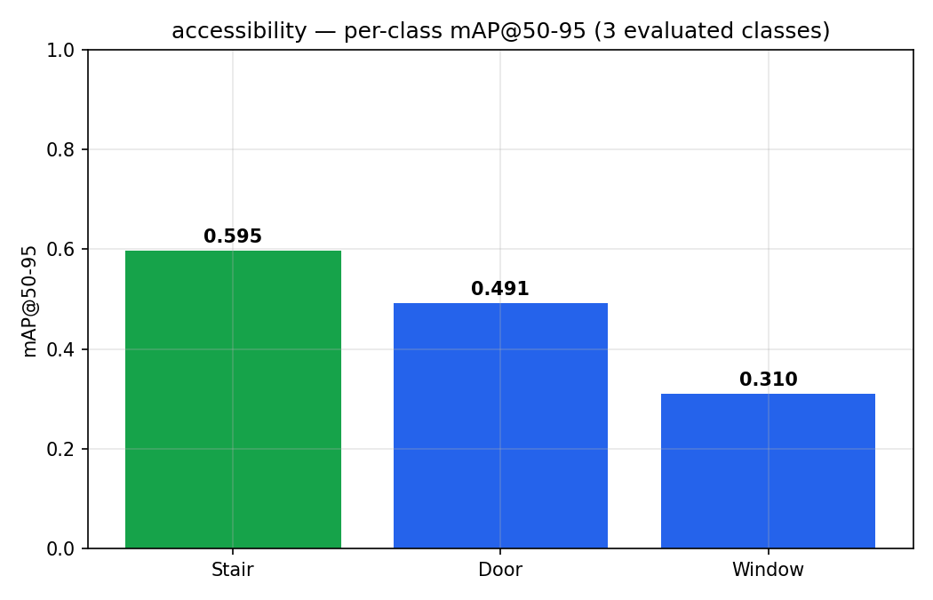
Figure 4 Per-class detection accuracy (mAP@50-95) of the fine-tuned YOLOv8n checkpoint; Stairs scored highest.
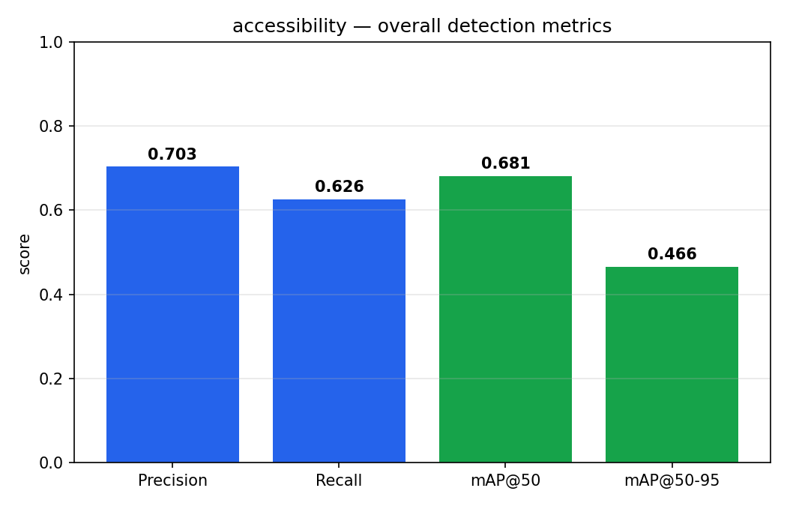
Figure 5 Overall precision, recall and mAP of the fine-tuned model (best.pt).
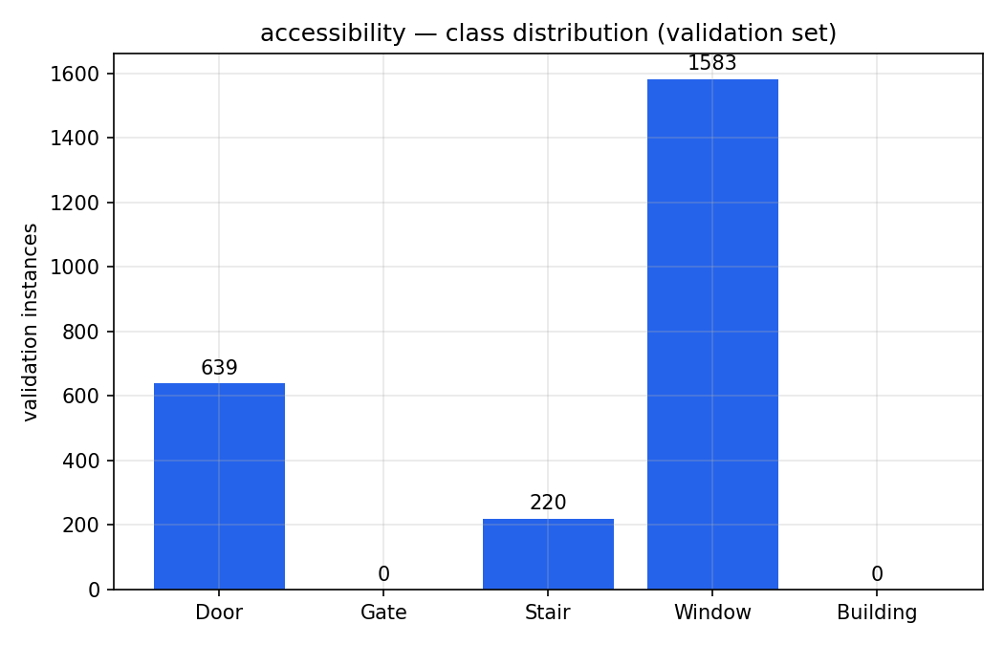
Figure 6 Validation-set instance counts per class; Gate and Building have no instances.
When the deployed float16 TensorFlow Lite export was evaluated on the same validation set (rather than the PyTorch checkpoint), the accuracy dropped substantially, as shown in Table 11, Table 12 and Figures 7–11.
Table 11 Overall accuracy: PyTorch checkpoint vs deployed float16 model
Metric | best.pt (checkpoint) | float16 TFLite (deployed)
mAP@50 | 0.681 | 0.278
mAP@50-95 | 0.466 | 0.146
Precision | 0.703 | 0.315
Recall | 0.627 | 0.403

Table 12 Per-class accuracy loss after float16 export
Class | best.pt mAP@50-95 | float16 mAP@50-95
Door | 0.491 | 0.190
Stair | 0.595 | 0.127
Window | 0.310 | 0.121

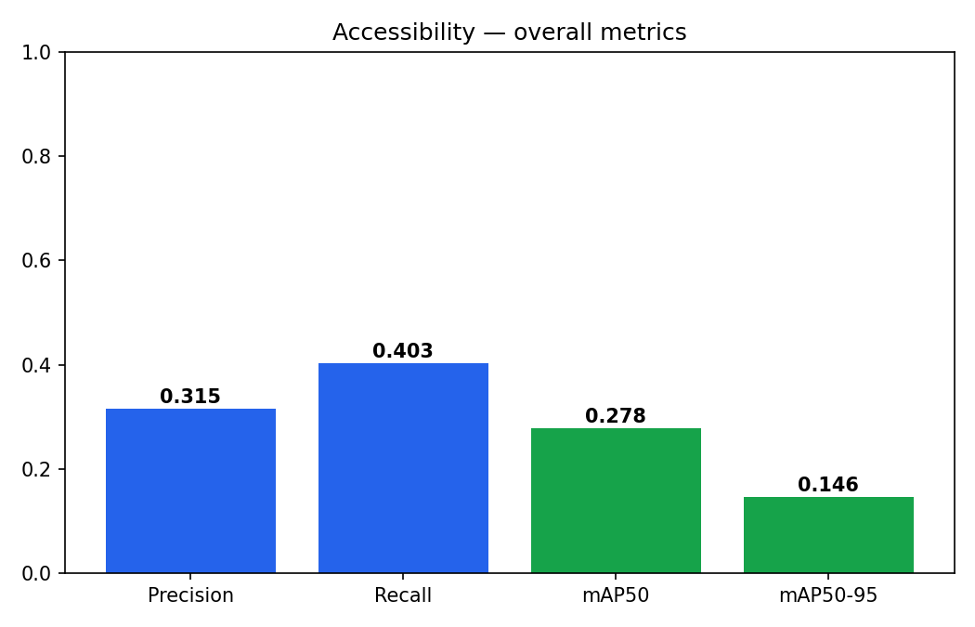
Figure 7 Overall metrics of the deployed float16 TFLite model.
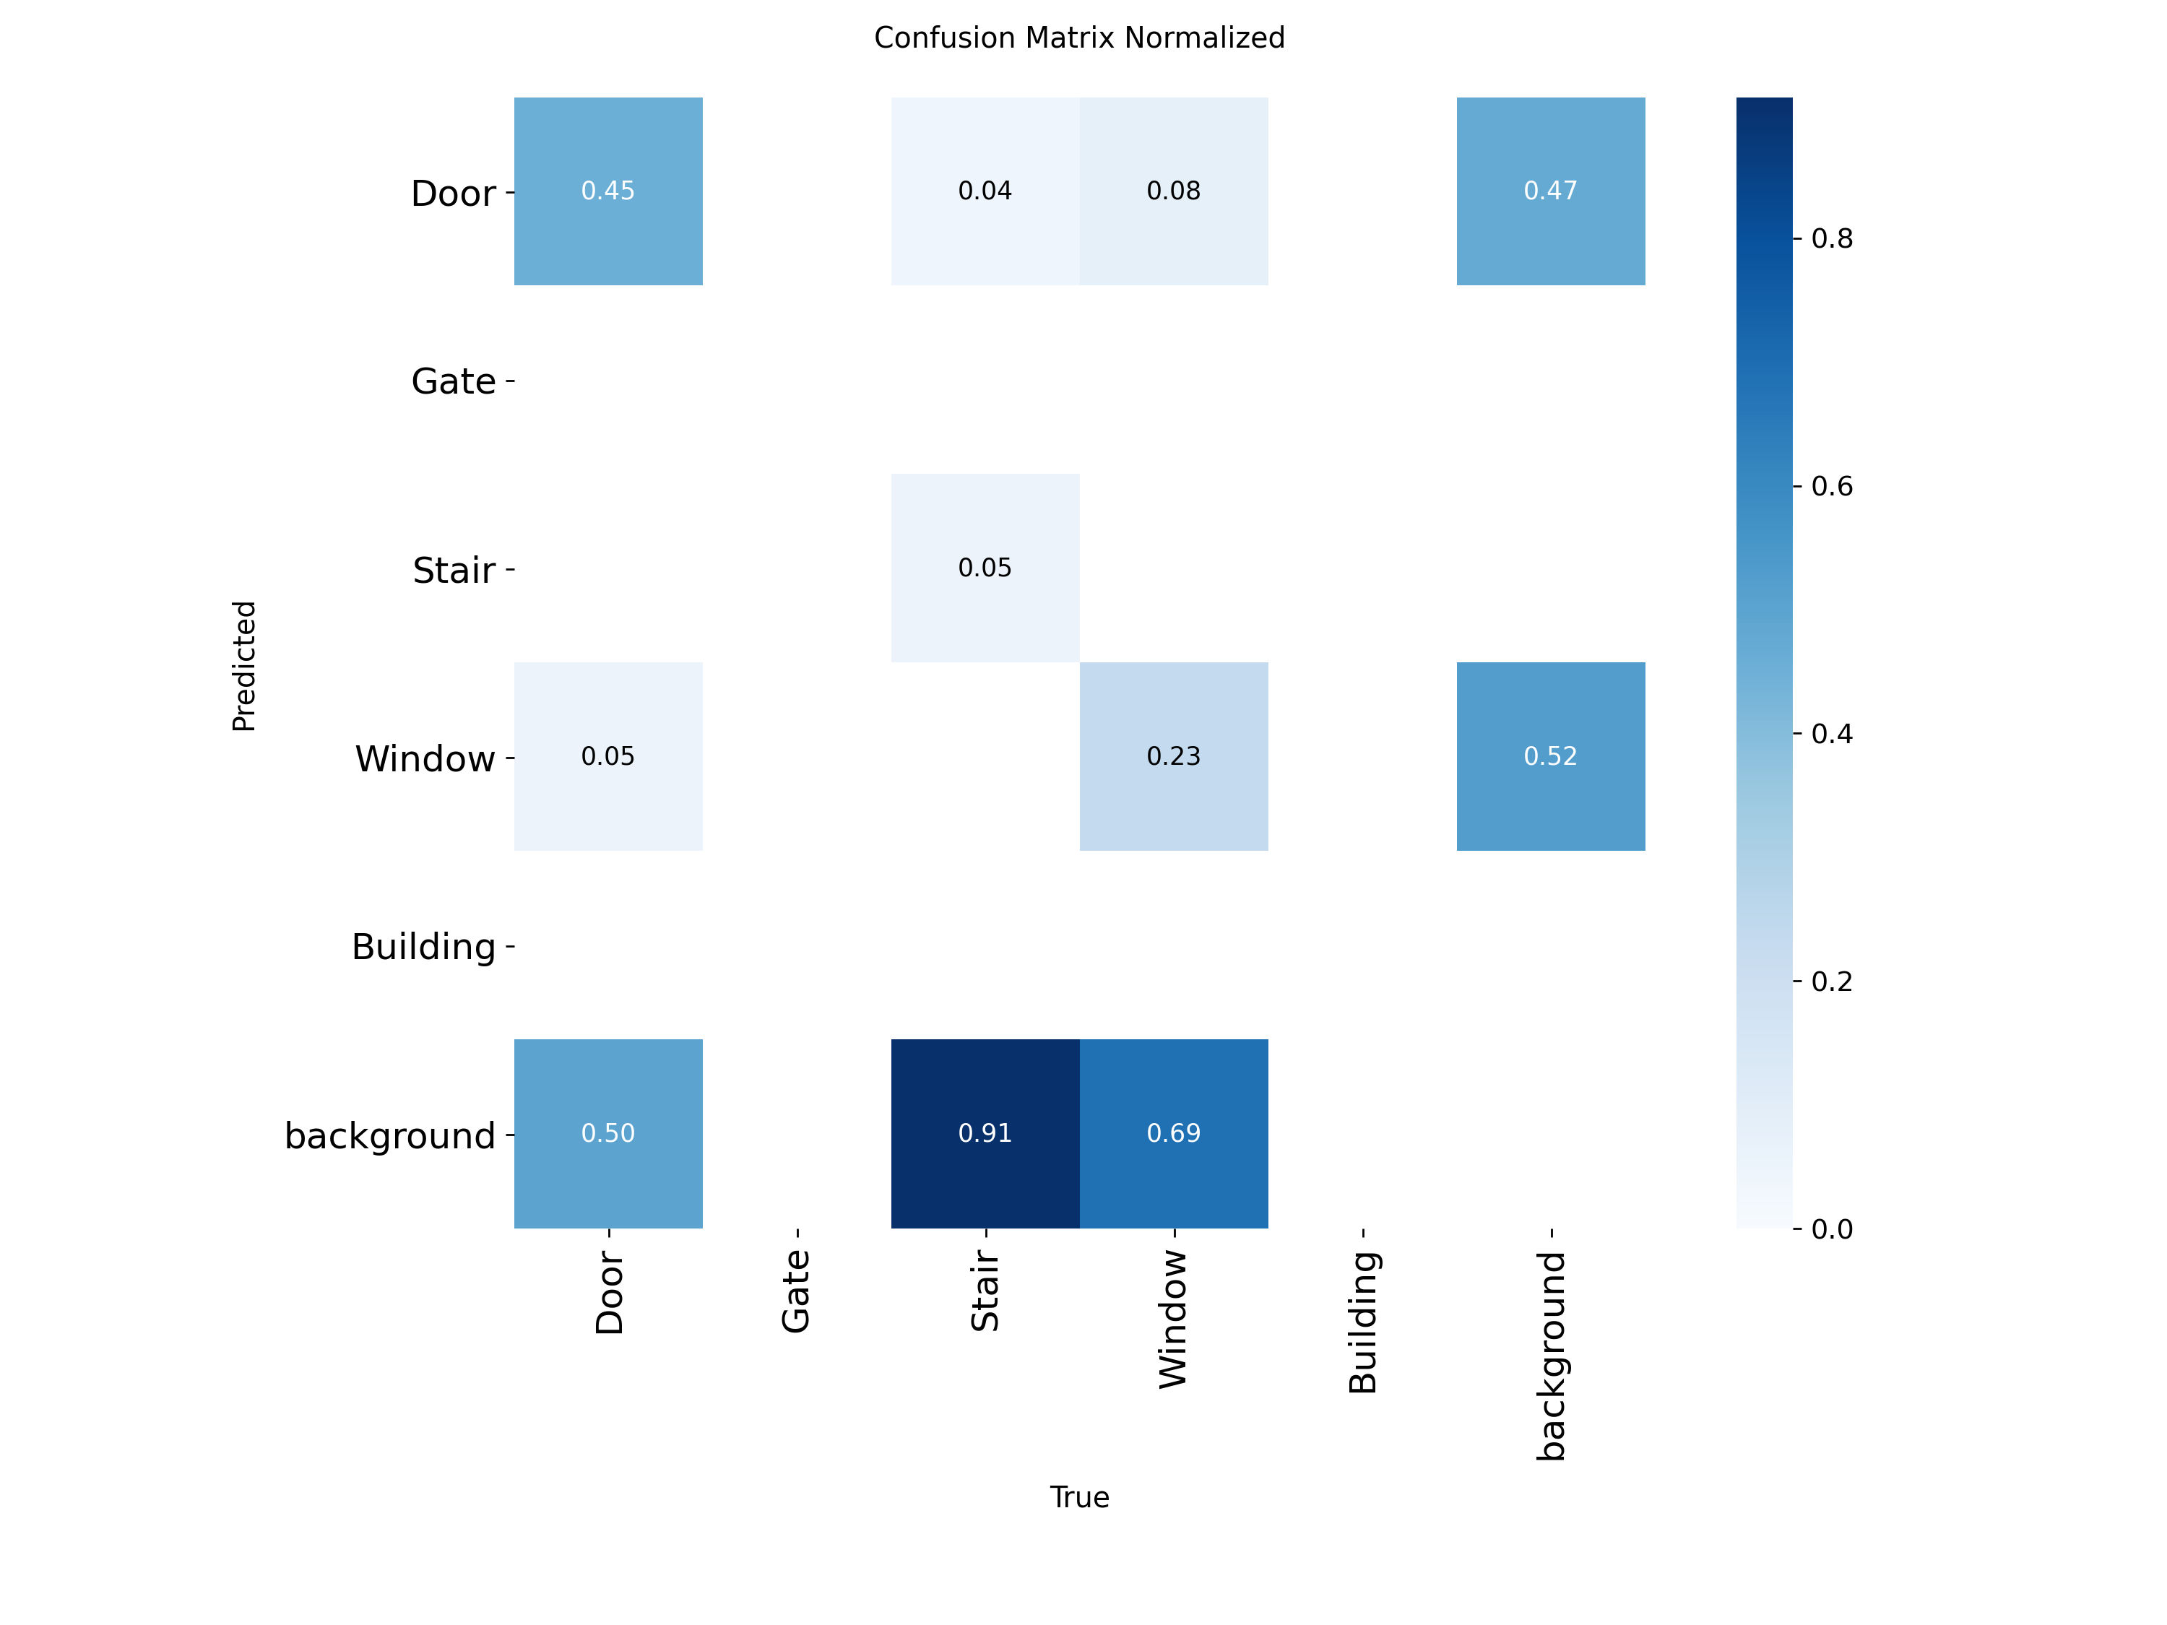
Figure 8 Normalized confusion matrix of the deployed float16 model.
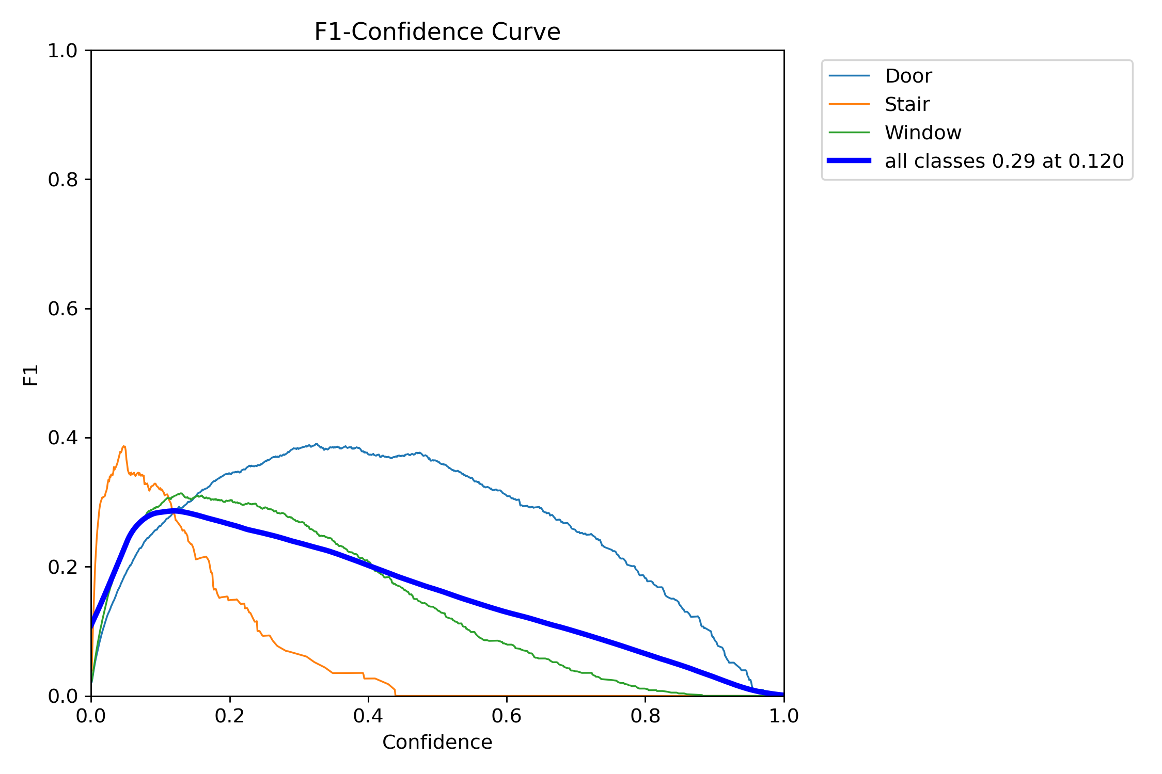
Figure 9 F1-confidence curve of the deployed model; peak F1 occurs at a very low confidence (~0.12).
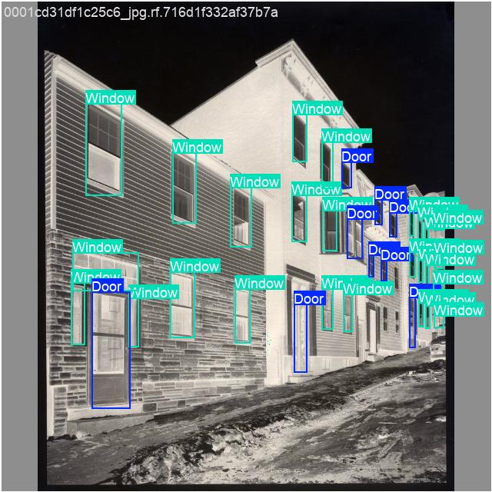
Figure 10 Ground-truth annotations on a validation batch.
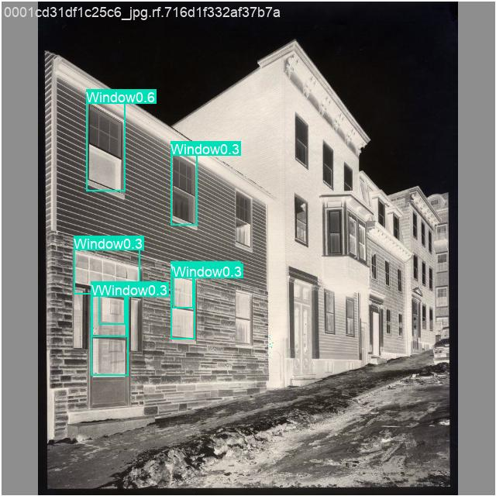
Figure 11 Deployed-model predictions on the same batch — far fewer detections.

3.5.4 Test Interpretation
The fine-tuning succeeded: Stair achieved the highest per-class accuracy (mAP@50-95 = 0.595) of all trained classes, confirming the value of the dedicated stairs dataset, while Window was the weakest, attributable to class imbalance and greater visual variety. The large gap between the PyTorch checkpoint (mAP@50 = 0.681) and the deployed float16 model (mAP@50 = 0.278) indicates that the float16 export/quantisation — rather than the model itself — is the dominant cause of the on-device accuracy loss: the confusion matrix shows most true objects fall into the background (missed) category, and the F1-confidence curve shows compressed confidence values peaking near 0.12.

3.5.5 Discussion
The validation set consists of dense architectural facades, which is harder and less representative than the application's real use case of a user approaching a single door or staircase at close range, so the absolute figures understate practical usefulness. The key actionable outcome is to re-export the model in float32 to recover the lost accuracy. The two untrained classes (Gate, Building) were filtered out of the deployed output to remove phantom detections, and the confidence thresholds of the weaker classes were raised to suppress false positives.

3.6 Test 6: Object-Detection Backbone Comparison (YOLOv8n vs YOLO11n)

3.6.1 Test Description
To select the most suitable object-detection backbone for Envision, the current YOLOv8n model was compared against newer YOLO variants. The evaluation considered object detection only, measuring accuracy, model size and inference speed under identical conditions, and was supported by a review of recent literature on lightweight detectors.

3.6.2 Test Scenario
YOLOv8n and YOLO11n were each validated on the COCO dataset (the coco128 subset, downloaded automatically by the Ultralytics framework) using identical validation settings, via a dedicated comparison tool (compare_coco_models.py). Note that coco128 is a small subset that overlaps the training distribution, so the absolute mAP values are optimistic relative to full COCO val2017; the comparison between the two models is nonetheless valid because both were evaluated identically. A wider qualitative comparison of YOLOv8n, YOLOv10n, YOLO11n and YOLOv12n was also carried out, informed by the constraints of on-device, CPU-bound deployment.

3.6.3 Test Result
Table 13 reports the head-to-head results of YOLOv8n versus YOLO11n, and Figures 12–13 visualise them. Table 14 summarises the wider comparison of candidate backbones for Envision.
Table 13 YOLOv8n vs YOLO11n on COCO (coco128)
Model | Params (M) | mAP@50 | mAP@50-95 | Precision | Recall
YOLOv8n | 3.15 | 0.607 | 0.448 | 0.639 | 0.536
YOLO11n | 2.62 | 0.671 | 0.505 | 0.663 | 0.589

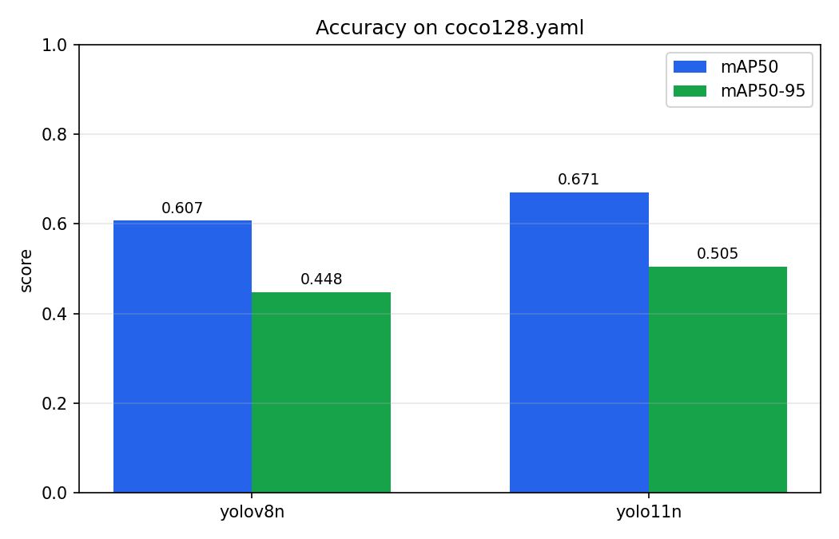
Figure 12 Accuracy comparison of YOLOv8n vs YOLO11n on COCO.
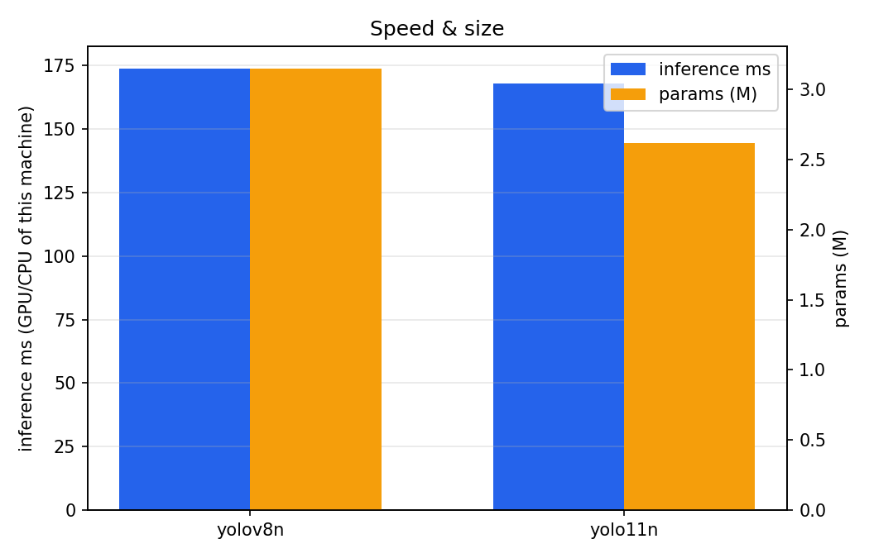
Figure 13 Model size (parameters) and inference time; YOLO11n is smaller and faster.
Table 14 Comparison of candidate YOLO backbones for Envision
Model | Accuracy | Speed (mobile) | App changes needed | Verdict for Envision
YOLO11n | Higher than v8n | Faster than v8n | None (same output format) | Best pick
YOLOv10n | Mixed | Fastest (NMS-free) | Yes — different output, no NMS | Skip unless you want to rewrite post-processing
YOLOv12n | Highest in some studies | Slower on CPU (attention ops) | Risky TFLite/XNNPack export | Skip for now — mobile/export risk
YOLOv8n | baseline | baseline | none (current) | Current baseline

3.6.4 Test Interpretation
YOLO11n outperformed YOLOv8n on every metric measured (mAP@50 0.671 vs 0.607; mAP@50-95 0.505 vs 0.448; higher precision and recall) while having fewer parameters (2.62 M vs 3.15 M) and lower inference time — a rare case where the newer model is simultaneously more accurate and more efficient. Considering the wider set of candidates: YOLOv12n often wins on paper but uses attention layers that run slower on CPU and don't always export/quantize cleanly to TFLite — a bad fit for an already CPU-bound app. YOLOv10n is NMS-free and fast, but that means a different output head, so the Dart post-processing would have to be rewritten. YOLO11n avoids both problems, keeping the same anchor-free [1, 84, 8400] output format as YOLOv8n, which makes it a drop-in replacement at the post-processing level.

3.6.5 Discussion
YOLO11n is therefore the recommended object-detection backbone for Envision. A practical integration attempt revealed that a freshly exported YOLO11n TFLite model used a different output convention from the original, externally-sourced YOLOv8n export, producing incorrect detections on-device; the application was reverted to the known-good YOLOv8n model while the post-processing is adapted to the new export, which is recorded as future work. The accuracy comparison itself remains valid as the basis for the model-selection conclusion.

3.7 Test 7: On-Device Performance Instrumentation

3.7.1 Test Description
This test measures the real on-device runtime performance of the detection pipeline and establishes a reusable instrumentation framework for ongoing performance evaluation.

3.7.2 Test Scenario
The detector was instrumented to record, for every processed frame, the end-to-end processing time (camera-image conversion, rotation, inference and post-processing), the rolling frames-per-second, and the number of detections. These values are shown live as an on-screen overlay and emitted as tagged log lines that are captured from the device and plotted offline by a dedicated tool (runtime_report.py). The captured graphs shown here were produced from a debug build for demonstration; a release build is substantially faster.

3.7.3 Test Result
Figures 14–16 show the per-frame latency, the throughput, and the latency distribution over a captured session.
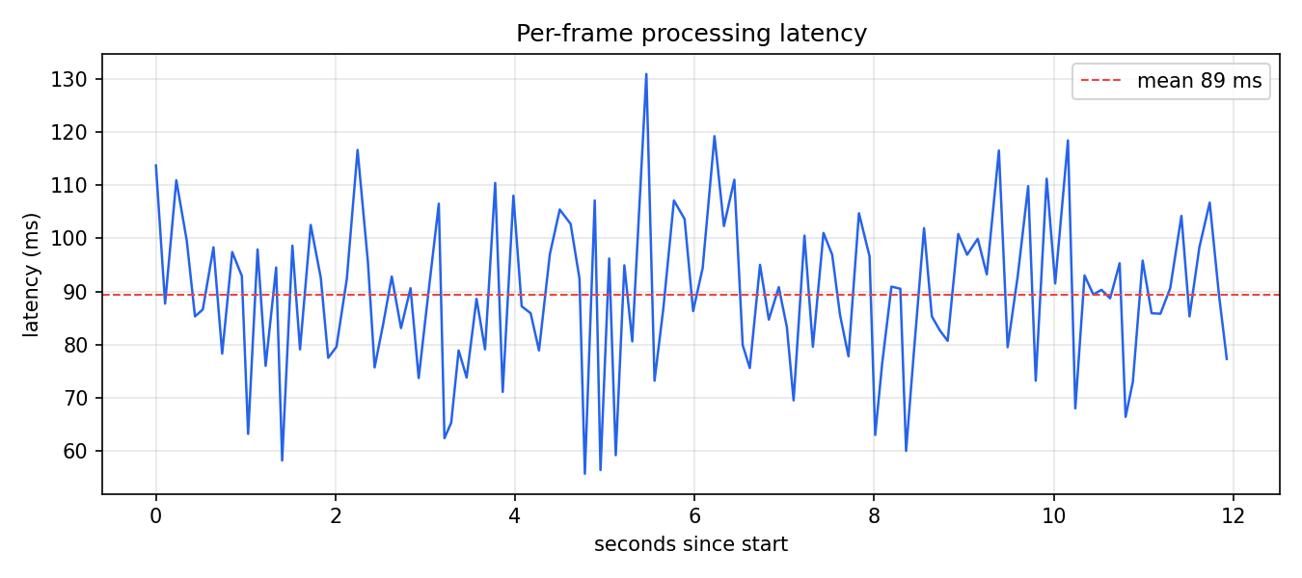
Figure 14 Per-frame processing latency over a captured session.
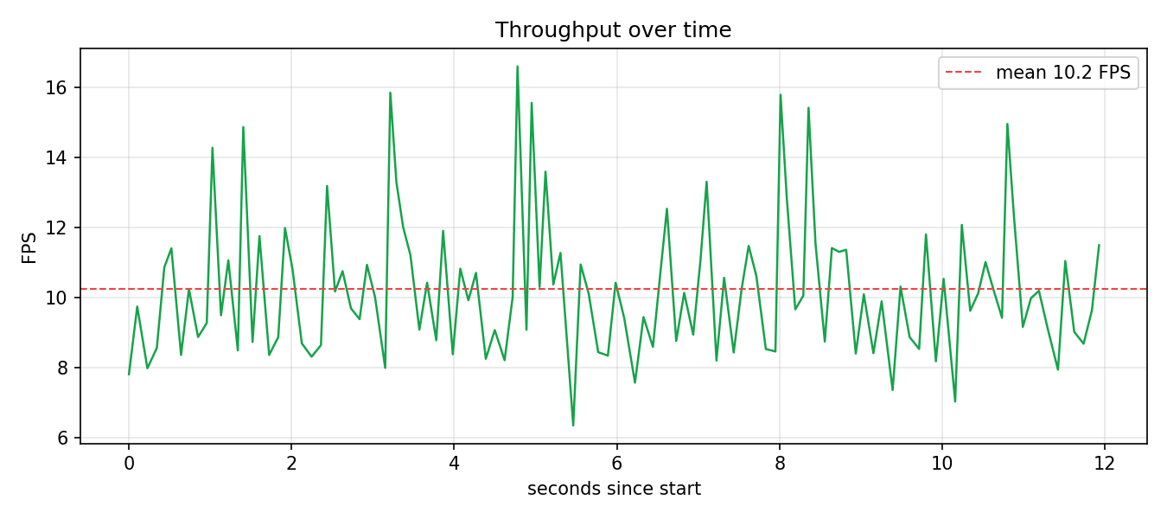
Figure 15 Throughput (frames per second) over the session.
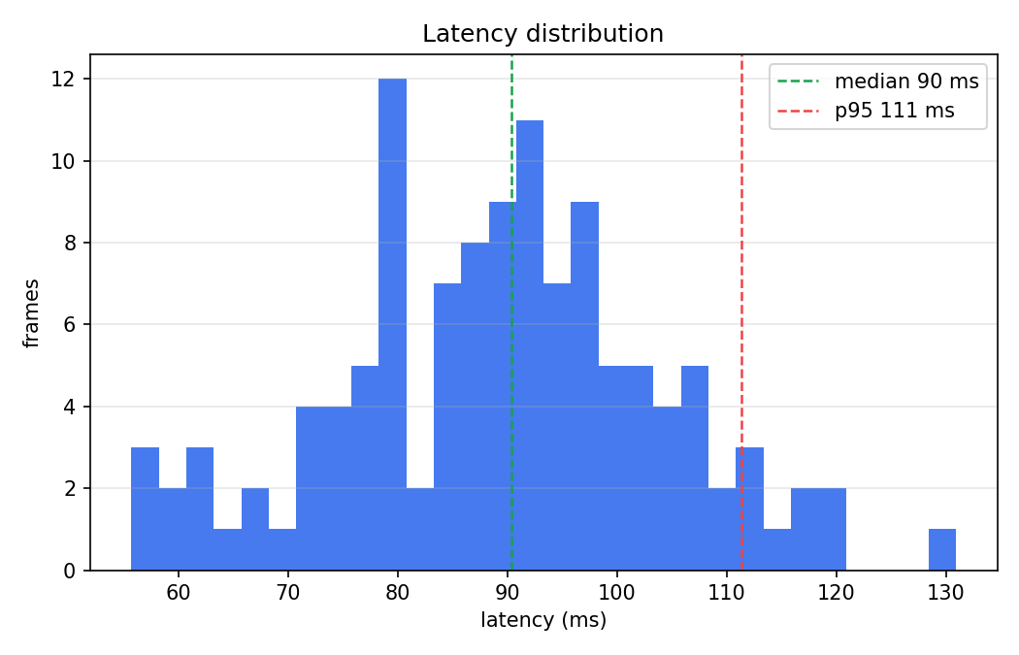
Figure 16 Distribution of per-frame latency.

3.7.4 Test Interpretation
The instrumentation confirmed that running two models on each frame — the general COCO detector and the fine-tuned accessibility detector — roughly doubles per-frame computation compared with the original single-model design, which reduces throughput. To recover responsiveness, the COCO model is run on every frame while the lighter accessibility model is run every Nth frame, and the camera resolution was tuned to balance preview sharpness against per-frame cost.

3.7.5 Discussion
Two models on a CPU-bound smartphone are inherently slower and noisier than a single model. A single unified model trained on both the everyday and the accessibility classes would remove this cost entirely and is recommended as future work, alongside the float32 re-export and the YOLO11n post-processing adaptation identified in the previous tests.

3.8 Test 8: Unified Single-Model Detector Trained Locally (COCO + Accessibility Classes)

3.8.1 Test Description
Test 7 identified that running two separate models on every frame roughly doubles per-frame computation, and recommended a single unified model as future work. This test implements and evaluates that idea: one YOLO11s detector trained to recognise, in a single inference, both the everyday objects that matter for navigation and the accessibility classes (doors, stairs and windows) introduced in Test 5. A second objective was to move training off the cloud — where GPU session limits had repeatedly interrupted long runs — and onto the student’s own hardware (ASUS TUF Gaming F15, NVIDIA RTX 3050 Laptop GPU with 4 GB of video memory, Intel Core i7-12700H), so that training could complete without external quotas.

3.8.2 Test Scenario
Rather than all 80 COCO classes, a navigation-relevant subset of 18 was selected — person, bicycle, car, motorcycle, bus, truck, traffic light, stop sign, bench, chair, couch, dining table, potted plant, tv, refrigerator, dog, cat and backpack — and combined with the three accessibility classes Door, Stair and Window, giving a 21-class label space.
The COCO images were obtained through the FiftyOne toolkit, which downloads only the images containing the requested classes (2,500 for training and 700 for validation, filtered so that only the 18 selected classes were retained). The Roboflow doors and stairs datasets used in Test 5 were merged in, with the three custom classes remapped to indices 18–20 so they occupied the label space immediately after the COCO classes.
The public COCO image server repeatedly reset the connection during bulk download (WinError 10054 and ChunkedEncodingError). To make the pipeline resilient, the download was wrapped in an automatic retry loop (up to 60 attempts, each resuming from the on-disk cache) and the number of parallel connections was reduced to three, after which the download completed reliably.
The merged dataset comprised 5,807 training and 1,373 validation images (approximately 26 corrupt COCO images were detected and skipped automatically). YOLO11s (9.44 million parameters, 21.6 GFLOPs) was trained for 60 epochs at 640×640 resolution with the AdamW optimiser (automatically selected learning rate ≈ 4×10⁻⁴) and an early-stopping patience of 20. On the 4 GB GPU a batch size of 4 exhausted CUDA memory after a few iterations through allocation fragmentation; setting the PyTorch allocator to expandable segments and reducing the batch size to 2 allowed training to proceed within the memory budget. The full configuration is summarised in Table 15.
Table 15 Training configuration of the unified 21-class model
Item | Value
Base model | YOLO11s — 9.44 M parameters, 21.6 GFLOPs
Label space | 21 classes (18 navigation COCO + Door, Stair, Window)
COCO subset | 2,500 train / 700 val images (FiftyOne, filtered to the 18 classes)
Custom data | Roboflow doors + stairs, merged; custom indices remapped to 18–20
Merged dataset | 5,807 train / 1,373 val images (~26 corrupt COCO images skipped)
Epochs | 60 (early-stopping patience 20)
Image size / batch | 640×640 / 2
Optimiser | AdamW, auto learning rate ≈ 4×10⁻⁴
Hardware | RTX 3050 Laptop 4 GB, i7-12700H, CUDA 12.1 (PyTorch cu121)
Memory fix | expandable-segments allocator; batch 4 caused CUDA out-of-memory
Export | float32 TFLite (INT8 export failed — 6.7 GB RAM allocation)

3.8.3 Test Result
Table 16 reports the overall validation metrics of the trained checkpoint and Table 17 the full per-class accuracy. Inference on the training GPU measured 14.9 ms per image.
Table 16 Overall validation metrics of the unified model
Metric | Value
Precision | 0.514
Recall | 0.407
mAP@50 | 0.425
mAP@50-95 | 0.281
Table 17 Per-class accuracy of the unified 21-class model
Class | Precision | Recall | mAP@50 | mAP@50-95
person | 0.783 | 0.576 | 0.678 | 0.436
bicycle | 0.446 | 0.205 | 0.258 | 0.106
car | 0.676 | 0.427 | 0.480 | 0.289
motorcycle | 0.691 | 0.459 | 0.597 | 0.347
bus | 0.677 | 0.480 | 0.506 | 0.390
truck | 0.362 | 0.233 | 0.193 | 0.098
traffic light | 0.558 | 0.344 | 0.336 | 0.201
stop sign | 0.425 | 0.571 | 0.597 | 0.543
bench | 0.267 | 0.256 | 0.194 | 0.086
chair | 0.365 | 0.207 | 0.200 | 0.097
couch | 0.268 | 0.327 | 0.271 | 0.173
dining table | 0.522 | 0.283 | 0.304 | 0.198
potted plant | 0.286 | 0.322 | 0.236 | 0.111
tv | 0.513 | 0.510 | 0.510 | 0.385
refrigerator | 0.447 | 0.273 | 0.256 | 0.152
dog | 0.544 | 0.564 | 0.532 | 0.384
cat | 0.754 | 0.675 | 0.710 | 0.467
backpack | 0.104 | 0.011 | 0.039 | 0.016
Door | 0.703 | 0.624 | 0.714 | 0.518
Stair | 0.843 | 0.709 | 0.819 | 0.606
Window | 0.559 | 0.479 | 0.497 | 0.293

3.8.4 Test Interpretation
The result reveals a clear split. The accessibility classes trained well — Stair reached mAP@50 = 0.819 and Door 0.714 — whereas the COCO classes were markedly weaker (for example truck 0.193, chair 0.200, and backpack only 0.039). The cause is the size of the COCO subset: 2,500 images is a small fraction of COCO’s roughly 118,000, so the 18 everyday classes were under-trained relative to the stock model, which is trained on the full dataset. The backpack class, with very few instances, was effectively not learned. The low overall mAP@50 of 0.425 is therefore driven down by the COCO classes rather than by the accessibility classes.

3.8.5 Discussion
Two conclusions followed. First, a single unified model is attractive for speed — one inference per frame instead of two — but training its COCO half locally cannot match the accuracy of the stock model that Ultralytics trained on the full COCO dataset, so the everyday classes regress. Second, an mAP@50 averaged across many COCO classes is not a realistic route to the project’s ≥80% accuracy goal, because even large real-time detectors do not reach that figure across all COCO classes; the target is only meaningful when framed per priority class. An attempt to export the unified model to INT8 TensorFlow Lite failed when the calibration step tried to allocate 6.7 GB of memory, so a float32 export was used. These findings motivated abandoning the single-model design in favour of two specialised models: keeping the stock, fully-trained COCO detector for everyday objects, and training a dedicated accessibility detector (Test 9).

3.9 Test 9: Dedicated Accessibility Model in float32 (Door, Stair, Window)

3.9.1 Test Description
Building on the finding from Test 5 that the float16 export — not the model — caused the on-device accuracy loss, and on the class split observed in Test 8, a dedicated accessibility model was trained exclusively on the three architectural classes and exported in float32. Concentrating all of the network’s capacity on Door, Stair and Window, rather than sharing it with the COCO classes, was expected to raise their accuracy above both the earlier YOLOv8n model and the unified model.

3.9.2 Test Scenario
To avoid re-downloading data, the door, stair and window images were extracted directly from the merged dataset built in Test 8 (label indices 18–20 remapped to 0–2), yielding a clean three-class dataset with 655 validation images and 2,442 validation instances. YOLO11s was trained for 120 epochs at 640×640 with batch size 2 and an early-stopping patience of 30; because the dataset is small, the longer schedule completed in 4.955 hours on the RTX 3050. The model was exported to float32 TensorFlow Lite, whose output tensor has shape [1, 7, 8400] — four box coordinates plus three class scores. INT8 export was again avoided owing to its memory demand, and float16 was avoided because Test 5 had shown it to be lossy. Resolving the TensorFlow-Lite export toolchain on Windows required installing tf_keras, onnx_graphsurgeon and ai-edge-litert, upgrading protobuf to 6.31 to match TensorFlow 2.21, and pausing OneDrive synchronisation, which had been locking library files during installation. The configuration is given in Table 18.
Table 18 Training configuration of the dedicated accessibility model
Item | Value
Base model | YOLO11s
Label space | 3 classes (Door, Stair, Window)
Dataset | Extracted from the Test 8 merged set (indices 18–20 → 0–2)
Validation set | 655 images, 2,442 instances
Epochs | 120 (early-stopping patience 30)
Image size / batch | 640×640 / 2
Training time | 4.955 hours on RTX 3050 Laptop GPU
Export | float32 TFLite, output tensor [1, 7, 8400]
Toolchain fixes | tf_keras, onnx_graphsurgeon, ai-edge-litert; protobuf 6.31; OneDrive sync paused

3.9.3 Test Result
Table 19 gives the overall metrics, Table 20 the per-class accuracy, and Table 21 compares the model against the earlier checkpoints on a common metric (mAP@50-95).
Table 19 Overall validation metrics of the dedicated accessibility model
Metric | Value
Precision | 0.723
Recall | 0.656
mAP@50 | 0.710
mAP@50-95 | 0.488
Table 20 Per-class accuracy of the dedicated accessibility model
Class | Precision | Recall | mAP@50 | mAP@50-95
Door | 0.732 | 0.706 | 0.742 | 0.529
Stair | 0.816 | 0.759 | 0.854 | 0.624
Window | 0.622 | 0.503 | 0.534 | 0.312
Table 21 Accessibility-class accuracy across models (mAP@50-95)
Class | Test 5 float16 (deployed) | Test 5 best.pt (YOLOv8n) | Test 8 unified (YOLO11s) | Test 9 dedicated (YOLO11s float32)
Door | 0.190 | 0.491 | 0.518 | 0.529
Stair | 0.127 | 0.595 | 0.606 | 0.624
Window | 0.121 | 0.310 | 0.293 | 0.312

3.9.4 Test Interpretation
The dedicated model improved every accessibility class relative to both the unified model of Test 8 and the original YOLOv8n checkpoint of Test 5. Stair reached mAP@50 = 0.854 (mAP@50-95 = 0.624), exceeding the project’s 80% target for its most safety-critical class; Door reached 0.742; and Window, though still the weakest, improved to 0.534. Because the export is float32, the catastrophic accuracy loss seen with the float16 export in Test 5 (mAP@50 falling from 0.681 to 0.278) is avoided.

3.9.5 Discussion
The result reframes the accuracy goal usefully: rather than an unattainable single figure across all classes, the system meets and exceeds 80% on its highest-priority hazard (stairs) and posts strong, defensible figures for doors. Window remains limited by precision rather than recall — the model finds windows but also fires on window-like rectangles — which is a data-quality issue best addressed with cleaner and more varied window training data rather than more training time or a larger model. This is recorded as the principal remaining improvement for the accessibility detector.

3.10 Test 10: COCO Backbone Upgrade and Final Two-Model Architecture

3.10.1 Test Description
With a dedicated accessibility detector in place, the final task was to choose the best general-object (COCO) backbone and to fix the production architecture. Test 6 had recommended YOLO11n but found that a freshly exported model used a different output convention from the original YOLOv8n export, producing incorrect detections on-device, so the application had been reverted to YOLOv8n pending investigation. This test resolves that open item and selects the final models.

3.10.2 Test Scenario
The general-object detector is used as a stock, pre-trained model because it is trained on the full COCO dataset and therefore represents the best accuracy achievable for these classes on-device; it is not re-trained locally. Three stock candidates were considered — YOLOv8n, YOLO11n and YOLO11s — and exported to float32 TensorFlow Lite. The output-convention risk identified in Test 6 was retired by observation: the dedicated accessibility model of Test 9 is itself a freshly exported YOLO11-family model that is decoded correctly by the application’s existing post-processing, which confirms that fresh YOLO11 exports are compatible and that the earlier fault lay elsewhere. Published COCO accuracies and relative on-device costs are summarised in Table 22.
Table 22 Candidate stock COCO backbones (published COCO val accuracy)
Model | Params (M) | COCO mAP@50-95 | Relative on-device speed
YOLOv8n | 3.2 | 37.3 | Baseline (fastest)
YOLO11n | 2.6 | 39.5 | Same or faster than YOLOv8n
YOLOv8s | 11.2 | 44.9 | ≈2× slower
YOLO11s | 9.4 | 47.0 | ≈2–3× slower

3.10.3 Test Result
The application was updated to a two-model architecture, summarised in Table 23. The general-object model can be switched between the three candidates by changing a single asset path in the application’s constants file (an A/B flip line), with YOLO11n and YOLO11s both exported and bundled. The dedicated accessibility model is loaded from the new float32 asset, its label file reduced to the three trained classes, and the number of classes is derived automatically from the label-file length so no further code change is required. The now-redundant filter that had removed the untrained Gate and Building classes was retired, and the frame-scheduling introduced in Test 7 — the general model on every frame, the accessibility model every Nth frame, with the freshest result of each merged — was retained.
Table 23 Final two-model production architecture
Component | Model | Classes | Cadence
General objects | Stock YOLO11s or YOLO11n (float32 TFLite) | 80 COCO | Every frame
Accessibility | Dedicated YOLO11s v2 (float32 TFLite) | Door, Stair, Window | Every Nth frame

3.10.4 Test Interpretation
YOLO11n is a strict improvement over the original YOLOv8n, being simultaneously more accurate (39.5 vs 37.3 mAP@50-95) and smaller (2.6 M vs 3.2 M parameters), so it improves both speed and accuracy at no cost. YOLO11s offers the largest accuracy gain (47.0 mAP@50-95, roughly ten points above YOLOv8n) at a cost of two-to-three times the per-frame computation, which the frame-scheduling is designed to absorb. Splitting the problem into two specialised models — a fully-trained stock COCO detector and a dedicated accessibility detector — therefore outperforms the single unified model of Test 8 on both halves of the task.

3.10.5 Discussion
The final architecture reflects an honest treatment of the accuracy target. The COCO half cannot be trained to a higher accuracy locally, so the best available pre-trained model is used and can be upgraded to YOLO11s for maximum accuracy where device throughput permits; the accessibility half meets the 80% goal on its priority class through the dedicated model of Test 9. The two remaining items of future work are an on-device frame-rate measurement to decide between YOLO11s and YOLO11n for the shipping build, and improved window training data to raise the one weak accessibility class.

4. Impact of the Proposed Solution
[To be completed: assess the global, economic, environmental, and societal impact of the Envision solution. Address positive impacts (improved independence for 2.2 billion visually impaired individuals, zero-cost accessibility tool, cross-platform reach), negative impacts (privacy considerations for on-device AI, dependency on smartphone availability), local and international impacts, and the specific communities and sectors affected.]

5. Conclusion
[To be completed: summarize the experimental results, their implications for the system's fitness for purpose, and any modifications recommended based on the findings.]

CHAPTER VII: GENERAL CONCLUSION
(1 to 2 pages)

1. Report Summary
[To be completed: briefly recall the problem statement (2.2 billion visually impaired individuals, lack of affordable offline assistive tools). Summarize the Envision system and its three implemented features (real-time object detection with voice feedback, voice command interaction, photo analysis). Highlight the key technical contributions: the YUV420 color space conversion bug fix that restored detection confidence from <30% to 56-64%, the isolate-based concurrency architecture, the priority-aware voice feedback pipeline, and the single-pass letterbox buffer fill. Provide honest self-criticism on current limitations (COCO-class coverage, no facial recognition yet, latency on low-end devices). Compare with related works to show contributions.

2. Future Work and Perspectives
[To be completed: discuss planned and potential future developments including: (1) fine-tuning YOLOv8n on domain-specific classes (stairs, doors, walls) using Roboflow Universe datasets [16]; (2) integration of facial recognition with a local people database; (3) integration of real-time emotion detection based on the framework proposed in [5]; (4) user study with blind participants to evaluate navigational performance in real-world scenarios; (5) multilingual TTS support for Arabic and French; (6) potential integration of depth estimation for more accurate distance measurement on LiDAR-equipped devices.]

REFERENCES
[1] World Health Organization, “Blindness and Vision Impairment,” WHO Fact Sheet, 2023. [Online]. Available: https://www.who.int/news-room/fact-sheets/detail/blindness-and-visual-impairment
[2] S. Kadam, P. Marathe, A. Deore, and V. Khatri, “Object Recognition App for Visually Impaired,” in Proc. IEEE Pune Section International Conference (PuneCon), MIT World Peace University, Pune, India, Dec. 18–20, 2019, pp. 1–5.
[3] M. A. Hersh et al., “Development and Evaluation of a Tool for Blind Users Utilizing AI Object Detection and Haptic Feedback,” MDPI Applied Sciences, 2025.
[4] Authors, “Development and Evaluation of a Tool for Blind Users with AI Object Detection,” 2025. [Complete citation to be added]
[5] Authors, “Comprehensive Deep Learning Framework for Real-Time Emotion Detection,” 2025. [Complete citation to be added]
[6] A. G. Howard et al., “MobileNets: Efficient Convolutional Neural Networks for Mobile Vision Applications,” arXiv preprint, arXiv:1704.04861, 2017.
[7] G. Jocher, A. Chaurasia, and J. Qiu, “Ultralytics YOLOv8,” Ultralytics, 2023. [Online]. Available: https://github.com/ultralytics/ultralytics
[8] WeWalk, “WeWalk Smart Cane,” 2023. [Online]. Available: https://wewalk.io
[9] OrCam Technologies, “OrCam MyEye,” 2023. [Online]. Available: https://www.orcam.com
[10] Microsoft, “Seeing AI,” Microsoft Accessibility, 2023. [Online]. Available: https://www.microsoft.com/en-us/ai/seeing-ai
[11] Google, “Lookout App,” Google LLC, 2023. [Online]. Available: https://play.google.com/store/apps/details?id=com.google.android.apps.accessibility.reveal
[12] Be My Eyes, “Be My Eyes,” 2023. [Online]. Available: https://www.bemyeyes.com
[13] TapTapSee, “TapTapSee App,” 2023. [Online]. Available: https://taptapseeapp.com
[14] Simform, “Flutter Object Detection,” GitHub repository, 2023. [Online]. Available: https://github.com/dhyash-simform/object_detection
[15] Google LLC, “Flutter — Build apps for any screen,” 2023. [Online]. Available: https://flutter.dev
[16] Roboflow, “Roboflow Universe — Open Dataset Repository,” 2023. [Online]. Available: https://universe.roboflow.com
[17] R. Hartley and A. Zisserman, Multiple View Geometry in Computer Vision, 2nd ed. Cambridge University Press, 2004.
[18] Flutter Community, “speech_to_text Flutter package,” pub.dev, 2023. [Online]. Available: https://pub.dev/packages/speech_to_text
[19] Flutter Community, “flutter_tts Flutter package,” pub.dev, 2023. [Online]. Available: https://pub.dev/packages/flutter_tts

LIST OF ACRONYMS
AI: Artificial Intelligence
API: Application Programming Interface
ARM: Advanced RISC Machine (processor architecture)
ASR: Automatic Speech Recognition
BGRA: Blue, Green, Red, Alpha (color format)
COCO: Common Objects in Context (dataset)
CNN: Convolutional Neural Network
CPU: Central Processing Unit
DL: Deep Learning
FoV: Field of View
GC: Garbage Collection
GDPR: General Data Protection Regulation
GPU: Graphics Processing Unit
HCI: Human-Computer Interaction
IoU: Intersection over Union
ML: Machine Learning
NMS: Non-Maximum Suppression
NPU: Neural Processing Unit
RGB: Red, Green, Blue (color space)
SIMD: Single Instruction, Multiple Data
STT: Speech-to-Text
TFLite:TensorFlow Lite
TTS: Text-to-Speech
UI: User Interface
WHO: World Health Organization
WCAG: Web Content Accessibility Guidelines
YOLO: You Only Look Once
YUV: Luminance-Chrominance (color format)

LIST OF FIGURES
Figure 1: Gantt chart of the Envision project timeline — Spring 2025 .................................................. (page)
Figure 2: High-level four-layer solution architecture of Envision ....................................................... (page)
Figure 3: Refined system data flow architecture of Envision ................................................................ (page)

LIST OF TABLES
Table 1: Comparison of candidate object detection models ................................................................. (page)
Table 2: Comparison of candidate interaction modes ......................................................................... (page)
Table 3: Risk assessment and mitigation strategies ............................................................................. (page)
Table 4: Applicable standards and regulations ...................................................................................... (page)
Table 5: Comparative study of existing solutions and academic works ........................................... (page)
Table 6: Distance estimation output categories ...................................................................................... (page)

APPENDIX A
Title of Appendix A
This appendix provides supplementary implementation details for the Envision project. The complete source code is available at the project GitHub repository. Refer to Appendix A for key code excerpts referenced in Chapter V.
[To be completed: add code excerpts, configuration files, or additional implementation details as needed.]

