**H64MOB/MOC Coursework**

**OFDM modulation for 4G LTE mobile**



**DEPARTMENT OF ELECTRICAL AND**

**ELECTRONIC ENGINEERING**

**Student: NANDI GUO-14311495**

**Date: 03/04/2020**

**Part 1**

1. **Introduction**

The communication technologies have improved significantly and the modulation part in the area of mobile communications also explicitly improved a lot in recent years, OFDM as one of the main transmission technologies has also developed very successfully and it showed a sufficient improve potential.

Orthogonal Frequency Division Multiplexing (OFDM) is orthogonal frequency division multiplexing technology and OFDM is also MCM (Multi-Carrier Modulation) which is a type of multi-carrier modulation. It identifies the parallel transmission of high-speed serial data through frequency division multiplexing. It has better resistance to multipath fading and can support multi-user access. [1]

OFDM technology is also one of the applications of the multiple carrier transmission system. Its modulation and demodulation are based on IFFT and FFT respectively. It is one of the most complicated, effective and widely used multiple carrier transmission system in modern communication systems. [2]

The report combines two parts, Principles (in part 1) and Simulations (in part 2). The report aims to make people know how OFDM is operated and how the modulator and demodulator are designed. In part 2 Simulations and data will be discussed.

* 1. **literature review of OFDM**

Modulation is played an important role in communication systems, it is a process method to change certain characteristics of one waveform to another signal. In signal communications, electromagnetic waves are regarded as carriers of information. OFDM is also one of the most fundamental modulation techniques of the digital signal.

OFDM is established on the famous technology of FDM (Frequency Division Multiplexing). In FDM various streams of data are recorded onto individual parallel frequency channels. Every FDM channel is split from the other channels by a frequency guard band to decrease interference between the adjacent channels. [3]

The differences from the OFDM scheme and traditional FDM in the following related ways:

1. Various carriers or known as ‘subcarriers’ contain the data stream,

2. These subcarriers are arranged orthogonal to each other.

3. A guard interval is included in every single symbol to decrease the channel delay spread and intersymbol interference.

OFDM technology is a fast multi-carrier transmission technology in a wireless ecosystem. The frequency response curve of the wireless channel is mostly non-flat, and the main idea of the OFDM technology is: the given channel is divided into many orthogonal sub-channels in the frequency domain, each sub-channel is modulated with a sub-carrier, and each sub-carrier is transmitted in parallel, Which can effectively suppress the inter-symbol interference (ISI) caused by the time dispersion of the wireless channel. The need for an equalizer and eliminates it only by inserting a cyclic prefix is eliminated by the reduces the complexity of equalization in the receiver, and sometimes even. The adverse effects of ISI. The signal bandwidth on every sub-channel is fewer than the channel's related bandwidth, so each sub-channel could be regarded as a fading flat, which can disregard inter-symbol crosstalk, due to the bandwidth of every sub-channel is only a minor part of the original channel bandwidth, the channel Balancing converts relatively informal.[4]

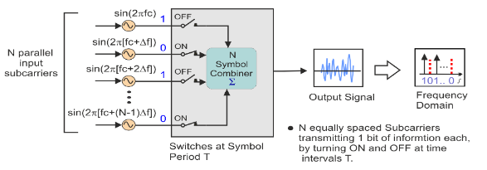

Figure 1: Simple OFDM Generation

In this example OFDM system, N sinusoidal input signals can be seen. Every subcarrier transmits one bit of data (N bits total) as suggested by its presence in the output spectrum. An orthogonal signal set is formed by the selected frequency of each subcarrier. These selected frequencies are known also at the receiver for signal recovery. The output is informed at a regular interval T which forms the symbol period. T must be the reciprocal of the subcarrier spacing in order to be maintained.[4]

* 1. **Uncomplicated Digital OFDM system Implementation using FFT transforms**

Although the application of multiple carriers transmitted in parallel is an effective way to reduce frequency selective fading, it does come with implementation issues. This can be overcome with the use of a discrete Fourier Transform technique.

Using a combination of Fast Fourier Transform (FFT) and Inverse Fast Fourier Transform (IFFT) digital signal processing could extend the models used in the simple analogue OFDM implementation. These transforms are key from the OFDM perspective because they can be viewed as planning digitally modulated input data (data symbols) onto orthogonal subcarriers. In principle, the IFFT takes frequency-domain input data (complex numbers representing the modulated subcarriers) and converts it to the time-domain output data (analogue OFDM symbol waveform).[4]

The IFFT takes in N source symbols at a time where N is the number of subcarriers in the system. Each of these N input symbols has a symbol period of T seconds. Recall that the output of the IFFT is N orthogonal sinusoids. These orthogonal sinusoids every have a distinct frequency and the lowest frequency is DC.[4]

The input bits are classed and mapped to source data symbols that are a complex number representing the modulation constellation point (e.g., the QAM symbols that would be present in a single subcarrier system) In a digitally implemented OFDM system. These complex source symbols are handled by the transmitter as though they are in the frequency-domain and are the inputs to an IFFT block that transforms the data into the time-domain. [4]

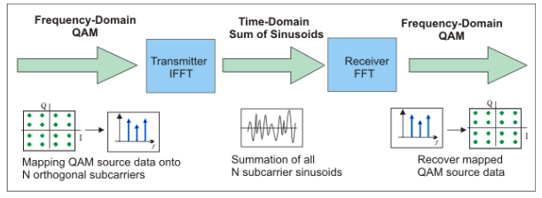**Figure 2: Simplified OFDM System Block Diagram**

The mapped constellation point is represented by the input symbols are complex values representing and therefore specify both the amplitude and phase of the sinusoid for that subcarrier. The IFFT output is the summation of all N sinusoids. Thus, the IFFT block offers an easy way to modulate data onto N orthogonal subcarriers. The block of N output samples from the IFFT make up a single OFDM symbol.

After several further processing, the time-domain signal that results from the IFFT is transmitted across the radio channel. At the receiver, an FFT block is used to process the received signal and bring it into the frequency domain which is used to recover the original data bits.

* 1. **OFDM implementations**

Areas, where OFDM are commonly implemented, are Wi-Fi networks, the video industry

, 4G LTE mobile communication networks.

|  |
| --- |
| Wi-Fi networks |
| IEEE 802.11a/g/n/ac all using this technology. Wi-Fi are using around 20MHz channels, each channel composed of 64 subcarriers spaced 312.5 kHz apart. The reason why the spacing is chosen this way is the use of 64-point FFT sampling [5]. |
| 4G LTE networks |
| The robustness of OFDM is multipath fading and interference, these factors are important when designing a real-time voice communication system. OFDM has a high bit rate, so the predecessors are required to be improved for 3G and 2G. For 4G LTE, OFDM is specifically used in the downlink part. A variation of OFDM is used for the uplink called SC-FDMA(Single Carrier Frequency Division Multiple Access). SC-FDMA is used for the uplink to save battery of the small mobile device. Therefore, OFDM is better used at the base station, where the power consumption may not be a significant factor because OFDM is very power consuming. [6].  For the specific channels,  These are 4MHz, 3MHz, 5MHz, 10MHz, 15MHz and 20MHz. The subcarrier spacing is 15kHz. Each subcarrier can have a maximum rate of 15-kilo symbols per second. 4G LTE has three different modulation types, dependant on the prevailing conditions. These are QPSK (2 bits per symbol), 16QAM (4 bits per symbol) and 64QAM (6 bits per symbol). The higher-order technique can only be used if there is a large enough signal to noise ratio (SNR) |
| Radio or Video |
| Digital audio broadcasting (DAB) and digital video broadcasting (DVB) techniques are using for Radio or Video industries. It has already become the European standard for DAB and HDTV transmission [6]. DAB has 1536 carriers at 1 kHz spacing. It has a symbol length of 1.246ms and uses Differential Quadrature Phase Shift Keying (DQPSK) technology [7]. |

**2.1 OFDM Operating Principles Figure 2.1**

It is probable to increase the bit rate of data signals that are transmitted across a bandwidth by using OFDM. QAM is applied to decrease the bandwidth which is required to send out an input bitstream. This is required K < N of the successive binary digits. This will generate one achievable QAM signal. While data is transmitting by using QAM, a signal constellation will be created. This can be seen in Figure 2.1. Every point on the constellation represents one of the 2k signals and they will be transmitted as a complex number. After that QAM generation would be carried out on each of the successive group. 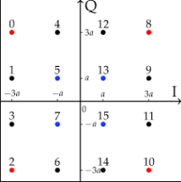

of K binary digits. The resultant N successive complex numbers are then stored. As before, the serial-to-parallel conversion is then used to transmit the complex numbers, with a different subcarrier used for each number. Next, the inverse discrete Fourier Transform technique is used again as a method of carrying out the OFDM operation. This time, the data is sampled at QAM intervals K/R apart. It is this combination of QAM and OFDM that is most commonly used in communication applications, especially 4G LTE. [8]

**2.2 Modulator and demodulator**

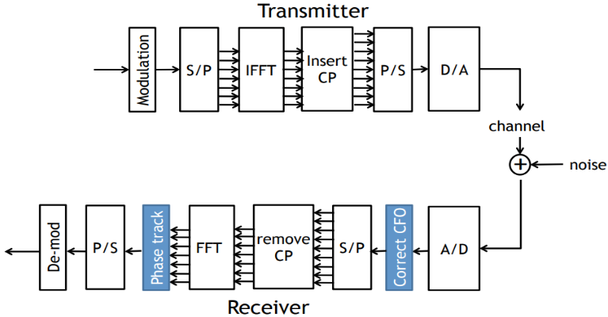All the designations are similar and have the same structure, a full block diagram for full QAM-OFDM transmitter and receiver can be seen in figure 2.2

**Figure 2.2 Modulator and Demodulator Block diagram**

|  |
| --- |
| Modulation |
| Data encoding and QAM modulation convert the data into a constellation of data points. |
| serial-to-parallel conversion |
| The input serial data stream is formatted into the word size required for transmission |
| Digital-to-analogue conversion |
| The final stage of the upconverter, which sends the data across the transmission line |
| QAM-OFDM |
| It is the reversal of the modulating sequence, all the different techniques used to modulate the signal are reversed by using the inverse of their techniques by adding components of noise. If the system is configured properly, noise levels will be decreased. |

**2.3 QAM modulator basics**

**Figure 2.3 modulator [9]**

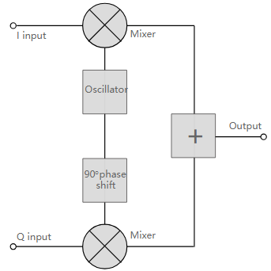The QAM modulator basically develops the concept that can be derived from the basic QAM theory where two carrier signals with a phase shift of 90°degree in the middle of them. The signals are then amplitude modulated with the two data streams known as the I or In-phase and the Q or quadrature data streams which are produced in the baseband processing region.

The total sum of two resultant signals is then processed as required into the RF signal chain, converting them in frequency to the required ending frequency and then intensifying them.

It is important to note that any RF amplifiers should be linear to maintain the integrity of the signal as the amplitude of the signal changes. Non-linearities will cause the relative levels of the signals to change and alteration in the phase difference. Thus, the signal will be distorted and increase the risk of 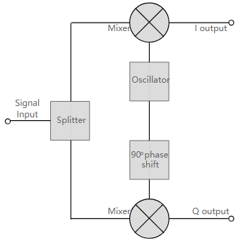data errors.

**Figure 2.4 demodulator [9]**

Whereas, QAM modulator is the opposite of QAM demodulator.

Signals that entered the system are split into two and each goes through a mixer. The first half goes into the in-phase local oscillator and the other second half goes into the quadrature oscillator signal.

The basic modulator assumes that the two quadrature signals remain exactly in quadrature.

Another necessity is to derive a local oscillator signal used for demodulation which is precisely on the required frequency for the signal. Any frequency offset caused a difference in the phase of the local oscillator signal as the two double sidebands repressed carrier constituents of the whole signal.[9]

**2.4 Advantages and Disadvantages of QAM**

|  |  |
| --- | --- |
| **Disadvantages** | **Advantages** |
| * As states become closer, QAM modulation is more susceptible to the noise. Because of this, the QAM receiver is more complex in comparison to other modulation receivers. [10] * QAM utilizes the amplitude component of the signal to represent binary data thus linear amplifier is required to consume more power in order to maintain linearity. * Loss of efficiency and bandwidth due to cyclic prefix. | * Efficient usage of bandwidth is the main advantage of QAM modulation variants. This is due to QAM representing more number of bits per carrier. For example, 16QAM maps 4 bits per carrier, 64QAM maps 6 bits per carrier, 256QAM maps 8 bits per carrier and so on. [10] * Can adapt to severe channel conditions. * Low sensitivity to time synchronizes errors. |

**3.1 Actual practical OFDM modulator or demodulator design**

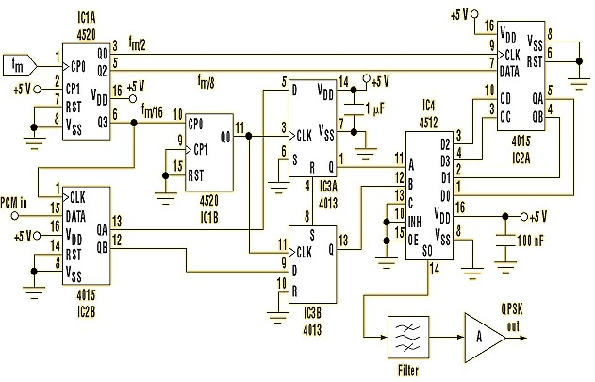To design an OFDM modulator, microcontrollers, flip-flops and logic circuits need to be constructed respectively. QAM block would be a modulator for 4G LTE OFDM.  **Figure 3.1 Practical circuit**

IC1A is the main oscillator (FM) feeds the frequency divider. This provides values of fm/2, fm/8, and fm/16. Values for FM depend on CMOS technology.

The PCM signal performs as a digital input and forms debits in the shift register IC2B and the dual flip-flop IC3. The required phases of 0º, 90º, 180º and 270º are generated at the outputs of the four-bit shift register IC2A. The outputs are QA, QB, QC, QD. The multiplexer output is dictated by the debits at pins A and B of IC4. This selects a phase from D0, D1, D2, or D3, dependent on the debit combinations. The various other sections of the circuit are compiled of a band-pass filter, used to eliminate DC level and pulse shaping. The final component is an amplifier which is used to set the desired output level. The output frequency seen from the QPSK circuit is fm/8 [11].

**4. BER analysis**

A Function called Simulink would show the bit error rate (BER) of a QAM-OFDM model. A full 16QAM-OFDM modulator and demodulator which process with the presence of additive Gaussian white noise have been set. The energy per bit to noise power spectral density ratio (Eb/N0) will be varied, and the effects on the system will be measured. The effects of varying the Eb/N0 with the removal of the OFDM blocks will also be investigated.[12]

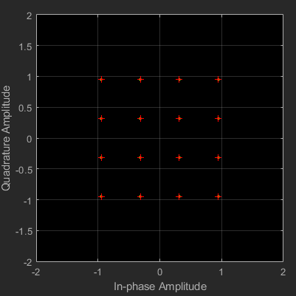**Figure 4 simulation model**

16QAM-OFDM system

4bits per a symbol

period = 1/bit rate

bit rate=192kbs

Symbol period=1/1.92*105

This picture showed the input constellation that is sent for transmission through the QAMOFDM system.

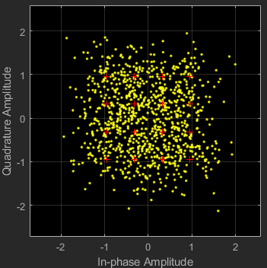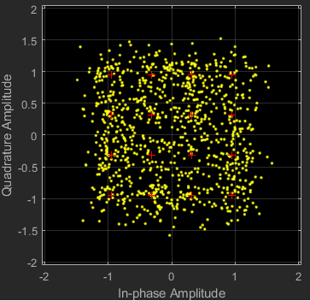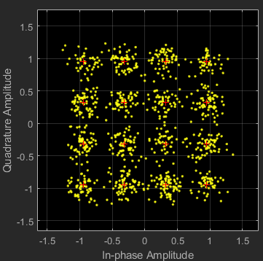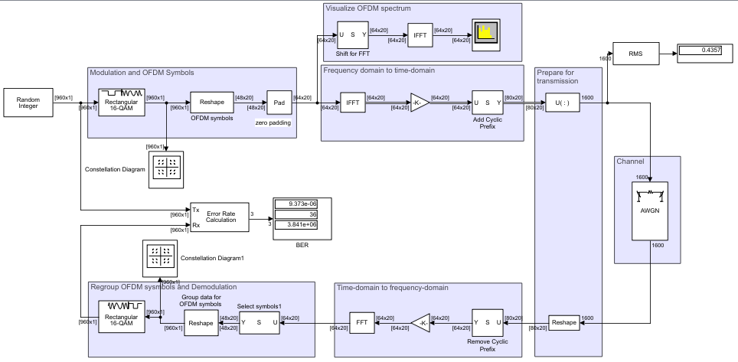**Figure 4.1 OFDM blocks simulation**

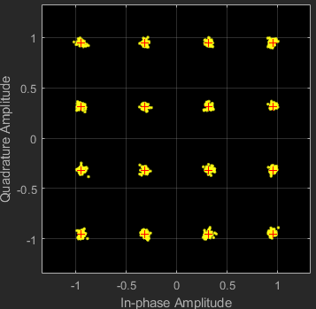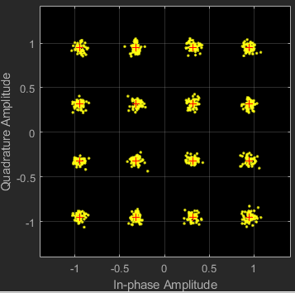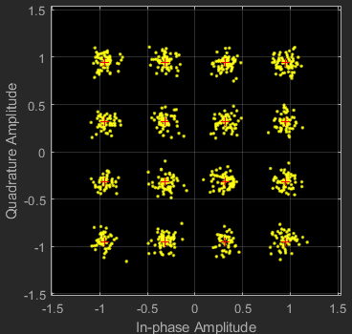**Figure 4.2 0db Figure 4.3 5db Figure 4.4 10db**

**Figure 4.5 15db Figure 4.6 20db Figure 4.7 25db**

It can be seen that the signal is severely distorted and most of the information would be lost at the receiver when Eb/N0 is 0db.

The Eb/N0 has a significant effect on the output in comparison to the input, the compactness of the data points around the constellation points would improve with the increases of Eb/N0. When the Eb/N0 of 25dB, the constellation is closest. Thus the theory (as a larger SNR should lead to less distortion seen at the output) is proved.

|  |  |  |  |
| --- | --- | --- | --- |
| **Eb/No (dB)** | **BER** | **EVM (dB)** | **MER (dB)** |
| **0** | **0.5335** | **-9.2** | **9.1** |
| **5** | **0.2172** | **-11.9** | **12.1** |
| **10** | **0.01679** | **-15.8** | **16.2** |
| **15** | **9.112*10-6** | **-20.7** | **21.1** |
| **20** | **0** | **-25.7** | **25.8** |
| **25** | **0** | **-30.7** | **30.3** |

The data shows the Eb/N0 increases, the BER decreases. If the SNR is high, there should be less distortion at the receiver. Thus the data with the theory is expected.

when the Eb/N0 increases, the EVM decreases. EVM (Average Error Vector Magnitude) is a measurement of how far away the points are from their ideal location. Therefore, a low value of EVM is preferred.

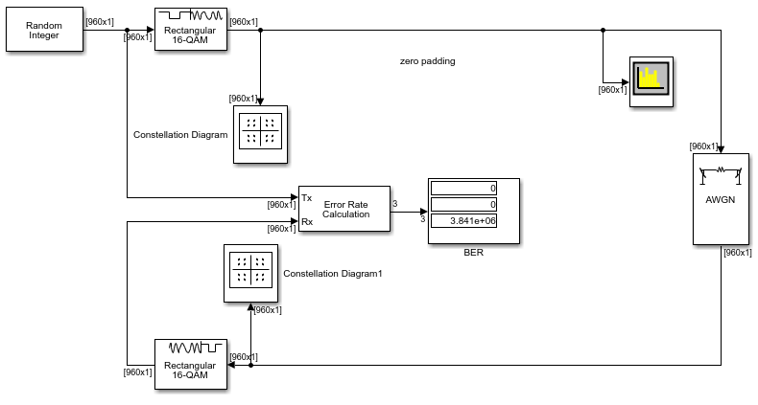**5. Simulation of a 16-QAM implementation without OFDM blocks**

**Figure 5. QAM-OFDM Simulink Model without OFDM Blocks**

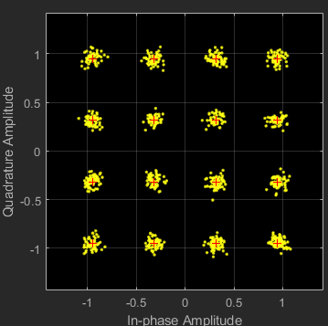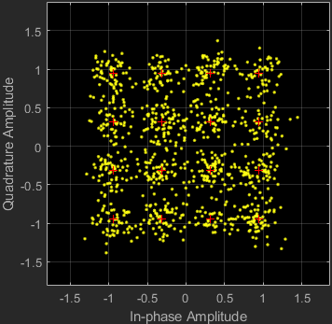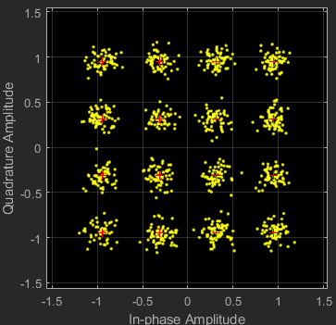**Figure 5.1 0db Figure 5.2 5db Figure 5.3 10db**

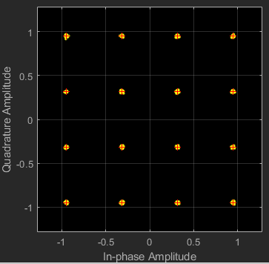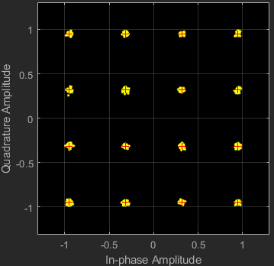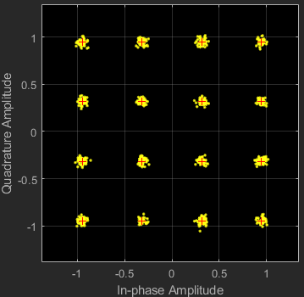

**Figure 5.4 15db Figure 5.5 20db Figure 5.6 25db**

|  |  |  |  |
| --- | --- | --- | --- |
| **Eb/No (dB)** | **EVM (dB)** | **MER (dB)** | **BER** |
| **0** | **-13.5** | **13.1** | **0.05335** |
| **5** | **-18.0** | **18.2** | **0.0003437** |
| **10** | **-22.9** | **23.1** | **0** |
| **15** | **-27.9** | **28.1** | **0** |
| **20** | **-32.9** | **32.8** | **0** |
| **25** | **-37.9** | **38.2** | **0** |

As expected, the BER and EVM decreased with the increases of Eb/N0. Showing the performance of the system will be better If the value of Eb/N0 is larger.

**6. Comparison and Summary**

According to the simulations, the model without the OFDM blocks performs better and the EVM and the BER of different Eb/N0 have better values due to OFDM has a higher data rate than QAM. Commonly, if a system has a higher data rate, it would increase error bits. vice a versa. Thus the performance would be better for lower data rates.

The constellations of two simulations are similar. However, it can be seen that the model without OFDM still has a better effect.

This report has explored the working principle of OFDM and the application of QAM techniques to increase data rates. The designations of modulator and demodulator are also introduced.

BER of a QAM-OFDM is also explored in the report. According to the several simulations, it can be seen that the values of BER would decrease when the Eb/N0 increases. Thus, the results are expected.

The constellation outputs of both models and the values for EVM and BER are all expected from the simulations.

The comparison part shows the two models are similar, they both have a small decrease in BER and EVM, and the data of simulations indicating the model without OFDM performed better.

By contrast, QAM-OFDM has a higher data rate, so BER and EVM values should be higher for this model. The constellations and the grouping of the points also performed better on the model without OFDM rather than QAM-OFDM model.

The performance of QAM seems better than the OFDM, however, the advantages of using OFDM are still obviously nowadays, such as the high data rate, High transmission speed. OFDM technologies will play an important in 5G LTE period.

**References**

[1] “What is Multicarrier Modulation” [Online]. Available: <https://www.electronics-notes.com/articles/radio/multicarrier-modulation/basics-techniques.php> [Accessed: 25/03/2020].

[2] Arrano, 2016. OFDM: today and in the future of next-generation wireless communications. Central America and Panama Student Conference (CONESCAPAN), pp.1–6.

[3] Terry Slattery and John Burke,” modulation” [Online]. Available: <https://searchnetworking.techtarget.com/definition/modulation> [Accessed: 25/03/2020].

[4]” Concepts of Orthogonal Frequency Division Multiplexing (OFDM) and 802.11WLAN”[Online].Available: <http://rfmw.em.keysight.com/wireless/helpfiles/89600b/webhelp/subsystems/wlan-ofdm/Content/ofdm_basicprinciplesoverview.htm> [Accessed: 26/03/2020].

[5] A. vonNagy, "PHY Basics: How OFDM Subcarriers Work", Revolution Wi-Fi, 2018.[Online].Available: <http://www.revolutionwifi.net/revolutionwifi/2015/3/how-ofdm-subcarriers-work> [Accessed: 26/03/2020].

[6] D. Kokane, "OFDM and its Applications", ECE Department, 2020.

[7] M. Brookes, "Digital Audio Broadcasting", SC5, 2020.

[8]” Study of Cognitive Radio Performance in Relation to Signal to Noise Ratio and Modulation Scheme”[Online].Available: <https://www.researchgate.net/publication/325959879_Study_of_Cognitive_Radio_Performance_in_Relation_to_Signal_to_Noise_Ratio_and_Modulation_Scheme> [Accessed: 26/03/2020].

[9]” QAM Modulator & Demodulator” [Online].Available: <https://www.electronics-notes.com/articles/radio/modulation/quadrature-amplitude-modulation-qam-modulator-demodulator.php> [Accessed: 27/03/2020].

[10]” Advantages of QAM | Disadvantages of QAM | 16QAM,64QAM,256QAM” [Online].Available: <https://www.rfwireless-world.com/Terminology/Advantages-and-Disadvantages-of-QAM-types.html> [Accessed: 29/03/2020].

[11] M. Khosroshahy, "QPSK Modulator/Demodulator", Masoodkh.com, 2018.[Online].Available: <http://www.masoodkh.com/projects/communications/18-qpskmodulatordemodulator> [Accessed: 29/03/2020].

[12]Amir Ligata, ” Bit Error Rate Analysis for an OFDM System with Channel Estimation in a Nonlinear and Frequency-Selective Fading Channel” [Online].Available:<https://jwcneurasipjournals.springeropen.com/articles/10.1155/2011/670637> [Accessed: 30/03/2020].