GitHub: Revision Control and

Change Management

What is Version Control?

* Version control is a system or method of tracking and controlling changes to your code, which is particularly useful when more than one person is involved in a project.
* It is commonplace in many IT Development areas such as programming.

Why is it so important?

* Tracking changes to code is important
* Managing changes in multi user environments is vital
* Keeping track of changes can be admittedly difficult without some form of control in place

You Have Probably used a form of it in the past.

* There are many programs that practice a limited version of version control & management
* Google Docs uses integrated limited revision control and version management for users to access prior versions and view what has been edited between them.

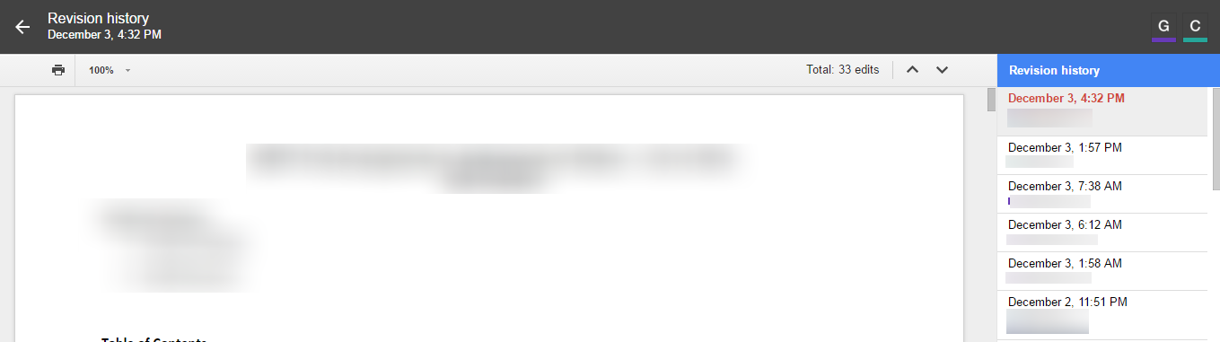

Figure Googles Versions Feature

**The platform**

For this case we will be using github, which offers a web interface to their tools and application so no install is necessary. This is one of the more popular tools present in many public projects that spans many areas of interest.

Offers all of the distributed revision control and code management functionality of other common tools as well as adding its own features.

In general Github:

* Is a platform for the management of Revisions and Code
* Offers all of the distributed revision control and code management functionality of other common tools as well as adding its own features.
* Includes Issue Tracking
* Includes Wiki Functionality

**Github Basic Documentation**

Many of the basic features of github are explained in github’s available documentation on the following page [**https://guides.github.com/**](https://guides.github.com/) which contains their official walkthroughs for a number of topics. For basic functions these references should answer any questions through their walkthroughs.

**Adding Collaborators**

In order for other group members to be able to directly add branches and edits to your repo and this can be done through the following. On the repository there will be a menu tab called “Settings”, which you need to go to in order to make the changes desired. Once here, select the collaborators menu option and add the desired users in your group.

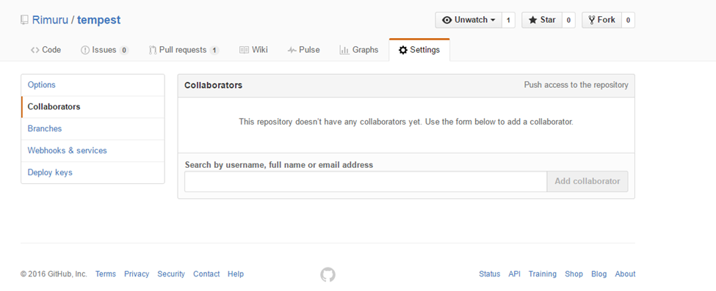

**General Terms**

* **Repository**: A general term for a file archive that stores the source code for programs or web pages. Many often incorporate revision control to support multiple users making changes.
* **Pull Request**: This is a request to integrate a change into the main code branch or to sync changes between branches.
* **Commit**: Pushing the changed code to the Revision Management Server
* **Branch**: This is an environment where you can try out new ideas without altering the main project files.
* **Fork**: This is the process of creating a copy of the repository in question on your own account in order to make changes without directly changing the master project.
* **Diff**: The differences between two versions of the file