1. Dataset Overview
- Total studies: 2019
- Total segmentation files: 87
- Total vertebra-level samples: 6,727
- Fractured (broken = 1): 1,444 (21.47%)
- Non-fractured (broken = 0): 5,283 (78.53%)

2. Study-Level Distribution
- Total studies: 2,019
- Studies with ≥1 fractured vertebra: 961 (47.6%)
- Studies with no fractures: 1,058 (52.4%)
- Key implication:
  - Study-level distribution is relatively balanced
  - However, imbalance emerges at the vertebra level within studies
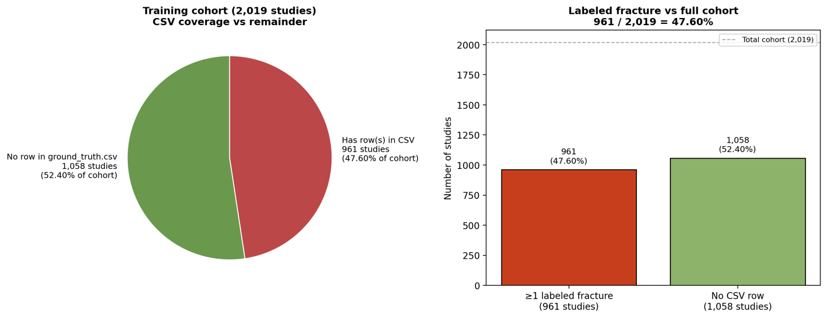

3. Vertebra-Level Fracture Distribution
- Fracture prevalence varies significantly across cervical levels:
  - C7: 40.89% (highest)
  - C2: 29.66%
  - C6: 28.82%
  - C5: 16.86%
  - C1: 15.19%
  - C4: 11.24%
  - C3: 7.60% (lowest)
- Key observations:
  - Lower cervical vertebrae (C6–C7) are substantially more fracture-prone
  - Upper levels (C3–C4) are underrepresented in fracture cases
  - This creates label imbalance across classes, not just binary imbalance
- Implications:
  - Models may bias predictions toward frequently fractured vertebrae (e.g., C7)
  - Poor sensitivity is likely for rare fracture locations (e.g., C3)
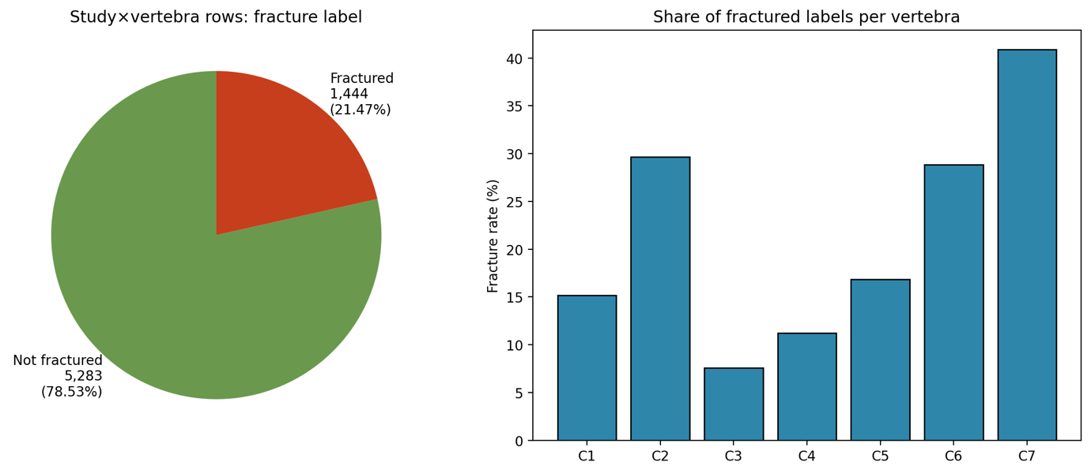

4. Pixel-Level Class Imbalance (Segmentation)
- Total pixels: 7.33 billion
- Background: 97.29%
- All vertebrae combined: 2.71%
- Per-class distribution:
  - Each vertebra class contributes ~0.21% – 0.31% individually
  - “Other vertebrae” class: 0.93%
- Key observations:
  - Extreme imbalance between background and foreground (~36:1)
  - Severe sparsity for individual vertebra classes
- Implications:
  - Standard loss functions (e.g., cross-entropy) will heavily favour background
  - Risk of trivial solutions (predicting mostly background)
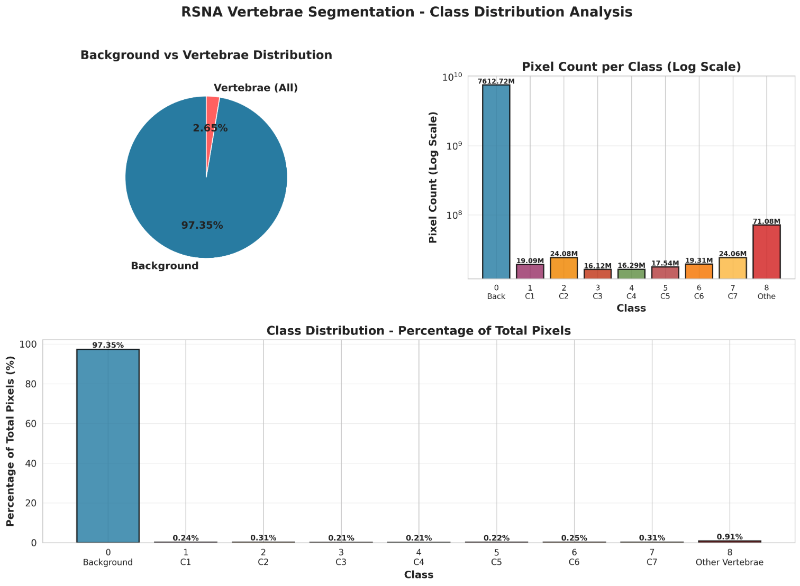

5. Data Volume and Slice Distribution
- Total studies with imaging: 2,019
- Slice statistics:
  - Min: 69
  - Max: 1,082
  - Median: 314
  - Mean: 352.5
- Segmentation-aligned slices (81 studies):
  - Min: 152
  - Max: 673
  - Median: 298
- Key observations:
  - High variability in scan length across studies
  - Potential inconsistency in spatial coverage and resolution
- Implications:
  - Models must handle variable input sizes
  - May require:
    - Resampling or normalization
    - Slice selection or 3D standardisation strategies

