Module2 - Rmarkdown Document 1

Prashant Dey

11/9/2018

# This is a level one header

## R Markdown

### this is a level three header

This is an R Markdown document. Markdown is a simple formatting syntax for authoring HTML, PDF, and MS Word documents. For more details on using R Markdown see <http://rmarkdown.rstudio.com>.

Here is link to [GOOGLE](https://google.com/)

Here is a word in **bold** and *italics*

Here is a word in ***BOLD Italics***

When we compile the the document, we are using the rmarkdown package.

2+2  
mean(c(1,2,3,4))

Here is an example of a non-numbered list:

* Breakfast
  + food
    - eggs
    - toast
    - bacon
  + drink
    - apple juice
* Lunch
  + taco
* Dinner
  + baked chicken
  + broccoli
  + rice

Here is an example of a numbered list:

1. Breakfast
   1. food
      1. eggs
      2. toast
      3. bacon
   2. drink
      1. apple juice
2. Lunch
   1. taco
3. Dinner
   1. baked chicken
   2. broccoli
   3. rice

Here is an example of a blockquote:

This is a block quote. This paragraph has two lines.

1. This is a list inside a block quote.
2. Second item.

Here is an example of a nested blockquote:

This is a block quote. This paragraph has two lines.

This text is nested

Here is an example of code in a blockquote:

2+2  
mean(c(1,2,3,4,5))

When you click the **Knit** button a document will be generated that includes both content as well as the output of any embedded R code chunks within the document. You can embed an R code chunk like this:

head(cars)

## speed dist  
## 1 4 2  
## 2 4 10  
## 3 7 4  
## 4 7 22  
## 5 8 16  
## 6 9 10

summary(cars)

## speed dist   
## Min. : 4.0 Min. : 2.00   
## 1st Qu.:12.0 1st Qu.: 26.00   
## Median :15.0 Median : 36.00   
## Mean :15.4 Mean : 42.98   
## 3rd Qu.:19.0 3rd Qu.: 56.00   
## Max. :25.0 Max. :120.00

## Including Plots

You can also embed plots, for example:



Note that the echo = FALSE parameter was added to the code chunk to prevent printing of the R code that generated the plot.

## Package

library(ggplot2)  
library(plotly)

##   
## Attaching package: 'plotly'

## The following object is masked from 'package:ggplot2':  
##   
## last_plot

## The following object is masked from 'package:stats':  
##   
## filter

## The following object is masked from 'package:graphics':  
##   
## layout

## Figures

cars %>%   
 ggplot(aes(x = speed, y = dist))+  
 geom_point(aes(color = speed))+  
 geom_line(aes(color = dist))+  
 theme_minimal()

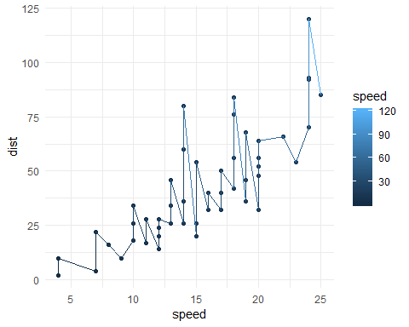

## Equation

$$Returns=Price_{t}/Price_{t−1}−1$$

or

$$Returns=ln(\frac{Price_{t}}{Price_{t−1}})$$