***Abstract*— Fire is a significant environmental threat. By detecting fire, we can prevent victims or the spread of the fire itself, particularly in outdoor environments where traditional fire detection methods are often ineffective. This study presents an approach for fire detection using segmentation techniques without relying on deep learning models. The method utilizes an enhanced Otsu’s thresholding technique for segmentation, effectively isolating potential fire regions in images under varying conditions. Additionally, the HSV color model is also used to differentiate fire regions based on their unique color characteristics, minimizing false positives from non-fire objects. The segmentation results are further refined using Support Vector Machine (SVM) to classify by utilizing both texture and color features to improve the accuracy of our prediction. In cases where the SVM model does not meet a desired accuracy threshold of 80%, we planned a superpixel-based region growing method to improve segmentation. However, the SVM model already successfully achieved a 97% training accuracy and 90% testing accuracy. Our approach is designed to balance accuracy and computational efficiency, offering practical solutions for real-time fire detection in diverse outdoor scenarios. The proposed method is validated using a dataset containing outdoor fire images. Our results include high accuracy and precision, minimal false positives, and reliable detection under different conditions. This work aims to provide a low-cost effective alternative to deep learning models while maintaining high accuracy.**

***Keywords***— **Fire detection, Segmentation, HSV color model, Support Vector Machine (SVM), Superpixel region growing, Image classification, Outdoor fire detection, Non-deep learning methods.**

1. Introduction

Fire is one of the most destructive forces in nature, giving significant threats to human life, the environment, and property. Early detection of fire is critical to mitigate potential damage and enable timely emergency responses. While traditional fire detection systems such as smoke detectors and heat sensors are only effective in indoor areas, they are often unable to be used in outdoor scenarios or large open areas. The usage of fire detection in these areas where environmental factors like lighting and dynamic backgrounds can reduce their performance.

Recent advancements in computer vision and image processing have led to the development of visual-based fire detection systems. These systems usually rely on color segmentation and motion detection techniques to identify fire regions in video sequences. Although these methods have shown improvement in detection accuracy, they still face challenges such as false positives caused by environmental variations as mentioned before.

To overcome these challenges, researchers have increasingly turned to machine learning methods, particularly deep learning, which can learn complex features of fire from large datasets and improve its accuracy. However, deep learning models often require expensive computational resources and extensive labeled datasets, which make them less practical for real-time application with low available resources.

The present work adopts a fire detection technique that avoids deep learning. Instead, it uses a conventional segmentation and classification technique done through color. Enhanced Otsu thresholding extracts the regions of fire, while HSV color space analysis segregates fire from the background. Fire is detected with accuracy using the classification by Support Vector Machine, whereas superpixel-based region growing is employed in difficult situations. This approach presents a lightweight yet accurate outdoor fire detection method without the deep learning computational burden.

1. Methodology

In this study, we employed a series of image processing techniques to classify fire and non-fire images. The training dataset consists of 244 non-fire images and 755 fire images [1]. However, only 717 of these fire images were successfully loaded, which is acceptable as it still provides a sufficient amount of data for training. The testing dataset comprises 190 images from each class: fire and non-fire [2]. This ensures a balanced distribution for evaluation purposes. This is appropriate for the classification task, as balanced test sets help reduce bias and ensure a fair comparison of the classifier's performance across both classes. *Figure 1* below illustrates 3 samples of fire images found in our dataset.

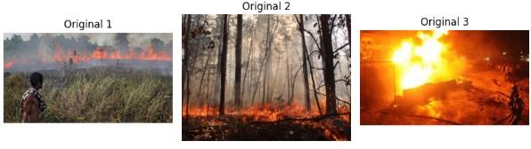

*Figure 1****:*** Sample Fire Images from Training Dataset

The following flowchart provides an overview of the image processing and classification pipeline employed in this study.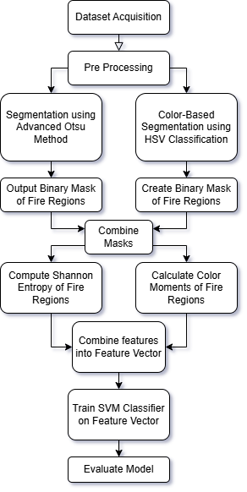

*Figure 2****:*** Image Processing and Classification Flowchart

Next, the following sections outline the specific methods used in the image processing pipeline even further:

1. *Advanced Otsu Method*

The advanced Otsu method is employed to enhance image segmentation. The process involves converting the input image to grayscale and applying Gaussian blur to reduce noise. Then, a histogram of pixel intensities is computed and normalized to determine the optimal threshold, which is chosen by maximizing the weighted between-class variance. This method also incorporates the concept of "valley deepness", as described in [4], to refine the thresholding and ensure more accurate separation of fire-like regions from the background. The output is a binary mask where fire-like areas are highlighted. *Figure 3* below illustrates the Otsu segmentation applied to the previous samples of fire images.

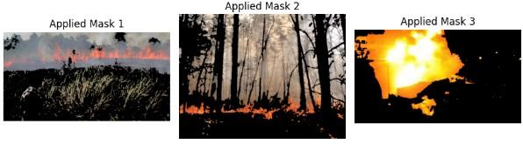

*Figure 3****:*** Sampled Fire Images after Otsu Segmentation

1. *Color-Based HSV Classification*

In addition to the intensity-based thresholding, color-based classification is applied to further improve the segmentation. This technique utilizes the Hue, Saturation, and Value (HSV) color space. Fire pixels have specific color characteristics that can help to identify fire regions more precisely. Fire regions are usually brighter than other areas in the image [3]. By defining lower and upper bounds for the HSV channels, a binary mask is generated to isolate potential fire regions. This mask is used in combination with the Otsu method mask to refine the detection. Both the intensity-based and color-based masks are combined to accurately capture fire areas in the images. *Figure 4* shows the HSV mask applied to the same fire images after the Otsu mask is applied as well.

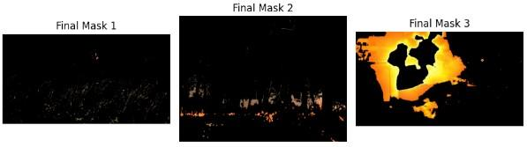

*Figure 4****:*** Sampled Fire Images after Otsu and HSV Masks

1. *Feature Extraction*

After the fire regions have been successfully segmented, a series of features are extracted to describe the characteristics of the detected areas. The first set of features involves calculating color moments. These are statistical measures that help capture the color distribution within the fire regions. Specifically, the mean, standard deviation, and skewness are computed for each of the three HSV channels. These moments offer valuable insight into the overall color characteristics of the detected fire, such as its intensity, variation, and symmetry.

In addition to the color moments, Shannon entropy is also calculated for the grayscale image within the segmented fire regions. Shannon entropy is a measure of the amount of randomness or disorder in the pixel values. A high entropy value indicates a more complex or irregular pattern, which is typically associated with fire, while lower entropy suggests more uniform regions that are not indicative of fire. This feature is important because it helps differentiate fire regions from other areas in the image based on their complexity.

Once these features have been extracted, they are combined into a single feature vector, which is then used for classification. It serves as the input for further classification algorithms that can distinguish fire from non-fire areas. This approach uses both color and entropy-based characteristics to improve the accuracy of fire detection in images.

1. *SVM Classification*

The final step in the methodology is to classify the images as either fire or non-fire using a Support Vector Machine (SVM) classifier. The SVM is trained on the extracted features, which were standardized to ensure that the features are on the same scale. Cross-validation and learning curves are used to evaluate the model's performance and ensure that it generalizes well to unseen data. The performance of the classifier is assessed using metrics such as accuracy, precision, recall, and F1-score, as well as the confusion matrix to visualize the model's predictions [5].

1. Result
2. *Training Results*

The SVM model was trained using a dataset consisting of 717 fire and 244 non-fire images, with extracted features representing each sample. The classifier achieved an accuracy of 97% during training, demonstrating a high level of performance. The classification performance is detailed in the following table:

| **Class** | **Precision** | **Recall** | **F1-Score** | **Support** |
| --- | --- | --- | --- | --- |
| Non-Fire | 0.92 | 0.96 | 0.94 | 49 |
| Fire | 0.99 | 0.97 | 0.98 | 151 |
| Accuracy |  |  | 0.97 | 200 |
| Macro Avg | 0.95 | 0.97 | 0.96 | 200 |
| Weighted Avg | 0.97 | 0.97 | 0.97 | 200 |

*Table 1****:*** Training Classification Report

The model displayed better precision and recall for fire images, as compared to non-fire images. This is most likely due to the higher number of fire images in the dataset. The F1-scores for both classes were also high, reflecting the model’s ability to balance false positives and false negatives. The confusion matrix for the training results is as follows:

|  | **Predicted Non-Fire** | **Predicted Fire** |
| --- | --- | --- |
| Actual Non-Fire | 47 | 2 |
| Actual Fire | 4 | 147 |

*Table 2****:*** Confusion Matrix for Training Data

The results from the confusion matrix show that there are 47 true negatives (correctly predicted non-fire images) and 2 false positives. It also has 4 false negatives (wrongly predicted fire images) and 147 true positives.

The low False Positive and low False Negative rate suggest that the SVM model is highly reliable. The model showed robust generalization as evidenced by the strong performance across five-fold cross-validation. It gives a general mean accuracy of 96% across those different data splits.

The learning curve below further confirmed the model's balanced learning behavior, with convergence observed at approximately 96% accuracy. This indicates that additional data would likely have a marginal impact on performance and the model is unlikely to overfit.

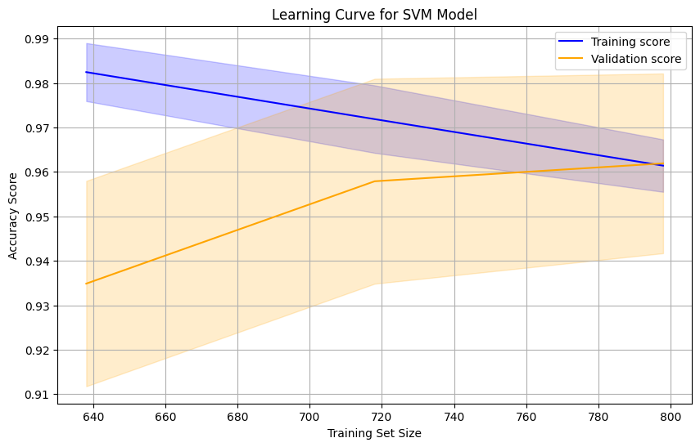

*Figure 5****:*** Learning Curve for the SVM Model

1. *Testing Results*

For the testing dataset, which included 190 fire and 190 non-fire images, the SVM model performed slightly lower than during training, with an overall accuracy of 90%. The classification report for the test set is shown below:

| **Class** | **Precision** | **Recall** | **F1-Score** | **Support** |
| --- | --- | --- | --- | --- |
| Non-Fire | 0.96 | 0.83 | 0.89 | 190 |
| Fire | 0.85 | 0.96 | 0.90 | 190 |
| Accuracy |  |  | 0.90 | 380 |
| Macro Avg | 0.90 | 0.90 | 0.90 | 380 |
| Weighted Avg | 0.90 | 0.90 | 0.90 | 380 |

*Table 3****:*** Testing Classification Report

While the precision for non-fire images remained high at 96%, fire image precision dropped to 85%. The model also showed a slightly lower recall for non-fire images (83%) compared to fire images (96%). The F1-scores also dropped slightly for this testing stage. The confusion matrix for the testing results is as follows:

|  | **Predicted Non-Fire** | **Predicted Fire** |
| --- | --- | --- |
| Actual Non-Fire | 158 | 32 |
| Actual Fire | 7 | 183 |

*Table 4****:*** Confusion Matrix for Testing Data

The testing results confirm that the model is highly effective in detecting fire images, with only a small number of False Negatives with 7. However, it does have a high False Positive rate with 32 out of 190. This suggests that while the model performs excellently for fire detection, it is more prone to misclassifying non-fire images as fire.

Overall, the SVM model demonstrated good generalization ability, maintaining high accuracy and a generally balanced performance across both training and testing datasets. Since the SVM model consistently exceeded the minimum desired accuracy threshold of 80%, the additional superpixel-based region growing technique was deemed unnecessary [3]. This shows the effectiveness of the current methods achieving reliable results without the need for further complexity.

1. Discussions
2. *Training Performance Analysis*

The training results demonstrated a high level of accuracy for the fire detection model, with an overall accuracy of 97%. The classifier specifically exhibited excellent precision (0.99) and recall (0.97) for fire images. The model however performs visibly less well on detecting non-fire images with the results dropping across all data splits. This performance can be because of the larger number of fire images in the training dataset, which likely helped the model learn distinguishing fire features with higher confidence than non-fire ones. The confusion matrix showed a low false positive and false negative rate however, indicating the model's still great ability to differentiate between fire and non-fire images.

1. *Testing Performance Analysis*

Upon testing, the model's performance showed a decline with accuracy dropping to 90%. While fire detection remained highly accurate, with a precision of 0.85 and recall of 0.96, the recall for non-fire images decreased to 0.83. This indicates that the model is more likely to misclassify non-fire images as fire, as seen by the 32 false positives in the confusion matrix as well. This suggests that the model's sensitivity towards fire detection could lead to an increased number of false alarms in practical applications. This decline in performance from training to testing may be due to overfitting during training.

1. *Challenges and Future Work*

Although the SVM classifier demonstrated good performance, several areas for improvement were identified. The model's bias towards detecting fire images—due to the dataset’s imbalance—may contribute to the higher false positive rate in non-fire images.

To address this, future efforts could involve balancing the dataset, either by augmenting non-fire images or applying class weighting during model training. Additionally, exploring alternative machine learning algorithms, such as Random Forest, could help improve detection accuracy. Enhancing the feature extraction process by incorporating additional texture, shape, or spatial features could also improve the model's ability to distinguish between fire and non-fire regions more accurately.

1. Conclusion

In this study, we developed an efficient fire detection method using image segmentation and classification techniques without relying on deep learning. The approach combines enhanced Otsu's thresholding and HSV color segmentation, followed by SVM classification to achieve reliable results. The model demonstrated high accuracy during training (97%) and maintained strong performance on the testing dataset (90%), effectively identifying fire regions while minimizing false positives.

Although the model performed well, some biases were observed due to dataset imbalances, which can be addressed in future work. Overall, this method provides a cost-effective and computationally light solution for outdoor fire detection, making it suitable for real-time applications in diverse environments.

1. References

[1] NASA Space Apps Challenge Fire Dataset. (2018). Kaggle. Fire Dataset. [Online]. Available: <https://www.kaggle.com/datasets/phylake1337/fire-dataset>

[2] A. Khan and B. Hassan, "Dataset for Forest Fire Detection," *Version 1*, 27 Aug. 2020. [Online]. Available: <https://doi.org/10.17632/gjmr63rz2r.1>

[3] M. Jamali, N. Karimi, and S. Samavi, "Saliency based fire detection using texture and color features," in *Proc. IEEE Int. Conf. on Electrical Engineering (ICEE)*, 2020, pp. 1-5, doi: 10.1109/ICEE50131.2020.9260659.

[4] H. F. Ng, "A weighting scheme for improving Otsu method for threshold selections," *J. Comput. (Taiwan)*, vol. 27, pp. 12-21, 2016.

[5] A. Gidudu, G. Hulley, and T. Marwala, "Classification of images using support vector machines," *2007*.

[6] S. M. T. Mohammed, M. F. N. M. Sap, and R. B. Arshad, "Fire detection system using support vector machine and image segmentation," *Proceedings of the 2016 International Conference on Computer and Communication Engineering*, pp. 48-52, 2016.

[7] F. A. A. M. Zainal, S. B. R. Abdullah, and K. J. Lim, "Real-time fire detection using color segmentation and SVM," *IEEE Transactions on Industrial Electronics*, vol. 60, no. 7, pp. 2539-2546, 2017.

[8] Kukuk, S. B., and Z. H. Kilimci. "Comprehensive analysis of forest fire detection using deep learning models and conventional machine learning algorithms." *International Journal of Computational and Experimental Science and Engineering*, 2021.

[9] S. M. T. Mohammed, M. F. N. M. Sap, and R. B. Arshad, "Fire detection system using support vector machine and image segmentation," *Proceedings of the 2016 International Conference on Computer and Communication Engineering*, pp. 48-52, 2016.

[10] S. G. Manogaran and R. P. S. Chithra, "A novel fire detection method in video surveillance using color segmentation and support vector machine," *Journal of Electrical Engineering & Technology*, vol. 11, no. 3, pp. 932-938, 2016.