TASKS

Task 1: Basic calculator

You are creating a basic calculator program for students to practice arithmetic operations. The calculator

should allow users to perform addition, subtraction, multiplication, division, and power on two

numbers entered via user input. Each operation will be executed using separate functions

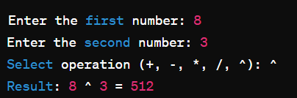

Task 2: ATM system

Create a simple ATM system that allows users to check their balance, deposit funds, and withdraw funds. Use functions to perform each operation and use if-else ladders to validate user input and ensure that withdrawals do not exceed the available balance. Use loops to allow multiple transactions until the user chooses to exit.

Sample Output:

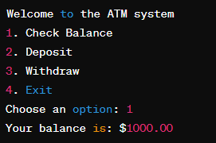

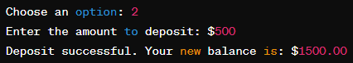

Task 3: Number Analysis

Write a C++ program that includes functions to find the least significant digit and most significant digit of a three-digit number. Additionally, implement functions to calculate the sum of digits and determine whether the number is a palindrome

Sample Output:
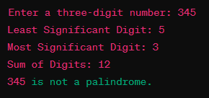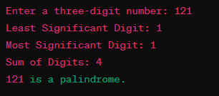

Task 4: Driving Eligible

Design a C++ program to assess a person's eligibility for driving based on age, vehicle type preference (car or motorcycle), and possession of a valid driving license. The program prompts the user to input their age, vehicle type preference, and whether they possess a valid driving license. Eligibility is determined based on the following criteria: minimum age requirements (18 for car, 16 for motorcycle), necessity of a valid driving license for driving a car, and local regulations regarding motorcycle driving. The program then displays a message indicating the person's eligibility status.
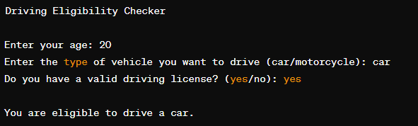
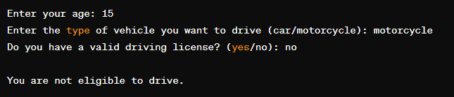

Task 5: Personal Finance Tracker

Develop a C++ program for personal finance tracking. The program should allow users to record financial transactions, categorize expenses, calculate total expenses and income, and view their budget.
Instructions:
Present a menu with the following options:
- Record Transaction: Users can record a transaction by entering the category and amount.
- View Expenses: Display the total expenses recorded.
- View Income: Display the total income recorded.
- View Budget: Display the budget, calculated as the difference between total income and total expenses.
- Exit: Terminate the program.
When recording a transaction, prompt the user to input the category and amount. Positive amounts denote income, while negative amounts denote expenses. Categorize each transaction as income or expense based on the amount entered. Display the category and amount of each transaction. Calculate and display the total expenses and income. Calculate and display the budget, which is the difference between total income and total expenses. Continue displaying the menu and prompting for options until the user chooses to exit.
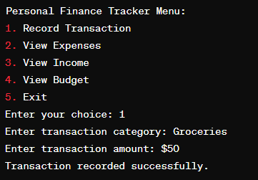

Task 6: Circular Pattern

Design a C++ program that generates a circular pattern using trigonometric functions and displays the coordinates of points along the circumference of the circle. Prompt the user to input the radius and no. of points of the circle. Generate points along the circumference of the circle using the sine and cosine functions. Calculate the coordinates of each point using the formula and Display the coordinates of each point to the user
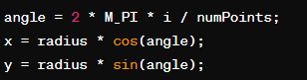
Sample Output:
