BUILD.CONTROL

We have to save a DL PACK in BCON the following steps are abided

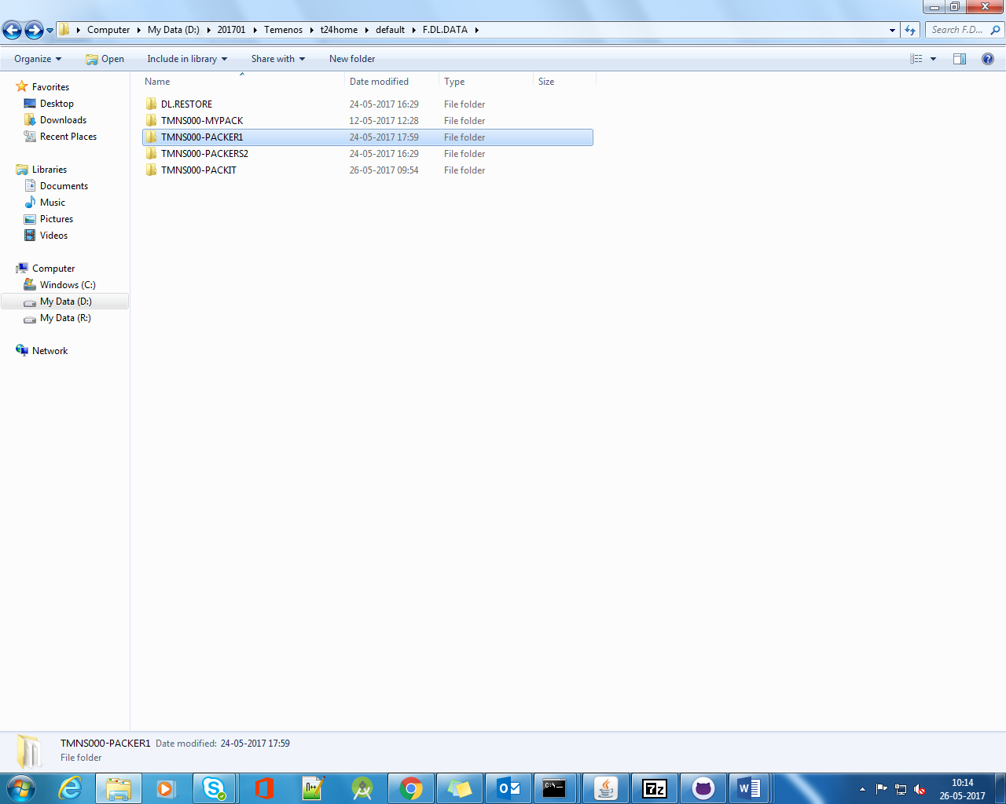

Select a pack in F.DL.DATA folder.

Mention the SAVE folder and DL.DEFINE.

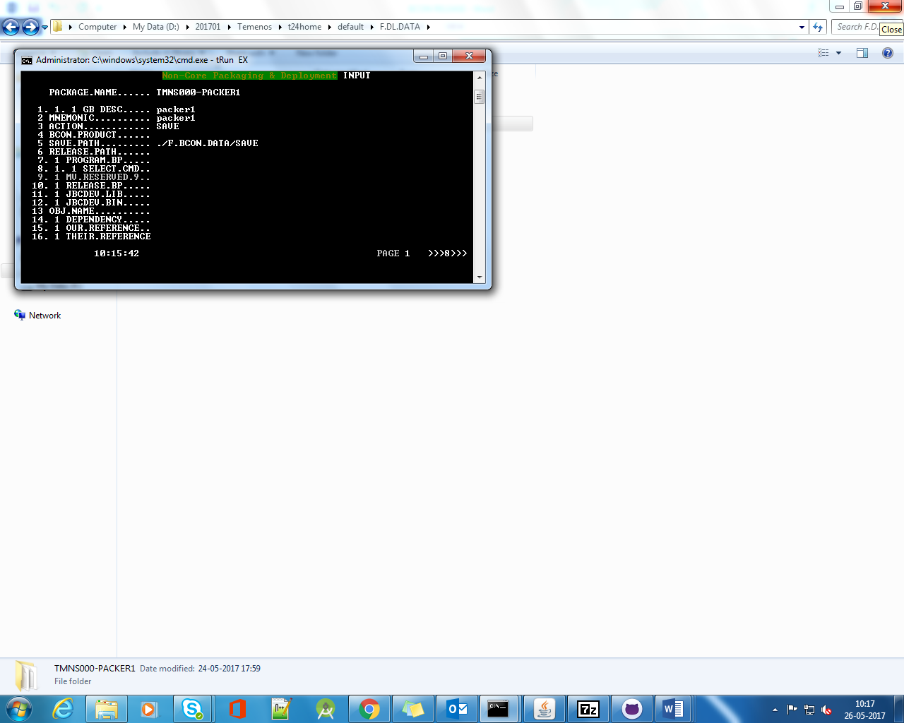

The programs are saved into the save folder as specified.

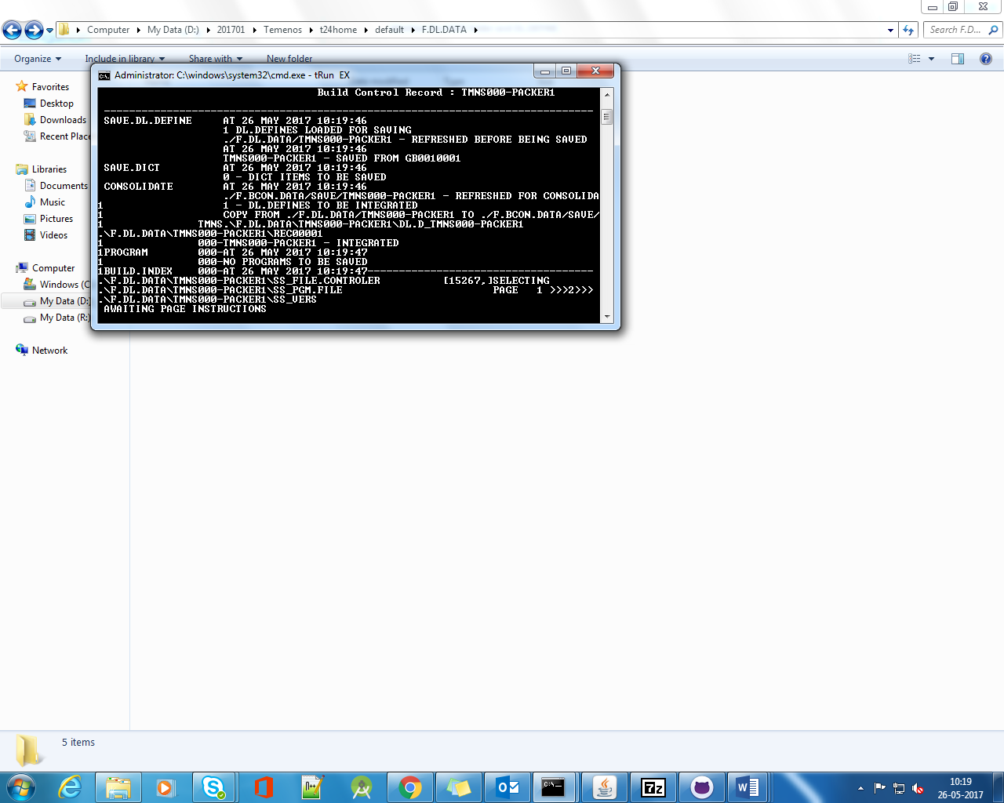

To release add the pack into F.BCON.DATA/RELEASE

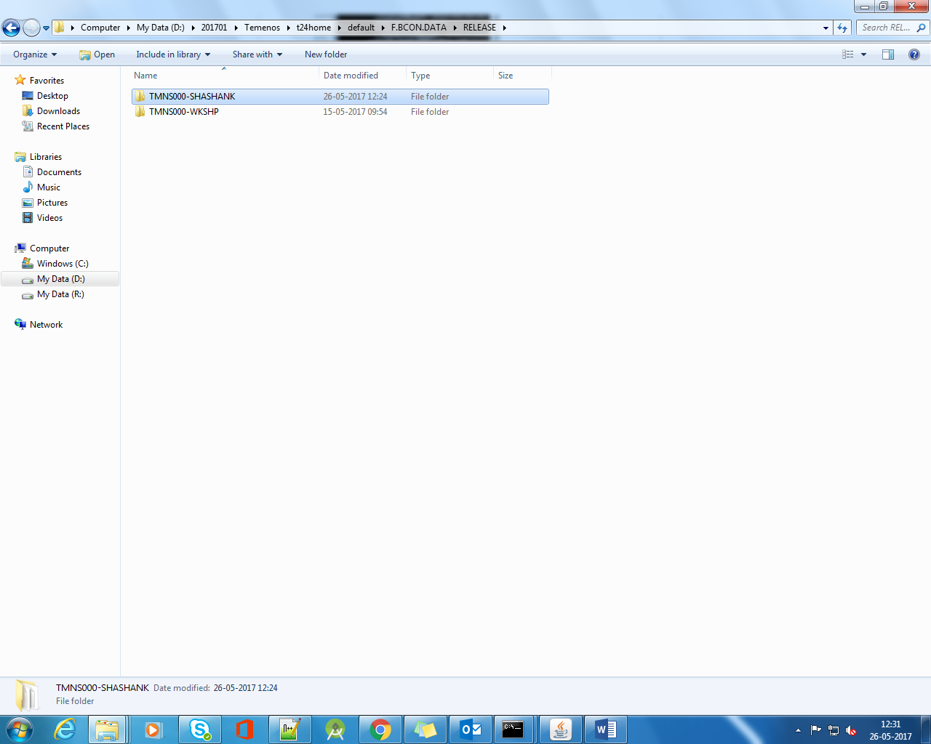

In BCON enter the release path and in OFS.SOURCE.ID enter BUILD.CONTROL

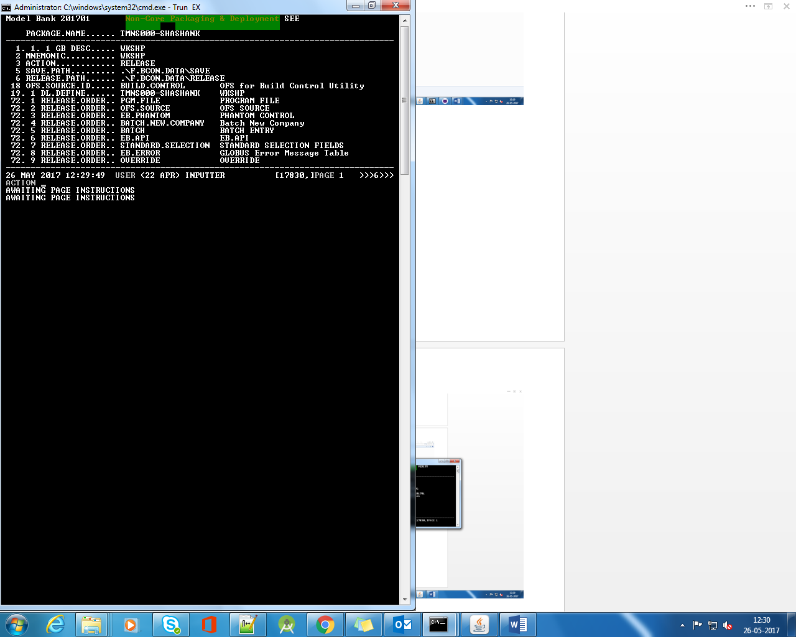

After proper release the pack folder can be found in F.DL.DATA & F.DL.DATA/DL.RESTORE

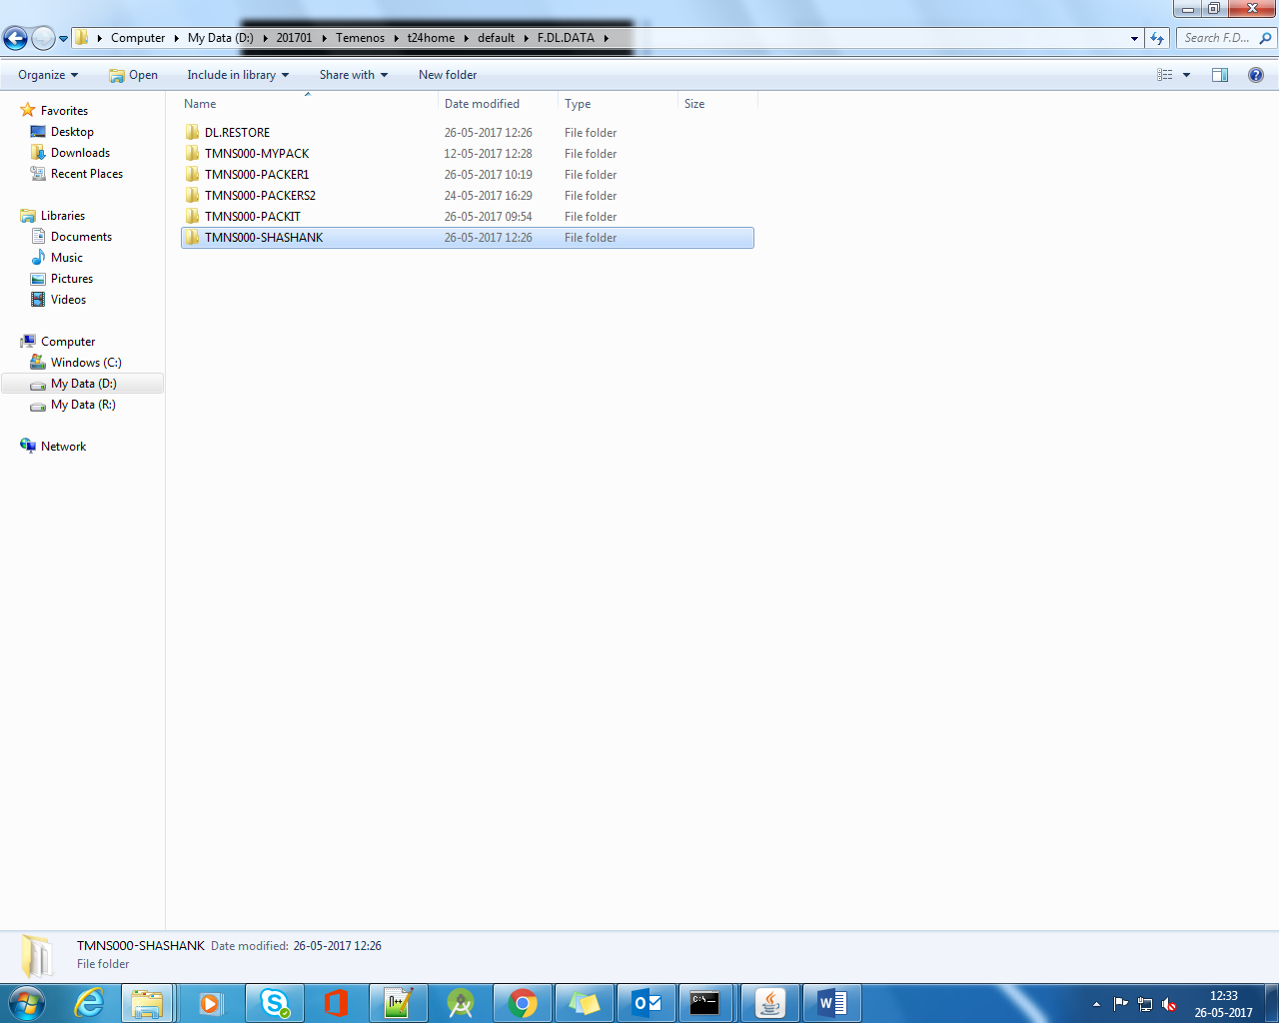

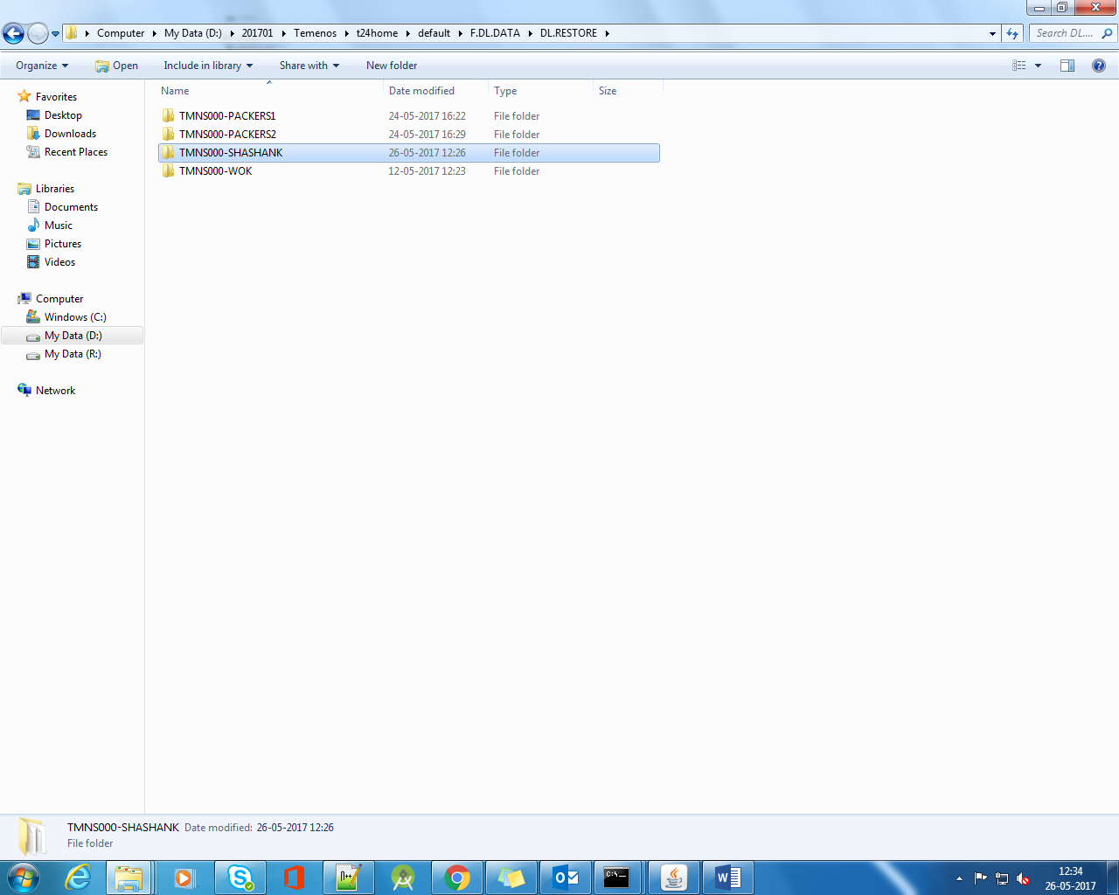

The released records are in IHLD in the target area.

