DL.DEFINE

* Make a text file that has record that needs to be made a pack of in this format.

Eg. FILE.CONTROL>EB.FT.TXN

* Make folders &SAVEDLISTS& and drop the text file in the same folder.
* Create folders F.DL.DATA & F.DL.DATA/DL.RESTORE.
* Make a DL.DEFINE record and verify the same.

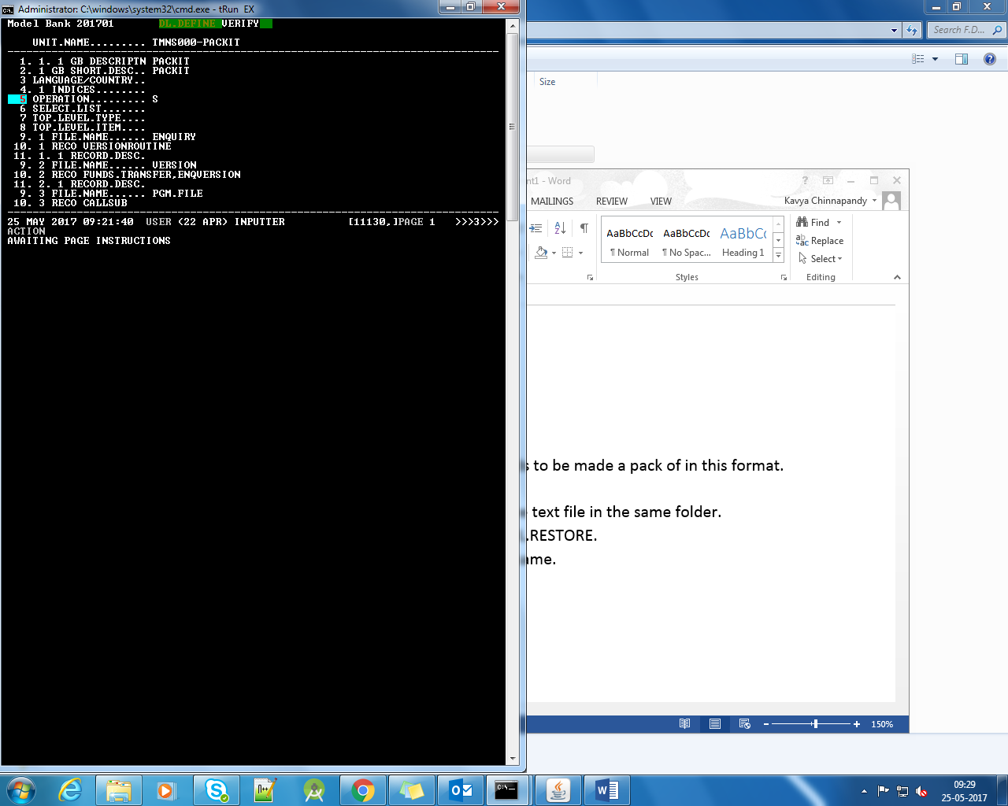

* The saved pack can be found in F.DL.DATA.

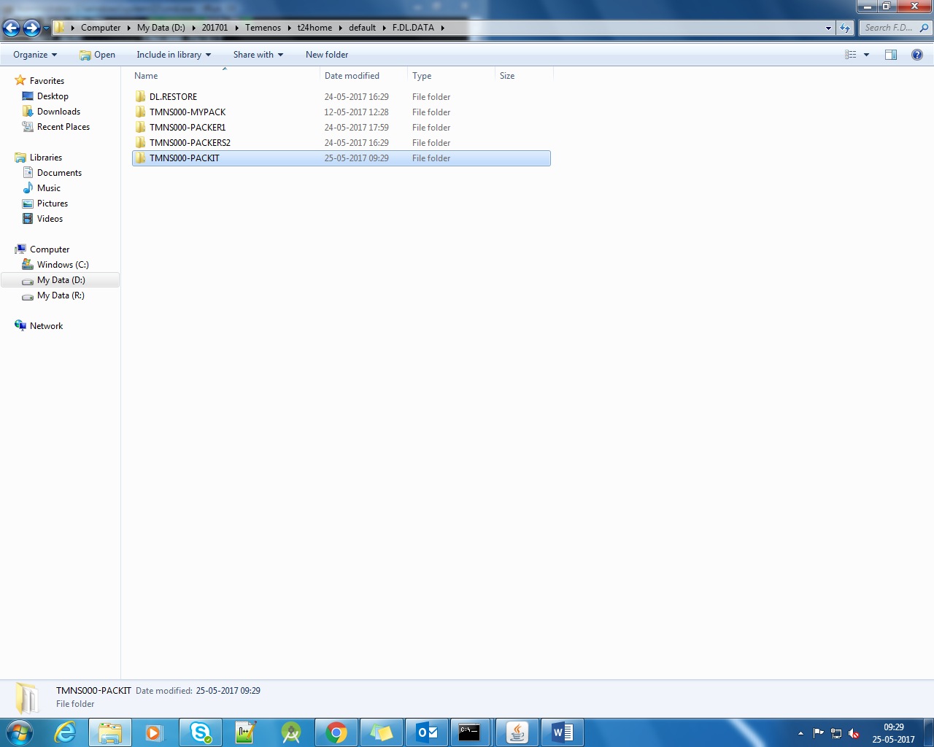

To release a pack in DL.DEFINE add the pack in F.DL.DATA/DL.RESTORE and make an entry for the pack in DL.PARAMETER(@ID SYSTEM)

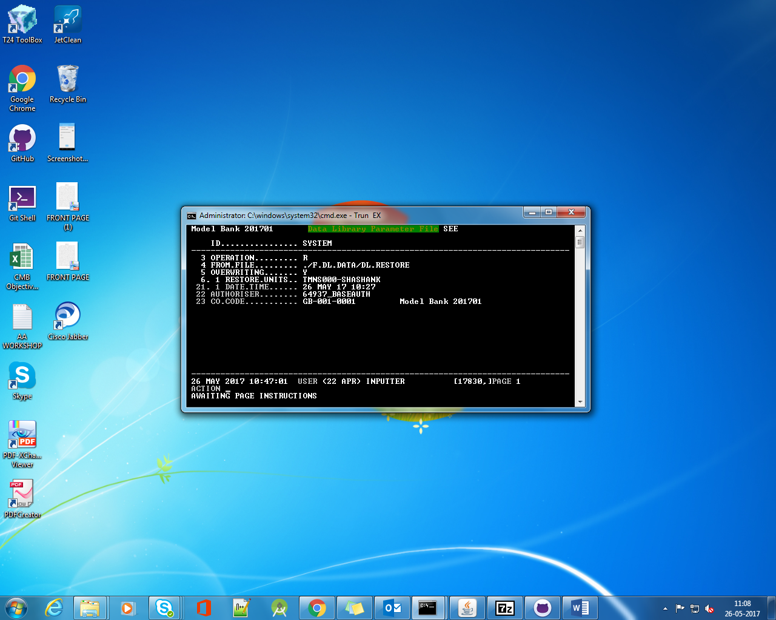

Check DL.DEFINE for ID specified in DL.PARAMETER and verify the recors.

All the records from the pack are released into our area in IHLD mode.

