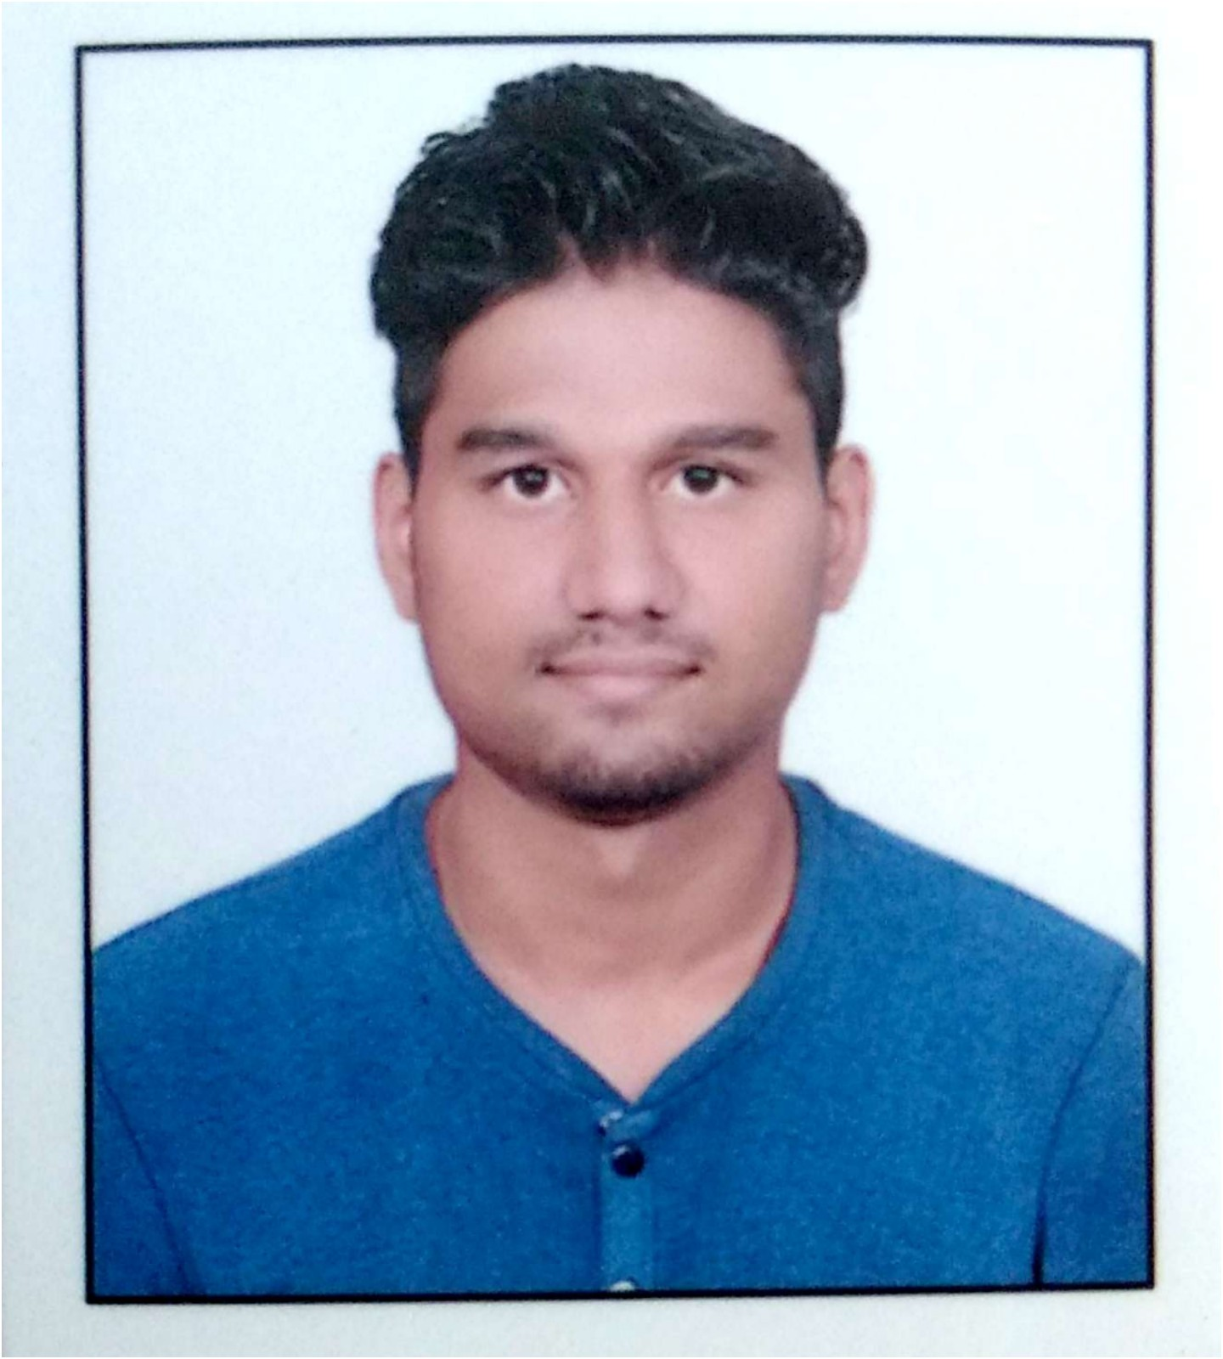

# CURRICULAM VITAE

**NAME**  : Mr.Rahul Yuvraj Jadhav

**ADDRESS**  :MIHIR PARK R/H -03,BEHIND BURKULE

HALL,JOGESHWARI APP. AMABAD LINK

ROAD,UTTAM NAGAR NEW CIDCO NASHIK-422009

**MOBILE NO**  : 9765435436

**EMAIL ID** : [rjrahul.jadhav3004@gmail.com](mailto:rjrahul.jadhav3004@gmail.com)

­­­­­**______________________________________________________________________________**

**CAREER OBJECTVE:**

* To continue my career with an organization that will utilize my MANAGEMENT, SUPERVISION & ADMINISTRATIVE skills to benefit mutual growth and success.

______________________________________________________________________________

# EDUCATIONAL QUALIFICATION:

|  |  |  |  |  |  |
| --- | --- | --- | --- | --- | --- |
| **Sr.** | **DEGREE** | **UNIVERSITY** | **YEAR OF PASSING** | **PERCENTAGE** | **CLASS** |
| **1** | **S.S.C** | Pune University | 2012 | 68.59 | First Class |
| **2** | **H.S.C.** | Pune University | 2014 | 60.00 | First Class |
| **3** | **FYBCA** | Pune University | 2015 | 60.00 | First Class |
| **4** | **SYBCA** | Pune University | 2016 | 58.00 | Second Class |
| **5** | **TYBCA** | Pune university | 2018 | ---------- | Appearing |

# EXPERIENCE

**FRESHER**

**______________________________________________________________________________**

# TECHNICAL SKILLS

* Basic Computer Skills
* Knowledge of C/C++/VB/ASP.NET/CSS/HTML/JAVA/MY-SQL
* Certificate In C And C++.
* Typing 40 Speed (English)
* Typing 30 Speed (Marathi)
* Certificate of MS-CIT And MS-Office
* Windows Operating Sytem, XP, Window 95, Windows 8, Windows 10.
* Knowledge of WordPress Development, And Design.
* Google Certificate Of Digital Unlock [Fundamental Marketing]
* PYTHON PROGRAMMING Certificate

____________________________________________________________

# PERSONAL INFORMATION:

|  |
| --- |
|  |

* **Name :** Mr.Rahul Yuvraj Jadhav
* **Date of birth**   **: 06/03/1997**
* **Marital Status :** Unmarried
* **Permanent Address :**  MIHIRPARKR/H-03,BEHINDBURKULE

HALL.JOGESHWARI APP. AMABAD LINK

ROAD,UTTAM NAGAR NEW CIDCO NASHIK 422009

* **Languages Known** : English, Hindi, Marathi,

I here by declare that all this statement made in this form is correct to the best of my knowledge and belief.

**DATE : ____________**

**(________________)**

**PLACE** : **________ Rahul Jadhav**