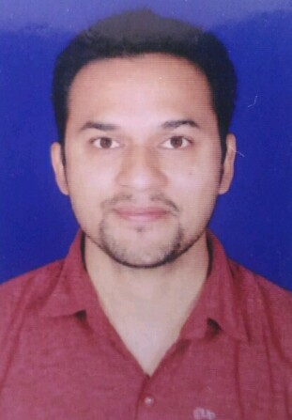



Linkedin.com/in/Swapnil PPingale



Swapnil.pingle7@gmail.com

**SWAPNIL PINGALE**

Marketing and Sales



8275583719

**CAREER OBJECTIVE**

**WORK EXPERIENCE**  
3 Years

**Aspires to pursue challenging assignments in Marketing/Business Operations Management with a front-line organization.**



**Education**

**Diploma in Civil Supervisor** Graduated, April 2015Dr. Moonje Institute, Nashik. Marks 60.53%  
Pune University   
Pune, Maharashtra

**Bachelor, Computer Application** Graduated, April 2013Panachvati College, Nashik. Marks 45.95%  
Pune University   
Pune, Maharashtra.

**H.S.C 12th** First Class, Feb 2008Govt College Marks 60.50%  
Maharashtra Board   
Nashik, Maharashtra.



**Professional Projects**

* Kaizen (CII) Event Management Project.
* MBA Coca Cola Sales Project.
* BCA Mobile Banking Project.



**Skills**

* Communication Skills
* Time Management
* Ability to Work Under Pressure.
* Decision Making



**Work Experience**

**May 2017 Business Development Executive (B2B Sales)**

**Perfect Engineering Works, Ambad Nasik.**

**Perfect Engineering Works, all types of Blades manufacture.**

**I work with this company May 2 2017.**

* Identifying new sales leads.
* Pitching products and/or services.
* Maintaining fruitful relationships with existing customers.
* Researching organizations and individuals online (especially on social media) to identify new leads and potential new markets.
* Researching the needs of other companies and learning who makes decisions about purchasing.
* Contacting potential clients via email or phone to establish rapport and set up meetings.
* Planning and overseeing new marketing initiatives.
* Attending conferences, meetings, and industry events.

**Government Online Exams Conduct**

**Sify Technologies Ltd.**

* SSC (Staff Selection Commission)
* IIBF

**Aptech Ltd.**

* Mahagenco.
* Mahatranco.

**Satvat Infosol**

* RRB (Railway Recruitment Board)

**APRIL 2016 – APRIL 2017 Sales Manager**

**Hero MotoCorp (Trambakraj Automobiles) Trambakeshwar Nasik.**

* Responsible for selling of Hero bikes & Accessories. Handling walking Clients for Sales, Inquiries, Complaints & Service issues.
* After sales service for registration of bike from RTO office. Processing of loan for bikes from Auto finance companies. Arranging Bike Exchange Melas.
* To motivate the advisers for selling of Insurance policies to achieve the targets. Maintaining relations with the customers.
* Monthly target-based job.



**Computer Proficiency**

* Word 2010
* Excel 2010
* Power Point 2010



**Languages**

* English Hindi Marathi



**Personal Interests**

* Cricket, Swimming, Surfing, Singing.
* Online Exams Conduct.
* I have experience in various online exams conduct e.g. SSC, MSRTC, JE Etc.



**Personal Details**

Name: Mr. Swapnil Pingale Marital Status: Married  
Birthday: DEC 06, 1989 Nationality: Indian  
Gender: Male

**Declaration**

**Declaration**

I, Swapnil Pingale, hereby declare that the information contained herein is true and correct to the best of my knowledge and belief.

Swapnil Pingale

Nashik, Maharashtra