UFCFXK-30-3 - Digital Systems Project

Formal Project Proposal

Student full name: | Nguyen Nhat Minh
Programme: | Computer Science - Artificial Intelligence
Student no: | 23085487
Email address: | W11220031@st.phenikaa-uni.edu.vn
Supervisor full name: | Mai Xuan Trang

Details of Project:
Project title: | Design and Development of an AI Agent–Based Customer Support System for Hotel Using Retrieval-Augmented Generation
Brief description of topic: | This project focuses on the design and development of an AI agent–based hotel customer support system to assist guests with common service enquiries and issues during their stay. Traditional hotel support systems often rely on static FAQs or human-operated chat services, which may struggle to handle complex guest requests efficiently or consistently.  The proposed system integrates Retrieval-Augmented Generation (RAG) to provide knowledge-grounded responses based on hotel policies and service information. Unlike conventional chatbots, the system is designed as an autonomous AI agent capable of analysing guest requests, generating appropriate responses, and making decisions on whether issues can be resolved automatically or require escalation to hotel staff. The project aims to demonstrate how agentic AI can improve the reliability and practicality of customer support within the hospitality domain.
Aims and objectives: | Aim  The aim of this project is to design and implement an AI agent–based customer support system for hotels that provides accurate, policy-aware assistance to guests while autonomously deciding when to escalate requests to human staff.  Objectives  - To review existing research on conversational AI, Retrieval-Augmented Generation, and agentic large language models in customer support contexts.  - To design a system architecture for an AI agent that supports hotel guest enquiries and service-related issues.  - To integrate Retrieval-Augmented Generation to ensure responses are grounded in hotel policies and service information.  - To implement decision-making logic that enables the AI agent to determine whether a request can be handled automatically or requires escalation.  - To evaluate the system through representative hotel customer support scenarios and analyse its effectiveness and limitations.
Full details of initial literature sources, in correct UWE Harvard format: | Shum, H.-Y., He, X. and Li, D. (2018) From ELIZA to XiaoIce: Challenges and opportunities with social chatbots. Frontiers of Information Technology & Electronic Engineering [online]. 19 (1), pp. 10–26. Available from: https://doi.org/10.1631/FITEE.1700826.  Wang, Y., Zhang, Y., Liu, Y., Li, C. and Song, J. (2022) Task-oriented dialogue systems in customer service: A survey. ACM Computing Surveys [online]. 55 (4), pp. 1–37. Available from: https://doi.org/10.1145/3485133.  Lewis, P., Perez, E., Piktus, A., et al. (2020) Retrieval-augmented generation for knowledge-intensive NLP tasks. Advances in Neural Information Processing Systems [online]. 33, pp. 9459–9474. Available from: https://papers.nips.cc/paper/2020/hash/6b493230205f780e1bc26945df7481e-paper.pdf.  Russell, S. and Norvig, P. (2021) Artificial Intelligence: A Modern Approach. 4th edn. Harlow: Pearson.  OpenAI (2023) GPT-4 technical report. arXiv [online]. Available from: https://arxiv.org/abs/2303.08774.  Buhalis, D. and Law, R. (2008) Progress in information technology and tourism management: 20 years on and 10 years after the Internet. Tourism Management [online]. 29 (4), pp. 609–623. Available from: https://doi.org/10.1016/j.tourman.2008.01.005.  Ivanov, S. and Webster, C. (2019) Conceptual framework of the use of robots, artificial intelligence and service automation in tourism. International Journal of Contemporary Hospitality Management [online]. 31 (7), pp. 2697–2717. Available from: https://doi.org/10.1108/IJCHM-04-2018-0340.
Signed (student): | 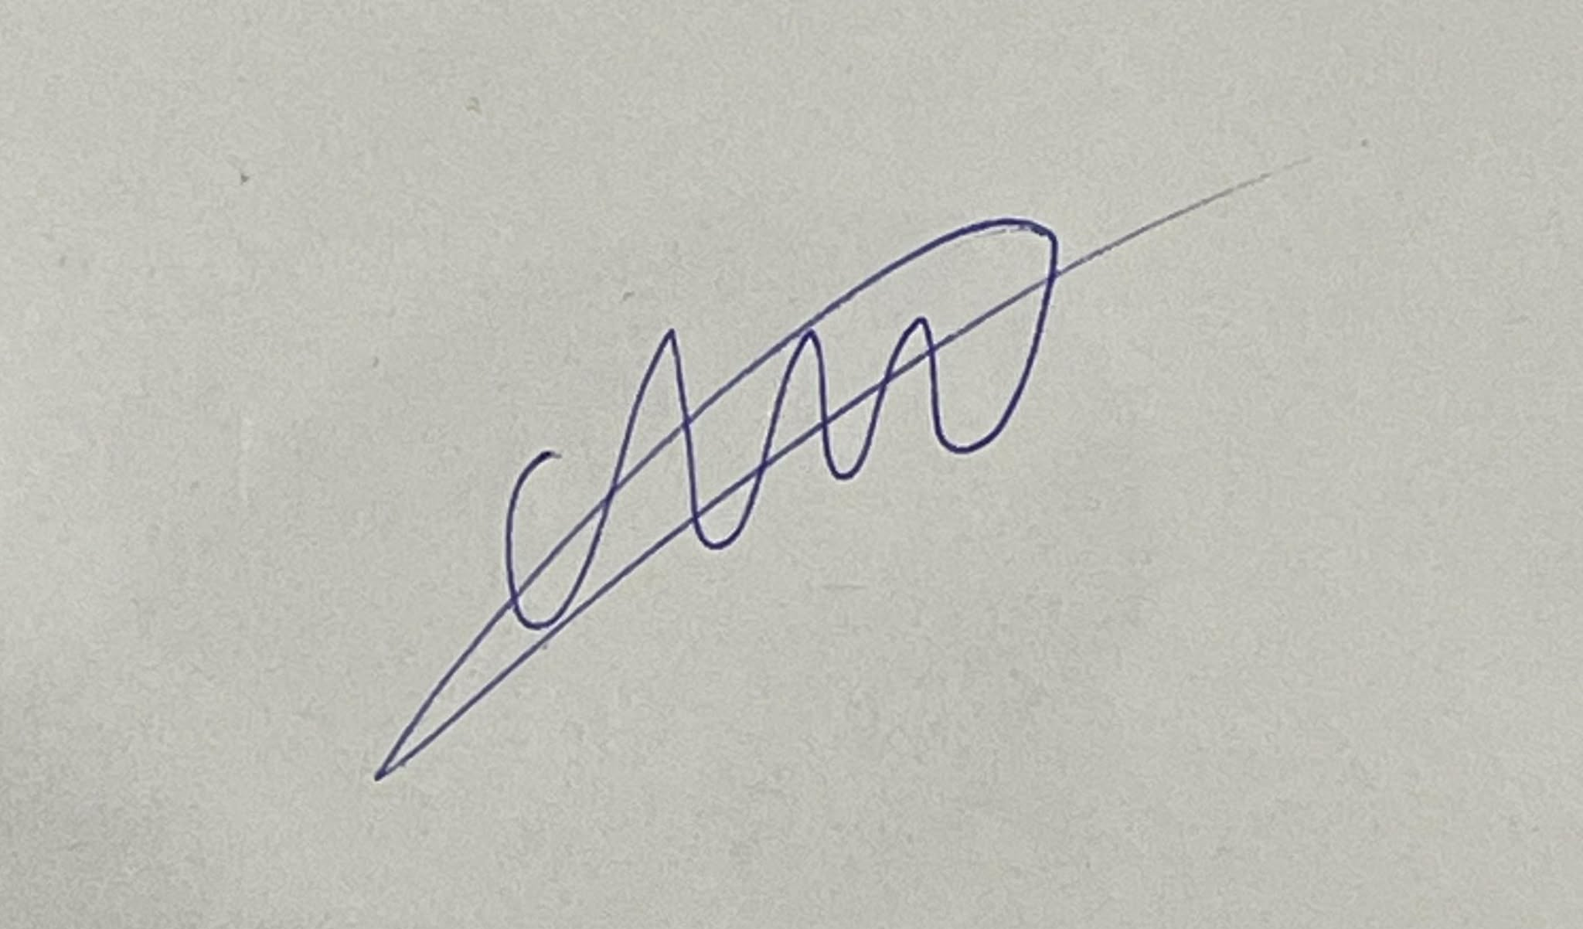
Signed (supervisor):

