**CME 2202 Data organization and management**

Assignment 1

File Convertor – BinToXML

Done by: 2020510130 Rinat Zhulfayev

2020510108 Aslan Tuyak

BinToXML is a program that reads and then converts binary file into XML file.

The following libraries were used to complete the task:



<stdio.h> standard library of C programming language which includes file input\output functions.

<stdlib.h> standard library of C programming language which includes functions involving memory allocation, process control, conversions and others.

The whole process takes place in a function ”binaryToXML” whose parameters are name of the binary file, and required name for the created xml file.



First of all, a binary file is opened which is scanned and translated from a binary language. Then the received information is stored in the structure and written to the created XML file.

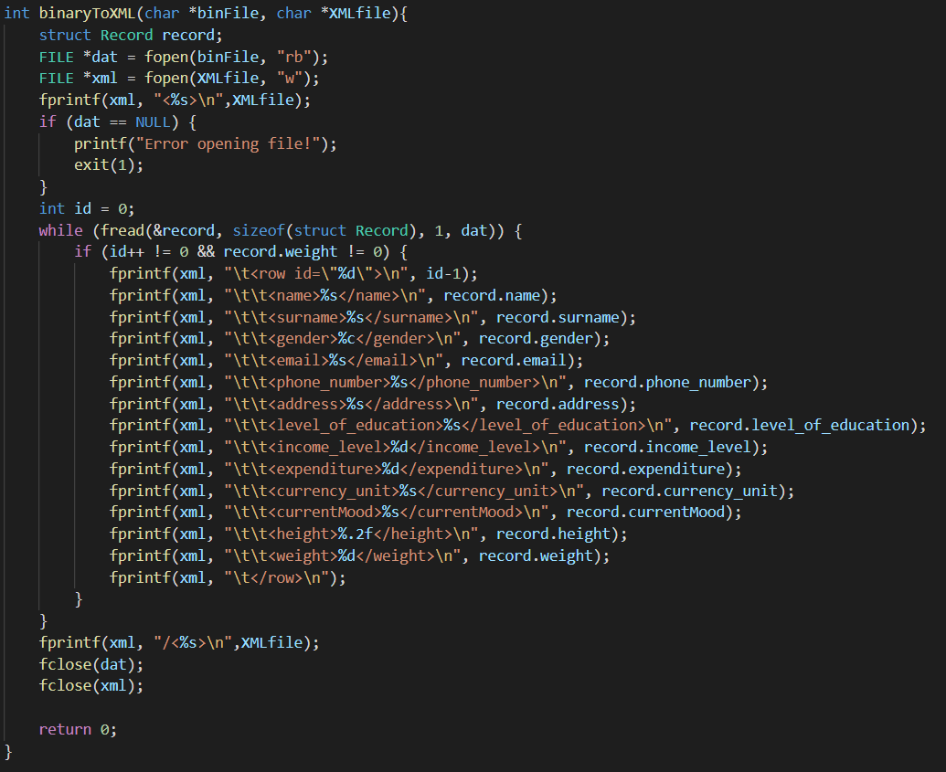

Sample input file:

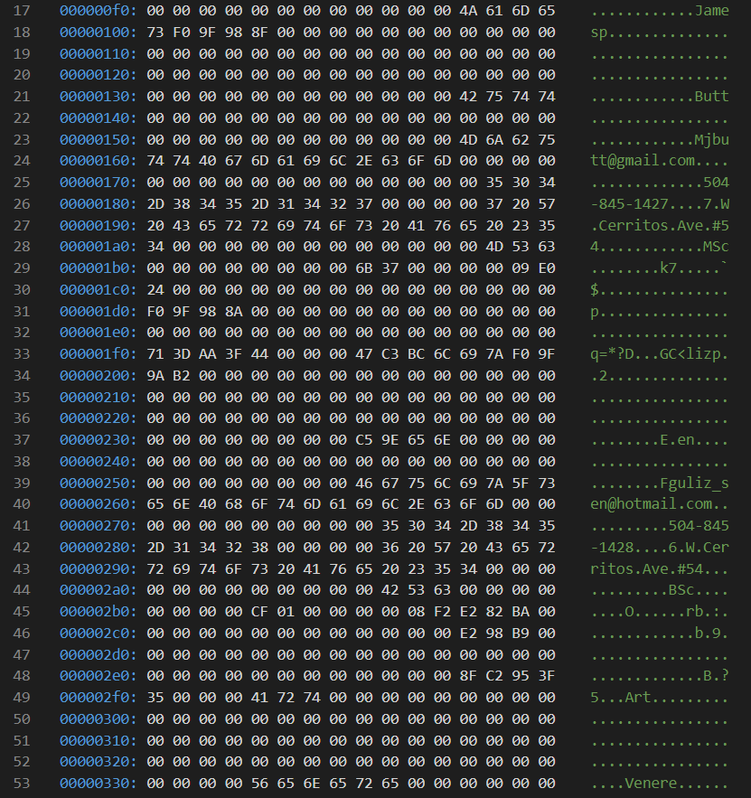

Sample output file:

