

When load factor equals 50%:

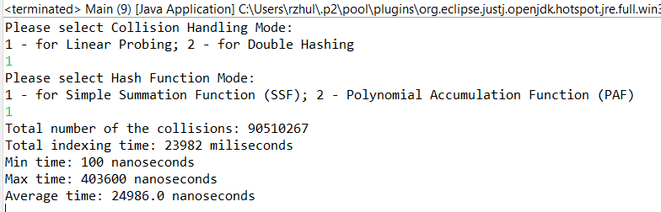

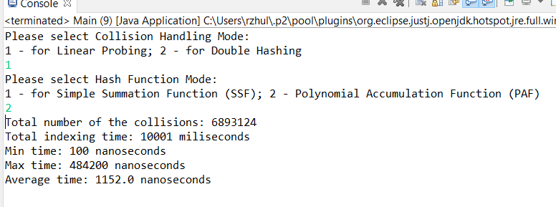

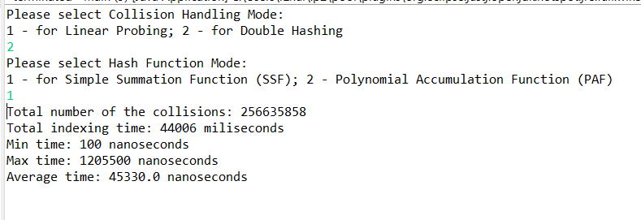

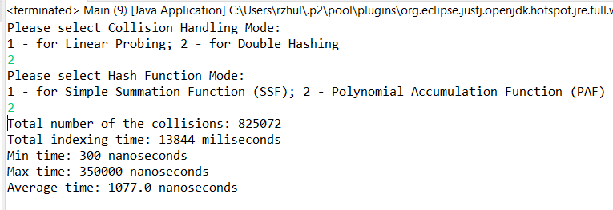

When load factor equals 80%:

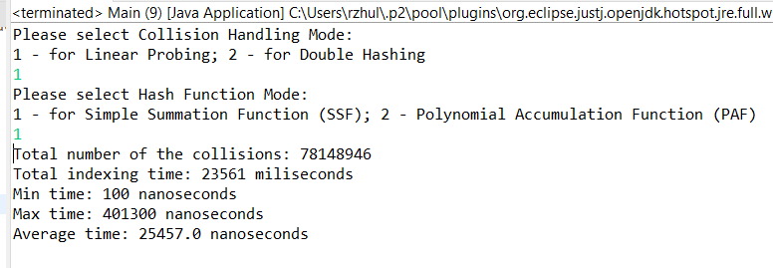

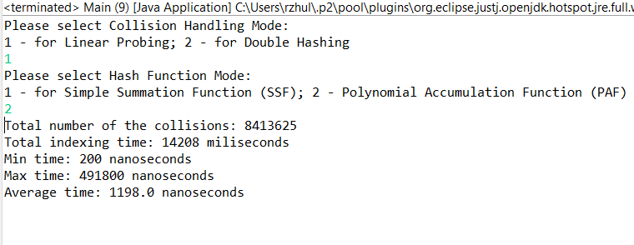

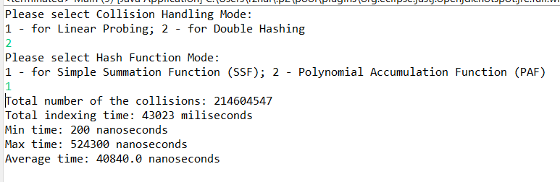

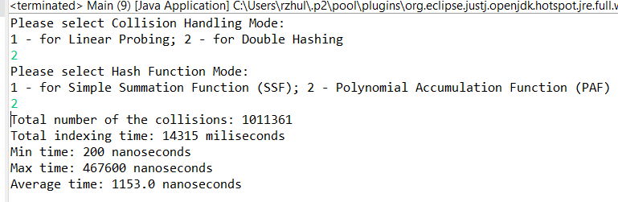

Using the result from the table above we can conclude:

1)The most efficient way to handle this task is Double hashing with PAF hash functions and with load factor 50%

2)The most inefficient is Double hashing with SSP hash functions and with load factor 50%

For myself, I have identified several important parameters when choosing Hash Table as data structure in my code:

* Double hashing hands with task much better than linear probing(if you need to store many information)
* Very important appropriately choose your Hash function
* And usually the best choice for load factor with open addressing is 50%