《数据结构》上机报告
2013年 10 月 22 日
姓名： | 蒋凌超 | 学号： | 1252366 | 班级： | 电子一班 | 得分：

试验题目 | 一元多项式的表示和相加
实验目的 | 掌握线性表的典型应用----多项式的加、减、乘运算的实现
问题描述 | 无
基本要求 | 应实现下列功能：  1、多项式的创建  2、多项式的相加
选做要求 | **1、多项式的相减  **2、多项式的相乘  **3、多项式的求值
选做要求 | 已完成选做内容（序号） | 1、2、3
数据结构  设计 | typedef struct ElemType{  float coef;//系数  int expn; //指数  }ElemType;// ElemType为LinkList的数据对象名  typedef struct LNode{  ElemType data;  struct LNode *next;  } LNode, *polynomail;  int CreatPolyn( polynomail &P, int m);  //输入m项的系数和指数，建立表示一元多项式的有序链表P  void CopyPolyn( polynomail &Pa, polynomail &Pb, int m );  //复制一元多项式  void DestroyPolyn( polynomail &P );  //销毁一元多项式P  void PrintPolyn( polynomail P );  //打印输出一元多项式P  int PolynLength( polynomail P );  //返回一元多项式P中的项  void AddPolyn( polynomail &Pa, polynomail &Pb);  //完成多项式相加运算，即：Pa = Pa + Pb,并销毁一元多项式Pb  void SubtractPolyn( polynomail &Pa, polynomail &Pb);  //完成多项式相减运算，即：Pa = Pa - Pb,并销毁一元多项式Pb  void MultiplyPolyn( polynomail &Pa, polynomail &Pb);  //完成多项式相乘运算，即：Pa = Pa * Pb,并销毁一元多项式Pb  void CalculatorPolyn( polynomail &Pa, int x , int &SUM);  //输入x，进行多项式的运算，返回SUM
功能(函数)说明 | int CreatPolyn( polynomail &P, int m)  {  if( m == 0 )  return 0;  polynomail p, q;  q=P=(polynomail)malloc(sizeof(LNode));//给头结点申请空间  P->next = NULL;  for (int i=m;i>0;--i) {  p=(polynomail)malloc(sizeof(LNode));  cin >> p->data.coef >> p->data.expn;//输入每个结点的内容  p->next = NULL;  q->next=p;  q=q->next;  }  }  void CopyPolyn( polynomail &Pa, polynomail &Pb, int m )  {  polynomail pb, pa = Pa->next;  Pb = (polynomail)malloc(sizeof(LNode));  Pb->next = NULL;  for ( ; m>0; --m)  {  pb=(polynomail)malloc(sizeof(LNode));  pb->data.coef = pa->data.coef;  pb->data.expn = pa->data.expn;  pb->next = Pb->next;  Pb->next=pb;  pa = pa->next;  }  }  void DestroyPolyn( polynomail &P )  {  polynomail p = P, q = P;  while( p ){  q = p->next;  free( p );  p = q;  }  }  void PrintPolyn( polynomail P )  {  polynomail p;  p=P->next;  if( !p )  {  cout << '0';  }  else  {  while(p->next)  {  cout << "(" << p->data.coef << ")" << "*x^" << p->data.expn << "+";  p=p->next;  }  cout << "(" << p->data.coef << ")" << "*x^" << p->data.expn;  }//保证输出格式的正确性  }  int PolynLength( polynomail P )  {  int j;  polynomail p;  p=P->next;  j=0;  while (p)  {  p=p->next;  j++;  }  return(j);  }  void AddPolyn( polynomail &Pa, polynomail &Pb )  {  polynomail pa = Pa->next, pb = Pb->next ,pc = Pa, pd, pe;  while( pa && pb )  {  if( pa->data.expn < pb->data.expn )//前者指数小  {  pc->next = pa;  pc = pa;  pa = pa->next;  }  else if( pa->data.expn > pb->data.expn )//前者指数大  {  pc->next = pb;  pc = pb;  pb = pb->next;  }  else  {  pa->data.coef += pb->data.coef;  if( pa->data.coef == 0 )//运算后系数为零时  {  pc->next = pa->next;  pe = pa;  pd = pb;  pb = pb->next;  pa = pa->next;  free( pd );  free( pe );  }  else  {  pc->next = pa;  pd = pb;  pb = pb->next;  pc = pa;  pa = pa->next;  free( pd );  }  }  }  pc->next = pa?pa:pb;//插入剩余段  free( Pb );  }  void SubtractPolyn( polynomail &Pa, polynomail &Pb )  {  polynomail pa = Pa->next, pb = Pb->next ,pc = Pa, pd, pe;  while( pa && pb )  {  if( pa->data.expn < pb->data.expn )//前者指数小  {  pc->next = pa;  pc = pa;  pa = pa->next;  }  else if( pa->data.expn > pb->data.expn )//前者指数大  {  pc->next = pb;  pc = pb;  pb->data.coef = 0 - pb->data.coef;  pb = pb->next;  }  else  {  pa->data.coef -= pb->data.coef;  if( pa->data.coef == 0 )//运算后系数为零时  {  pc->next = pa->next;  pe = pa;  pd = pb;  pb = pb->next;  pa = pa->next;  free( pd );  free( pe );  }  else  {  pc->next = pa;  pd = pb;  pb = pb->next;  pa = pa->next;  free( pd );  }  }  }  pc->next = pa?pa:pb;//插入剩余段  free( Pb );  }  void MultiplyPolyn( polynomail &Pa, polynomail &Pb)  {  polynomail pa = Pa->next, pb = Pb->next, Pc, pc;  int i = PolynLength( Pa );  pa->data.expn += pb->data.expn;  pa->data.coef *= pb->data.coef;  pa = pa->next;  pa = Pa->next;  pb = pb->next;  while( pb )//pb的每项与pa相乘然后相加  {  CopyPolyn( Pa, Pc, i );  pc = Pc->next;  while( pc )  {  pc->data.expn += pb->data.expn;  pc->data.coef *= pb->data.coef;  pc = pc->next;  }  AddPolyn( Pa, Pc );  pb = pb->next;  }  free( Pb );  }  void CalculatorPolyn( polynomail &Pa, int x , int &SUM)  {  polynomail pa = Pa->next;  int i, ery = 1;  SUM = 0;  while( pa )  {  i = pa->data.expn;  while( i )  {  ery *= x;  i--;  }  SUM += (pa->data.coef * ery);  pa = pa->next;  }  }
界面设计和使用说明 | int main()  {  cout << "输入的多项式的项数必须大于0" << endl;  cout << "检验多项式的相加，先创建2个新多项式，请输入多项式A的项数" << endl;  polynomail A, B;  int m;  cin >> m;  cout << "请输入A各项的系数和指数" << endl;  CreatPolyn( A, m );  cout << "请输入B的项数" << endl;  cin >> m;  cout << "请输入B各项的系数和指数" << endl;  CreatPolyn( B, m );  AddPolyn( A, B );  cout << "相加后的多项式A为：" << endl << endl;  PrintPolyn( A );  cout << endl;  DestroyPolyn( A );  cout << "----------------------------------------------------------------" << endl;  cout << "检验多项式的相减，先创建2个新多项式，请输入多项式A的项数" << endl;  cin >> m;  cout << "请输入A各项的系数和指数" << endl;  CreatPolyn( A, m );  cout << "请输入B的项数" << endl;  cin >> m;  cout << "请输入B各项的系数和指数" << endl;  CreatPolyn( B, m );  SubtractPolyn( A, B );  cout << "相减后的多项式A为：" << endl << endl;  PrintPolyn( A );  cout << endl;  DestroyPolyn( A );  cout << "----------------------------------------------------------------" << endl;  cout << "检验多项式的相乘，先创建2个新多项式，请输入多项式A的项数" << endl;  cin >> m;  cout << "请输入A各项的系数和指数" << endl;  CreatPolyn( A, m );  cout << "请输入B的项数" << endl;  cin >> m;  cout << "请输入B各项的系数和指数" << endl;  CreatPolyn( B, m );  MultiplyPolyn( A, B );  cout << "相减后的多项式A为：" << endl << endl;  PrintPolyn( A );  cout << endl;  DestroyPolyn( A );  cout << "----------------------------------------------------------------" << endl;  int SUM;  cout << "检验多项式的运算，先创建1个新多项式，请输入多项式A的项数" << endl;  cin >> m;  cout << "请输入A各项的系数和指数" << endl;  CreatPolyn( A, m );  cout << "请输入未知数的值" << endl;  cin >> m;  CalculatorPolyn( A, m, SUM);  cout << "运算之后的数值为：" << endl << endl;  cout << SUM;  cout << endl;  DestroyPolyn( A );  return 0;  }
调试分析 | 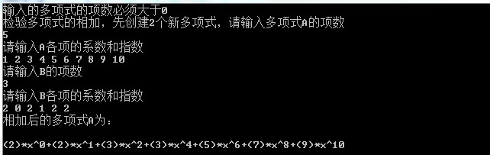  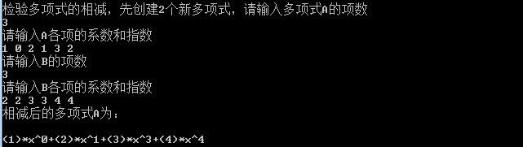  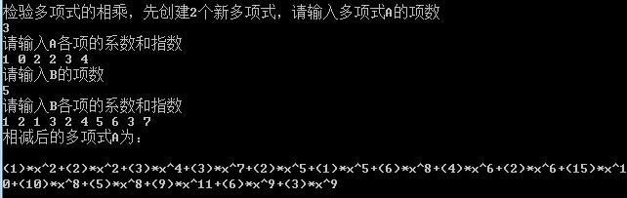  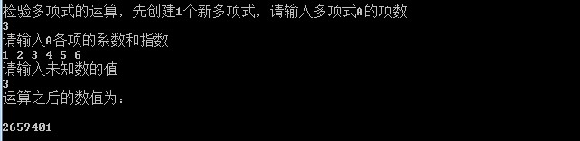
心得体会 | （对整个实验过程做出总结，对重要的算法做出性能分析。）  这次实验让我熟悉了链表的使用

