Analysis Report: Spectrum1
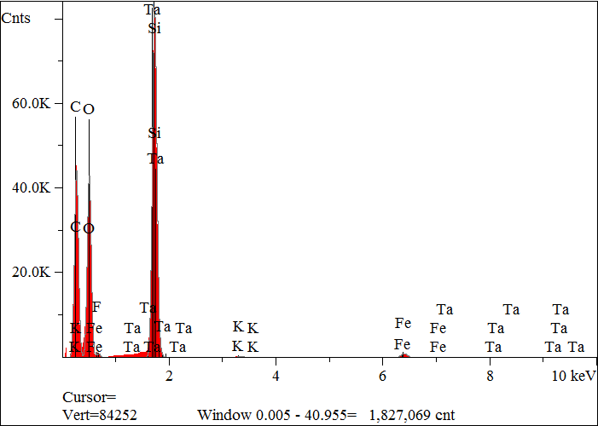
Elt. | Line | Intensity  (c/s) | Atomic  % | Conc | Units | Error  2-sig | MDL  3-sig
C | Ka | 2,078.51 | 54.438 | 43.127 | wt.% | 0.067 | 0.022
O | Ka | 2,007.72 | 36.220 | 38.222 | wt.% | 0.061 | 0.021
F | Ka | 0.00 | 0.000 | 0.000 | wt.% | 0.000 | 0.000
Si | Ka | 2,862.56 | 8.645 | 16.014 | wt.% | 0.056 | 0.009
K | Ka | 26.35 | 0.091 | 0.235 | wt.% | 0.007 | 0.014
Fe | Ka | 77.13 | 0.586 | 2.159 | wt.% | 0.021 | 0.030
Ta | La | 1.42 | 0.020 | 0.242 | wt.% | 0.047 | 0.148
 |  |  | 100.000 | 100.000 | wt.% |  |  | Total

kV 15.0
Takeoff Angle 35.0°
Elapsed Livetime 200.0

