Analysis Report: Spectrum1
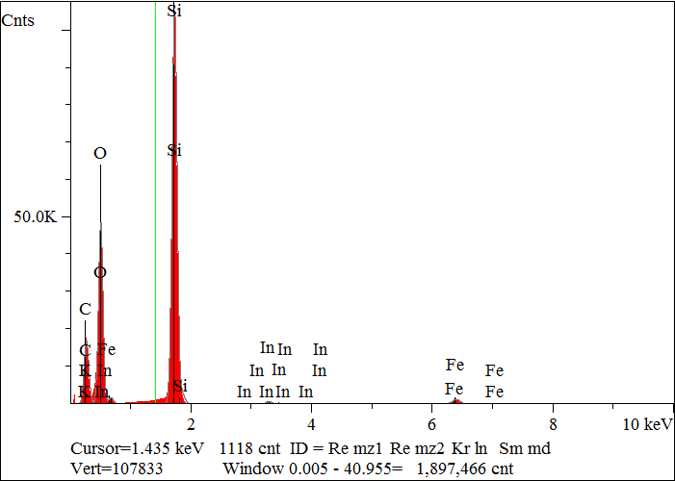
Elt. | Line | Intensity  (c/s) | Atomic  % | Conc | Units | Error  2-sig | MDL  3-sig
C | Ka | 829.64 | 39.507 | 27.832 | wt.% | 0.070 | 0.031
O | Ka | 2,286.21 | 41.135 | 38.602 | wt.% | 0.057 | 0.018
F | Ka | 0.00 | 0.000 | 0.000 | wt.% | 0.000 | 0.000
Si | Ka | 5,518.64 | 18.399 | 30.308 | wt.% | 0.029 | 0.008
K | Ka | 15.58 | 0.062 | 0.142 | wt.% | 0.013 | 0.014
Fe | Ka | 99.83 | 0.845 | 2.769 | wt.% | 0.023 | 0.031
In | La | 19.38 | 0.051 | 0.347 | wt.% | 0.020 | 0.028
 |  |  | 100.000 | 100.000 | wt.% |  |  | Total

kV 15.0
Takeoff Angle 35.0°
Elapsed Livetime 200.0

