Analysis Report: Spectrum1
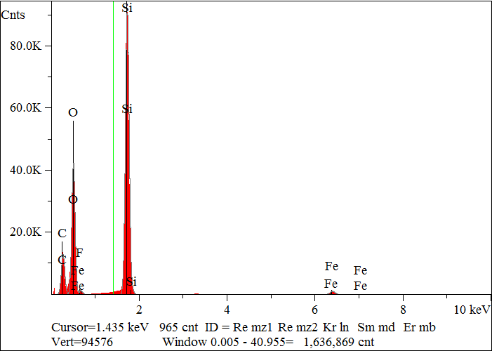
Elt. | Line | Intensity  (c/s) | Atomic  % | Conc | Units | Error  2-sig | MDL  3-sig
C | Ka | 636.99 | 37.860 | 26.455 | wt.% | 0.076 | 0.036
O | Ka | 1,993.14 | 41.866 | 38.969 | wt.% | 0.062 | 0.019
F | Ka | 0.00 | 0.000 | 0.000 | wt.% | 0.000 | 0.000
Si | Ka | 4,877.47 | 19.377 | 31.662 | wt.% | 0.032 | 0.009
Fe | Ka | 88.79 | 0.897 | 2.914 | wt.% | 0.026 | 0.035
 |  |  | 100.000 | 100.000 | wt.% |  |  | Total

kV 15.0
Takeoff Angle 35.0°
Elapsed Livetime 200.0

