Analysis Report: Spectrum1
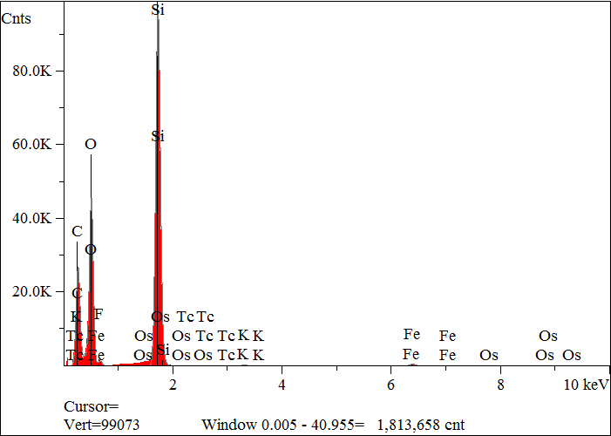
Elt. | Line | Intensity  (c/s) | Atomic  % | Conc | Units | Error  2-sig | MDL  3-sig
C | Ka | 1,195.80 | 46.879 | 34.768 | wt.% | 0.074 | 0.028
O | Ka | 2,015.94 | 36.575 | 36.133 | wt.% | 0.058 | 0.019
F | Ka | 35.81 | 0.636 | 0.746 | wt.% | 0.032 | 0.023
Si | Ka | 5,043.45 | 15.479 | 26.845 | wt.% | 0.027 | 0.008
K | Ka | 23.22 | 0.085 | 0.206 | wt.% | 0.007 | 0.014
Fe | Ka | 41.95 | 0.330 | 1.139 | wt.% | 0.017 | 0.030
Tc | La | 0.78 | 0.002 | 0.012 | wt.% | 0.007 | 0.023
Os | Ma | 13.37 | 0.013 | 0.152 | wt.% | 0.008 | 0.018
 |  |  | 100.000 | 100.000 | wt.% |  |  | Total

kV 15.0
Takeoff Angle 35.0°
Elapsed Livetime 200.0

