Analysis Report: Spectrum1
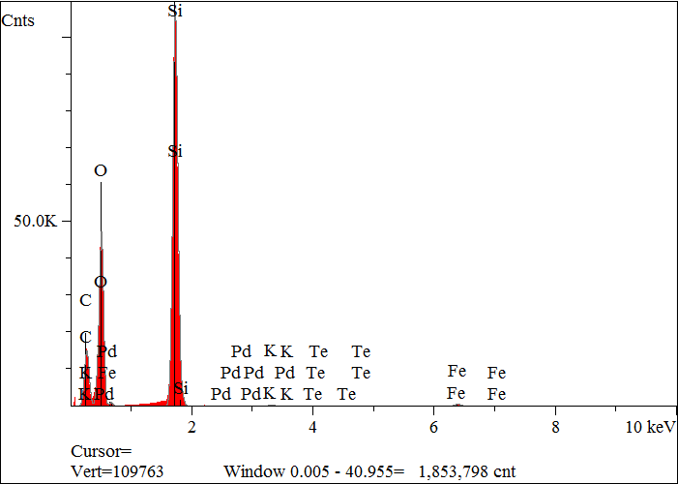
Elt. | Line | Intensity  (c/s) | Atomic  % | Conc | Units | Error  2-sig | MDL  3-sig
C | Ka | 734.92 | 47.629 | 33.718 | wt.% | 0.090 | 0.042
O | Ka | 1,193.83 | 29.517 | 27.835 | wt.% | 0.150 | 0.024
F | Ka | 26.35 | 0.534 | 0.599 | wt.% | 0.024 | 0.025
Si | Ka | 5,636.47 | 21.707 | 35.933 | wt.% | 0.034 | 0.009
K | Ka | 28.24 | 0.135 | 0.312 | wt.% | 0.008 | 0.017
Fe | Ka | 46.36 | 0.468 | 1.541 | wt.% | 0.022 | 0.037
Pd | La | 0.62 | 0.002 | 0.012 | wt.% | 0.010 | 0.030
Te | La | 1.75 | 0.007 | 0.051 | wt.% | 0.014 | 0.043
 |  |  | 100.000 | 100.000 | wt.% |  |  | Total

kV 15.0
Takeoff Angle 35.0°
Elapsed Livetime 200.0

